**全景摄像机和球机协同软件三期项目需求**

**项目简介(Introduction of the project)**

迭代升级现有的全景摄像机和球机协同软件（软件名：EShong）。

Update the current version of software controlling the panoramic camera and dome cameras

**项目名词(The Nouns in the project)**

全景摄像机：反射式全景相机，输出图片类型为鱼眼，抓拍全貌。

Panoramic camera: Reflective panoramic camera, the output picture type is fisheye, full shot

球机： 带云台，可变焦相机，输出图片为矩形，抓拍细节。

Dome camera: with gimbal, zoom camera, rectangular output picture, capture details.

**开发内容(Content of development)**

1. 已添加的硬盘录像机，再次增加摄像机后，列表数量无法自动增加。必须删除录像机及相关联动组后，统一增加摄像机，然后再次添加录像机并标定； 请修改。（软件开启自动刷新和右键刷新按钮; After adding a hard disk video recorder, the number of lists cannot be automatically increased after the camera is added again. After deleting the recorder and related linkage group, add cameras uniformly, then add the recorder again and calibrate; please modify. (The software enables the automatic refresh and right-click refresh buttons)

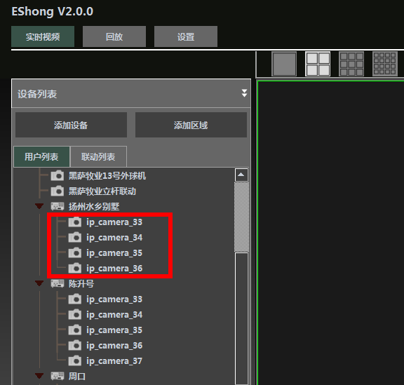

2. 完善：回放及下载功能需优化，可参考海康4200软件，回放条密度可调

如下图每个格代表半小时

Improvements: Playback and download functions need to be optimized. Please refer to Haikang 4200 software. Playback bar density can be adjusted.

As shown in the figure below, each cell represents half an hour

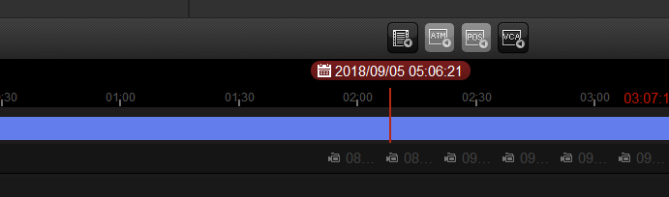

如下图每个格代表一分钟

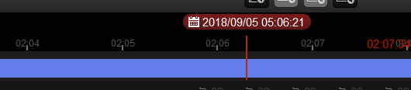

### 回放增加电子放大功能（电子放大倍数及区域可框选指定）

Add electronic zoom function for playback (electronic zoom and area can be specified by frame selection)

放大前

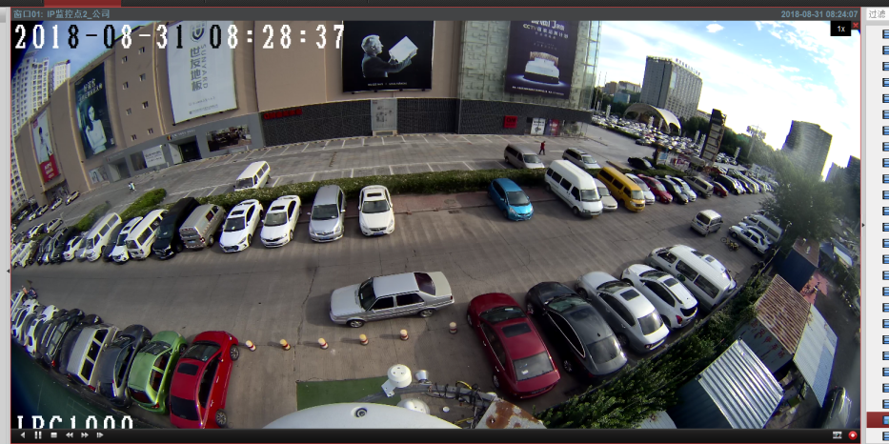

放大后

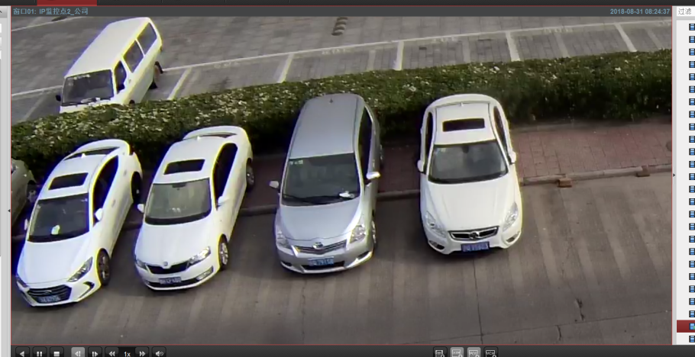

1. 完善：广角联动标定方式更换为纵横点方式，5横7纵至7横9纵（目前为同心圆方式）（pano type = 0： 全景， =1 广角）

Improvements: The wide-angle linkage calibration method is changed to the vertical and horizontal point method, 5 x7 vertical to 7 x 9 vertical (current concentric circle method)

1. 完善： 联动列表”添加“区域”功能（分组功能）;

Improvements: add “Area”(grouping function)

1. 添加： 注册机功能，去除水印“试用版”;

Add: add keymaker function

1. 云台调用，添加，删除，预置，巡航功能；

Add: PTZ call, add, delete, preset, cruise function

注意：

1. 只添加硬盘录像机不可以实现联动，已确认;
2. 远程回访可按照时间段下载，已确认。