程式設計與應用 期中作業

全局變數 & 套件包
ps:做完才發現有ticker().download()可以用，以後要記得先看完文檔...
import os
import time
from datetime import datetime
import pandas as pd
import requests
from IPython.display import Markdown
from yfinance import Ticker
session = requests.Session()
session.headers['User-agent'] = (
'Mozilla/5.0 (Windows NT 10.0; Win64; x64) AppleWebKit/537.36 (KHTML, like Gecko) Chrome/91.0.4472.124 Safari/537.36'
)
class StockData:
def __init__(
self,
ticker: str,
name: str,
session: requests.Session,
start: str,
end: str,
):
self.name = name
self.getData(ticker, session, start, end)
self.ax = None
def getData(
self, ticker: str, session: requests.Session, start: str, end: str
) -> None:
printName = f'{ticker}-{start.date()}_{end.date()}'
filename = f'data/{printName}.csv'
if os.path.exists(filename):
print(f'讀取 {printName} 資料: {filename}')
self.data = pd.read_csv(filename, index_col=0, parse_dates=True)
self.data.index = pd.to_datetime(self.data.index, utc=True)
else:
print(f'下載 {printName} 資料...')
self.data = Ticker(ticker, session=session).history(
start=start, end=end
)
if self.data is None:
print(f'找不到 {printName} 的資料')
else:
self.data.to_csv(filename)
print(f'{printName} 存檔至 {filename}')
def locateRange(self, start: str, end: str) -> pd.DataFrame:
if self.data is None:
raise ValueError(f'{self.name} 未初始化')
return self.data.loc[start:end]

第一大題: 取得數據
使用 yfinance 抓取特斯拉、福特和通用汽車的股票價格（2013-2023 年）。
start = datetime(2013, 1, 1)
end = datetime(2023, 1, 1)
tesla_first = StockData('TSLA', 'Tesla', session, start, end)
time.sleep(1)
ford_first = StockData('F', 'Ford', session, start, end)
time.sleep(1)
gm_first = StockData('GM', 'GM', session, start, end)
time.sleep(1)
# 設定顯示選項
pd.set_option('display.max_columns', None)
pd.set_option('display.max_rows', 10)
pd.set_option('display.width', 1000)
pd.set_option('display.float_format', '{:.2f}'.format)
# 列印數據
display(Markdown('### **Tesla**'))
display(tesla_first.data.head())
display(Markdown('### **Ford**'))
display(ford_first.data.head())
display(Markdown('### **GM**'))
display(gm_first.data.head())

output:
讀取 TSLA-2013-01-01_2023-01-01 資料: data/TSLA-2013-01-01_2023-01-01.csv
讀取 F-2013-01-01_2023-01-01 資料: data/F-2013-01-01_2023-01-01.csv
讀取 GM-2013-01-01_2023-01-01 資料: data/GM-2013-01-01_2023-01-01.csv
<IPython.core.display.Markdown object>
Open High Low Close Volume Dividends Stock Splits
Date
2013-01-02 05:00:00+00:00 2.33 2.36 2.31 2.36 17922000 0.00 0.00
2013-01-03 05:00:00+00:00 2.35 2.36 2.32 2.32 11130000 0.00 0.00
2013-01-04 05:00:00+00:00 2.32 2.32 2.26 2.29 10110000 0.00 0.00
2013-01-07 05:00:00+00:00 2.32 2.32 2.26 2.29 6630000 0.00 0.00
2013-01-08 05:00:00+00:00 2.30 2.30 2.21 2.25 19260000 0.00 0.00
<IPython.core.display.Markdown object>
Open High Low Close Volume Dividends Stock Splits
Date
2013-01-02 05:00:00+00:00 6.93 6.96 6.81 6.92 75274700 0.00 0.00
2013-01-03 05:00:00+00:00 6.94 7.18 6.84 7.05 121284700 0.00 0.00
2013-01-04 05:00:00+00:00 7.08 7.13 6.99 7.11 54669900 0.00 0.00
2013-01-07 05:00:00+00:00 7.08 7.12 6.99 7.04 43482400 0.00 0.00
2013-01-08 05:00:00+00:00 7.01 7.04 6.92 6.99 46336200 0.00 0.00
<IPython.core.display.Markdown object>
Open High Low Close Volume Dividends Stock Splits
Date
2013-01-02 05:00:00+00:00 21.98 22.04 21.39 21.77 15605900 0.00 0.00
2013-01-03 05:00:00+00:00 21.71 22.59 21.55 22.28 22903800 0.00 0.00
2013-01-04 05:00:00+00:00 22.22 22.31 21.84 22.31 8066600 0.00 0.00
2013-01-07 05:00:00+00:00 22.15 22.31 21.89 22.16 8385300 0.00 0.00
2013-01-08 05:00:00+00:00 22.16 22.30 21.71 21.95 10435200 0.00 0.00

第二大題: 視覺化
取得特斯拉、福特和通用汽車的股票價格 (2012 年 1月)。
並使用matplotlib視覺化(蠟燭圖)
1. 每家各別視覺化
2. 三家合併到同一張圖中做比較
import matplotlib.pyplot as plt
import mplfinance as mpf
start = datetime(2012, 1, 1)
end = datetime(2012, 12, 31)
tesla_second = StockData('TSLA', 'Tesla', session, start, end)
time.sleep(1)
ford_second = StockData('F', 'Ford', session, start, end)
time.sleep(1)
gm_second = StockData('GM', 'GM', session, start, end)
time.sleep(1)
# 第一小題
for stock in [tesla_second, ford_second, gm_second]:
mpf.plot(
stock.locateRange('2012-01', '2012-01'),
type='candle',
style='charles',
title=f'S&P 500, Jan 2012 - {stock.name}',
ylabel='Price ($)',
ylabel_lower='Shares \nTraded',
volume=True,
mav=(3, 6, 9),
)
# 第二小題
addplot = [
mpf.make_addplot(
ford_second.locateRange('2012-01', '2012-01'),
type='candle',
panel=1,
ylabel='Ford',
),
mpf.make_addplot(
gm_second.locateRange('2012-01', '2012-01'),
type='candle',
panel=2,
ylabel='GM',
),
]
mpf.plot(
tesla_second.locateRange('2012-01', '2012-01'),
type='candle',
style='charles',
addplot=addplot,
panel_ratios=(1, 1, 1),
title='Comparison: Tesla vs Ford vs GM',
ylabel='Tesla',
)

Output:
讀取 TSLA-2012-01-01_2012-12-31 資料: data/TSLA-2012-01-01_2012-12-31.csv
讀取 F-2012-01-01_2012-12-31 資料: data/F-2012-01-01_2012-12-31.csv
讀取 GM-2012-01-01_2012-12-31 資料: data/GM-2012-01-01_2012-12-31.csv
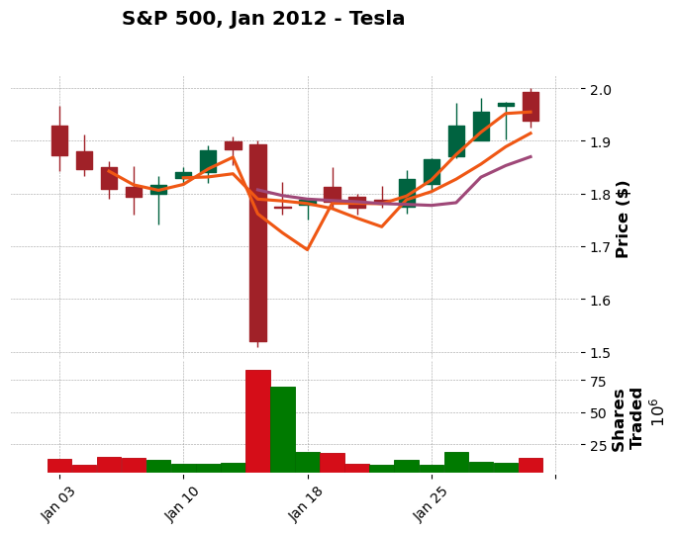
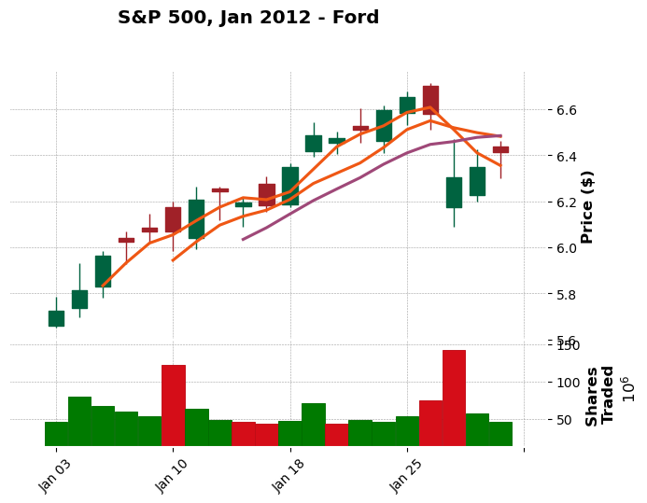
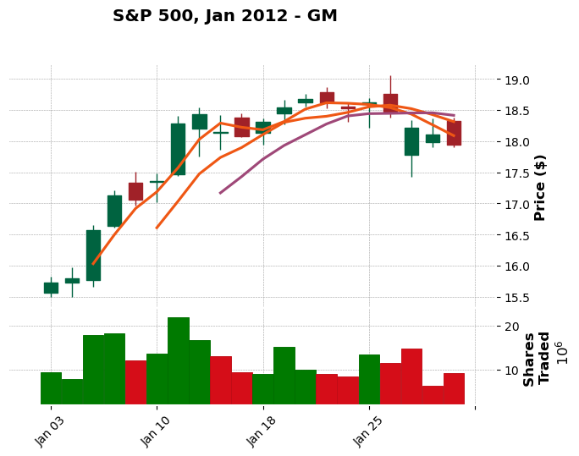
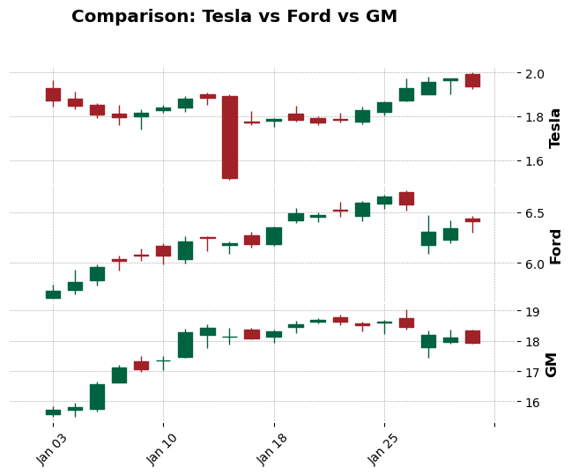

第三大題:基本財務分析
- 為每個資料框建立一個名為 returns 的新欄位。該列的值將根據收盤價列計算得出。有兩種方法可以實現：一種是使用 .shift() 方法，並按照上述公式進行簡單計算；另一種是使用 pandas 內建的pct_change 方法。
- 繪製每家公司收益率的直方圖。可以分別繪製，也可以將它們疊在一起繪製。
start = datetime(2012, 1, 1)
end = datetime(2022, 1, 1)
tesla_third = StockData('TSLA', 'Tesla', session, start, end)
ford_third = StockData('F', 'Ford', session, start, end)
gm_third = StockData('GM', 'General Motors', session, start, end)
# 方法一
# tesla_third.data['returns'] = (tesla_third.data['Close'] / tesla_third.data['Close'].shift(1) ) - 1
# ford_third.data['returns'] = (ford_third.data['Close'] / ford_third.data['Close'].shift(1) ) - 1
# gm_third.data['returns'] = (gm_third.data['Close'] / gm_third.data['Close'].shift(1) ) - 1
# 方法二
tesla_third.data['returns'] = tesla_third.data['Close'].pct_change(1)
ford_third.data['returns'] = ford_third.data['Close'].pct_change(1)
gm_third.data['returns'] = gm_third.data['Close'].pct_change(1)
# 第一小題
display(Markdown('### ** Tesla **'))
display(tesla_third.data['returns'].head())
display(Markdown('### ** Ford **'))
display(ford_third.data['returns'].head())
display(Markdown('### ** GM **'))
display(gm_third.data['returns'].head())
# 第二小題
tesla_third.data['returns'].hist(
bins=100, label='Tesla', figsize=(10, 8), alpha=0.5
)
ford_third.data['returns'].hist(
bins=100, label='Ford', figsize=(10, 8), alpha=0.5
)
gm_third.data['returns'].hist(
bins=100,
label='GM',
figsize=(10, 8),
alpha=0.5,
)
plt.legend()
plt.show()
Output:
讀取 TSLA-2012-01-01_2022-01-01 資料: data/TSLA-2012-01-01_2022-01-01.csv
讀取 F-2012-01-01_2022-01-01 資料: data/F-2012-01-01_2022-01-01.csv
讀取 GM-2012-01-01_2022-01-01 資料: data/GM-2012-01-01_2022-01-01.csv
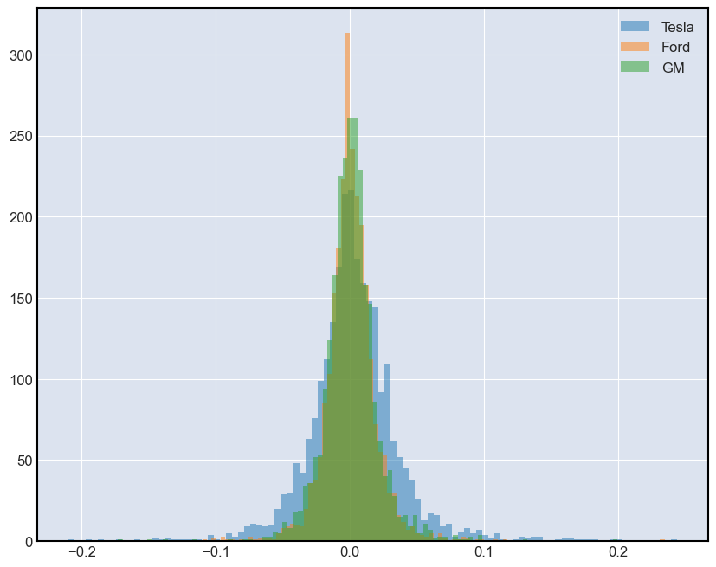

第四大題: 每日累積收益率
每日收益率 = (每日收盤價 - 昨日收盤價) / 昨日收盤價
累積收益率 = 目前價格 / 買入價格
df[daily_cumulative_return] = ( 1 + df[pct_daily_return] ).cumprod()
ps: pct_daily_return 就是上一題的函式。
- (20%) Please Create a cumulative daily return column for each car company's dataframe, response the source code and results in your document.
- (5%) Please plot three companies’ Cumulative Return columns against the time series index in one figure. And answer which stock showed the highest return for a $1 invested? Which showed the lowest?
start = datetime(2025, 1, 1)
end = datetime(2025, 11, 26)
tesla_fourth = StockData('TSLA', 'tesla', session, start, end)
time.sleep(1)
ford_fourth = StockData('F', 'ford', session, start, end)
time.sleep(1)
gm_fourth = StockData('GM', 'gm', session, start, end)
time.sleep(1)
tesla_fourth.data['daily_cumulative_return'] = (
1 + tesla_fourth.data['Close'].pct_change(1).fillna(0)
).cumprod()
ford_fourth.data['daily_cumulative_return'] = (
1 + ford_fourth.data['Close'].pct_change(1).fillna(0)
).cumprod()
gm_fourth.data['daily_cumulative_return'] = (
1 + gm_fourth.data['Close'].pct_change(1).fillna(0)
).cumprod()
# 第一小題
display(Markdown('### **Tesla**'))
display(tesla_fourth.data['daily_cumulative_return'])
display(Markdown('### **Ford**'))
display(ford_fourth.data['daily_cumulative_return'])
display(Markdown('### **GM**'))
display(gm_fourth.data['daily_cumulative_return'])
# 第二小題
tesla_fourth.data['daily_cumulative_return'].plot(label='Tesla')
ford_fourth.data['daily_cumulative_return'].plot(label='Ford')
gm_fourth.data['daily_cumulative_return'].plot(label='GM')
plt.legend()
plt.show()
Output:
讀取 TSLA-2025-01-01_2025-11-26 資料: data/TSLA-2025-01-01_2025-11-26.csv
讀取 F-2025-01-01_2025-11-26 資料: data/F-2025-01-01_2025-11-26.csv
讀取 GM-2025-01-01_2025-11-26 資料: data/GM-2025-01-01_2025-11-26.csv
<IPython.core.display.Markdown object>
Date
2025-01-02 05:00:00+00:00 1.00
2025-01-03 05:00:00+00:00 1.08
2025-01-06 05:00:00+00:00 1.08
2025-01-07 05:00:00+00:00 1.04
2025-01-08 05:00:00+00:00 1.04
...
2025-11-19 05:00:00+00:00 1.07
2025-11-20 05:00:00+00:00 1.04
2025-11-21 05:00:00+00:00 1.03
2025-11-24 05:00:00+00:00 1.10
2025-11-25 05:00:00+00:00 1.11
Name: daily_cumulative_return, Length: 226, dtype: float64
<IPython.core.display.Markdown object>
Date
2025-01-02 05:00:00+00:00 1.00
2025-01-03 05:00:00+00:00 1.02
2025-01-06 05:00:00+00:00 1.03
2025-01-07 05:00:00+00:00 1.01
2025-01-08 05:00:00+00:00 1.01
...
2025-11-19 05:00:00+00:00 1.44
2025-11-20 05:00:00+00:00 1.38
2025-11-21 05:00:00+00:00 1.43
2025-11-24 05:00:00+00:00 1.44
2025-11-25 05:00:00+00:00 1.47
Name: daily_cumulative_return, Length: 226, dtype: float64
<IPython.core.display.Markdown object>
Date
2025-01-02 05:00:00+00:00 1.00
2025-01-03 05:00:00+00:00 1.01
2025-01-06 05:00:00+00:00 1.04
2025-01-07 05:00:00+00:00 1.01
2025-01-08 05:00:00+00:00 0.99
...
2025-11-19 05:00:00+00:00 1.34
2025-11-20 05:00:00+00:00 1.34
2025-11-21 05:00:00+00:00 1.38
2025-11-24 05:00:00+00:00 1.39
2025-11-25 05:00:00+00:00 1.43
Name: daily_cumulative_return, Length: 226, dtype: float64
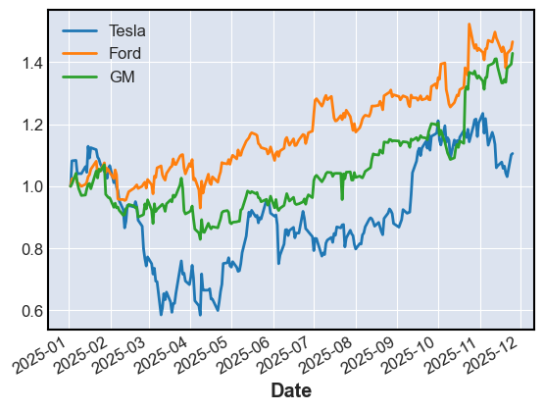
第二小題: 根據圖表投資 Ford 回報最高( GM 也不錯)， Tesla 回報最低。

結論
學習筆記:
- mamba 真的很好用，可以快速的建置環境，而且可以快速且乾淨的安裝套件，相信社群是對的。
- python 各個套件的使用方法，以及如何使用套件來完成特定的任務。
- 了解資料分析的粗略步驟，因為資料是已經被清整過的，感覺少了很多困難度。
- 使用 Markdown 做標題，這是問AI的。
- 學會怎麼使用 jupyter notebook 來呈現輸出(但是我也不知道是不是這樣用)。
- 學會使用 jupyter notebook 匯出檔案。
- Session的設計有點多餘了，應該直接調用宣告的 session。
- 永遠記得套件包的文檔一定要概略的看完再開始寫...
展望:
- 需要學習財報的各種指標，才能跟這個課程整合出一個完整的分析。
提問:
- 是不是可以在其他檔案包好物件，然後在 jupyter notebook 中引用，這樣應該會更乾淨?

