# Tools for computer input files

In order to facilitate users in calculating raw frequency ambiguity, satellite altitude angle, and cycle jump input files, we provide executable program named **gpar_for_fcb.exe**. This program was developed again based on the open-source software GAMP developed by Zhou et al. (2018), and is used the same way as GAMP software, both of which execute the program by reading control files.

In the tools, we provide the name of the control file is "gpar.cfg", and users can solve and output “input files” for different satellite systems by setting this control file. The file input into the executable program includes GNSS observation, Precision orbit and clock bias, broadcast ephemeris, DCB, and antenna. If the solution is GPS triple-frequency uncombined PPP, then an inter frequency clock deviation file is also required.

After opening the Command Prompt panel, the user enters the following command:

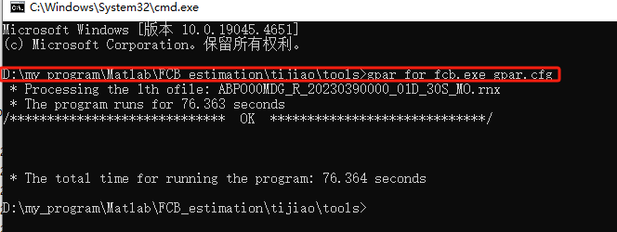

**Fig. 1**  Command of executable program gpar_for_ifcb