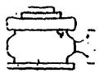
Yates Petroleum Corporation
Typical 3,000 psi Pressure System
Schematic
Annular with Double Ram Preventer Stack
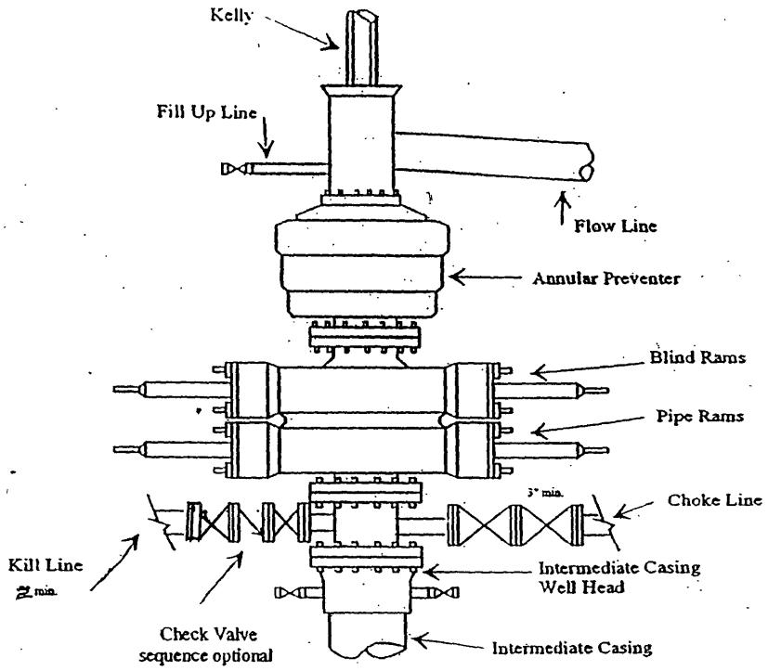
Typical 3,000 psi choke manifold assembly with at least these minimum features
