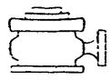
Yates Petroleum Corporation
Typical 5,000 psi Pressure System
Schematic
Annular with Double Ram Preventer Stack
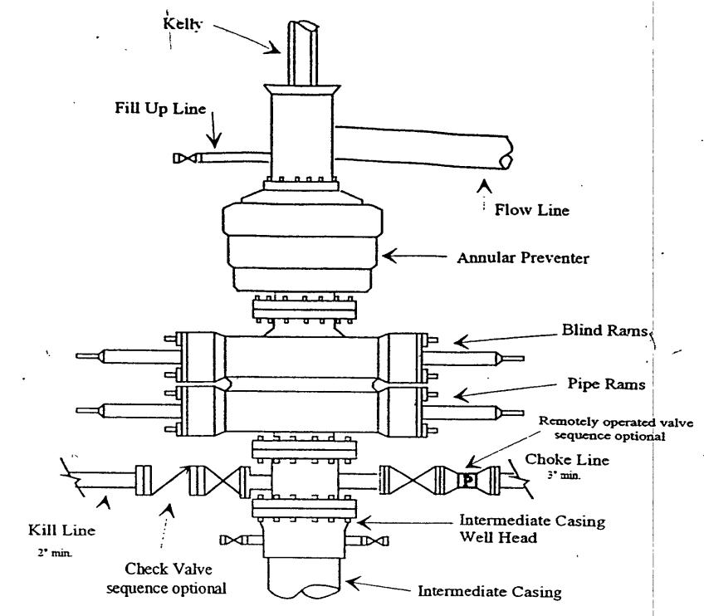
Typical 5,000 psi choke manifold assembly with at least these minimum features
Adjustable choke
