3D-015-36499
RECEIVED
AUG 30 2010
NMOCD ARTESIA
Patriot Drilling, LLC
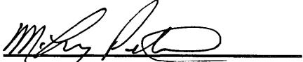
M. Leroy Peterson, Executive Vice-
President
The foregoing instrument was acknowledged before me on this 25th day of May, 2010 by M. Leroy Peterson, Executive Vice-President of Patriot Drilling, LLC.
My Commission Expires: 5/29/2013
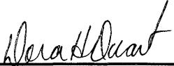
DORA H. DUARTE
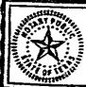
Dora H. Duarte
Notary Public for Midland Co., Texas

