3D $ ^{3} $ Directional Drilling Planner - 3D View
Company: Yates Petroleum Corporation
Well: Jericho BKJ State Com. #2H
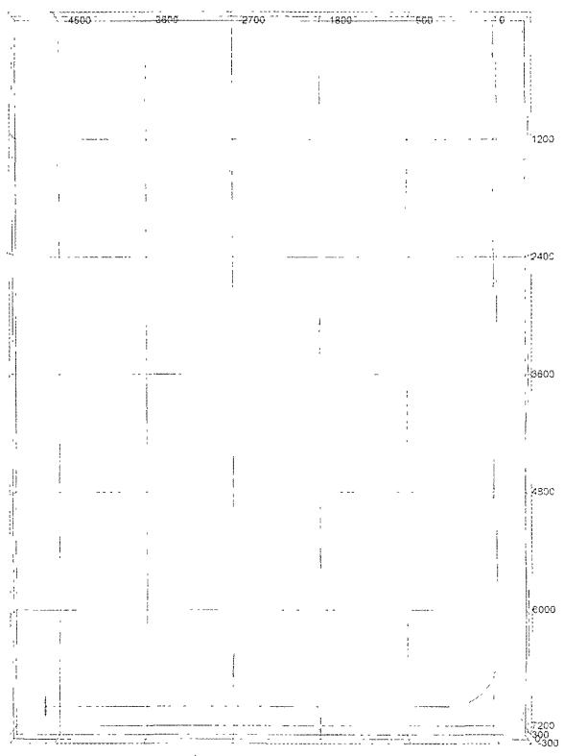
File: G:\drilling toolbox wellplans\Horizontal\jericho2h wpp

