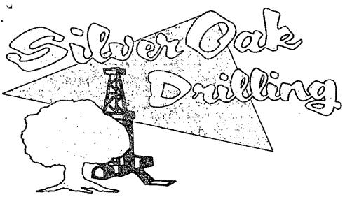
PO Box 1370
Artesia, NM 88211-1370
(505) 748-1288
July 15, 2010
Yates Petroleum Corporation
105 S. 4th
Artesia, NM 88211-1395
RE: Jericho BKJ St Com.#2H
660' F2L & 330' FEL
Sec. 15, T25S, R27E
Eddy County, New Mexico
Dear Sir,
The attached is the Deviation Survey for the above captioned well.
Very truly yours,
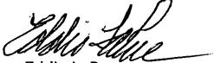
Eddie LaRue Operations Manager
State of New Mexico }
The foregoing was acknowledged before me this 15th day of July, 2010.
