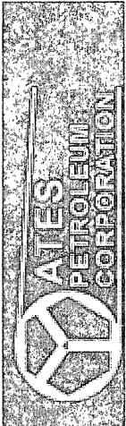
Yates Petroleum Corp.
Eddy County
Jericho "BKJ" State Com
Survey: MWD #1
Pathfinder X & Y Survey Report
12 July, 2010
