
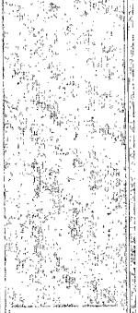
07/12/2010 8:21:59 AM
COMPASS 2003.16 Build 71

