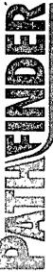
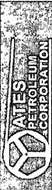
Company: | Yates Petroleum Corp. |  | Local Co-ordinate Reference: | Well #2H
Project: | Eddy County |  | TVD Reference: | WELL @ 3190.50ft (Original Well Elev)
Site: | Jericho "BKJ" State Com |  | MD Reference: | WELL @ 3190.50ft (Original Well Elev)
Well: | #2H |  | North Reference: | Grid
Wellbore: | OH |  | Survey Calculation Method: | Minimum Curvature
Design: | OH |  | Database: | Midland Database
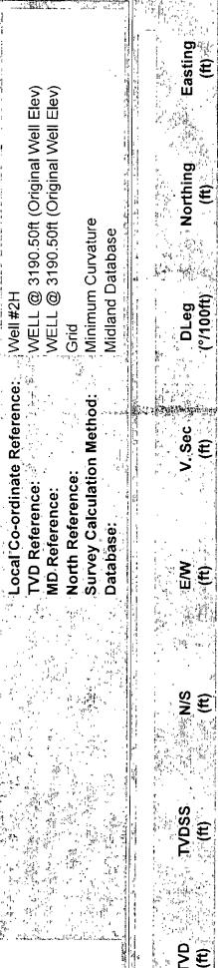
07/12/2010 8:21:59AM
COMPASS 2003.16 Build 71

