
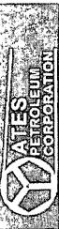
Pathfinder
Pathfinder X & Y Survey Report


