Michelle Lujan Grisham
Governor
Sarah Cottrell Propst
Cabinet Secretary Designate
Gabriel Wade, Acting Director
Oil Conservation Division
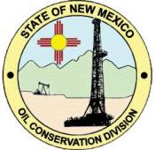
OIL CONSERVATION DIVISION
NOTICE TO OIL AND GAS OPERATORS
Vented & Flared Volumes Reporting Communication
On October 19, 2015, the Oil Conservation Division issued a Notice to Operators that implemented the "Non-Transported Disposition" Code "F" for flared gas and to report vented volumes utilizing the existing "V" code for any vented gas. The change became effective for November, 2015 production month with reporting date of January 15, 2016.
The Gas Capture Committee's continuing evaluation of volumes being reported determined that not all Operators are following the requirement to report flared and vented volumes. Out of 603 well Operators active in the state. Only 51 Operators are reporting volumes using the "V" and "F" code.
It is very important that all Operators in New Mexico report flared and vented volumes since part of the evaluation will help determine any policy or requirements setting goals for reduction of flared gas. We urge all companies to work with their operations and production accounting groups to ensure proper production reporting.
DAVID R. CATANACH, Director
March 8, 2017

