Submit Copy to Appropriate District Office\nDistrict I | State of New Mexico\nEnergy, Minerals and Natural Resources | Form C-103\nOctober 13, 2009
1625 N. Beach Dr., Hobbs, NM 88240\nDistrict II\n130 W. Grand Ave., Artesia, NM 88210\nDistrict III\n1000 Rio Brazos Rd., Aztec, NM 87410\nDistrict IV\n1220 S. St. Francis Dr., Santa Fe, NM\n87505 | OIL CONSERVATION DIVISION\n1220 South St. Francis Dr.\nSanta Fe, NM 87505 | WELL API NO.\n30-015-37500
5. Indicate Type of Lease\nSTATE ☒ FEE ☐
6. State Oil & Gas Lease No.\nV-7318
SUNDRY NOTICES AND REPORTS ON WELLS\n(DO NOT USE THIS FORM FOR PROPOSALS TO DRILL OR TO DEEPEN OR PLUG BACK TO A DIFFERENT RESERVOIR. USE "APPLICATION FOR PERMIT" (FORM C-101) FOR SUCH PROPOSALS.)\n1. Type of Well: Oil Well ☒ Gas Well ☐ Other | 7. Lease Name or Unit Agreement Name\nJericho BKJ State Com
8. Well Number\n2H
2. Name of Operator\nYates Petroleum Corporation | 9. OGRID Number\n025575
3. Address of Operator\n105 South Fourth Street, Artesia, NM 88210 | 10. Pool name or Wildcat Wildcat; Bone Spring
4. Well Location\nSurf-Unit Letter A : 660 feet from the North line and 330 feet from the East line\nBHL-Unit Letter D : 703 feet from the North line and 4518 feet from the East line
Section 15 Township 25S Range 27E NMPM Eddy County
 | 11. Elevation (Show whether DR, RKB, RT, GR, etc.)\n3172'GR
12. Check Appropriate Box to Indicate Nature of Notice, Report or Other Data
NOTICE OF INTENTION TO: PERFORM REMEDIAL WORK ☐ PLUG AND ABANDON ☐ TEMPORARILY ABANDON ☐ CHANGE PLANS ☐ PULL OR ALTER CASING ☐ MULTIPLE COMPLADE ☐ DOWNHOLE COMMINGLE ☐ OTHER: | SUBSEQUENT REPORT OF: REMEDIAL WORK ☐ ALTERING CASING ☐ COMMENCE DRILLING OPNS. ☐ P AND A CASING/CEMENT JOB ☐ OTHER: Completion Operations | ☒
13. Describe proposed or completed operations. (Clearly state all pertinent details, and give pertinent dates, including estimated date of starting any proposed work). SEE RULE 19.15.7.14 NMAC. For Multiple Completions: Attach wellbore diagram of proposed completion or recompletion.
7/26/10 – Tagged up at 5374'. Started drilling cement down to 5496'. Began drilling DV tool. Drilled out and circulated clean. Pressured up on casing to 3000 psi, held good for 15 min.
7/27/10 – Tagged PBTD at 10,440'. Pickled tubing with 1000g 15% NEFE HCL and spotted 1500g 10% acetic acid. Cleaned up DV tool at 5496'.
7/28/10 – Tested casing to 3000 psi, held good. Est TOC 1700'. Perforated Bone Spring 9984' (9), 10,134' (9), 10,284' (9) and 10,434' (9). Frac with a 30# borate gel, pumped 66,508# Ottawa 40/70, 73,044# Super LC 20/40, 38,655# into formation.
9/10/10 – Spotted 1500g 7-1/2% HCL acid at 9854'. Perforated Bone Spring 9834' (9), 9684' (9), 9534' (9) and 9384' (9). Frac with a 30# borate gel, pumped 1500g 7-1/2% HCL acid, 59,417# Ottawa 40/70, 120,000# Ottawa 20/40, 80,000# Super LC 20/40. Spotted 1500g 7-1/2% HCL acid at 9250'. Perforated Bone Spring 9234' (9), 9084' (9), 8934' (9) and 8734' (9). Frac with a 30# borate gel, pumped 1500g 7-1/2% HCL acid, 65,013# 40/70, 124,965# Ottawa 20/40, 78,743# Super LC 20/40.
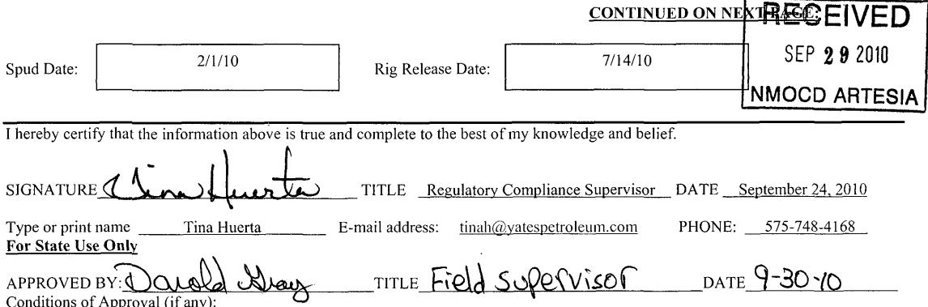
NMOCD ARTESIA
SIGNATURE
APPROVED BY: Donald Wary TITLE Field Supervisor DATE 9-30-10 Conditions of Approval (if any):

