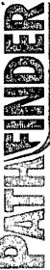
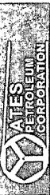
Pathfinder
Pathfinder X & Y Survey Report
Company: | Yates Petroleum Corp. |  |  | Local Co-ordinate Reference: | Well #2H
Project: | Eddy County |  |  | TVD Reference: | WELL @ 3190.50ft (Original Well Elev)
Site: | Jericho "BKJ" State Com |  |  | MD Reference: | WELL @ 3190.50ft (Original Well Elev)
Well: | #2H |  |  | North Reference: | Grid
Wellbore: | OH |  |  | Survey Calculation Method: | Minimum Curvature
Design: | OH |  |  | Database: | Midland Database
Survey Annotations
Measured Depth (ft) | Vertical Depth (ft) | Local Coordinates | 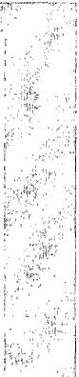
+N/-S (ft) | +E/-W (ft) | Comment
10,495.00 | 6,124.09 | -20.72 | -4,541.61 | BHL-10495.00MD,88.55° INC,269.19° AZI, 6124.09° TVD, 4541.43° VS, -:
Checked By: ________ | Approved By: ________ | Date:

