Well Name: | Jericho BKJ State Com #2H
Location: | Sec. 15 T. 25S R. 27E , 660 FNL 330 FEL
County: | Eddy, NM
Lat/Long: | 32.1356, -104.1708
API #: | 30-015-37500
Spud Date: | RH 2/1/2010; RT 6/18/10
Compl. Date: | 9/20/10
Current Wellbore Diagram:
KB: 3190
GL: 3172
17-1/2" Hole
13-3/8" 48# H-40 @ 470'
Cmt w/ 365 sx Class C (circ) to surface
12-1/4" Hole
9-5/8" 36# J-55 to 2232'
Cmt w/ 760 sx Class C (circ) to surface
DV tool @ 5,496'
KOP @ 5710
Pert @ 150'
PLUG: Sqz 64 sxs from 150' to 0'
15 sxs inside, 49 sxs outside
Pilot hole plug from 5380' - 5880'
300 sxs class H
Tag at 5569, slide to 5710, then start directional drill
8-3/4" Pilot Hole to 8497' TVD
Cement Plug @ 6600'-6815'
Perf @ 520' for surf shoe plug
PLUG: Sqz 51 sxs from 520' to 399'
12 sxs in, 39 sxs out. WOC/TAG.
Perf @ 784'
PLUG: Squeeze 64 sxs from 784' to 632'
15 sxs in, 49 sxs out
This will cover top of salt
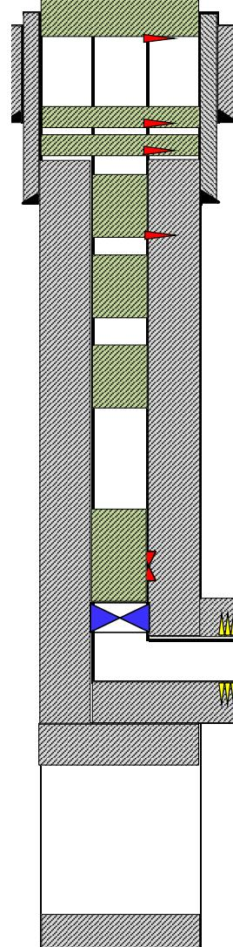
Formation Tops
Top of Salt | 734
Bottom of Salt | 2117
Bell Canyon | 2358
Cherry Canyon | 3174
Brushy Canyon | 4250
Bone Spring | 5828
Leonard | 5926
Perf @ 2282', attempt to inject
PLUG: If able to inject, sqz 102 sxs class C from 2282-2040
24 sxs in, 78 sxs out. WOC/TAG.
This will cover the int. csg shoe and top of Delaware
PLUG: Spot 25 sxs class C from 3224 - 2971
This will cover the Cherry Canyon.
PLUG: Spot 25 sxs class C from 4300 - 4047
This will cover the Brushy Canyon.
Set CIBP @ 5710 (KOP)
Tag, test casing to 500 psi for 30 min
PLUG: Spot 35 sxs class C on CIBP from 5710 5356. WOC/TAG. This will cover the CIBP and DV tool.
Top Perf 6,384'
Bottom Perf @ 10,434'
TD 10495
Pilot Hole TD @ 8,500'
8-3/4" Lateral Hole
5.5" 17# L80 Prod CSG
to 10,490'. 1380 sx cmt
PBTD @ 10,440'
Not to Scale
By: DSC 4/23/26

