Case Study: data in UK

Yue Han

2023-05-10

## Purpose

Determine what characteristics (variables) make someone more likely to smoke.

## Dataset

UK smoking dataset retrieved from [Kaggle](https://www.kaggle.com/datasets/utkarshx27/smoking-dataset-from-uk) original [source](https://www.stem.org.uk/resources/elibrary/resource/28452/large-datasets-stats4schools) with 1691 observations and 12 variables.

### Dataset Reliability

This dataset has been reviewed and been deemed factually accurate by the source’s learning team.

## Setup

Preparing packages used.

library(tidyverse)  
library(ggplot2)  
library(dplyr)  
library(ggcorrplot)

Importing dataset.

data = read.csv("smoking.csv")  
head(data)

## X gender age marital_status highest_qualification nationality ethnicity  
## 1 1 Male 38 Divorced No Qualification British White  
## 2 2 Female 42 Single No Qualification British White  
## 3 3 Male 40 Married Degree English White  
## 4 4 Female 40 Married Degree English White  
## 5 5 Female 39 Married GCSE/O Level British White  
## 6 6 Female 37 Married GCSE/O Level British White  
## gross_income region smoke amt_weekends amt_weekdays type  
## 1 2,600 to 5,200 The North No NA NA   
## 2 Under 2,600 The North Yes 12 12 Packets  
## 3 28,600 to 36,400 The North No NA NA   
## 4 10,400 to 15,600 The North No NA NA   
## 5 2,600 to 5,200 The North No NA NA   
## 6 15,600 to 20,800 The North No NA NA

## Diving into the Data

data %>% count(gender) %>% rename("amount"="n")

## gender amount  
## 1 Female 965  
## 2 Male 726

data %>% count(marital_status) %>% rename("amount"="n")

## marital_status amount  
## 1 Divorced 161  
## 2 Married 812  
## 3 Separated 68  
## 4 Single 427  
## 5 Widowed 223

data %>% count(highest_qualification) %>% rename("amount"="n")

## highest_qualification amount  
## 1 A Levels 105  
## 2 Degree 262  
## 3 GCSE/CSE 102  
## 4 GCSE/O Level 308  
## 5 Higher/Sub Degree 125  
## 6 No Qualification 586  
## 7 ONC/BTEC 76  
## 8 Other/Sub Degree 127

Here we have Refused and Unknown values. Instead of having both of these categories we will combine the two together. By checking again we see we have successfully combined the two.

data$nationality[data$nationality == "Refused" ] <- "Unknown"  
data %>% count(nationality) %>% rename("amount"="n")

## nationality amount  
## 1 British 538  
## 2 English 833  
## 3 Irish 23  
## 4 Other 71  
## 5 Scottish 142  
## 6 Unknown 18  
## 7 Welsh 66

data %>% count(ethnicity) %>% rename("amount"="n")

## ethnicity amount  
## 1 Asian 41  
## 2 Black 34  
## 3 Chinese 27  
## 4 Mixed 14  
## 5 Refused 13  
## 6 Unknown 2  
## 7 White 1560

data %>% count(gross_income) %>% rename("amount"="n")

## gross_income amount  
## 1 10,400 to 15,600 268  
## 2 15,600 to 20,800 188  
## 3 2,600 to 5,200 257  
## 4 20,800 to 28,600 155  
## 5 28,600 to 36,400 79  
## 6 5,200 to 10,400 396  
## 7 Above 36,400 89  
## 8 Refused 108  
## 9 Under 2,600 133  
## 10 Unknown 18

Here we have Refused and Unknown values. Instead of having both of these categories we will combine the two together. By checking again we see we have successfully combined the two.

data$gross_income[data$gross_income == "Refused" ] <- "Unknown"  
data %>% count(gross_income) %>% rename("amount"="n")

## gross_income amount  
## 1 10,400 to 15,600 268  
## 2 15,600 to 20,800 188  
## 3 2,600 to 5,200 257  
## 4 20,800 to 28,600 155  
## 5 28,600 to 36,400 79  
## 6 5,200 to 10,400 396  
## 7 Above 36,400 89  
## 8 Under 2,600 133  
## 9 Unknown 126

data %>% count(region) %>% rename("amount"="n")

## region amount  
## 1 London 182  
## 2 Midlands & East Anglia 443  
## 3 Scotland 148  
## 4 South East 252  
## 5 South West 157  
## 6 The North 426  
## 7 Wales 83

data %>% count(smoke) %>% rename("amount"="n")

## smoke amount  
## 1 No 1270  
## 2 Yes 421

This means 75.1 % of the data has null values for the amt_weekends

amt <- data %>% count(is.na(amt_weekends)) %>%   
 rename("NA_value" = "is.na(amt_weekends)" ) %>%   
 rename("amount"="n")   
amt

## NA_value amount  
## 1 FALSE 421  
## 2 TRUE 1270

amt$amount[2]/(amt$amount[2] + amt$amount[1])

## [1] 0.7510349

This means 75.1 % of the data has null values for the amt_weekdays too.

amt <- data %>% count(is.na(amt_weekdays)) %>% rename("NA_value" = "is.na(amt_weekdays)" ) %>% rename("amount"="n")  
amt$amount[2]/(amt$amount[2] + amt$amount[1])

## [1] 0.7510349

amt

## NA_value amount  
## 1 FALSE 421  
## 2 TRUE 1270

Since this a high percentage I have decided to not include these two variables (amt_weekdays and amt_weekends)

Similar action is taken for type where there are a large amount of null values also.

data %>% count(type) %>% rename("amount"="n")

## type amount  
## 1 1270  
## 2 Both/Mainly Hand-Rolled 10  
## 3 Both/Mainly Packets 42  
## 4 Hand-Rolled 72  
## 5 Packets 297

Additionally the first column called X is not useful for analysis since it is just the number of the row. We will also change the gender, marital_status, highest_qualification, nationality, ethnicity, gross_income, region, and smoke columns into factors.

data <- data[2:10]  
data$gender <- as.factor(data$gender)  
data$marital_status <- as.factor(data$marital_status)  
data$highest_qualification <- as.factor(data$highest_qualification)  
data$nationality <- as.factor(data$nationality)  
data$ethnicity <- as.factor(data$ethnicity)  
data$gross_income <- as.factor(data$gross_income)  
data$region <- as.factor(data$region)  
data$smoke <- as.factor(data$smoke)  
head(data)

## gender age marital_status highest_qualification nationality ethnicity  
## 1 Male 38 Divorced No Qualification British White  
## 2 Female 42 Single No Qualification British White  
## 3 Male 40 Married Degree English White  
## 4 Female 40 Married Degree English White  
## 5 Female 39 Married GCSE/O Level British White  
## 6 Female 37 Married GCSE/O Level British White  
## gross_income region smoke  
## 1 2,600 to 5,200 The North No  
## 2 Under 2,600 The North Yes  
## 3 28,600 to 36,400 The North No  
## 4 10,400 to 15,600 The North No  
## 5 2,600 to 5,200 The North No  
## 6 15,600 to 20,800 The North No

## Data Visualization of Data

Some visualizations of data that could bring some insight on predicting who smokes.

data %>% group_by(nationality) %>%   
 count(smoke) %>% rename("population" = "n") -> nat_smoke  
   
   
ggplot(data = nat_smoke, aes(x=nationality, y = population, fill = smoke)) + geom_bar(stat="identity") + scale_fill_brewer(palette="Set2")+  
 theme_minimal() #+ facet_wrap(~smoke)

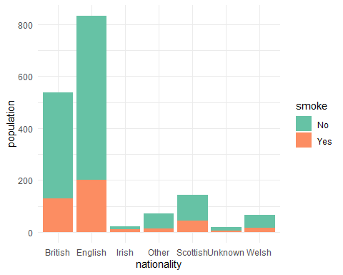

data %>% group_by(gender) %>%   
 count(smoke) -> gend_smoke  
   
ggplot(data = gend_smoke, aes(x=gender, y = n, fill = smoke)) + labs(title="Comparison of Smokers to Non-Smokers by Gender",   
 x="Gender", y = "Amount") + geom_bar(stat="identity") + scale_fill_brewer(palette="Set2") + theme_minimal()

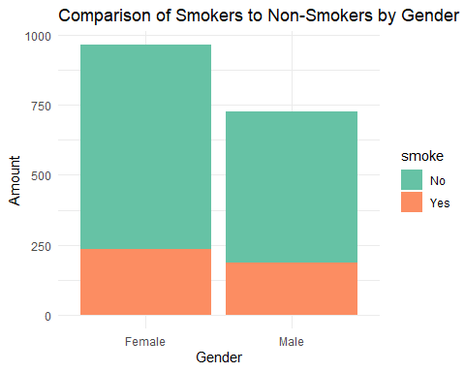

To be continued