**Team #14**

**November 29, 2021**



Tony Allard

Namratha Acharya

Yueh-Ting Wu

Peter Yeu-Shyang Yeh

**Abstract**

In this paper, we analyze box office data from the past 20 years with regards to the potential impact video streaming has had on box office performance. A variety of data preprocessing were performed that included variables such as the timeline of video streaming services so we could effectively analyze the effect video streaming had on the box office. Logistic regression, K-Nearest Neighbors, Naive Bayes, decision tree, and neural network algorithms were used to analyze the data. After that, we close the paper with results and recommendations based on the outcomes of the algorithms. Our 1st recommendation is to not shut down movie theaters because of the impact of video streaming on profits. Our 2nd recommendation is movie theaters should consider hosting events on non-opening weekends because of the cyclical nature of earnings. Our final recommendation is that movie theaters should collaborate with streaming services to advertise their trailers for movies to the subscribers to boost movie theater attendance and profits.

**Statement of the Problem**

Over the past 20 years, streaming services such as Netflix and Hulu have impacted the way movies are consumed by the public. Rather than going into a movie theater, the public can stream and watch movies at home with a monthly subscription fee. In addition, original content is now produced and released exclusively on streaming services which could negatively impact the box office. The box office data is going to be used to determine the impact video streaming services have had on box office earnings, and develop suggestions as to how theaters and movie makers should proceed.

**Dataset**

We utilized two datasets for this analysis. The first dataset was acquired from Kaggle and contained data regarding the top weekend box office. Features included are listed in Table 1. The initial dataset had 3223 records from 1960 to 2021. The weekend gross was heavily right-skewed as can be seen in Figure 4.

The second dataset was self-generated and contained all of the Sundays for holiday weekends from the year 2000 to 2020. The reason why these years were selected will be discussed in the data preprocessing section. In total, there are 210 records in this dataset using the following holidays: New Year’s, Valentine’s Day, Mother’s Day, Memorial Day, Father’s Day, Fourth of July, Labor Day, Halloween, Veteran’s Day, Thanksgiving, and Christmas.

**Hypotheses:**

1. The introduction of streaming services will lead to a loss in revenue for movie theaters. This is under the belief that accessibility to a library of movies at low prices will disincentivize potential customers from going to the theater.
2. The summer season is expected to have a direct relationship with box office gross. The remaining seasons are expected to have no relationship with box office gross. This is due to the idea that summer is often considered the blockbuster season.

**Data Queries**

1. Does the introduction of streaming services negatively impact movie box office earnings?
   * According to data preprocessing, there was no indication that streaming services negatively impacted the box office.
2. Are box office earnings higher over holiday weekends?
   * According to the generated linear model, holiday weekends have significantly higher earnings compared to non-holiday weekends.
3. Does season of the year impact or influence the box office earnings?
   * According to the generated linear model, seasons do have an impact on box office earnings. With the fall as a baseline, summer and spring do significantly increase box office earnings. Winter does not significantly change box office earnings.

**Data Preprocessing**

A list of generated features is stated in Table 2 in the appendix. A month feature was generated using the dates feature. Four binary season categories were also generated. If a record had the months 3, 4, or 5, SpringSeason was coded as 1. If a record had the months 6, 7, or 8, SummerSeason was coded as 1. If a record had the months 9, 10, or 11, FallSeason was coded as 1. All remaining records were coded with WinterSeason as 1.

Several binary features were generated regarding streaming services. From 2007 onwards, records were coded as 1 in Streaming to indicate that streaming services such as Netflix were available. From 2012 and onwards, records were coded as 1 in OriginalStreaming to indicate that streaming services were introducing their own original shows such as Netflix Originals. From 2017 and onwards, records were coded as 1 in InternationalStreaming to indicate that streaming services were now introducing content from foreign countries on their platforms.

In the interest of having comparable data, records from before 2000 were filtered out of the dataset because the year 2000 is often compared to the time when the entertainment industry and availability of the internet grew at unprecedented rates. The records after the year 2019 were also filtered out. These points were clearly outliers as seen by Figure 6. The low earnings were most likely due to the Covid-19 pandemic and lockdowns. After filtering the records, the dataset contained 1139 records.

A continuous variable called MilleniumWeek was also generated. The feature indicates the number of weeks into the millennium when the record occurred.

A binary feature called HolidayWeekend was generated and coded whether or not a record occurred during a holiday weekend. This was generated by comparing the date from box office data with the dates generated for the holiday weekend data. If the dates matched, the feature was coded as 1 to indicate that the records were during a holiday weekend.

A Box Cox transformation was applied to the gross to correct the skewness of the data. The linear model used for determining the necessary transformation used gross fitted to the millenium week number, winter season, spring season, summer season, holiday weekend, streaming, original streaming, and international streaming. Millennium week was used over the weekend and year features because correlation indicated that gross was more correlated to millennium week. The fall season was used as the baseline season. The suggested Box Cox transformation was -0.2 as seen in Figure 12 in the Appendix, and the NormalizedGross feature was generated. The results of the transformation can be seen in the histogram displayed in Figure 5.

Fitting the same model to the normalized gross, the scatter plot in Figure 7 was generated. A new binary Success feature was generated. If the records were on or above the fitted line, the record was coded as 0 or failures. Records below the fitted line were coded as 1 or success.

**Algorithms**

*Logistic Regression*

For logistic regression, seasons, streaming services, and holiday weekends were used as inputs to predict if the weekend box office would be a success or not. The model had a 58.2% accuracy. It was observed that the inclusion of holiday weekends improved the prediction accuracy. Streaming service features (Streaming,OriginalStreaming,InternationalStreaming) did not impact the accuracy to a great extent. The results can be seen on Table 18 in the Appendix.

*K-Nearest Neighbors*

The purpose of this model is to see how accurately season could predict a weekend box office’s success. For the K-Nearest Neighbors model, Fourseason was set as the dependent variable. Gross, HolidayWeekend, Streaming, OriginalStreaming, InternationalStreaming, and Pandemic were the independent variables. To make a prediction is based on using those independent variables to predict which seasons the release of the film. The initial k was set as the square root of the number of records in creating the model. The predictive accuracy using this value of k was 31.03%. The confusion matrix is shown in Table 17 in the Appendix.

Using a for loop, a table of k values and their predictive accuracy was generated as seen in Table 20 in the Appendix. The highest predictive accuracy was 31.8%. While the predictive accuracy was low, this could be due to the fact that Fourseason was split into 4 categories.

*Naïve Bayes*

For the Naive Bayes model, we wished to see if features such as which season a movie was released in, whether or not the record was for a holiday weekend, and what streaming services were available would be good predictors as to whether or not a weekend was a success or not. Success was fitted using all of the binary variables. This model had a predictive accuracy of approximately 52%, however had the issue that many of the predictor variables were dependent on each other. In order to correct for the dependence, several other models were created using fewer variables. The confusion matrices are listed in Tables 3-14. The predictive accuracies can be seen in Table 19 in the Appendix. Because all of the predictive accuracies are approximately 50%, we can determine that seasons, holiday weekends, and streaming services are not good predictors for weekend box office success when using Naive Bayes. As a result of the ambiguity of the results, a conclusive answer regarding the effect of the predictor variables on the gross cannot be stated when using Naive Bayes methods.

*Decision Tree*

Our group created a decision tree model for the box office dataset. The intended purpose of this model is to find out which variables predict whether a film is successful or not in the box office. The variable that showed itself the most on this model was the MilleniumWeek variable. However, the predictive accuracy of this model was only 46.74%. This low predictive accuracy means that the decision tree model does not do a good job at predicting box office success based on the following variables: MilleniumWeek, WinterSeason, SpringSeason, SummerSeason, FallSeason, HolidayWeekend, Streaming, OriginalStreaming and InternationalStreaming. The visualization of the decision tree is shown with Figure 10 in the Appendix.

*Neural Network*

Finally, our group created a neural network based on the box office dataset. The intention of the neural network was to have another model to predict box office success based on the presence of video streaming as an alternative platform for watching movies. The neural network model can be seen in Figure 11 in the Appendix. The predictive accuracy for the neural network model was 54.79%. This low predictive accuracy means that this neural network model is not good at predicting box office success based on the following variables: WinterSeason, SpringSeason, SummerSeason, FallSeason, HolidayWeekend, Streaming, OriginalStreaming and InternationalStreaming.

**Best Model**

For the Logistic Regression, K-Nearest Neighbors, Naïve Bayes, Decision Tree, and the Neural Network model we got predictive accuracies of 58.2%, 31.8%, 52%, 46.74%, and 54.79% respectively. All of the models were within close range in terms of predictive accuracy. However, with the given inputs we see that the Logistic Regression model is the most accurate model with 58.2% accuracy.

**Recommendations**

1. Don’t shut down movie theaters because of the impact of video streaming on profits.
2. Because of the cyclical nature of earnings, movie theaters should consider hosting events on non-opening weekends.
3. Movie theaters should collaborate with streaming services to advertise their trailers for movies to the subscribers to boost movie theater attendance.

**Ethics**

One ethical concern is that any data gained by the streaming services to recommend movie trailers should be kept confidential and not used for anything else. Streaming services users deserve to own their data and should not have to worry about other sources outside of streaming services using their data. Movie theaters should be concerned about how streaming services handle this data since the theaters are giving the streaming services the opportunity to collect it.

**Team Members & Contributions**

* Tony-27%
  + Abstract
  + Statement of the Problem
  + Decision Tree
  + Neural Network
  + Slides Formatting
  + Report Formatting
  + Ethics
* Peter-27%
  + Data Preprocessing (Code, Paper, Slides)
  + Naive Bayes (Code, Paper, Slides)
  + Appendix
* Alice-23%
  + K-Nearest Neighbors Model
  + Best model
* Namratha-23%
  + Hypothesis
  + Logistic Regression Model
  + Recommendations

**Appendix-R Code**

# Preliminary Setup -------------------------------------------------------

# Sets the working directory

# K-Nearest Neighbors

# Works well without MASS package

# Installs and loads tidyverse library

# install.packages("tidyverse")

library(tidyverse)

# Installs and loads tidyverse library

# install.packages("lubridate")

library(lubridate)

# Installs and loads corrplot library

# install.packages("corrplot")

library(corrplot)

# Installs and loads e1071 library

# install.packages("e1071")

library(e1071)

# KNN R Code

# Install tidyverse packages

# install.packages("tidyverse")

# Load tidyverse libraries

library(class)

library(olsrr)

# Setting the working directory

setwd("/Users/robertallard/Desktop/MIS 545/Final Project")

# Read weekendsv2.csv into tibble called BoxOffice

# l for logical

# n for numeric

# i for integer

# c for character

# f for factor

# D for date

# T for datetime

BoxOffice <- read_csv(file = "weekendsv2.csv",

col_types = "ffnnn",

col_names = TRUE)

# Display the tibble

print(BoxOffice)

# Diplay the structure of the tibble

str(BoxOffice)

# Summary the tibble

summary(BoxOffice)

# Converts data from character into data

BoxOffice$Date <- as.Date(BoxOffice$Date, format="%m/%d/%Y")

# Explanatory Data Analysis -----------------------------------------------

# Recodes Date into Months

BoxOffice <- BoxOffice %>%

mutate(Month = months(BoxOffice$Date))

# Recode Months into Season

BoxOffice <- BoxOffice %>%

mutate(Season = 4)

for (i in 1:length(BoxOffice$Month)) {

if (BoxOffice$Month[i] == "January" || BoxOffice$Month[i] =="February"

|| BoxOffice$Month[i] == "December") {

BoxOffice$Season[i] <- 4

} else if (BoxOffice$Month[i] == "November" || BoxOffice$Month[i] =="October"

|| BoxOffice$Month[i] == "September"){

BoxOffice$Season[i] <-3

} else if (BoxOffice$Month[i] == "July" || BoxOffice$Month[i] =="June"

|| BoxOffice$Month[i] == "August"){

BoxOffice$Season[i] <- 2

} else {

BoxOffice$Season[i] <- 1

}

}

# Dummy codes Seasons into 4 variables

BoxOffice <- BoxOffice %>%

mutate(WinterSeason = 0)

BoxOffice <- BoxOffice %>%

mutate(FallSeason = 0)

BoxOffice <- BoxOffice %>%

mutate(SummerSeason = 0)

BoxOffice <- BoxOffice %>%

mutate(SpringSeason = 0)

for (i in 1:length(BoxOffice$Month)) {

if (BoxOffice$Month[i] == "January" || BoxOffice$Month[i] =="February"

|| BoxOffice$Month[i] == "December") {

BoxOffice$WinterSeason[i] <- 1

} else if (BoxOffice$Month[i] == "November" || BoxOffice$Month[i] =="October"

|| BoxOffice$Month[i] == "September"){

BoxOffice$FallSeason[i] <- 1

} else if (BoxOffice$Month[i] == "July" || BoxOffice$Month[i] =="June"

|| BoxOffice$Month[i] == "August"){

BoxOffice$SummerSeason[i] <- 1

} else {

BoxOffice$SpringSeason[i] <- 1

}

}

str(BoxOffice)

# Factorizes Winter Season

BoxOffice$WinterSeason <- as.factor(BoxOffice$WinterSeason)

# Factorizes Fall Season

BoxOffice$FallSeason <- as.factor(BoxOffice$FallSeason)

# Factorizes Summer Season

BoxOffice$SummerSeason <- as.factor(BoxOffice$SummerSeason)

# Factorizes Spring Season

BoxOffice$SpringSeason <- as.factor(BoxOffice$SpringSeason)

# Season factorization check

summary(BoxOffice)

# Select data from 2000 to 2021

BoxOffice2K <- filter(.data = BoxOffice,

Year > 1999)

# Week numeric check

summary(BoxOffice2K)

# HolidayWeekend Data for 2000-2020

holidayWeekend <- read_csv(file = "HolidayWeek.csv",

col_names = TRUE,

col_types = "f")

# Converts data from character into data

holidayWeekend$HolidayWeekend <- as.Date(holidayWeekend$HolidayWeekend,

format="%m/%d/%Y")

# Summary indicates a NA output

summary(holidayWeekend)

# NA filled with the appropriate date

holidayWeekend$HolidayWeekend[82] <- as.Date("5/11/2008",

format="%m/%d/%Y")

# Summary indicates a NA output

summary(holidayWeekend)

# Create For loop to generate a logical holiday weekend column

BoxOffice2K <- BoxOffice2K %>%

mutate(HolidayWeekend = 0)

for (i in 1 : length(BoxOffice2K$Date)) {

for (j in 1 : length(holidayWeekend$HolidayWeekend)) {

if(BoxOffice2K$Date[i] == holidayWeekend$HolidayWeekend[j]) {

BoxOffice2K$HolidayWeekend[i] <- 1

}

}

}

# Turns the HolidayWeekend into a logical feature

BoxOffice2K$HolidayWeekend <- as.factor(BoxOffice2K$HolidayWeekend)

# j does not match up with the number of holiday weekends

summary(BoxOffice2K$HolidayWeekend)

# Data Subsetting By Year -------------------------------------------------

# Streaming Availablility

BoxOffice2K <- BoxOffice2K %>%

mutate(Streaming = ifelse(Year > 2007, 1,0))

BoxOffice2K$Streaming <- as.factor(BoxOffice2K$Streaming)

# Original Streaming Availablility

BoxOffice2K <- BoxOffice2K %>%

mutate(OriginalStreaming = ifelse(Year > 2012, 1, 0))

BoxOffice2K$OriginalStreaming <- as.factor(BoxOffice2K$OriginalStreaming)

# International Streaming Availablility

BoxOffice2K <- BoxOffice2K %>%

mutate(InternationalStreaming = ifelse(Year > 2017, 1, 0))

BoxOffice2K$InternationalStreaming <-

as.factor(BoxOffice2K$InternationalStreaming)

# Pandemic

BoxOffice2K <- BoxOffice2K %>%

mutate(Pandemic = ifelse(Year > 2019, 1, 0))

BoxOffice2K$Pandemic <- as.factor(BoxOffice2K$Pandemic)

# Streaming factor check

summary(BoxOffice2K)

# Filter out the outlier data

BoxOfficePrePandemic <- filter(.data = BoxOffice2K, Pandemic ==0)

# Histogram

hist(BoxOfficePrePandemic$Gross)

# Create a new feature called Fourseason

BoxOfficePrePandemic <- BoxOfficePrePandemic %>%

mutate(Fourseason = 0)

for (i in 1:length(BoxOfficePrePandemic$Month)) {

if(BoxOfficePrePandemic$Season[i] == 4){

BoxOfficePrePandemic$Fourseason[i] <- "Winter"

} else if(BoxOfficePrePandemic$Season[i] ==3) {

BoxOfficePrePandemic$Fourseason[i] <- "Fall"

} else if (BoxOfficePrePandemic$Season[i] ==2) {

BoxOfficePrePandemic$Fourseason[i] <- "Summer"

} else{

BoxOfficePrePandemic$Fourseason[i] <- "Spring"

}

}

# K-nearest model

BoxOfficePrePandemicKnn <- BoxOfficePrePandemic %>% select(-Film)

BoxOfficePrePandemicKnnLabel <- BoxOfficePrePandemic %>% select(Fourseason)

BoxOfficePrePandemicKnn <- BoxOfficePrePandemic %>%

select(Gross,

HolidayWeekend,

Streaming,

OriginalStreaming,

InternationalStreaming,

Pandemic)

# Set.seed() function

set.seed(370)

# Split into BoxOfficeTraining and BoxOfficeTesting

sampleSet <- sample(nrow(BoxOfficePrePandemicKnn),

round(nrow(BoxOfficePrePandemicKnn) * 0.75),

replace = FALSE)

# Creating training set

BoxOfficeTraining <- BoxOfficePrePandemicKnn[sampleSet, ]

BoxOfficeTraingLabel <- BoxOfficePrePandemicKnnLabel[sampleSet, ]

# Creating the testing set

BoxOfficeTesting <- BoxOfficePrePandemicKnn[-sampleSet, ]

BoxOfficeTestingLabel <- BoxOfficePrePandemicKnnLabel[-sampleSet, ]

# Generate the model

BoxOfficePrediction <- knn(train = BoxOfficeTraining,

test = BoxOfficeTesting,

cl = BoxOfficeTraingLabel$Fourseason,

k = 59)

print(BoxOfficePrediction)

summary(BoxOfficePrediction)

# Confusion matrix

BoxOfficeConfusionMatrix <- table(BoxOfficeTestingLabel$Fourseason,

BoxOfficePrediction)

print(BoxOfficeConfusionMatrix)

BoxOfficePredictiveAccuracy <- sum(diag(BoxOfficeConfusionMatrix)) /

nrow(BoxOfficeTesting)

print(BoxOfficePredictiveAccuracy)

kValuematrix <- matrix(data = NA,

ncol = 2,

nrow = 0)

colnames(kValuematrix) <- c("k value", "Predictive accuracy")

for (kValue in 1:nrow(BoxOfficeTraining)) {

if(kValue %% 2 != 0) {

BoxOfficePrediction <- knn(train = BoxOfficeTraining,

test = BoxOfficeTesting,

cl = BoxOfficeTraingLabel$Fourseason,

k = 59)

BoxOfficeConfusionMatrix <- table(BoxOfficeTestingLabel$Fourseason,

BoxOfficePrediction)

BoxOfficePredictiveAccuracy <- sum(diag(BoxOfficeConfusionMatrix)) /

nrow(BoxOfficeTesting)

kValuematrix <- rbind(kValuematrix, c(kValue, BoxOfficePredictiveAccuracy))

}

}

print(kValuematrix)

# EDA and Naive Bayes R Code

# Peter Yeu-Shyang Yeh

# MIS 545 Section 02

# GroupProject.R

# Installs and loads MASS library

# install.packages("MASS")

library(MASS)

# Read in CSV -------------------------------------------------------------

# Reads the csv into R with date column

boxOffice <- read.csv(file = "weekendsv2.csv",

colClasses = "character",

na.strings="?")

# Converts data from character into data

boxOffice$Date <- as.Date(boxOffice$Date, format="%m/%d/%Y")

# Converts data from character into numeric values

boxOffice$Year <- as.numeric(boxOffice$Year)

boxOffice$Weekend <- as.numeric(boxOffice$Weekend)

boxOffice$Gross <- as.numeric(boxOffice$Gross)

# Converts to a tibble

as_tibble(boxOffice)

# Displays the tibble

print(boxOffice)

str(boxOffice)

summary(boxOffice)

# Explanatory Data Analysis -----------------------------------------------

# Recodes Date into Months

boxOffice <- boxOffice %>%

mutate(Month = month(ymd(boxOffice$Date)))

boxOffice$Month <- as.numeric(boxOffice$Month)

# Recodes Months into Season

boxOffice <- boxOffice %>%

mutate(WinterSeason = 0)

boxOffice <- boxOffice %>%

mutate(SpringSeason = 0)

boxOffice <- boxOffice %>%

mutate(SummerSeason = 0)

boxOffice <- boxOffice %>%

mutate(FallSeason = 0)

for (i in 1:length(boxOffice$Month)) {

if(boxOffice$Month[i] > 11) {

boxOffice$WinterSeason[i] <- 1

} else if(boxOffice$Month[i] > 8) {

boxOffice$FallSeason[i] <- 1

} else if(boxOffice$Month[i] > 5) {

boxOffice$SummerSeason[i] <- 1

} else if(boxOffice$Month[i] > 2) {

boxOffice$SpringSeason[i] <- 1

} else {

boxOffice$WinterSeason[i] <- 1

}

}

# Factorizes Winter Season

boxOffice$WinterSeason <- as.factor(boxOffice$WinterSeason)

# Factorizes Spring Season

boxOffice$SpringSeason <- as.factor(boxOffice$SpringSeason)

# Factorizes Season

boxOffice$SummerSeason <- as.factor(boxOffice$SummerSeason)

# Factorizes Season

boxOffice$FallSeason <- as.factor(boxOffice$FallSeason)

# Season factorization check

summary(boxOffice)

# Selects movies from 2000-2021

boxOffice2K <- filter(.data = boxOffice, Year > 1999)

# Coding in column of continuous week number since start of 2000

MilleniumWeek <- c(1:length(boxOffice2K$Gross))

boxOffice2K <- cbind(boxOffice2K, MilleniumWeek)

# Week numeric check

summary(boxOffice2K)

# HolidayWeekend Data for 2000-2020

holidayWeekend <- read.csv(file = "HolidayWeek.csv",

colClasses = "character",

na.strings="?")

# Converts data from character into data

holidayWeekend$HolidayWeekend <- as.Date(holidayWeekend$HolidayWeekend,

format="%m/%d/%Y")

# Summary indicates a NA output

summary(holidayWeekend)

# NA filled with the appropriate date

holidayWeekend$HolidayWeekend[82] <- as.Date("5/11/2008",

format="%m/%d/%Y")

# Summary indicates a NA output

summary(holidayWeekend)

# Generate holiday weekend column with 0 default

boxOffice2K <- boxOffice2K %>%

mutate(HolidayWeekend = 0)

# Generate a nested for loop code holiday weekend with 1 for matching dates

for (i in 1:length(boxOffice2K$Date)) {

for (j in 1:length(holidayWeekend$HolidayWeekend)) {

if(boxOffice2K$Date[i] == holidayWeekend$HolidayWeekend[j]) {

boxOffice2K$HolidayWeekend[i] <- 1

}

}

}

# Turns the HolidayWeekend into a logical feature

boxOffice2K$HolidayWeekend <- as.factor(boxOffice2K$HolidayWeekend)

# j does not match up with the number of holiday weekends

summary(boxOffice2K$HolidayWeekend)

# Data Subsetting By Year -------------------------------------------------

# Streaming Availablility

boxOffice2K <- boxOffice2K %>%

mutate(Streaming = ifelse(Year > 2007, 1, 0))

boxOffice2K$Streaming <- as.factor(boxOffice2K$Streaming)

# Original Streaming Availablility

boxOffice2K <- boxOffice2K %>%

mutate(OriginalStreaming = ifelse(Year > 2012, 1, 0))

boxOffice2K$OriginalStreaming <- as.factor(boxOffice2K$OriginalStreaming)

# International Streaming Availablility

boxOffice2K <- boxOffice2K %>%

mutate(InternationalStreaming = ifelse(Year > 2017, 1, 0))

boxOffice2K$InternationalStreaming <- as.factor(

boxOffice2K$InternationalStreaming)

# Pandemic

boxOffice2K <- boxOffice2K %>%

mutate(Pandemic= ifelse(Year > 2019, 1, 0))

boxOffice2K$Pandemic <- as.factor(boxOffice2K$Pandemic)

# Streaming factor check

summary(boxOffice2K)

# Visualizations ----------------------------------------------------------

# Plot, noticeable dip at year 2020.

plot(boxOffice2K$Gross ~ boxOffice2K$Date)

# Filter out the outlier data

boxOfficePrePandemic <- filter(.data = boxOffice2K, Pandemic == 0)

# Plot data of interest

plot(boxOfficePrePandemic$Gross ~ boxOfficePrePandemic$MilleniumWeek)

# Histogram

hist(boxOfficePrePandemic$Gross,

xlab = "Gross")

# Correlation check, create dataset of only numeric columns

boxOfficePrePandemicCorrelation <- c(boxOfficePrePandemic$Gross,

boxOfficePrePandemic$Year,

boxOfficePrePandemic$Weekend,

boxOfficePrePandemic$MilleniumWeek)

# Gives dimensions to the matrix

dim(boxOfficePrePandemicCorrelation) <- c(1043,4)

# Gives labels to the matrix

colnames(boxOfficePrePandemicCorrelation) <- c("Gross",

"Year",

"Weekend",

"MilleniumWeek")

# Visualizes the correlations

corrplot(cor(boxOfficePrePandemicCorrelation),

method = "number",

type = "lower")

# Correlation of Year and Gross

cor(boxOfficePrePandemicCorrelation[,1], boxOfficePrePandemicCorrelation[,2])

# Correlation of MilleniumWeek and Gross

cor(boxOfficePrePandemicCorrelation[,1], boxOfficePrePandemicCorrelation[,4])

# Gross is skewed. Need to generate box cox to determine transformation

boxOfficePrePandemicLinear <- lm(data = boxOfficePrePandemic, Gross ~

MilleniumWeek +

# FallSeason is the baseline

WinterSeason +

SpringSeason +

SummerSeason +

HolidayWeekend +

# No Streaming is the baseline

Streaming +

OriginalStreaming +

InternationalStreaming)

# Generates box cox transformations, -0.2 is the best transformation

grossBoxCox <- boxcox(boxOfficePrePandemicLinear,

lambda = seq(-.5,.3,0.1),

interp = F)

# Generates Normalized Gross using boxcox transformation

boxOfficePrePandemic <- boxOfficePrePandemic %>%

mutate(NormalizedGross = Gross^(-0.2))

summary(boxOfficePrePandemic)

# Visualize normalized gross

hist(boxOfficePrePandemic$NormalizedGross)

# Correlation check, create dataset of only numeric columns

boxOfficePrePandemicCorrelation <- c(boxOfficePrePandemic$NormalizedGross,

boxOfficePrePandemic$Year,

boxOfficePrePandemic$Weekend,

boxOfficePrePandemic$MilleniumWeek)

# Gives dimensions to the matrix

dim(boxOfficePrePandemicCorrelation) <- c(1043,4)

# Gives labels to the matrix

colnames(boxOfficePrePandemicCorrelation) <- c("NormalizedGross",

"Year",

"Weekend",

"MilleniumWeek")

# Visualizes the correlations

corrplot(cor(boxOfficePrePandemicCorrelation),

method = "number",

type = "lower")

# Correlation of Year and NormalizedGross

cor(boxOfficePrePandemicCorrelation[,1], boxOfficePrePandemicCorrelation[,2])

# Correlation of MilleniumWeek and Gross

cor(boxOfficePrePandemicCorrelation[,1], boxOfficePrePandemicCorrelation[,4])

# Generate a scattterplot

plot(boxOfficePrePandemic$NormalizedGross ~ boxOfficePrePandemic$MilleniumWeek,

xlab = "Millenium Week",

ylab = "Normalized Gross")

# Generate linear model using normalized gross

boxOfficeNormalLM <- lm(data = boxOfficePrePandemic, NormalizedGross ~

MilleniumWeek +

# FallSeason is the baseline

WinterSeason +

SpringSeason +

SummerSeason +

HolidayWeekend +

# No streaming is the baseline

Streaming +

OriginalStreaming +

InternationalStreaming)

# Generates red line of linear model

abline(boxOfficeNormalLM,

col = "red")

# Summary of linear model

summary(boxOfficeNormalLM)

# Generate a success criteria using the fitted values of the model

boxOfficePrePandemic <- boxOfficePrePandemic %>%

mutate(SuccessCriteria = fitted(boxOfficeNormalLM))

# Generates a success binary column with default 0

boxOfficePrePandemic <- boxOfficePrePandemic %>%

mutate(Success = 0)

# For loop to code for success and fail

for (i in 1:length(boxOfficePrePandemic$NormalizedGross)) {

# Compares Normalized Gross with Success Criteria

if(boxOfficePrePandemic$NormalizedGross[i] <

boxOfficePrePandemic$SuccessCriteria[i]) {

# Success is for Normalized Gross less than the criteria

boxOfficePrePandemic$Success[i] <- 1

} else{

boxOfficePrePandemic$Success[i] <- 0

}

}

# Factorizes the Success

boxOfficePrePandemic$Success <- as.factor(boxOfficePrePandemic$Success)

# Summary of the final data set

summary(boxOfficePrePandemic)

# Naive Bayes -------------------------------------------------------------

# Establishes seed for random sampling

# set.seed(154)

# Creates a 75:25 smaple split without replacement from sedanSize

sampleSet <- sample(nrow(boxOfficePrePandemic),

round(nrow(boxOfficePrePandemic) * 0.75),

replace = FALSE)

# Creates the Training set using 75% of the data

boxOfficeTraining <- boxOfficePrePandemic[sampleSet,]

# Creates the Testing set using 25% of the data

boxOfficeTesting <- boxOfficePrePandemic[-sampleSet,]

# Generates the Naive Bayes Model

boxOfficeNaive <- naiveBayes(formula = Success ~ WinterSeason +

SpringSeason +

SummerSeason +

FallSeason +

HolidayWeekend +

Streaming +

OriginalStreaming +

InternationalStreaming,

data = boxOfficeTraining,

laplace = 1)

# Builds probabilities for each record in the testing data

boxOfficeProbability <- predict(boxOfficeNaive,

boxOfficeTesting,

type = "raw")

# Displays the probabilities

print(boxOfficeProbability)

# Predicts classes for each record in testing set

boxOfficePrediction <- predict(boxOfficeNaive,

boxOfficeTesting,

type = "class")

# Displays the predictions

print(boxOfficePrediction)

# Create the Confusion Matrix

confusionMatrix <- table(boxOfficeTesting$Success,

boxOfficePrediction)

print(confusionMatrix)

# Calculate the model prediction accuracy.

predictiveAccuracy <- sum(diag(confusionMatrix))/nrow(boxOfficeTesting)

# Displays the predictive accuracy 52

print(predictiveAccuracy)

# Correcting for Dependence -----------------------------------------------

# Streaming ---------------------------------------------------------------

# Fall: 49.04%

# Generates the Naive Bayes Model

boxOfficeNaive <- naiveBayes(formula = Success ~ FallSeason +

HolidayWeekend +

Streaming,

data = boxOfficeTraining,

laplace = 1)

# Builds probabilities for each record in the testing data

boxOfficeProbability <- predict(boxOfficeNaive,

boxOfficeTesting,

type = "raw")

# Displays the probabilities

print(boxOfficeProbability)

# Predicts classes for each record in testing set

boxOfficePrediction <- predict(boxOfficeNaive,

boxOfficeTesting,

type = "class")

# Displays the predictions

print(boxOfficePrediction)

# Create the Confusion Matrix

confusionMatrix <- table(boxOfficeTesting$Success,

boxOfficePrediction)

print(confusionMatrix)

# Calculate the model prediction accuracy.

predictiveAccuracy <- sum(diag(confusionMatrix))/nrow(boxOfficeTesting)

# Displays the predictive accuracy 0.49

print(predictiveAccuracy)

# Winter = 49.04%

# Generates the Naive Bayes Model

boxOfficeNaive <- naiveBayes(formula = Success ~ WinterSeason +

HolidayWeekend +

Streaming,

data = boxOfficeTraining,

laplace = 1)

# Builds probabilities for each record in the testing data

boxOfficeProbability <- predict(boxOfficeNaive,

boxOfficeTesting,

type = "raw")

# Displays the probabilities

print(boxOfficeProbability)

# Predicts classes for each record in testing set

boxOfficePrediction <- predict(boxOfficeNaive,

boxOfficeTesting,

type = "class")

# Displays the predictions

print(boxOfficePrediction)

# Create the Confusion Matrix

confusionMatrix <- table(boxOfficeTesting$Success,

boxOfficePrediction)

print(confusionMatrix)

# Calculate the model prediction accuracy.

predictiveAccuracy <- sum(diag(confusionMatrix))/nrow(boxOfficeTesting)

# Displays the predictive accuracy 0.49

print(predictiveAccuracy)

# Spring = 49.04%

# Generates the Naive Bayes Model

boxOfficeNaive <- naiveBayes(formula = Success ~ SpringSeason +

HolidayWeekend +

Streaming,

data = boxOfficeTraining,

laplace = 1)

# Builds probabilities for each record in the testing data

boxOfficeProbability <- predict(boxOfficeNaive,

boxOfficeTesting,

type = "raw")

# Displays the probabilities

print(boxOfficeProbability)

# Predicts classes for each record in testing set

boxOfficePrediction <- predict(boxOfficeNaive,

boxOfficeTesting,

type = "class")

# Displays the predictions

print(boxOfficePrediction)

# Create the Confusion Matrix

confusionMatrix <- table(boxOfficeTesting$Success,

boxOfficePrediction)

print(confusionMatrix)

# Calculate the model prediction accuracy.

predictiveAccuracy <- sum(diag(confusionMatrix))/nrow(boxOfficeTesting)

# Displays the predictive accuracy 0.49

print(predictiveAccuracy)

# Summer = 50.57%

# Generates the Naive Bayes Model

boxOfficeNaive <- naiveBayes(formula = Success ~ SummerSeason +

HolidayWeekend +

Streaming,

data = boxOfficeTraining,

laplace = 1)

# Builds probabilities for each record in the testing data

boxOfficeProbability <- predict(boxOfficeNaive,

boxOfficeTesting,

type = "raw")

# Displays the probabilities

print(boxOfficeProbability)

# Predicts classes for each record in testing set

boxOfficePrediction <- predict(boxOfficeNaive,

boxOfficeTesting,

type = "class")

# Displays the predictions

print(boxOfficePrediction)

# Create the Confusion Matrix

confusionMatrix <- table(boxOfficeTesting$Success,

boxOfficePrediction)

print(confusionMatrix)

# Calculate the model prediction accuracy.

predictiveAccuracy <- sum(diag(confusionMatrix))/nrow(boxOfficeTesting)

# Displays the predictive accuracy 0.50

print(predictiveAccuracy)

# Original Streaming ------------------------------------------------------

# Fall: 49.04%

# Generates the Naive Bayes Model

boxOfficeNaive <- naiveBayes(formula = Success ~ FallSeason +

HolidayWeekend +

OriginalStreaming,

data = boxOfficeTraining,

laplace = 1)

# Builds probabilities for each record in the testing data

boxOfficeProbability <- predict(boxOfficeNaive,

boxOfficeTesting,

type = "raw")

# Displays the probabilities

print(boxOfficeProbability)

# Predicts classes for each record in testing set

boxOfficePrediction <- predict(boxOfficeNaive,

boxOfficeTesting,

type = "class")

# Displays the predictions

print(boxOfficePrediction)

# Create the Confusion Matrix

confusionMatrix <- table(boxOfficeTesting$Success,

boxOfficePrediction)

print(confusionMatrix)

# Calculate the model prediction accuracy.

predictiveAccuracy <- sum(diag(confusionMatrix))/nrow(boxOfficeTesting)

# Displays the predictive accuracy 0.49

print(predictiveAccuracy)

# Winter = 49.04%

# Generates the Naive Bayes Model

boxOfficeNaive <- naiveBayes(formula = Success ~ WinterSeason +

HolidayWeekend +

OriginalStreaming,

data = boxOfficeTraining,

laplace = 1)

# Builds probabilities for each record in the testing data

boxOfficeProbability <- predict(boxOfficeNaive,

boxOfficeTesting,

type = "raw")

# Displays the probabilities

print(boxOfficeProbability)

# Predicts classes for each record in testing set

boxOfficePrediction <- predict(boxOfficeNaive,

boxOfficeTesting,

type = "class")

# Displays the predictions

print(boxOfficePrediction)

# Create the Confusion Matrix

confusionMatrix <- table(boxOfficeTesting$Success,

boxOfficePrediction)

print(confusionMatrix)

# Calculate the model prediction accuracy.

predictiveAccuracy <- sum(diag(confusionMatrix))/nrow(boxOfficeTesting)

# Displays the predictive accuracy 0.49

print(predictiveAccuracy)

# Spring = 49.04%

# Generates the Naive Bayes Model

boxOfficeNaive <- naiveBayes(formula = Success ~ SpringSeason +

HolidayWeekend +

OriginalStreaming,

data = boxOfficeTraining,

laplace = 1)

# Builds probabilities for each record in the testing data

boxOfficeProbability <- predict(boxOfficeNaive,

boxOfficeTesting,

type = "raw")

# Displays the probabilities

print(boxOfficeProbability)

# Predicts classes for each record in testing set

boxOfficePrediction <- predict(boxOfficeNaive,

boxOfficeTesting,

type = "class")

# Displays the predictions

print(boxOfficePrediction)

# Create the Confusion Matrix

confusionMatrix <- table(boxOfficeTesting$Success,

boxOfficePrediction)

print(confusionMatrix)

# Calculate the model prediction accuracy.

predictiveAccuracy <- sum(diag(confusionMatrix))/nrow(boxOfficeTesting)

# Displays the predictive accuracy 0.49

print(predictiveAccuracy)

# Summer = 50.57%

# Generates the Naive Bayes Model

boxOfficeNaive <- naiveBayes(formula = Success ~ SummerSeason +

HolidayWeekend +

OriginalStreaming,

data = boxOfficeTraining,

laplace = 1)

# Builds probabilities for each record in the testing data

boxOfficeProbability <- predict(boxOfficeNaive,

boxOfficeTesting,

type = "raw")

# Displays the probabilities

print(boxOfficeProbability)

# Predicts classes for each record in testing set

boxOfficePrediction <- predict(boxOfficeNaive,

boxOfficeTesting,

type = "class")

# Displays the predictions

print(boxOfficePrediction)

# Create the Confusion Matrix

confusionMatrix <- table(boxOfficeTesting$Success,

boxOfficePrediction)

print(confusionMatrix)

# Calculate the model prediction accuracy.

predictiveAccuracy <- sum(diag(confusionMatrix))/nrow(boxOfficeTesting)

# Displays the predictive accuracy 0.50

print(predictiveAccuracy)

# International -----------------------------------------------------------

# Fall: 50.96%

# Generates the Naive Bayes Model

boxOfficeNaive <- naiveBayes(formula = Success ~ FallSeason +

HolidayWeekend +

InternationalStreaming,

data = boxOfficeTraining,

laplace = 1)

# Builds probabilities for each record in the testing data

boxOfficeProbability <- predict(boxOfficeNaive,

boxOfficeTesting,

type = "raw")

# Displays the probabilities

print(boxOfficeProbability)

# Predicts classes for each record in testing set

boxOfficePrediction <- predict(boxOfficeNaive,

boxOfficeTesting,

type = "class")

# Displays the predictions

print(boxOfficePrediction)

# Create the Confusion Matrix

confusionMatrix <- table(boxOfficeTesting$Success,

boxOfficePrediction)

print(confusionMatrix)

# Calculate the model prediction accuracy.

predictiveAccuracy <- sum(diag(confusionMatrix))/nrow(boxOfficeTesting)

# Displays the predictive accuracy 0.51

print(predictiveAccuracy)

# Winter = 47.89%

# Generates the Naive Bayes Model

boxOfficeNaive <- naiveBayes(formula = Success ~ WinterSeason +

HolidayWeekend +

InternationalStreaming,

data = boxOfficeTraining,

laplace = 1)

# Builds probabilities for each record in the testing data

boxOfficeProbability <- predict(boxOfficeNaive,

boxOfficeTesting,

type = "raw")

# Displays the probabilities

print(boxOfficeProbability)

# Predicts classes for each record in testing set

boxOfficePrediction <- predict(boxOfficeNaive,

boxOfficeTesting,

type = "class")

# Displays the predictions

print(boxOfficePrediction)

# Create the Confusion Matrix

confusionMatrix <- table(boxOfficeTesting$Success,

boxOfficePrediction)

print(confusionMatrix)

# Calculate the model prediction accuracy.

predictiveAccuracy <- sum(diag(confusionMatrix))/nrow(boxOfficeTesting)

# Displays the predictive accuracy 0.48

print(predictiveAccuracy)

# Spring = 49.04%

# Generates the Naive Bayes Model

boxOfficeNaive <- naiveBayes(formula = Success ~ SpringSeason +

HolidayWeekend +

InternationalStreaming,

data = boxOfficeTraining,

laplace = 1)

# Builds probabilities for each record in the testing data

boxOfficeProbability <- predict(boxOfficeNaive,

boxOfficeTesting,

type = "raw")

# Displays the probabilities

print(boxOfficeProbability)

# Predicts classes for each record in testing set

boxOfficePrediction <- predict(boxOfficeNaive,

boxOfficeTesting,

type = "class")

# Displays the predictions

print(boxOfficePrediction)

# Create the Confusion Matrix

confusionMatrix <- table(boxOfficeTesting$Success,

boxOfficePrediction)

print(confusionMatrix)

# Calculate the model prediction accuracy.

predictiveAccuracy <- sum(diag(confusionMatrix))/nrow(boxOfficeTesting)

# Displays the predictive accuracy 0.49

print(predictiveAccuracy)

# Summer = 50.57%

# Generates the Naive Bayes Model

boxOfficeNaive <- naiveBayes(formula = Success ~ SummerSeason +

HolidayWeekend +

InternationalStreaming,

data = boxOfficeTraining,

laplace = 1)

# Builds probabilities for each record in the testing data

boxOfficeProbability <- predict(boxOfficeNaive,

boxOfficeTesting,

type = "raw")

# Displays the probabilities

print(boxOfficeProbability)

# Predicts classes for each record in testing set

boxOfficePrediction <- predict(boxOfficeNaive,

boxOfficeTesting,

type = "class")

# Displays the predictions

print(boxOfficePrediction)

# Create the Confusion Matrix

confusionMatrix <- table(boxOfficeTesting$Success,

boxOfficePrediction)

print(confusionMatrix)

# Calculate the model prediction accuracy.

predictiveAccuracy <- sum(diag(confusionMatrix))/nrow(boxOfficeTesting)

# Displays the predictive accuracy 0.51

print(predictiveAccuracy)

# Logistic Regression R Code

# Preliminary Setup -------------------------------------------------------

# Installs and loads tidyverse library

# install.packages("tidyverse")

library(tidyverse)

# Installs and loads tidyverse library

# install.packages("lubridate")

library(lubridate)

# Installs and loads MASS library

# install.packages("MASS")

library(MASS)

# For group by

library(dplyr)

library(corrplot)

library(olsrr)

library(smotefamily)

# Read in CSV -------------------------------------------------------------

# Reads the csv into R with date column

boxOffice <- read.csv(file = "weekendsv2.csv",

colClasses = "character",

na.strings="?")

# Converts data from character into data

boxOffice$Date <- as.Date(boxOffice$Date, format="%m/%d/%Y")

# Converts data from character into numeric values

boxOffice$Year <- as.numeric(boxOffice$Year)

boxOffice$Weekend <- as.numeric(boxOffice$Weekend)

boxOffice$Gross <- as.numeric(boxOffice$Gross)

# Converts to a tibble

as_tibble(boxOffice)

# Displays the tibble

print(boxOffice)

str(boxOffice)

summary(boxOffice)

# Explanatory Data Analysis -----------------------------------------------

# Recodes Date into Months

boxOffice <- boxOffice %>%

mutate(Month = month(ymd(boxOffice$Date)))

boxOffice$Month <- as.numeric(boxOffice$Month)

# Recodes Months into Season

boxOffice <- boxOffice %>%

mutate(WinterSeason = 0)

boxOffice <- boxOffice %>%

mutate(SpringSeason = 0)

boxOffice <- boxOffice %>%

mutate(SummerSeason = 0)

boxOffice <- boxOffice %>%

mutate(FallSeason = 0)

for (i in 1:length(boxOffice$Month)) {

if(boxOffice$Month[i] > 11) {

boxOffice$WinterSeason[i] <- 1

} else if(boxOffice$Month[i] > 8) {

boxOffice$FallSeason[i] <- 1

} else if(boxOffice$Month[i] > 5) {

boxOffice$SummerSeason[i] <- 1

} else if(boxOffice$Month[i] > 2) {

boxOffice$SpringSeason[i] <- 1

} else {

boxOffice$WinterSeason[i] <- 1

}

}

# Factorizes Winter Season

boxOffice$WinterSeason <- as.factor(boxOffice$WinterSeason)

# Factorizes Spring Season

boxOffice$SpringSeason <- as.factor(boxOffice$SpringSeason)

# Factorizes Season

boxOffice$SummerSeason <- as.factor(boxOffice$SummerSeason)

# Factorizes Season

boxOffice$FallSeason <- as.factor(boxOffice$FallSeason)

# Season factorization check

summary(boxOffice)

# Selects movies from 2000-2021

boxOffice2K <- filter(.data = boxOffice, Year > 1999)

# Coding in column of continuous week number since start of 2000

MilleniumWeek <- c(1:length(boxOffice2K$Gross))

boxOffice2K <- cbind(boxOffice2K, MilleniumWeek)

# Week numeric check

summary(boxOffice2K)

# HolidayWeekend Data for 2000-2020

holidayWeekend <- read.csv(file = "HolidayWeek.csv",

colClasses = "character",

na.strings="?")

# Converts data from character into data

holidayWeekend$HolidayWeekend <- as.Date(holidayWeekend$HolidayWeekend,

format="%m/%d/%Y")

# Summary indicates a NA output

summary(holidayWeekend)

# NA filled with the appropriate date

holidayWeekend$HolidayWeekend[82] <- as.Date("5/11/2008",

format="%m/%d/%Y")

# Summary indicates a NA output

summary(holidayWeekend)

# Create For loop to generate a logical holiday weekend column

boxOffice2K <- boxOffice2K %>%

mutate(HolidayWeekend = 0)

for (i in 1:length(boxOffice2K$Date)) {

for (j in 1:length(holidayWeekend$HolidayWeekend)) {

if(boxOffice2K$Date[i] == holidayWeekend$HolidayWeekend[j]) {

boxOffice2K$HolidayWeekend[i] <- 1

}

}

}

# Turns the HolidayWeekend into a logical feature

boxOffice2K$HolidayWeekend <- as.factor(boxOffice2K$HolidayWeekend)

# j does not match up with the number of holiday weekends

summary(boxOffice2K$HolidayWeekend)

# Data Subsetting By Year -------------------------------------------------

# Streaming Availablility

boxOffice2K <- boxOffice2K %>%

mutate(Streaming = ifelse(Year > 2007, 1, 0))

boxOffice2K$Streaming <- as.factor(boxOffice2K$Streaming)

# Original Streaming Availablility

boxOffice2K <- boxOffice2K %>%

mutate(OriginalStreaming = ifelse(Year > 2012, 1, 0))

boxOffice2K$OriginalStreaming <- as.factor(boxOffice2K$OriginalStreaming)

# International Streaming Availablility

boxOffice2K <- boxOffice2K %>%

mutate(InternationalStreaming = ifelse(Year > 2017, 1, 0))

boxOffice2K$InternationalStreaming <- as.factor(

boxOffice2K$InternationalStreaming)

# Pandemic

boxOffice2K <- boxOffice2K %>%

mutate(Pandemic= ifelse(Year > 2019, 1, 0))

boxOffice2K$Pandemic <- as.factor(boxOffice2K$Pandemic)

# Streaming factor check

summary(boxOffice2K)

# Visualizations ----------------------------------------------------------

# Plot, noticeable dip at year 2020.

plot(boxOffice2K$Gross ~ boxOffice2K$Date)

# Filter out the outlier data

boxOfficePrePandemic <- filter(.data = boxOffice2K, Pandemic == 0)

# Plot data of interest

plot(boxOfficePrePandemic$Gross ~ boxOfficePrePandemic$MilleniumWeek)

# Histogram

hist(boxOfficePrePandemic$Gross)

# Correlation check, Use MilleniumWeek since most correlated to Gross

cor(boxOfficePrePandemic$Gross, boxOfficePrePandemic$MilleniumWeek)

cor(boxOfficePrePandemic$Gross, boxOfficePrePandemic$Year)

cor(boxOfficePrePandemic$Gross, boxOfficePrePandemic$Weekend)

# Gross is skewed. Need to generate box cox to determine transformation

boxOfficePrePandemicLinear <- lm(data = boxOfficePrePandemic, Gross ~

MilleniumWeek +

WinterSeason +

SpringSeason +

SummerSeason +

HolidayWeekend +

Streaming +

OriginalStreaming +

InternationalStreaming)

grossBoxCox <- boxcox(boxOfficePrePandemicLinear,

lambda = seq(-.5,.3,0.1),

interp = F)

boxOfficePrePandemic <- boxOfficePrePandemic %>%

mutate(NormalizedGross = Gross^(-0.2))

summary(boxOfficePrePandemic)

hist(boxOfficePrePandemic$NormalizedGross)

cor(boxOfficePrePandemic$NormalizedGross, boxOfficePrePandemic$MilleniumWeek)

cor(boxOfficePrePandemic$NormalizedGross, boxOfficePrePandemic$Year)

cor(boxOfficePrePandemic$NormalizedGross, boxOfficePrePandemic$Weekend)

plot(boxOfficePrePandemic$NormalizedGross ~ boxOfficePrePandemic$MilleniumWeek)

boxOfficeNormalLM <- lm(data = boxOfficePrePandemic, NormalizedGross ~

MilleniumWeek +

WinterSeason +

SpringSeason +

SummerSeason +

HolidayWeekend +

Streaming +

OriginalStreaming +

InternationalStreaming)

abline(boxOfficeNormalLM,

col = "red")

summary(boxOfficeNormalLM)

boxOfficePrePandemic <- boxOfficePrePandemic %>%

mutate(SuccessCriteria = fitted(boxOfficeNormalLM))

boxOfficePrePandemic <- boxOfficePrePandemic %>%

mutate(Success = 0)

for (i in 1:length(boxOfficePrePandemic$NormalizedGross)) {

if(boxOfficePrePandemic$NormalizedGross[i] <

boxOfficePrePandemic$SuccessCriteria[i]) {

boxOfficePrePandemic$Success[i] <- 1

} else{

boxOfficePrePandemic$Success[i] <- 0

}

}

boxOfficePrePandemic$Succes <- as.factor(boxOfficePrePandemic$Success)

summary(boxOfficePrePandemic)

-----------------------------------

#seed variable is set to ensure we get the same result every time we run a

#sampling process

# set.seed(203)

#create a vector of 75% randomly sampled rows from the original data

sample<- sample(nrow(boxOfficePrePandemic),

round(nrow(boxOfficePrePandemic) * 0.75),

replace = FALSE)

# Put the records (75%) sample into traning data set

boxOfficePrePandemicTraining <- boxOfficePrePandemic[sample, ]

# Put the records (25%) sample into testing data set

boxOfficePrePandemicTesting <- boxOfficePrePandemic[-sample, ]

# Check for class imbalance

summary(boxOfficePrePandemic$Succes)

# Generate the logistic regression model

boxOfficePrePandemicModel <- glm(boxOfficePrePandemic,

family = binomial,

formula = Succes ~ WinterSeason +

SpringSeason +

SummerSeason +

FallSeason +

HolidayWeekend +

Streaming +

OriginalStreaming +

InternationalStreaming)

boxOfficePrePandemicModel <- glm(boxOfficePrePandemic,

family = binomial,

formula = Succes ~ WinterSeason +

SpringSeason +

SummerSeason +

FallSeason +

Year +

HolidayWeekend +

Streaming +

OriginalStreaming +

InternationalStreaming)

summary(boxOfficePrePandemicModel)

# Predicting testing data

boxOfficePrePandemicModelpredict<- predict(boxOfficePrePandemicModel,

boxOfficePrePandemicTesting,

type="response")

# Print predicted data

print(boxOfficePrePandemicModelpredict)

# Anything below or equal to 0.5 as 0, anything above 0.5 as 1.

boxOfficePrePandemicModelpredict<-

ifelse(boxOfficePrePandemicModelpredict >= 0.5,1,0)

print(boxOfficePrePandemicModelpredict)

# Creating confusion matrix

boxOfficePrePandemicConfusionMatrix <- table(boxOfficePrePandemicTesting$Succes,

boxOfficePrePandemicModelpredict)

print(boxOfficePrePandemicConfusionMatrix)

# False positive rate

boxOfficePrePandemicConfusionMatrix[1,2] /

(boxOfficePrePandemicConfusionMatrix[1,2]+

boxOfficePrePandemicConfusionMatrix[1,1] )

# False negative

boxOfficePrePandemicConfusionMatrix[2,1] /

(boxOfficePrePandemicConfusionMatrix[2,1]+

boxOfficePrePandemicConfusionMatrix[2,2] )

# Accuracy

sum(diag(boxOfficePrePandemicConfusionMatrix)) /

nrow(boxOfficePrePandemicTesting)

# Decision Tree R Code

# Preliminary Setup -------------------------------------------------------

# Sets the working directory

# Installs and loads tidyverse library

# install.packages("tidyverse")

library(tidyverse)

# Installs and loads tidyverse library

# install.packages("lubridate")

library(lubridate)

# Installs and loads MASS library

# install.packages("MASS")

library(MASS)

# install.packages("rpart.plot")

library(rpart)

library(rpart.plot)

# Read in CSV -------------------------------------------------------------

# Reads the csv into R with date column

boxOffice <- read.csv(file = "weekendsv2.csv",

colClasses = "character",

na.strings="?")

# Converts data from character into data

boxOffice$Date <- as.Date(boxOffice$Date, format="%m/%d/%Y")

# Converts data from character into numeric values

boxOffice$Year <- as.numeric(boxOffice$Year)

boxOffice$Weekend <- as.numeric(boxOffice$Weekend)

boxOffice$Gross <- as.numeric(boxOffice$Gross)

# Converts to a tibble

as_tibble(boxOffice)

# Displays the tibble

print(boxOffice)

str(boxOffice)

summary(boxOffice)

# Exploratory Data Analysis -----------------------------------------------

# Recodes Date into Months

boxOffice <- boxOffice %>%

mutate(Month = month(ymd(boxOffice$Date)))

boxOffice$Month <- as.numeric(boxOffice$Month)

# Recodes Months into Season

boxOffice <- boxOffice %>%

mutate(WinterSeason = 0)

boxOffice <- boxOffice %>%

mutate(SpringSeason = 0)

boxOffice <- boxOffice %>%

mutate(SummerSeason = 0)

boxOffice <- boxOffice %>%

mutate(FallSeason = 0)

for (i in 1:length(boxOffice$Month)) {

if(boxOffice$Month[i] > 11) {

boxOffice$WinterSeason[i] <- 1

} else if(boxOffice$Month[i] > 8) {

boxOffice$FallSeason[i] <- 1

} else if(boxOffice$Month[i] > 5) {

boxOffice$SummerSeason[i] <- 1

} else if(boxOffice$Month[i] > 2) {

boxOffice$SpringSeason[i] <- 1

} else {

boxOffice$WinterSeason[i] <- 1

}

}

# Factorizes Winter Season

boxOffice$WinterSeason <- as.factor(boxOffice$WinterSeason)

# Factorizes Spring Season

boxOffice$SpringSeason <- as.factor(boxOffice$SpringSeason)

# Factorizes Season

boxOffice$SummerSeason <- as.factor(boxOffice$SummerSeason)

# Factorizes Season

boxOffice$FallSeason <- as.factor(boxOffice$FallSeason)

# Season factorization check

summary(boxOffice)

# Selects movies from 2000-2021

boxOffice2K <- filter(.data = boxOffice, Year > 1999)

# Coding in column of continuous week number since start of 2000

MilleniumWeek <- c(1:length(boxOffice2K$Gross))

boxOffice2K <- cbind(boxOffice2K, MilleniumWeek)

# Week numeric check

summary(boxOffice2K)

# HolidayWeekend Data for 2000-2020

holidayWeekend <- read.csv(file = "HolidayWeek.csv",

colClasses = "character",

na.strings="?")

# Converts data from character into data

holidayWeekend$HolidayWeekend <- as.Date(holidayWeekend$HolidayWeekend,

format="%m/%d/%Y")

# Summary indicates a NA output

summary(holidayWeekend)

# NA filled with the appropriate date

holidayWeekend$HolidayWeekend[82] <- as.Date("5/11/2008",

format="%m/%d/%Y")

# Summary indicates a NA output

summary(holidayWeekend)

# Create For loop to generate a logical holiday weekend column

boxOffice2K <- boxOffice2K %>%

mutate(HolidayWeekend = 0)

for (i in 1:length(boxOffice2K$Date)) {

for (j in 1:length(holidayWeekend$HolidayWeekend)) {

if(boxOffice2K$Date[i] == holidayWeekend$HolidayWeekend[j]) {

boxOffice2K$HolidayWeekend[i] <- 1

}

}

}

# Turns the HolidayWeekend into a logical feature

boxOffice2K$HolidayWeekend <- as.factor(boxOffice2K$HolidayWeekend)

# j does not match up with the number of holiday weekends

summary(boxOffice2K$HolidayWeekend)

# Data Subsetting By Year -------------------------------------------------

# Streaming Availability

boxOffice2K <- boxOffice2K %>%

mutate(Streaming = ifelse(Year > 2007, 1, 0))

boxOffice2K$Streaming <- as.factor(boxOffice2K$Streaming)

# Original Streaming Availability

boxOffice2K <- boxOffice2K %>%

mutate(OriginalStreaming = ifelse(Year > 2012, 1, 0))

boxOffice2K$OriginalStreaming <- as.factor(boxOffice2K$OriginalStreaming)

# International Streaming Availability

boxOffice2K <- boxOffice2K %>%

mutate(InternationalStreaming = ifelse(Year > 2017, 1, 0))

boxOffice2K$InternationalStreaming <- as.factor(

boxOffice2K$InternationalStreaming)

# Pandemic

boxOffice2K <- boxOffice2K %>%

mutate(Pandemic= ifelse(Year > 2019, 1, 0))

boxOffice2K$Pandemic <- as.factor(boxOffice2K$Pandemic)

# Streaming factor check

summary(boxOffice2K)

# Visualizations ----------------------------------------------------------

# Plot, noticeable dip at year 2020.

plot(boxOffice2K$Gross ~ boxOffice2K$Date)

# Filter out the outlier data

boxOfficePrePandemic <- filter(.data = boxOffice2K, Pandemic == 0)

# Plot data of interest

plot(boxOfficePrePandemic$Gross ~ boxOfficePrePandemic$MilleniumWeek)

# Histogram

hist(boxOfficePrePandemic$Gross)

# Correlation check, Use MilleniumWeek since most correlated to Gross

cor(boxOfficePrePandemic$Gross, boxOfficePrePandemic$MilleniumWeek)

cor(boxOfficePrePandemic$Gross, boxOfficePrePandemic$Year)

cor(boxOfficePrePandemic$Gross, boxOfficePrePandemic$Weekend)

# Gross is skewed. Need to generate box cox to determine transformation

boxOfficePrePandemicLinear <- lm(data = boxOfficePrePandemic, Gross ~

MilleniumWeek +

WinterSeason +

SpringSeason +

SummerSeason +

HolidayWeekend +

Streaming +

OriginalStreaming +

InternationalStreaming)

grossBoxCox <- boxcox(boxOfficePrePandemicLinear,

lambda = seq(-.5,.3,0.1),

interp = F)

boxOfficePrePandemic <- boxOfficePrePandemic %>%

mutate(NormalizedGross = Gross^(-0.2))

summary(boxOfficePrePandemic)

hist(boxOfficePrePandemic$NormalizedGross)

cor(boxOfficePrePandemic$NormalizedGross, boxOfficePrePandemic$MilleniumWeek)

cor(boxOfficePrePandemic$NormalizedGross, boxOfficePrePandemic$Year)

cor(boxOfficePrePandemic$NormalizedGross, boxOfficePrePandemic$Weekend)

plot(boxOfficePrePandemic$NormalizedGross ~ boxOfficePrePandemic$MilleniumWeek)

boxOfficeNormalLM <- lm(data = boxOfficePrePandemic, NormalizedGross ~

MilleniumWeek +

WinterSeason +

SpringSeason +

SummerSeason +

HolidayWeekend +

Streaming +

OriginalStreaming +

InternationalStreaming)

abline(boxOfficeNormalLM,

col = "red")

summary(boxOfficeNormalLM)

boxOfficePrePandemic <- boxOfficePrePandemic %>%

mutate(SuccessCriteria = fitted(boxOfficeNormalLM))

boxOfficePrePandemic <- boxOfficePrePandemic %>%

mutate(Success = 0)

for (i in 1:length(boxOfficePrePandemic$NormalizedGross)) {

if(boxOfficePrePandemic$NormalizedGross[i] <

boxOfficePrePandemic$SuccessCriteria[i]) {

boxOfficePrePandemic$Success[i] <- 0

} else{

boxOfficePrePandemic$Success[i] <- 1

}

}

boxOfficePrePandemic$Success <- as.factor(boxOfficePrePandemic$Success)

summary(boxOfficePrePandemic)

# Setting random seed

# set.seed(370)

# Randomly splitting the data into training(75) and testing(25)

sampleSet <- sample(nrow(boxOfficePrePandemic),

round(nrow(boxOfficePrePandemic) * .75),

replace = FALSE)

# Putting 75% into training

boxOfficePrePandemicTraining <- boxOfficePrePandemic[sampleSet, ]

# Putting 25% into testing

boxOfficePrePandemicTesting <- boxOfficePrePandemic[-sampleSet, ]

# Creating the Decision Tree Model

boxOfficePrePandemicDecisionTreeModel <- rpart(formula = Success ~

MilleniumWeek +

WinterSeason +

SpringSeason +

SummerSeason +

HolidayWeekend +

Streaming +

OriginalStreaming +

InternationalStreaming,

method = "class",

cp = .01,

data = boxOfficePrePandemicTraining)

# Displaying the decision tree visualization

rpart.plot(boxOfficePrePandemicDecisionTreeModel)

# Calculating the prediction

boxOfficePrePandemicPrediction <- predict(boxOfficePrePandemicDecisionTreeModel,

boxOfficePrePandemicTesting,

type = "class")

# Displaying the prediction in the console

print(boxOfficePrePandemicPrediction)

# Creating a confusion matrix

boxOfficePrePandemicConfusionMatrix <- table(

boxOfficePrePandemicTesting$Success,

boxOfficePrePandemicPrediction)

# Displaying the confusion matrix

print(boxOfficePrePandemicConfusionMatrix)

# Calculating the predictive accuracy

predictiveAccuracy <- sum(diag(boxOfficePrePandemicConfusionMatrix)) /

nrow(boxOfficePrePandemicTesting)

# Displaying predictive accuracy in the console

print(predictiveAccuracy)

# Neural Network R Code

# Preliminary Setup -------------------------------------------------------

# Sets the working directory

# Installs and loads tidyverse library

# install.packages("tidyverse")

library(tidyverse)

# Installs and loads tidyverse library

# install.packages("lubridate")

library(lubridate)

# Installs and loads MASS library

# install.packages("MASS")

library(MASS)

# install.packages("neuralnet")

library(neuralnet)

# Read in CSV -------------------------------------------------------------

# Reads the csv into R with date column

boxOffice <- read.csv(file = "weekendsv2.csv",

colClasses = "character",

na.strings="?")

# Converts data from character into data

boxOffice$Date <- as.Date(boxOffice$Date, format="%m/%d/%Y")

# Converts data from character into numeric values

boxOffice$Year <- as.numeric(boxOffice$Year)

boxOffice$Weekend <- as.numeric(boxOffice$Weekend)

boxOffice$Gross <- as.numeric(boxOffice$Gross)

# Converts to a tibble

as_tibble(boxOffice)

# Displays the tibble

print(boxOffice)

str(boxOffice)

summary(boxOffice)

# Explanatory Data Analysis -----------------------------------------------

# Recodes Date into Months

boxOffice <- boxOffice %>%

mutate(Month = month(ymd(boxOffice$Date)))

boxOffice$Month <- as.numeric(boxOffice$Month)

# Recodes Months into Season

boxOffice <- boxOffice %>%

mutate(WinterSeason = 0)

boxOffice <- boxOffice %>%

mutate(SpringSeason = 0)

boxOffice <- boxOffice %>%

mutate(SummerSeason = 0)

boxOffice <- boxOffice %>%

mutate(FallSeason = 0)

for (i in 1:length(boxOffice$Month)) {

if(boxOffice$Month[i] > 11) {

boxOffice$WinterSeason[i] <- 1

} else if(boxOffice$Month[i] > 8) {

boxOffice$FallSeason[i] <- 1

} else if(boxOffice$Month[i] > 5) {

boxOffice$SummerSeason[i] <- 1

} else if(boxOffice$Month[i] > 2) {

boxOffice$SpringSeason[i] <- 1

} else {

boxOffice$WinterSeason[i] <- 1

}

}

# Factorizes Winter Season

boxOffice$WinterSeason <- as.factor(boxOffice$WinterSeason)

# Factorizes Spring Season

boxOffice$SpringSeason <- as.factor(boxOffice$SpringSeason)

# Factorizes Season

boxOffice$SummerSeason <- as.factor(boxOffice$SummerSeason)

# Factorizes Season

boxOffice$FallSeason <- as.factor(boxOffice$FallSeason)

# Season factorization check

summary(boxOffice)

# Selects movies from 2000-2021

boxOffice2K <- filter(.data = boxOffice, Year > 1999)

# Coding in column of continuous week number since start of 2000

MilleniumWeek <- c(1:length(boxOffice2K$Gross))

boxOffice2K <- cbind(boxOffice2K, MilleniumWeek)

# Week numeric check

summary(boxOffice2K)

# HolidayWeekend Data for 2000-2020

holidayWeekend <- read.csv(file = "HolidayWeek.csv",

colClasses = "character",

na.strings="?")

# Converts data from character into data

holidayWeekend$HolidayWeekend <- as.Date(holidayWeekend$HolidayWeekend,

format="%m/%d/%Y")

# Summary indicates a NA output

summary(holidayWeekend)

# NA filled with the appropriate date

holidayWeekend$HolidayWeekend[82] <- as.Date("5/11/2008",

format="%m/%d/%Y")

# Summary indicates a NA output

summary(holidayWeekend)

# Create For loop to generate a logical holiday weekend column

boxOffice2K <- boxOffice2K %>%

mutate(HolidayWeekend = 0)

for (i in 1:length(boxOffice2K$Date)) {

for (j in 1:length(holidayWeekend$HolidayWeekend)) {

if(boxOffice2K$Date[i] == holidayWeekend$HolidayWeekend[j]) {

boxOffice2K$HolidayWeekend[i] <- 1

}

}

}

# Turns the HolidayWeekend into a logical feature

boxOffice2K$HolidayWeekend <- as.factor(boxOffice2K$HolidayWeekend)

# j does not match up with the number of holiday weekends

summary(boxOffice2K$HolidayWeekend)

# Data Subsetting By Year -------------------------------------------------

# Streaming Availablility

boxOffice2K <- boxOffice2K %>%

mutate(Streaming = ifelse(Year > 2007, 1, 0))

boxOffice2K$Streaming <- as.factor(boxOffice2K$Streaming)

# Original Streaming Availablility

boxOffice2K <- boxOffice2K %>%

mutate(OriginalStreaming = ifelse(Year > 2012, 1, 0))

boxOffice2K$OriginalStreaming <- as.factor(boxOffice2K$OriginalStreaming)

# International Streaming Availablility

boxOffice2K <- boxOffice2K %>%

mutate(InternationalStreaming = ifelse(Year > 2017, 1, 0))

boxOffice2K$InternationalStreaming <- as.factor(

boxOffice2K$InternationalStreaming)

# Pandemic

boxOffice2K <- boxOffice2K %>%

mutate(Pandemic= ifelse(Year > 2019, 1, 0))

boxOffice2K$Pandemic <- as.factor(boxOffice2K$Pandemic)

# Streaming factor check

summary(boxOffice2K)

# Visualizations ----------------------------------------------------------

# Plot, noticeable dip at year 2020.

plot(boxOffice2K$Gross ~ boxOffice2K$Date)

# Filter out the outlier data

boxOfficePrePandemic <- filter(.data = boxOffice2K, Pandemic == 0)

# Plot data of interest

plot(boxOfficePrePandemic$Gross ~ boxOfficePrePandemic$MilleniumWeek)

# Histogram

hist(boxOfficePrePandemic$Gross)

# Correlation check, Use MilleniumWeek since most correlated to Gross

cor(boxOfficePrePandemic$Gross, boxOfficePrePandemic$MilleniumWeek)

cor(boxOfficePrePandemic$Gross, boxOfficePrePandemic$Year)

cor(boxOfficePrePandemic$Gross, boxOfficePrePandemic$Weekend)

# Gross is skewed. Need to generate box cox to determine transformation

boxOfficePrePandemicLinear <- lm(data = boxOfficePrePandemic, Gross ~

MilleniumWeek +

WinterSeason +

SpringSeason +

SummerSeason +

HolidayWeekend +

Streaming +

OriginalStreaming +

InternationalStreaming)

grossBoxCox <- boxcox(boxOfficePrePandemicLinear,

lambda = seq(-.5,.3,0.1),

interp = F)

boxOfficePrePandemic <- boxOfficePrePandemic %>%

mutate(NormalizedGross = Gross^(-0.2))

summary(boxOfficePrePandemic)

hist(boxOfficePrePandemic$NormalizedGross)

cor(boxOfficePrePandemic$NormalizedGross, boxOfficePrePandemic$MilleniumWeek)

cor(boxOfficePrePandemic$NormalizedGross, boxOfficePrePandemic$Year)

cor(boxOfficePrePandemic$NormalizedGross, boxOfficePrePandemic$Weekend)

plot(boxOfficePrePandemic$NormalizedGross ~ boxOfficePrePandemic$MilleniumWeek)

boxOfficeNormalLM <- lm(data = boxOfficePrePandemic, NormalizedGross ~

MilleniumWeek +

WinterSeason +

SpringSeason +

SummerSeason +

HolidayWeekend +

Streaming +

OriginalStreaming +

InternationalStreaming)

abline(boxOfficeNormalLM,

col = "red")

summary(boxOfficeNormalLM)

boxOfficePrePandemic <- boxOfficePrePandemic %>%

mutate(SuccessCriteria = fitted(boxOfficeNormalLM))

boxOfficePrePandemic <- boxOfficePrePandemic %>%

mutate(Success = 0)

for (i in 1:length(boxOfficePrePandemic$NormalizedGross)) {

if(boxOfficePrePandemic$NormalizedGross[i] <

boxOfficePrePandemic$SuccessCriteria[i]) {

boxOfficePrePandemic$Success[i] <- 0

} else{

boxOfficePrePandemic$Success[i] <- 1

}

}

# Turning Success into a logical

boxOfficePrePandemic$Success <- as.logical(boxOfficePrePandemic$Success)

# Turning WinterSeason into numeric

boxOfficePrePandemic$WinterSeason <- as.numeric(

boxOfficePrePandemic$WinterSeason) - 1

# Turning SpringSeason into numeric

boxOfficePrePandemic$SpringSeason <- as.numeric(

boxOfficePrePandemic$SpringSeason) - 1

# Turning SummerSeason into numeric

boxOfficePrePandemic$SummerSeason <- as.numeric(

boxOfficePrePandemic$SummerSeason) - 1

# Turning FallSeason into numeric

boxOfficePrePandemic$FallSeason <- as.numeric(

boxOfficePrePandemic$FallSeason) - 1

# Turning HolidayWeekend into numeric

boxOfficePrePandemic$HolidayWeekend <- as.numeric(

boxOfficePrePandemic$HolidayWeekend) -1

# Turning Streaming into numeric

boxOfficePrePandemic$Streaming <- as.numeric(

boxOfficePrePandemic$Streaming) - 1

# Turning OriginalStreaming into numeric

boxOfficePrePandemic$OriginalStreaming <- as.numeric(

boxOfficePrePandemic$OriginalStreaming) - 1

# Turning InternationalStreaming into numeric

boxOfficePrePandemic$InternationalStreaming <- as.numeric(

boxOfficePrePandemic$InternationalStreaming) -1

# Summary of the boxOfficePrePandemic

summary(boxOfficePrePandemic)

# Setting Random Seed

# set.seed(370)

# Randomly splitting the data into training(75) and testing(25)

sampleSet <- sample(nrow(boxOfficePrePandemic),

round(nrow(boxOfficePrePandemic) * .75),

replace = FALSE)

# Putting 75% into training

boxOfficePrePandemicTraining <- boxOfficePrePandemic[sampleSet, ]

# Putting 25% into testing

boxOfficePrePandemicTesting <- boxOfficePrePandemic[-sampleSet, ]

# Generating the neural network

boxOfficePrePandemicNeuralNet <- neuralnet(

formula = Success ~ WinterSeason +

SpringSeason +

SummerSeason +

FallSeason +

HolidayWeekend +

Streaming +

OriginalStreaming +

InternationalStreaming,

data = boxOfficePrePandemicTraining,

hidden = 9,

act.fct = "logistic",

linear.output = FALSE)

# Displaying Neural Network numeric results

print(boxOfficePrePandemicNeuralNet$result.matrix)

# Visualizing the neural network

plot(boxOfficePrePandemicNeuralNet)

# Generating the probabilities

boxOfficePrePandemicProbability <- compute(boxOfficePrePandemicNeuralNet,

boxOfficePrePandemicTesting)

# Displaying the probabilities

print(boxOfficePrePandemicProbability$net.result)

# Converting the probabilities to 0 & 1

boxOfficePrePandemicPrediction <-

ifelse(boxOfficePrePandemicProbability$net.result > 0.5, 1, 0)

# displaying fishingCharterPrediction

print(boxOfficePrePandemicPrediction)

# Creating the confusion matrix

boxOfficePrePandemicConfusionMatrix <- table(

boxOfficePrePandemicTesting$Success,boxOfficePrePandemicPrediction)

# Printing the confusion matrix

print(boxOfficePrePandemicConfusionMatrix)

# Calculating predictive accuracy

predictiveAccuracy <- sum(diag(boxOfficePrePandemicConfusionMatrix)) /

nrow(boxOfficePrePandemicTesting)

# Printing the predictive accuracy

print(predictiveAccuracy)

**Appendix-Visualizations**

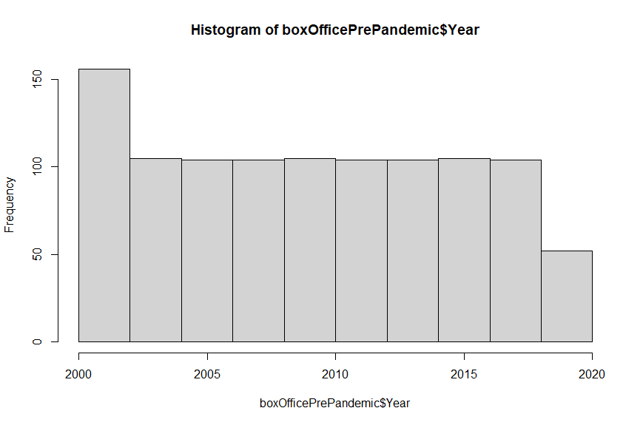

Figure 1: Histogram of the frequency of box office weekends by Year

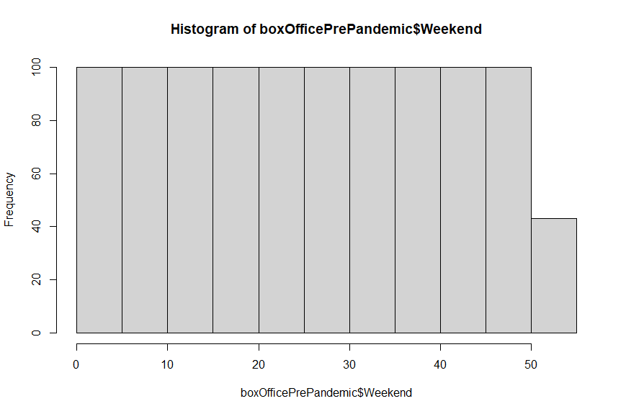

Figure 2: Histogram of the frequency of box office weekends by Weekend

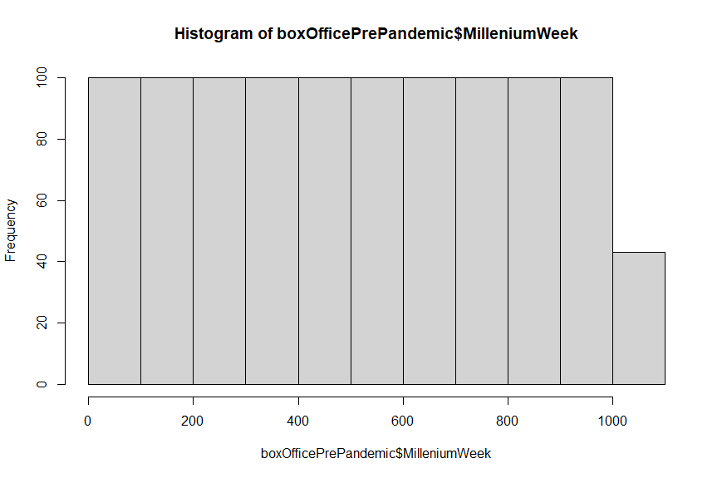

Figure 3: Histogram of MilleniumWeek

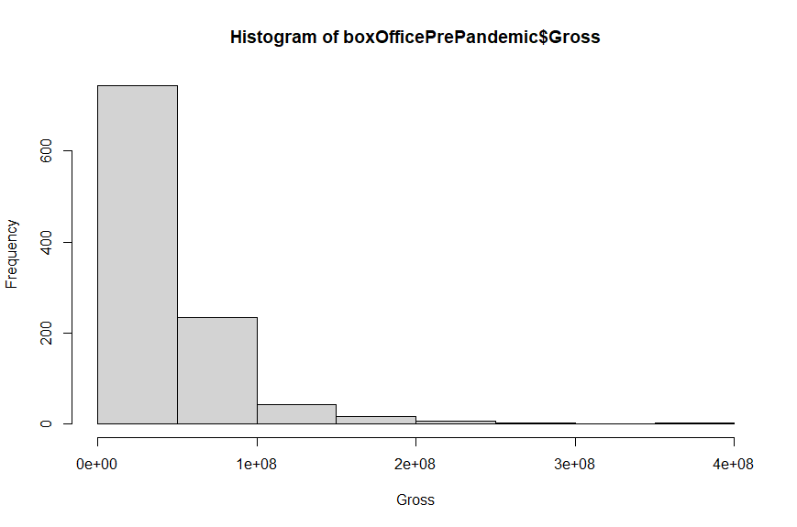

Figure 4: Histogram of Gross between the years 2000 and 2019

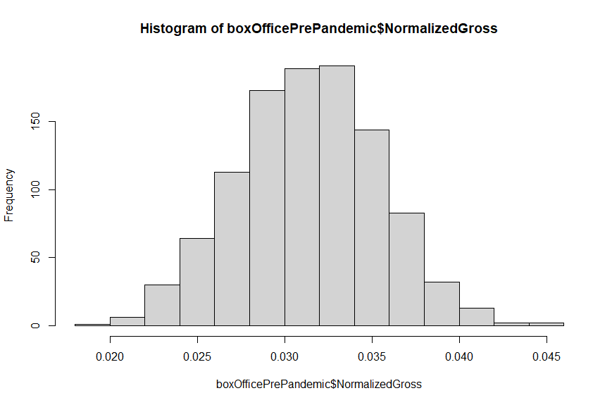

Figure 5: Histogram of NormalizedGross between the years 2000 and 2019

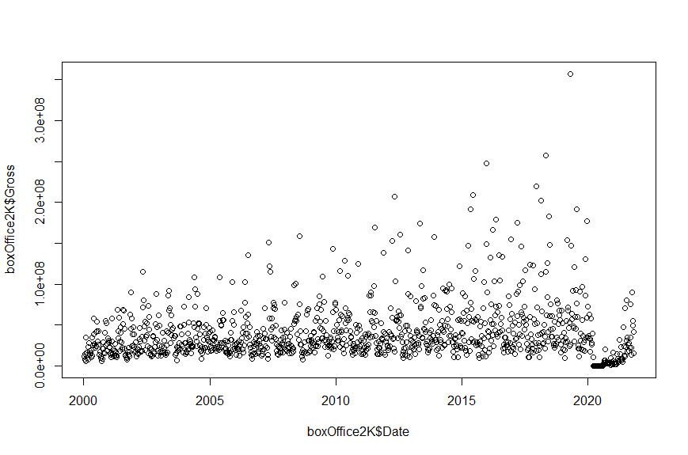

Figure 6: Scatterplot of gross against date. Year 2020 and afterwards appear to be outliers

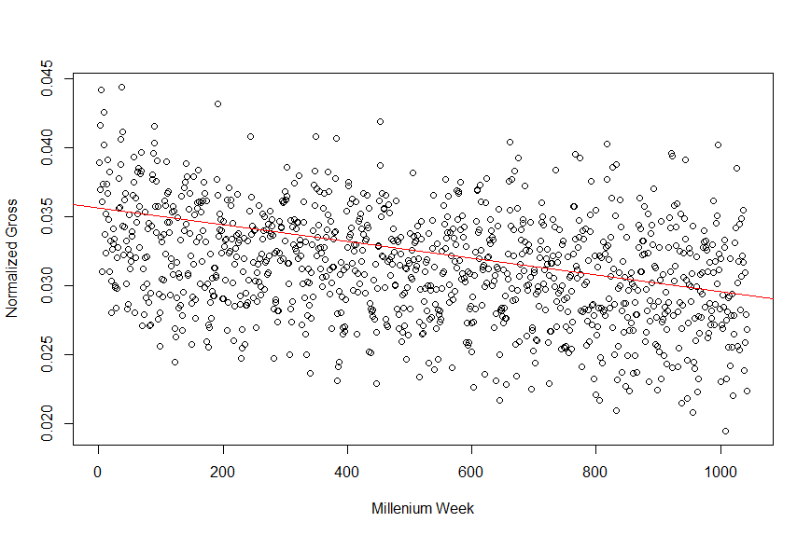

Figure 7: Scatterplot of the normalized gross against millennium week with fitted regression line.

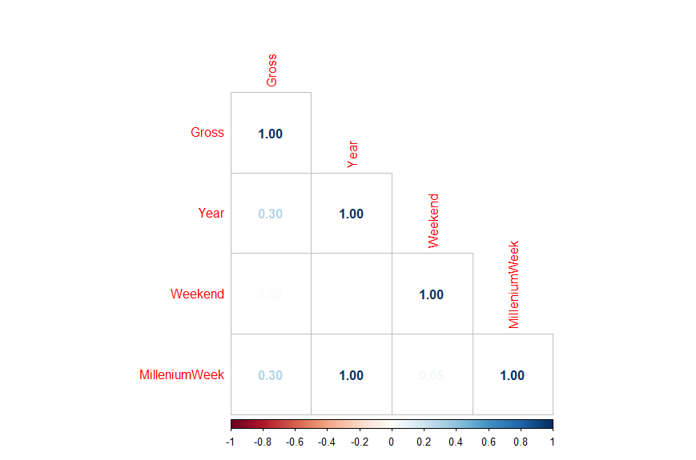

Figure 8: Correlation plot of continuous variables with Gross

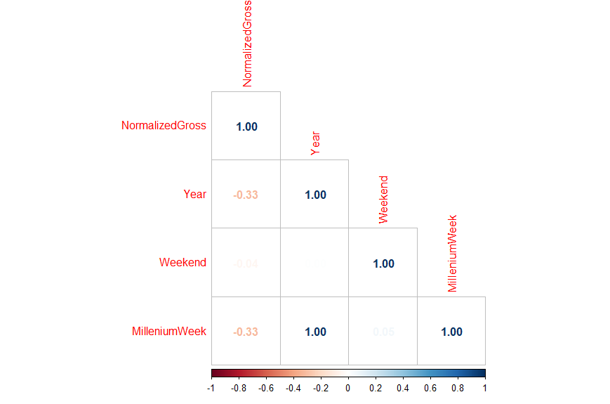

Figure 9: Correlation plot of continuous variables with NormalizedGross

**Appendix-Model Results**

* + Model results screenshots from R for each of the 5 models

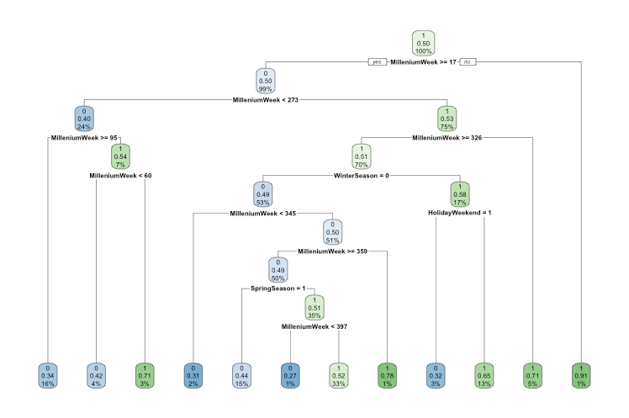

Figure 10: Decision Tree plot

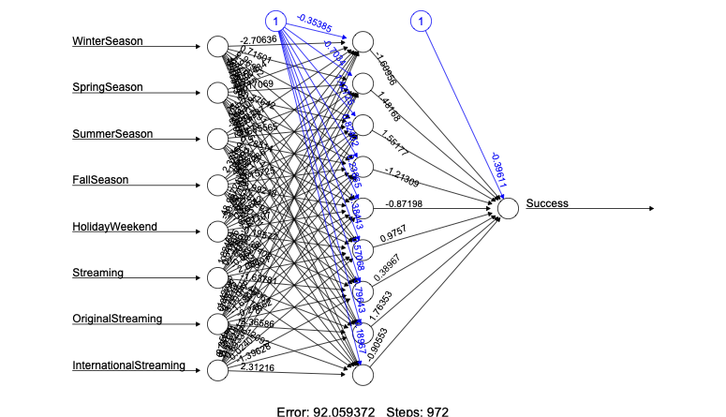

Figure 11: Neural Network plot

| Variable | Type | Description |
| --- | --- | --- |
| Film | Character | Name of the top grossing weekend box office |
| Date | Date | Sunday of the weekend box office |
| Year | Numeric | Year for the weekend box office (1960-2021) |
| Weekend | Numeric | Week number of the year (1:53) |
| Gross | Numeric | Box office earnings of the top film for the weekend |

Table 1: Initial Box Office Features

| Variable | Type | Description |
| --- | --- | --- |
| Month | Numeric | Month of the weekend box office (1:12) |
| WinterSeason | Logical | 1 = box office in the winter  0 = box office did not occur during the winter |
| SpringSeason | Logical | 1 = box office in the spring  0 = box office did not occur during the spring |
| SummerSeason | Logical | 1 = box office in the summer  0 = box office did not occur during the summer |
| FallSeason | Logical | 1 = box office in the fall  0 = box office did not occur during the fall |
| MilleniumWeek | Numeric | Week number into the millenium |
| HolidayWeekend | Logical | 1 = box office was during the holiday weekend  0 = box office did not occur during the holiday weekend |
| Streaming | Logical | 1 = streaming services were available (2008)  0 = streaming services were not available |
| OriginalStreaming | Logical | 1 = original streaming content was available (2013)  0 = original streaming content was not available |
| InternationalStreaming | Logical | 1 = international streaming content was available (2018)  0 = international streaming content was not available |
| NormalizedGross | Numeric | Gross normalized with a Box Cox Transformation |
| Success | Logical | 1 = box office generated sufficient earnings to be a success  0 = box office generated to little to be a success |
| Fourseason | character | Season of the weekend box office (Winter, Spring, Summer, and Fall) |

Table 2: Generated Box Office Features

Naive Bayes Confusion Matrices

|  | 0 | 1 |
| --- | --- | --- |
| 0 | 72 | 48 |
| 1 | 76 | 65 |

Table 3: Naive Bayes Confusion Matrix using all variables

|  | 0 | 1 |
| --- | --- | --- |
| 0 | 104 | 16 |
| 1 | 117 | 24 |

Table 4: Naive Bayes Confusion Matrix using FallSeason, HolidayWeekend, Streaming

|  | 0 | 1 |
| --- | --- | --- |
| 0 | 104 | 16 |
| 1 | 117 | 24 |

Table 5: Naive Bayes Confusion Matrix using WinterSeason, HolidayWeekend, Streaming

|  | 0 | 1 |
| --- | --- | --- |
| 0 | 104 | 16 |
| 1 | 117 | 24 |

Table 6: Naive Bayes Confusion Matrix using SpringSeason, HolidayWeekend, Streaming

|  | 0 | 1 |
| --- | --- | --- |
| 0 | 78 | 42 |
| 1 | 87 | 54 |

Table 7: Naive Bayes Confusion Matrix using SummerSeason, HolidayWeekend, Streaming

|  | 0 | 1 |
| --- | --- | --- |
| 0 | 104 | 16 |
| 1 | 117 | 24 |

Table 8: Naive Bayes Confusion Matrix using FallSeason, HolidayWeekend, OriginalStreaming

|  | 0 | 1 |
| --- | --- | --- |
| 0 | 104 | 16 |
| 1 | 117 | 24 |

Table 9: Naive Bayes Confusion Matrix using WinterSeason, HolidayWeekend, OriginalStreaming

|  | 0 | 1 |
| --- | --- | --- |
| 0 | 104 | 16 |
| 1 | 117 | 24 |

Table 10: Naive Bayes Confusion Matrix using SpringSeason, HolidayWeekend, OriginalStreaming

|  | 0 | 1 |
| --- | --- | --- |
| 0 | 78 | 42 |
| 1 | 87 | 54 |

Table 11: Naive Bayes Confusion Matrix using SummerSeason, HolidayWeekend, OriginalStreaming

|  | 0 | 1 |
| --- | --- | --- |
| 0 | 103 | 17 |
| 1 | 111 | 30 |

Table 12: Naive Bayes Confusion Matrix using FallSeason, HolidayWeekend, InternationalStreaming

|  | 0 | 1 |
| --- | --- | --- |
| 0 | 92 | 28 |
| 1 | 108 | 33 |

Table 13: Naive Bayes Confusion Matrix using WinterSeason, HolidayWeekend, InternationalStreaming

|  | 0 | 1 |
| --- | --- | --- |
| 0 | 93 | 27 |
| 1 | 106 | 35 |

Table 14: Naive Bayes Confusion Matrix using SpringSeason, HolidayWeekend, InternationalStreaming

|  | 0 | 1 |
| --- | --- | --- |
| 0 | 78 | 42 |
| 1 | 87 | 54 |

Table 14: Naive Bayes Confusion Matrix using SummerSeason, HolidayWeekend, InternationalStreaming

|  | 0 | 1 |
| --- | --- | --- |
| 0 | 59 | 73 |
| 1 | 66 | 63 |

Table 15: Decision Tree Confusion Matrix

|  | 0 | 1 |
| --- | --- | --- |
| 0 | 63 | 69 |
| 1 | 49 | 80 |

Table 16: Neural Network Confusion Matrix

|  | Fall | Spring | Summer | Winter |
| --- | --- | --- | --- | --- |
| Fall | 17 | 3 | 17 | 27 |
| Spring | 7 | 16 | 16 | 27 |
| Summer | 8 | 13 | 24 | 18 |
| Winter | 15 | 11 | 18 | 24 |

Table 17: K-Nearest Neighbor Confusion Matrix

**Appendix-Other Relevant Visuals**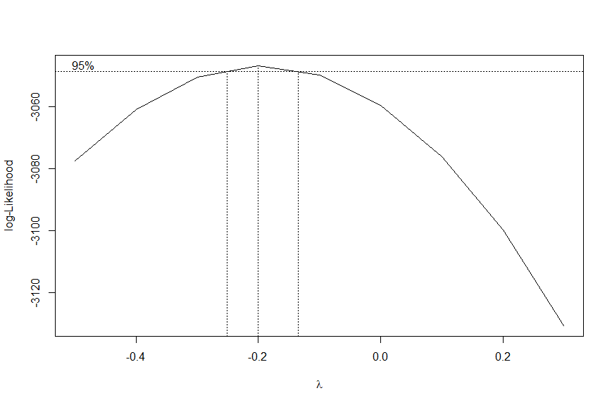

Figure 12: Box Cox transformation of Gross, -0.2 is suggested transformation for normalizing Gross

| Variable Included | Predictive Accuracy |
| --- | --- |
| FallSeason, HolidayWeekend, Streaming | 55.10% |
| WinterSeason, HolidayWeekend, Streaming | 55.10% |
| SpringSeason, HolidayWeekend, Streaming | 55.10% |
| SummerSeason, HolidayWeekend, Streaming | 57.40% |
| FallSeason, HolidayWeekend, OriginalStreaming | 55.10% |
| WinterSeason, HolidayWeekend, OriginalStreaming | 53.60% |
| SpringSeason, HolidayWeekend, OriginalStreaming | 55.10% |
| SummerSeason, HolidayWeekend, OriginalStreaming | 57.40% |
| FallSeason, HolidayWeekend, InternationalStreaming | 55.10% |
| WinterSeason, HolidayWeekend, InternationalStreaming | 55.10% |
| SpringSeason, HolidayWeekend, InternationalStreaming | 55.10% |
| SummerSeason, HolidayWeekend, InternationalStreaming | 57.40% |
| WinterSeason,SpringSeason,SummerSeason,FallSeason,Year,HolidayWeekend,Streaming,OriginalStreaming,InternationalStreaming | 55.55% |
| WinterSeason,SpringSeason,SummerSeason,FallSeason,HolidayWeekend,Streaming,OriginalStreaming,InternationalStreaming | 58.20% |
| Year,HolidayWeekend,Streaming,OriginalStreaming, InternationalStreaming | 55.93% |
| Year,Streaming,OriginalStreaming,InternationalStreaming | 49.80% |
| WinterSeason, SpringSeason, SummerSeason, FallSeason, HolidayWeekend, Year | 57.47% |
| SummerSeason, HolidayWeekend, Year | 57.47% |

Table 18: Logistic Regression Predictive Accuracy

| Variables Included | Predictive Accuracy |
| --- | --- |
| FallSeason, HolidayWeekend, Streaming | 49.04% |
| WinterSeason, HolidayWeekend, Streaming | 49.04% |
| SpringSeason, HolidayWeekend, Streaming | 49.04% |
| SummerSeason, HolidayWeekend, Streaming | 50.57% |
| FallSeason, HolidayWeekend, OriginalStreaming | 49.04% |
| WinterSeason, HolidayWeekend, OriginalStreaming | 49.04% |
| SpringSeason, HolidayWeekend, OriginalStreaming | 49.04% |
| SummerSeason, HolidayWeekend, OriginalStreaming | 50.57% |
| FallSeason, HolidayWeekend, InternationalStreaming | 50.96% |
| WinterSeason, HolidayWeekend, InternationalStreaming | 47.89% |
| SpringSeason, HolidayWeekend, InternationalStreaming | 49.04% |
| SummerSeason, HolidayWeekend, InternationalStreaming | 50.57% |

Table 19: Naive Bayes Predictive Accuracy

| K-value | Predictive Accuracy |
| --- | --- |
| 153 | 31.80% |
| 171 | 31.80% |
| 193 | 31.80% |
| 219 | 31.80% |
| 253 | 31.80% |
| 323 | 31.80% |
| 405 | 31.80% |
| 467 | 31.80% |
| 473 | 31.80% |
| 621 | 31.80% |
| 665 | 31.80% |

Table 20: The best value of k for the K-Nearest Neighbor