NWC User Guide

Introduction
This document describes the basic features and some of the utilities in the Node WWN collector (NWC) system. NWC is a light web tool to collect node WWN and its connection status. In addition to it, NWC could do zone creating and deleting on dedicated fabric.

Revision History
Date | Version | Description
Nov 27, 2014 | 0.1 | Original version base on NWC basic feature and function introduction

Getting Started

Login into system
The NWC web interface is http://10.35.82.23:8080/ . You are recommended to use browser Firefox or Chrome.
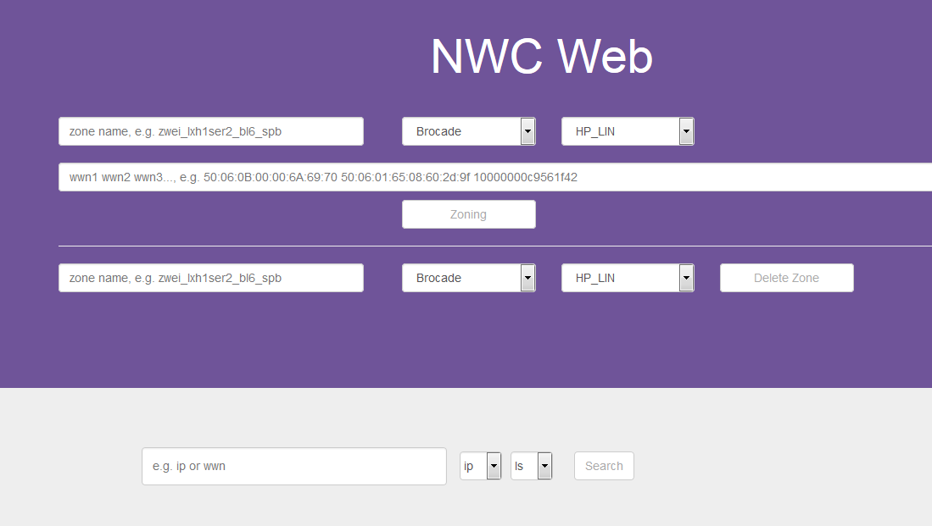
The web interface is divided into two main function area, Zone operation and WWN search. The upper is area of zone operation and the lower is area of WWN search.

Search Node WWN
To search out node WWN, User needs to fill the WWN filter, select filter type and fabric name, then click “Search” button.
Filter type | Value
WWN | node WWN address
IP | Node IP or Switch IP

Fabric name | Value
SG | PST Singapore fabric
LS | PST Linux/Solaris fabric
WV | PST Window/VMware fabric

The Search result consist of three part
Search Output
DEVICE WWNS | all WWN address the host or switch have if you search IP of host or switch
DEVICE INFO | host or switch info where WWN locate
CONNECTION INFO | HBA port connection status, it show connected switch and port info

Below are three examples of WWN search.
- WWN address with fortmat (xx:xx:xx:xx:xx:xx)
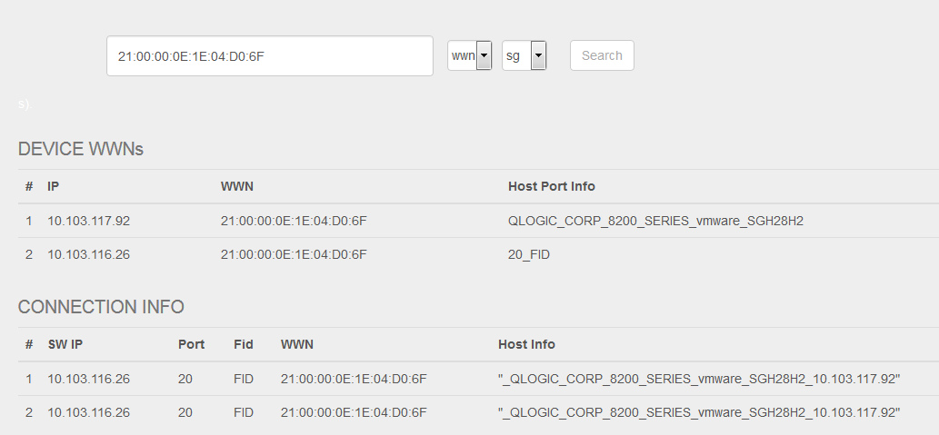
- Node IP
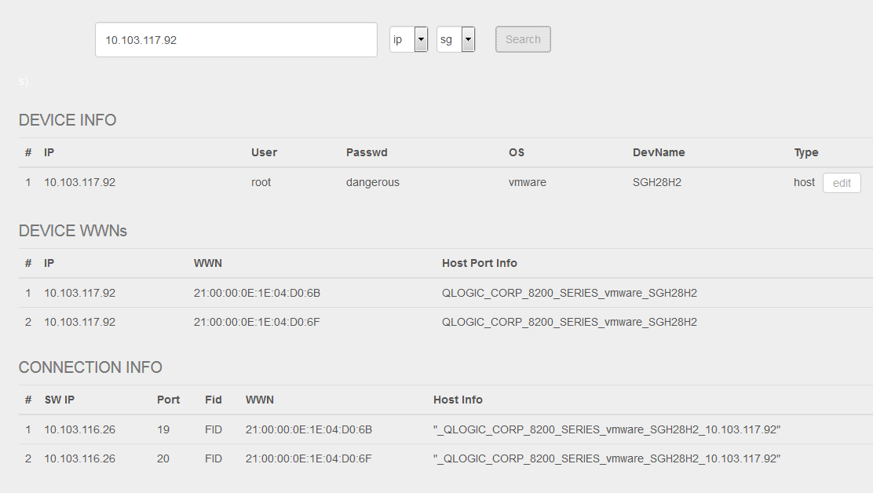
- Switch IP
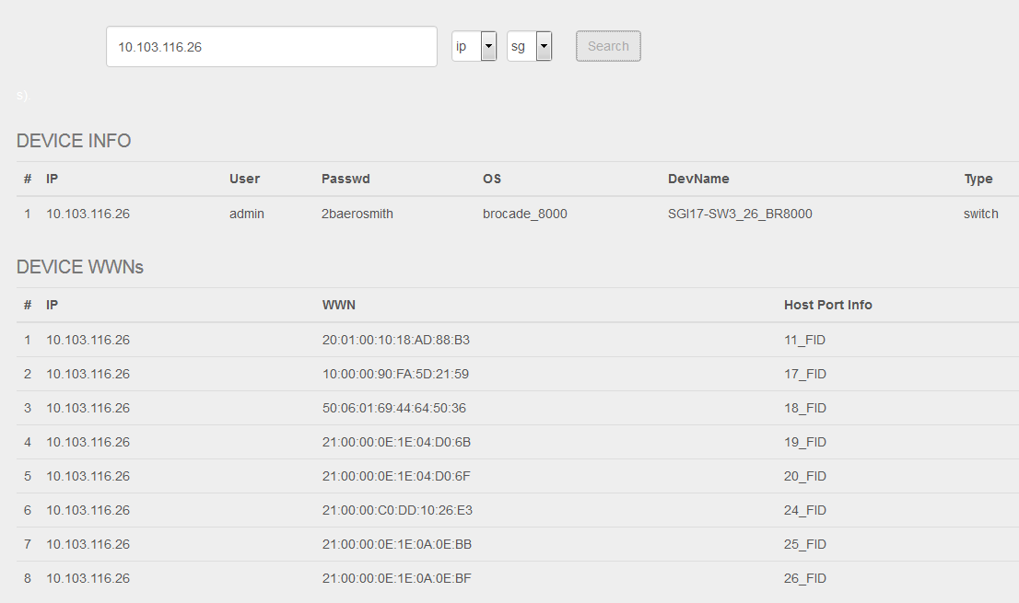

Zone operation
NWC can create and remove zone from GUI web. There is an example on black for user reference.
Zone Create:
Element name | Value
Zone name | User defined
Switch type | Brocade  Cisco
Fabric name | SG_LIN – PST lab4  HP_LIN – PST lab2 Linux/Solaris fabric  HP_VMW – PST lab2 Window/VMware fabric
WWN address list | Address list support two WWN format:  - 21:00:00:0E:1E:04:D0:6F  - 2100000e1e04d06f  Address list support multipath WWN in a request.

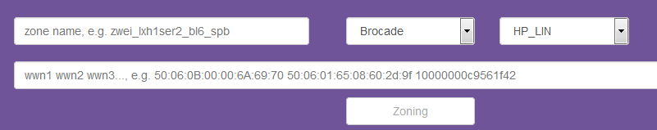

Zone Remove:
Zone remove use same element as Zone creating. Please refer above.

To avoid the zone conflict, NWC don’t support multiple zone operation in parallel. NWC only execute zone operation request in one time. If one zone request is running by NWC, other zone request will be pending and wait prior request be done.

