# NWC User Guide

## Introduction

This document describes the basic features and some of the utilities in the Node WWN collector (NWC) system. NWC is a light web tool to collect node WWN and its connection status. In addition to it, NWC could do zone creating and deleting on dedicated fabric.

## Revision History

|  |  |  |
| --- | --- | --- |
| **Date** | **Version** | **Description** |
| Nov 27, 2014 | 0.1 | Original version base on NWC basic feature and function introduction |
|  |  |  |

**Getting Started**

### Login into system

The NWC web interface is <http://10.35.82.23:8080/> . You are recommended to use browser Firefox or Chrome.

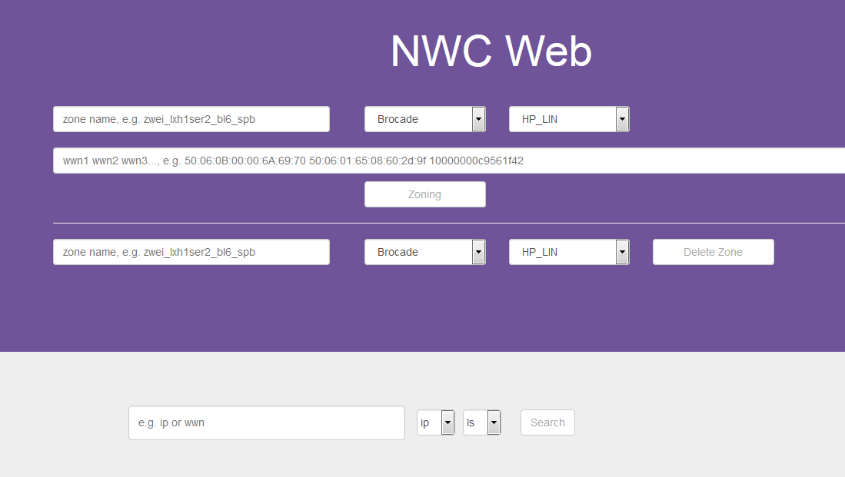

The web interface is divided into two main function area, Zone operation and WWN search. The upper is area of zone operation and the lower is area of WWN search.

### Search Node WWN

To search out node WWN, User needs to fill the WWN filter, select filter type and fabric name, then click “Search” button.

|  |  |
| --- | --- |
| Filter type | Value |
| WWN | node WWN address |
| IP | Node IP or Switch IP |

|  |  |
| --- | --- |
| Fabric name | Value |
| SG | PST Singapore fabric |
| LS | PST Linux/Solaris fabric |
| WV | PST Window/VMware fabric |

The Search result consist of three part

|  |  |
| --- | --- |
| Search Output |  |
| DEVICE WWNS | all WWN address the host or switch have if you search IP of host or switch |
| DEVICE INFO | host or switch info where WWN locate |
| CONNECTION INFO | HBA port connection status, it show connected switch and port info |

Below are three examples of WWN search.

1. WWN address with fortmat (xx:xx:xx:xx:xx:xx)

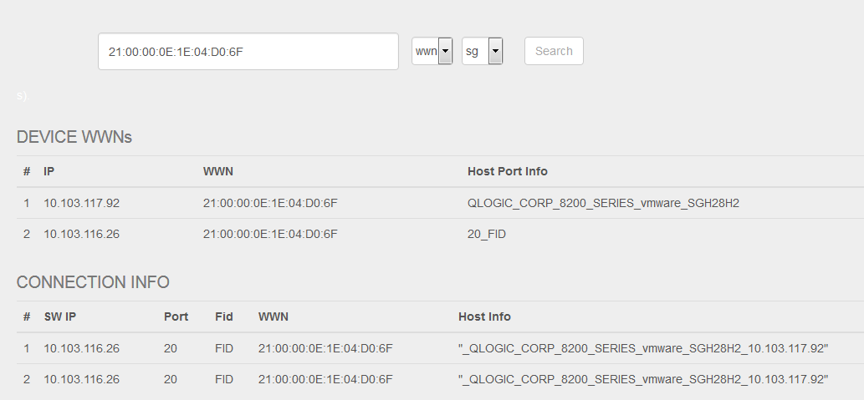

1. Node IP

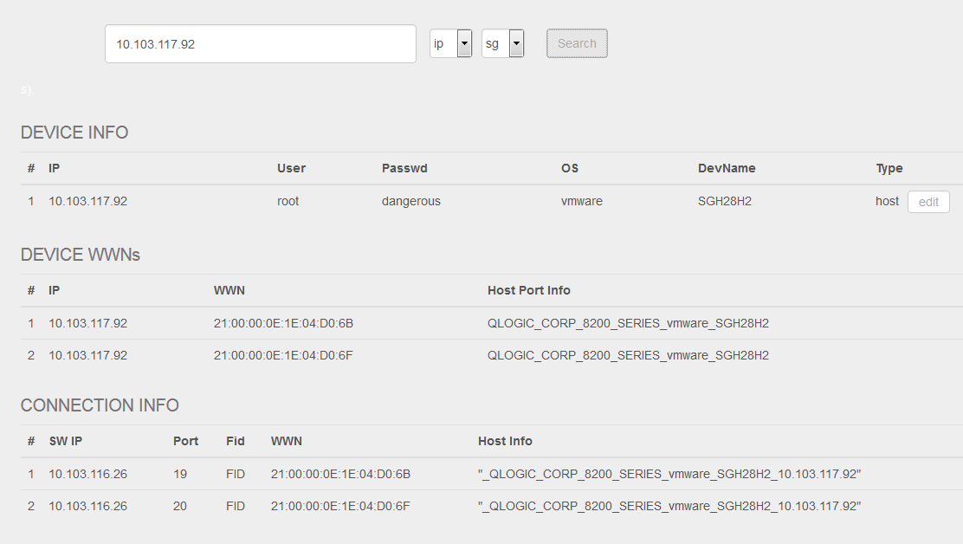

1. Switch IP

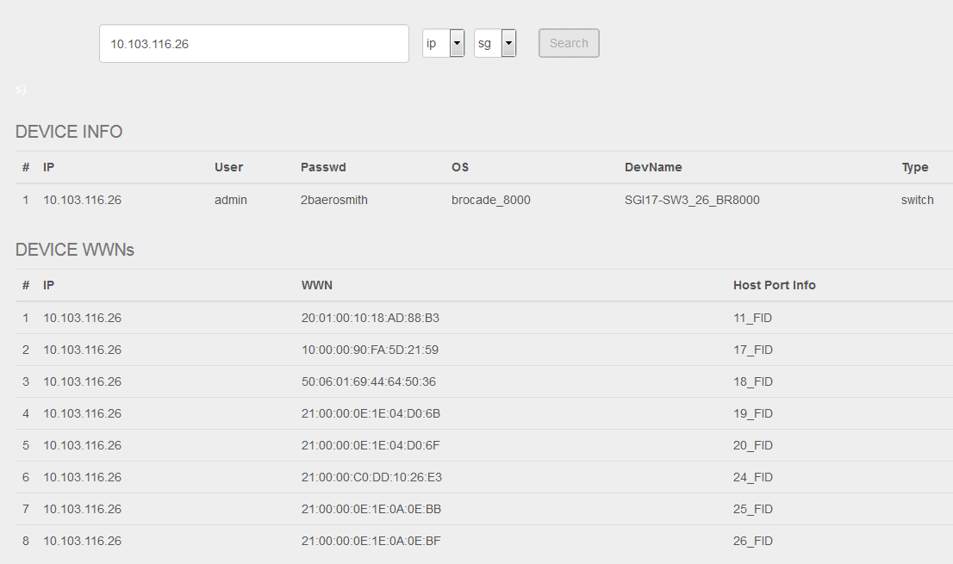

### Zone operation

NWC can create and remove zone from GUI web. There is an example on black for user reference.

Zone Create:

|  |  |
| --- | --- |
| Element name | Value |
| Zone name | User defined |
| Switch type | Brocade  Cisco |
| Fabric name | SG_LIN – PST lab4  HP_LIN – PST lab2 Linux/Solaris fabric  HP_VMW – PST lab2 Window/VMware fabric |
| WWN address list | Address list support two WWN format:   1. 21:00:00:0E:1E:04:D0:6F 2. 2100000e1e04d06f   Address list support multipath WWN in a request. |

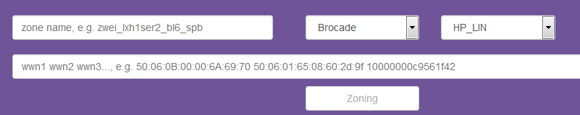

Zone Remove:

Zone remove use same element as Zone creating. Please refer above.



To avoid the zone conflict, NWC don’t support multiple zone operation in parallel. NWC only execute zone operation request in one time. If one zone request is running by NWC, other zone request will be pending and wait prior request be done.