Yining Qiao (yqiao44)

Yuejie Jing (yjing47)

Chen Liang (cliang73)

Ning Zhu (nzhu34)

Yingjie Chen (ychen3060)

team 52

Phase [3]

# EER

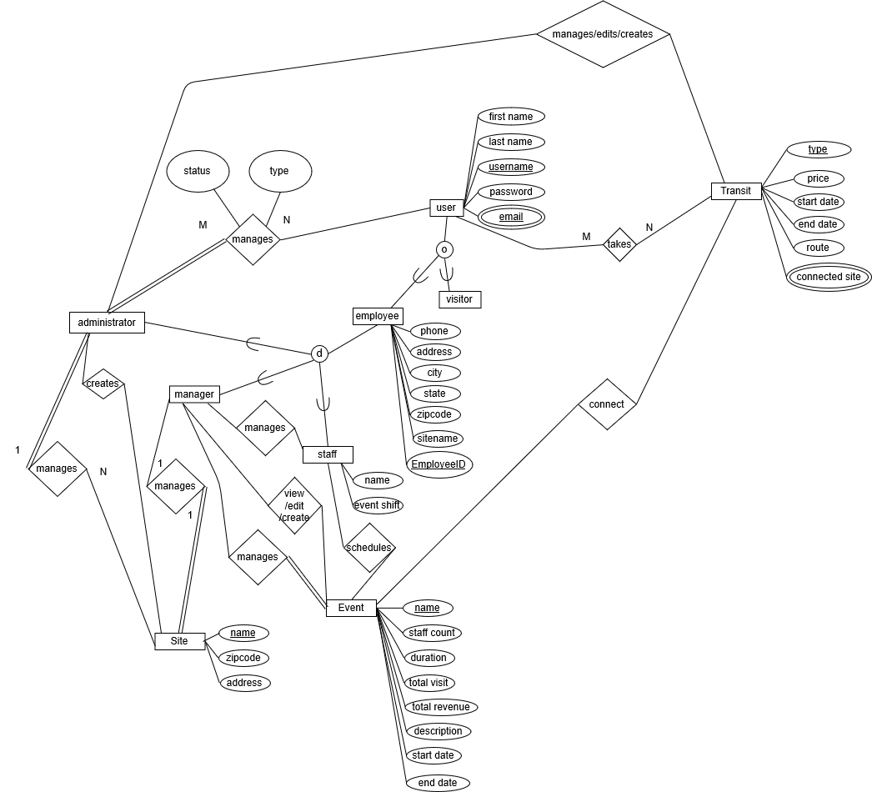

# IFD

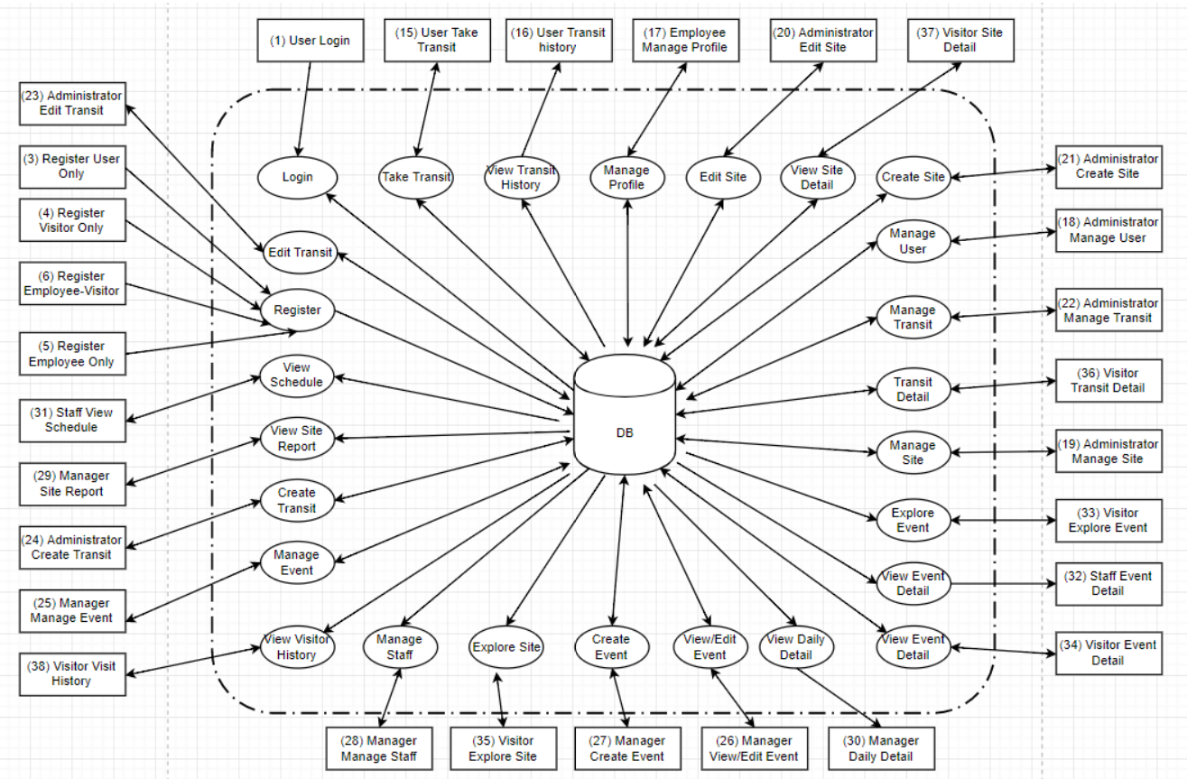

# Logical Constraint:

1. User accounts must be approved by administrators for login.
2. All newly registered user accounts will be “pending” for administrator’s approval.
3. Transit must select at least 2 Connected Sites.
4. The start date must be earlier than end date in an event.
5. Visitor can Log Visit to the selected event if there are still tickets remaining.
6. Price must be nonnegative numbers.

Tasks List (detailed SQL statement shows in Team52_Phase3_SQL_Query_final.txt)

Screen 1: user login

Task1:sc1_email_exist

Task2:sc1_login_verify

Screen 3: register user only

Task1:sc3_user_registration

Task2: sc3_display_email

Task3: sc3_delete_email

Screen 4: register visitor only

Task1: sc4_visitor_registration

Task2: sc4_display_email

Task3: sc4_delete_email

Screen 5: register employee only

Task1: sc5_manager_registration

Task2: sc5_staff_registration

Task3: sc5_delete_email

Task4: sc5_display_email

Screen 6: register employee-visitor

Task1: sc6_manager_registration

Task2: sc6_staff_registration

Task3: sc6_delete_email

Screen 15:

user take transit

Task1: sc15_filter

Task2: sc15_log_date

Screen 16: user transit history

task1: show a user transit history

Screen 17: employee mange profile

Task1: view profile

Task2: delete profile

Task3: add email

Task4: add visitor account

Task5: update name and phone

Task6: delete email

Screen 18: administrator manage user

Task1: view user information

Task2: approve users

Task3: decline users

Screen 19: administrator manage site

Task1: filter

Task2: delete sites

Screen 20: administrator edit site

Task1: filter sites

Task2: update sites

Screen 21: administrator create site

Task1: filter sites

Task2: add new sites

Screen 22: Manage transit

Task1: Manage_Transit

-- create a view as Manage_Transit

---create stored procedure as Manage_Transit

Screen 23: Administrator edit transit

Task1: Display_Current_Connected_Sites

Task2: Edit_Connected_Sites

Screen 24: Administrator create transit

Task1: Create_Transit

Screen 25: manager manage event

Task1: Manage_Event

--- create a view

--- create a stored procedure to show event

Screen 26: manager view/edit event

Task1: View Event Staff

Task2: View_Event_Visit&Revenue

--- create a date list view

--- create a view to show daily events

--- create a view to show daily visits and daily revenue

---a stored procudure to filter

Task3: Edit_Event_Description

Task4: Edit_Event_Staff(Delete)

Task5: Edit_Event_Staff(Insert)

Screen 27: manager create event

Task1: Create_Event

Screen 28: Manager manage staff

Task1: retrieve the staff name and event shifts based on the inputs: site, first name, last name, start date, end date

---Stored Procedures: sc28

---view1: view28

Screen 29: Manager site report

Task1: retrieve date, event count, staff count, total visit, total revenue based on the inputs: start date, end date, event count range, staff count range, total visits range, total revenue range

---Stored Procedures: sc29

---view1: eventcount

---view2: event_staff

---view3: event_staff_datelist

---view4: datelist

---view5: totalvisits

---view6: total_revenues_visit

Screen 30: Manager daily detail

Task1: retrieve daily detail of event name, staff name, visits, revenue based on the date

---Stored Procedure: sc30

---view1: new3

Screen 31: Staff view schedule

Task1: retrieve the schedule of event name, site name, start date, end date, staff count based on the inputs: event name, description keywords, start date, end date

---Stored Procedure: sc31

---view1: view31

Screen 32: Staff event detail

Task1: retrieve event details based on inputs: event name and staff name

---Stored Procedure: sc32

Screen 33: Visitor Explore Event

Task1: site name drop list

Task2: filter

---create a event view without filter

---filter(Note: input sitename is a list and notvisit, notsoldout both are bool. It means these two input should be 0 or 1.)

Task3: event detail

Screen 34: Visitor Event Detail

Task1: log visit

Screen 35: Visitor Explore Site

Task1: filter

---create a view to show all visits' site and event

---create a view to show total visits

---create a view to show event count

---create a view conbine event count and total visits

---filter(Note: input sitename is a list and notvisit is bool. It means input should be 0 or 1.)

Task2: Transit Detail

---create all transit detail with price

---see transit detail

Task3: Site detail

Screen 36: Visitor Transit Detail

Task1: log visit

Screen 37: Visitor site detail

Task1: log visit

Screen 38: visitor visit history

Task1: visitor visited sitename

Task2: filter with startdate and enddate

---create a view with all information

---filter (Note: sitename can be a list)

Task3: filter without startdate and enddate (Note: sitename can be a list)