Assignment 2: Group project

Project idea:

Instagram clone

***We need to give the project another name.

# Project Group Member:

|  |  |  |
| --- | --- | --- |
| No | Student Name | Student Number |
| 1 | Pham Dieu Binh |  |
| 2 |  |  |
| 3 |  |  |

# Introduction:

Instagram is very popular mobile application that allow user to take photos, record videos, filter the photos and posts in social platform. This project is purposed to build a similar application that can access phone photo library, using camera to take photos and videos and upload online.

# Requirement:

- Database: SQL lite (other platform needs to be asked for approval)

* USER (UserID, Username, User_Email, User_Password, User_DOB, UploadID)
* UPLOAD (UploadID, Upload_Type, Upload_Date, Upload_caption)

For Upload_Type in table Upload should be either Photo or Video.

- Gradle build system

- Minimum API level 27

# Basic Feature:

*** There are basic features that I found it’s possible for us to implement. All the examples are from Android developers website, source at: <https://developer.android.com/samples?language=java>

- My profile display: personal page that store history

- Record video: example from Android developers website, source at: <https://github.com/android/camera-samples/tree/master/Camera2VideoJava/#readme>

- Take photo

- Create a new account and log in: Add autofill frameworks, source at:

<https://github.com/android/input-samples/tree/master/AutofillFramework/#readme>

- Change photo effect: example from Android developers website, source at: <https://github.com/android/graphics-samples/tree/master/MediaEffects/#readme>

- Write a short caption for the photo and video.

- Upload online.

# Advance Feature:

*** Advance feature to be considered after we completed all the basic function of our project:

- Playback video when switching to another app: Android studio example, source at:

<https://github.com/android/media-samples/tree/master/PictureInPicture/#readme>

- Location GPS that indicate where the photo/video is taken.

# Outline:

Storyboard:

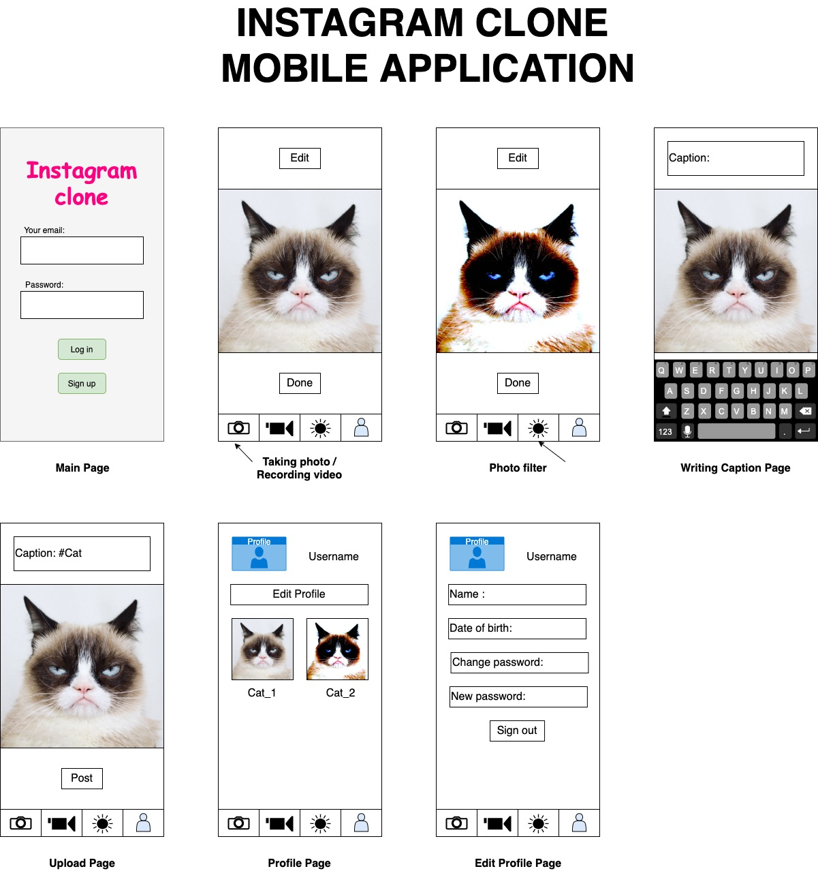

Notes: All text in red are informational and are to be removed before submission

# **Project description**

Submit a report of two pages maximum, which describes your project. The report should include

**Project Title**

**\*Brainstorming App Ideas\***

1. **Game**
2. **Instant Messaging** [Jeremy vote for this]
3. **Photo Diary**
4. **Expenses Calculator / Tracker** [Jeremy vote for this, but take note that **programs that work with currencies will be a pain**]
5. **Reminders** [Jeremy vote for this]
6. **Health checking**
7. **Railway Assist**
8. **Exercise Planning** [Jeremy vote for this]
9. **Crime Alerts**
10. **Mall Navigation** [Jeremy: **this is very hard/tedious to implement, should not do this**]
11. **Food Recommends** [Jeremy vote for this if it refers to P2P recommendation and not in-built/predefined ones]
12. **What's in your fridge** [Jeremy vote for this]
13. **Vacation** [Jeremy vote for this]
14. **Water Tap reminder**
15. **Travel planning reminder**
16. **Stress relief app** [Jeremy vote for this, looks promising since the features that can be added are not constrained]
17. **Pregnant mum app**
18. **Motivational app**
19. **Disaster warning app**
20. **Entertainment app**

**\*IDEA DIRECTIONS* - kw**

* **Develop an app that uses a Database**
* **Interacts with user**
* **Features that is specific to mobile devices**
  + Camera, Phone Dialing, Accelerometer, Gyroscope, Magnetometer,GPS,  barometer, microphones, nfc, bluetooth, <https://www.w3.org/Mobile/roadmap/sensors.html>
* **Create a promotional video on our App**

**Questions to answer - kw**

* **Who will be using our app? [Target user? - Child, Teens, Young Adults, Seniors]**
* **What will our app User with? [Functionality of app]**
* **When will our app be used? [What scenario will our app be used / useful?]**
* **Where will our app be used? [What location?]**
* **Why will our app be used? [How can we promote our app?]**
* **How will our app be used? [Will it be an easy to use app?]**

**Team Number**

Group 02

**Team member details**

|  |  |  |
| --- | --- | --- |
| **Team Member** | **Student ID** | **Email Address** |
| Pham Dieu Binh | 33784908 | [im.lyaclip@gmail.com](mailto:im.lyaclip@gmail.com) |
| Soh Wee Kee Jeremy | 33582314 | [astray03@gmail.com](mailto:astray03@gmail.com) |
| Yue Kok Weng | 33569494 | [yuekokweng@hotmail.com](mailto:yuekokweng@hotmail.com) |

(4) A paragraph that describes the application you want to develop.

(5) A description and sketch of the user interface(s).

(6) A description of the interactions that are going to be implemented

(7) What database are you going to implement.

(8) The additional features, specific to mobile devices, that you would like to implement.

Please read carefully the minimal requirements for the project which are available on LMS (in Group Project area).

# **Team Charter**

Prepare and submit the team charter. As a minimum, the team charter would have:

## **Names of team members and contact details**

|  |  |
| --- | --- |
| **Team Member** | **Contact Details** |
| Pham Dieu Binh | 97971170 |
| Soh Wee Kee Jeremy | 81984362 |
| Yue Kok Weng | 81234692 |

## **Team Communication Methods**

The following communication methods will be applicable to our team:

* ***Face-to-face*** meetings for discussion and clarifications
* ***WhatsApp*** messenger will be used as the main form of communication
* ***Google Drive*** will be used for storing of common documents and assets

## **Team Member Expectations**

|  |  |
| --- | --- |
| **Team Member** | **Expectations** |
| Pham Dieu Binh |  |
| Soh Wee Kee Jeremy | To build a robust and unique app. And most important, having an in-depth understanding on how android development works after the assignment and unit. |
| Yue Kok Weng | To be able to understand how an Android Application on a mobile device is being built and how it is able to interact with features of a mobile device. |

## **Constraints on each team member**

(work days and times, other units, family, etc.)

|  |  |
| --- | --- |
| **Team Member** | **Constraints** |
| Pham Dieu Binh |  |
| Soh Wee Kee Jeremy | Other than this unit, I have bi-weekly lessons on Thursday & Saturday as well as a weekly lesson on Monday. My work schedule is Monday to Friday on a 9am - 6pm basis. |
| Yue Kok Weng | My workplace is at Changi and I live in the North. I am able to make time on weekends to meet up for assignment submission or study. I have an alternate Saturday class. |

## **Conflict resolution procedure**

1. Conflicted parties are expected to take a breather to calm down for at least 10 minutes before resuming any ongoing discussion.
2. If the conflict remains, other team members are to step forward to assess the situation.  
   Conflicted parties are expected to take turn in explaining their individual conflicted point in detail to the other members where they will then discuss among themselves for a consolidated stand in the current situation.
3. If there remain conflicts that cannot be resolved internally, the team should proceed with the group dispute form whereby the lecturer or unit coordinator will assist in resolving the conflict.

The team agree that each of us have read through and have no form of dispute with regards to the information listed in this team charter document.

Signature by

Signature by

Signature by

The project will have its own mark based on its own merit. The individual marks will be allocated based on the fraction of the load completed by the individual. So, if a team member completed their work load, they will get the full project mark. If the team member did less than their fair load, the team member’s mark will be reduced by that amount. No one gets higher than the project mark. The document that will determine the individual's mark is the last page of the unit outline. This is the group declaration sheet.

There would be penalties applied to the final mark for not providing the signed Team Charter, group declaration sheet, Individual accounting spreadsheet, and the self and peer assessment.

To be eligible for a P grade (minimum requirements), the project must

• Be an approved project implemented in Android Studio for Android mobile devices.

• Have a user interface with at least two Activities (please refer to the lecture notes of the meaning of Activity)

• Use Fragments

• Have Interactivity, i.e. users can interact with the application via a user interface (UI)

• Have a database implemented using SQLite

• Model at least one feature specific to mobile devices. This includes but not limited to location features, maps,

cameras, sensors, and so on.

• Implement and document an Automated UI testing plan.

• Written documentation for both the design and the implementation.

• Create a promotional video highlighting the interesting aspects of your program.

• Internal students must present the project (and show the application running) in the last lab session. Each group

will have approximately 15mins presentation (10 mins for the presentation which also includes the demo of the

app + 5mins for questions).

You may want to exceed the minimum criteria for higher grades

To be eligible for a P grade (minimum requirements), the project must

• Be an approved project implemented in Android Studio for Android mobile devices.

• Have a user interface with at least two Activities (please refer to the lecture notes of the meaning of Activity)

• Use Fragments

• Have Interactivity, i.e. users can interact with the application via a user interface (UI)

• Have a database implemented using SQLite

• Model at least one feature specific to mobile devices. This includes but not limited to location features, maps,

cameras, sensors, and so on.

• Implement and document an Automated UI testing plan.

• Written documentation for both the design and the implementation.

• Create a promotional video highlighting the interesting aspects of your program.

• Internal students must present the project (and show the application running) in the last lab session. Each group

will have approximately 15mins presentation (10 mins for the presentation which also includes the demo of the

app + 5mins for questions).

You may want to exceed the minimum criteria for higher grades