Reservoir regulation rotates river thermal response geometry across a contiguous-U.S. benchmark
Authors: Zijie Deng¹*, Yu Xia¹, Jiyang Yu¹ and Zhenyu Liao²
¹ Jiangxi Provincial Key Laboratory of Water Resources Allocation and Efficient Utilization, Jiangxi University of Water Resources and Electric Power, Tianxiang Avenue 289, Nanchang, Jiangxi 330099, China
² School of Geography and Environment, Jiangxi Normal University, Ziyang Avenue 99, Nanchang, Jiangxi 330022, China
*Corresponding author: Zijie Deng (3335196397vip@gmail.com)

Abstract
River thermal extremes reflect atmospheric heat, hydrologic memory and reservoir release state, yet broad-scale studies have generally treated regulation as a shift in mean or seasonal temperature. A contiguous-U.S. benchmark was developed to test how regulation changes the mapping from atmospheric heat to river peaks, heatwave events and warm burden. Daily water and air temperatures at 213 stream gauges were placed in a three-tier design comprising reference streams, gauges above reservoirs and downstream tailwaters. Peak coupling β, the slope of annual maximum 7-day water temperature against annual peak air temperature, averaged 0.483, 0.460 and 0.283 in the three tiers. In an annual-panel mixed model, the tailwater slope was 0.143 °C/°C lower than the reference slope and persisted after climate-position, drainage-area and flow-aware adjustment. Percentile-defined heatwave transmission remained comparable, whereas peak sensitivity was markedly lower, separating two response dimensions that are often treated as interchangeable. Tailwater stations also carried the highest observed warm burden, with 84.5 days above 22 °C per year. In a storage-state panel spanning 310 tailwater years, a one-SD increase in within-reservoir antecedent storage lowered the annual peak by 0.334 °C. Reservoir regulation therefore rotates river thermal response geometry: peak sensitivity contracts, event transmission persists and warm burden remains high, making release-water state and observed flow priorities for environmental-flow management.
Keywords: river thermal regime; water temperature; reservoir operation; air–water temperature coupling; heatwave; environmental flow

1. Introduction
River thermal extremes reflect how atmospheric forcing is filtered through catchment storage, flow and river–air exchange. Stream temperature also regulates downstream water quality under climate change (Ducharne, 2008; Luce et al., 2014). The thermal regime of rivers has long been described through air–water relationships, process controls and seasonal memory (Mohseni & Stefan, 1999; Mohseni et al., 2003; Caissie, 2006; Webb et al., 2008; Leach et al., 2023). Multi-day extremes are intensifying in rivers across the United States and worldwide (Tassone et al., 2023; Sadayappan & Li, 2025). Yet a warming atmosphere does not impose a single thermal trajectory on rivers: regional stream-temperature trends can diverge from air-temperature trends (Arismendi et al., 2012, 2014; Isaak et al., 2012; Rice & Jastram, 2015), snowmelt-fed rivers can show heightened thermal vulnerability to warming (Yan et al., 2021), and atmospheric heatwaves do not translate uniformly into riverine heatwaves (Feng et al., 2018; van Hamel et al., 2026). This is the central climate–river paradox. How much of an atmospheric peak reaches a river, and how often does that river cross a locally defined heatwave threshold?
Reservoirs are a natural test of this paradox because they can alter both the baseline thermal state and the pathway by which atmospheric heat reaches downstream rivers. Across the southeastern United States, reservoirs also modify river-temperature sensitivity to climate change (Cheng et al., 2020). Seasonal storage and releases from depth can cool summer peaks, warm winter minima and damp annual variation (Olden & Naiman, 2010; Ward & Stanford, 1979; Gooseff et al., 2005; Kędra & Wiejaczka, 2018), while persistent hypolimnetic withdrawal can produce cold-water pollution (Preece & Jones, 2002; Gray et al., 2019; Daniels & Danner, 2020). National satellite observations confirm that dams are associated with widespread upstream–downstream temperature contrasts, including downstream warming in many profiles (Ellis et al., 2026; Seyedhashemi et al., 2021). That satellite perspective resolves surface-temperature contrasts along dam profiles, whereas the present station-based analysis uses daily records to estimate annual peak coupling, percentile-defined event transmission and absolute warm burden across a three-tier national design. But a shift in mean or seasonal temperature does not reveal how atmospheric heat is expressed in annual river extremes. The unresolved question is therefore not simply whether reservoirs change water temperature, but how storage and release state decouple atmospheric heat from the river peak. Likewise, the reported increase in heatwave frequency at free-flowing and above-reservoir sites, but not below reservoirs (Tassone et al., 2023), motivates a distinct test of peak coupling and percentile-defined event occurrence.
Reservoir-related air–water desynchronization has been documented in individual basins and cascade systems (Kędra & Wiejaczka, 2016, 2018; Wang et al., 2020, 2024; Soomro et al., 2023; Zhao et al., 2025; Xiao et al., 2022). Recent large-scale hydrological modeling studies have advanced CONUS stream-temperature prediction and process representation (Philippus et al., 2025, 2026; Melaku et al., 2025; Piotrowski & Napiorkowski, 2019; Piotrowski et al., 2021). Spatial-network and process-based models have clarified how air temperature, discharge and network position shape prediction (Gallice et al., 2015; Detenbeck et al., 2016; Toffolon & Piccolroaz, 2015; Feigl et al., 2021; Carraro et al., 2020), while large-scale climate controls remain active across regulated rivers (Sanikhani et al., 2026). What remains unresolved is whether regulation changes one thermal response dimension or rotates the relation among several dimensions. We frame this as a response-geometry problem: each reach has a marginal peak sensitivity (β), an event-transmission slope (τ) and a baseline warm burden (B), and regulation may move these coordinates in different directions. The conceptual gap is therefore not another inventory of dam-induced warming. It is whether regulation changes the mapping from atmospheric forcing to river risk so that peak sensitivity, event occurrence and absolute thermal burden no longer move together. We address this problem with 213 continuous stream gauges, linking USGS water temperatures and collocated Daymet air temperatures (Thornton et al., 2022) to reservoir locations and operating records from ResOpsUS (Steyaert et al., 2022; Steyaert & Condon, 2024). Our three-tier design contrasts minimally disturbed reference streams, gauges above reservoirs and downstream tailwaters, placing the downstream signal in a broader regulation context. We ask three linked questions: does regulation attenuate the slope of annual river peaks against atmospheric peaks; does the same attenuation appear in percentile-defined heatwave occurrence; and can a reach be less sensitive to additional atmospheric warming while carrying a greater absolute warm burden? Here β is an empirical coupling index for atmospheric and river thermal extremes; it can reflect changes in amplitude, peak timing or the process that sets the annual maximum. These comparisons place the two response dimensions on a common gauge-level scale, test the peak contrast against aligned discharge, and use storage and inflow records to examine release-state controls. The resulting benchmark sharpens the familiar question of whether dams warm rivers: which component of atmospheric heat is transmitted as a peak, which appears as an event, and which remains as accumulated thermal burden?

2. Materials and methods

2.1 Gauge classification and eligibility
Daily water-temperature series (parameter code 00010; daily maximum preferred, daily mean where the maximum was absent; 1985–2024) were extracted from the National Water Information System. The analysis is restricted to the contiguous United States, the coverage of ResOpsUS. The three tiers and their climate setting are shown in Fig. 1. Reference gauges carry the GAGES-II “reference” designation (Falcone, 2011). Tailwater gauges lie within 30 km (straight-line radial distance) downstream of a ResOpsUS reservoir, at least 5 m below the reservoir surface elevation, with corroborating station naming or matching river names. An additional 30–60 km band is reported separately as a sensitivity analysis. Above-reservoir gauges show upstream naming indicators within 50 km of a reservoir; no elevation screen is applied on this tier because the reservoir-surface constraint has no analogue above a dam. An eligibility screen retained stream gauges (USGS site type ST, ST-TS or ST-CA). Initial candidate labels were provisional; final mutually exclusive tiers followed the distance, direction, elevation and precedence rules summarized in Supplementary Table S1. Tailwater and above-reservoir assignments were additionally audited against the NHDPlus river network in the routing checks described in Section 2.5.

2.2 Quality control and analysis samples
The June–August completeness rule is used for eligibility and record stability; the AMWT7 and annual exposure metrics are calculated over the full calendar year.
A summer (June–August) was complete when at least 90% of daily values were present; gauges required five complete summers, including three consecutive summers, and at least eight overlapping water- and air-temperature years. Supplementary Table S1 summarizes the screening stages, including the 44 stream-type candidates that did not meet a final tier assignment. Annual metrics use daily maximum water temperature where available; daily mean temperature was used for 2.6% of reference, 0% of above-reservoir and 6.7% of tailwater gauges, and excluding these gauges did not change the conclusions. Applying the annual-coverage rule left 213 gauges for primary per-gauge analyses (117 reference, 36 above-reservoir and 60 tailwater). The mixed-model panel additionally retains 38 gauges with fewer than eight eligible years when they contribute complete annual rows, giving 3,676 observations from 251 gauges. A separate sensitivity sample includes 26 tailwater gauges 30–60 km downstream. The complete-case attribution subset comprises 21 gauges on 10 reservoirs across seven state clusters; its covariate table is released as data/samples/analysis/pred_reservoir_features_tailwater.csv. In the sample map, 213 gauges are the primary per-gauge β sample, 251 gauges and 3,676 rows form the mixed-model panel, 3,666 rows form the heatwave GEE, and 26 gauges form the 30–60 km sensitivity band.

2.3 Thermal metrics
For each gauge-year, we calculated AMWT7 as the maximum 7-day running mean of daily water temperature, requiring all seven daily values, and recorded the end date of that window. The air counterpart used the identical 7-day running-mean algorithm applied to daily air temperature at the gauge coordinate; water and air peaks were defined independently within each calendar year, and their end dates were retained for the timing analysis. We also counted days above 18, 22 and 26 °C; 22 °C was the primary screening threshold for cold-water salmonid growth and rearing (McCullough, 1999; Mohseni et al., 2003), with the other thresholds used to assess sensitivity. Heatwave days followed the Hobday et al. (2016) percentile definition, with the choice of event metric informed by recent river-heatwave analyses (Tassone et al., 2023; Feng et al., 2018), using a station-specific 90th-percentile day-of-year threshold estimated over 1996–2021 within a ±5-day day-of-year window and a minimum five-day event duration. Each annual metric required at least 90% calendar coverage, so incomplete years contributed neither observed events nor implicit non-exceedances. Heatwave gap handling, leap-day alignment, threshold interpolation outside the climatology baseline and boundary tests are documented in Supplementary Table S6 and the released code. The primary mixed model uses 3,676 complete annual AMWT7 and exposure observations; the tier ordering was unchanged under 75% and 95% coverage thresholds. Water and air records cover 1985–2024.

2.4 Reservoir attributes
From ResOpsUS measured daily series we derived release variability (CV of daily outflow), mean annual outflow, and the fraction of annual release occurring in summer (June–August). Reservoir capacity (10⁶ m³), dam height, mean depth and purpose flags come from GRanD v1 (Lehner et al., 2011), with missing-value flags (−99) treated as missing; inflow time series come from ResOpsUS daily records. The capacity-to-throughflow ratio (CI) indexes theoretical residence time; values above 50 were set to missing and values below 0.01 were floored before the log-transform. These variables define the mechanistic bridge used below: the national panel estimates baseline atmospheric response, while storage, inflow, outflow and withdrawal state are candidate variables that should modulate that response at a given reservoir and year.

2.5 Statistical analysis
Peak-coupling inference. For the annual panel (3,676 complete gauge-years from 251 gauges), we fitted water AMWT7 ~ centered air AMWT7 × tier + (1 + air | gauge), with gauge-level random intercepts and slopes. The predictor was divided by ten for optimization; coefficients are reported per °C. An alternative nested reservoir random-intercept specification was evaluated but omitted because it did not converge. Separately, per-gauge β values (at least eight eligible years) were compared using one-sided Mann–Whitney tests for the two prespecified contrasts (tailwater < reference; tailwater < above-reservoir) and a two-sided above-reservoir–reference comparison, with Holm correction across all three. The mixed model estimates a tier contrast in annual-panel slopes; the use of partially pooled slopes follows the regional stream-temperature modeling literature (Kelleher et al., 2012; Sohrabi et al., 2017; Feigl et al., 2021), the joint bootstrap estimates uncertainty in the unadjusted difference between per-gauge β means, resampling tailwater reservoirs and reference/above-reservoir gauges. These distinct estimands are reported in parallel, not as independent replications. Reservoir-level aggregation and equal-weight reservoir resampling assess sensitivity to gauge weighting.
Exposure, heatwaves and peak timing. Absolute exposure was summarized as median annual days and the share of gauges with any days above 18, 22 and 26 °C among gauges with at least one eligible year (n = 142/39/70). Marginal exposure sensitivity was estimated as the per-gauge slope of annual days above 22 °C against annual peak air temperature among gauges with at least eight eligible years (n = 117/36/60). Tier comparisons used unweighted means, gauge-bootstrap intervals, a negative-binomial panel model and matched samples. Percentile-defined heatwave-day transmission was estimated separately from 3,666 complete gauge-years using a negative-binomial GEE of water heatwave-day counts against centered air heatwave-day counts × tier (gauge grouping; independent working correlation; α = 1); the tailwater/reference ratio of transmission multipliers and its interaction test quantify this distinct outcome. Water–air annual peak-date offsets were calculated circularly and summarized by gauge; the primary timing comparison used the same ≥8-year per-gauge eligibility gate as the β analysis. These metrics distinguish peak-temperature coupling, fixed-threshold thermal burden, marginal threshold-day sensitivity and locally defined heatwave occurrence.
Comparisons and robustness. We assessed the β ordering using consecutive-year first differences and reduced-major-axis slopes, and compared within-gauge variability of annual air and water peaks. Reference and tailwater gauges were matched on mean annual peak air temperature (±1 °C caliper; 49 pairs), consistent with regional evidence that air temperature alone does not determine stream-temperature sensitivity (Kelleher et al., 2012; Wondzell et al., 2019); climate- and drainage-area-adjusted estimates were also calculated. Routing assignments were checked on NHDPlus/NLDI and independently on HydroRIVERS, and the tier analyses were repeated in verified-pair subsets. A within-gauge quadratic term tested whether a simple thermal plateau could account for the slope contrast. Distance-bin means (0–10, 10–30 and 30–60 km) and reservoir-cluster intervals were descriptive. Inference checks included year-block resampling, gauge/year clustering and HUC4 clustering (46 units), alongside residual autocorrelation and equal-weight reservoir-bootstrap diagnostics. Signal-to-noise restrictions and precision-weighted estimates were treated as sensitivities. Full algorithms and sensitivity specifications are provided in Supplementary Tables S2–S8 and the analysis archive. The primary estimands are the per-gauge tier β comparison, the mixed-model tier contrast, the heatwave transmission ratio and absolute exposure; routing, matching, clustering, distance and storage analyses are robustness or process-context analyses.
Reservoir attributes and storage associations. Tailwater β was aggregated by reservoir and related to log capacity-to-throughflow ratio, release variability, dam height and electricity use, with standard errors clustered by state (10 reservoirs, 21 gauges, seven state clusters). The Shasta analysis related annual tailwater peaks to mean storage over the strictly antecedent window [T−30, T−1], jointly accounting for atmospheric peak temperature. The 18-reservoir non-Shasta analysis used the longest-record eligible primary tailwater gauge per reservoir and pooled storage–peak partial associations, conditional on atmospheric peak temperature, using Fisher-z weights. A station-year storage panel then estimated the within-reservoir storage effect with reservoir fixed effects. Detailed data coverage, seasonal contrasts and diagnostics are reported in the supplement.

2.6 A common-scale diagnostic of response-geometry separation
Peak sensitivity and percentile-defined event transmission are different response variables, so their tier contrasts are not directly compared by juxtaposing p values. To test whether the two dimensions separate on a common relative scale, we estimated two slopes for each primary gauge: the slope of annual AMWT7 against annual peak air temperature and the slope of annual heatwave-day count against annual air heatwave-day count. The same gauge-level sample and tier definitions were used for both slopes. We formed tailwater/reference ratios for the two slopes and defined the separation statistic as the event-transmission ratio minus the peak-sensitivity ratio. Uncertainty was obtained from 5,000 stratified bootstrap resamples of gauges within tier, with the random seed fixed at 20261010. This diagnostic places the two responses on a common relative scale, so raw units of temperature and event counts are not mixed. It adds a cross-dimension check to the mixed model for peak coupling and the negative-binomial GEE for heatwave counts. The calculation is released as code/pipeline/33_response_geometry.py, with machine-readable outputs in data/samples/analysis/response_geometry.json and response_geometry_gauge.csv.
We use the term response geometry for the joint position of three observable coordinates: peak sensitivity (β), event transmission (τ) and warm burden (B, an observed coordinate represented by annual threshold-day counts). A regulation effect can then be compared as a vector of changes. When β falls, τ holds steady and observed B rises, the response profile rotates while the baseline thermal load persists.

2.7 A state-dependent mechanism hypothesis
The benchmark is organized as the first stage of a state-dependent thermal model. For a gauge-year, the next mechanism layer can be written as the following state-dependent equation:
$$T_{g,t}^{peak} = α_{g} + β_{g}·A_{g,t}^{peak} + γ·S_{d,t} + δ·Q_{g,t} + η·A_{g,t}^{peak}·S_{d,t} + ε_{g,t}$$
Here S denotes antecedent storage or withdrawal state for the associated reservoir, and Q denotes discharge or release state. In this formulation, the national three-tier analysis estimates the baseline response geometry, represented by the gauge-specific peak-coupling slope β; the storage-state panel estimates the state intercept γ; and the Shasta and multi-reservoir records provide independent process evidence. The model predicts that storage and release variables explain residual peak variation in regulated reaches, with modification of the atmospheric slope treated as a separate hypothesis. Flow-aware estimation is evaluated below on the subset with an observed peak-window discharge, while the primary contrast remains unchanged because complete station-year flow coverage is not available for every national gauge.
The mechanism involves ordered state variables that act at different stages. Antecedent storage supplies thermal memory and sets the baseline state; withdrawal depth and outlet configuration determine which part of that stored thermal profile enters the river; discharge then controls residence time and the opportunity for exchange with the atmosphere and channel. The corresponding prediction is asymmetric: storage and withdrawal state should be most visible in the peak intercept, whereas discharge should explain residual peak variation without necessarily removing the tier contrast. Modification of the atmospheric slope is treated as a separate test.

2.8 Flow-aware sensitivity
To address discharge as a first-order thermal control, we linked the annual AMWT7 window to USGS NWIS daily discharge records (parameter 00060; statistic 00003, mean daily discharge). For each gauge-year, peak-window discharge $Q_{peak7}$ was the mean discharge over the seven days ending on the AMWT7 end date; windows with fewer than five valid days were excluded. The resulting complete-flow subset contained 2,841 primary gauge-years from 202 gauges (138 reference, 19 above-reservoir and 45 tailwater gauges). Because only 19 of the 36 above-reservoir gauges contributed to this flow subset, that tier serves as a sensitivity control; the flow subset is not a complete flow-adjusted census. We refitted the primary mixed model after adding centered $\log_{10}$-transformed peak-window discharge and its interaction with tier. With incomplete flow availability and a window aligned to the thermal peak, the analysis asks whether the tier contrast survives observed flow adjustment, not whether flow mediates the relation. The released 34_discharge_sensitivity.py, discharge_peak_window.csv and discharge_sensitivity.json reproduce the calculation without redistributing raw daily discharge (Supplementary Table S11).

2.9 Storage-state panel
We then assembled a post hoc station-year storage panel for reservoirs with co-recorded ResOpsUS storage and eligible tailwater temperatures. For each reservoir, we retained the longest-record primary tailwater gauge; required at least 20 valid daily storage values in [T−30, T−1]; and retained reservoirs with at least 10 complete years. These gates follow the existing multi-reservoir protocol and were fixed before panel coefficients were inspected: the storage-day rule limits interpolation of the antecedent window, and the record-length rule preserves within-reservoir standardization. Air temperature was centered within reservoir, storage was standardized within reservoir, and reservoir fixed effects absorbed time-invariant site and infrastructure differences. Standard errors were clustered by reservoir. The primary panel excluded Shasta to avoid conflation with the case study; sensitivities added Shasta, controlled for centered year, omitted each reservoir once, and resampled reservoir clusters 5,000 times. The compact table and 35_storage_state_panel.py reproduce the analysis without redistributing raw ResOpsUS series (Supplementary Table S12).
Analyses were run in Python 3.9 (numpy 2.0.2, pandas 2.3.3, scipy 1.13.1, statsmodels 0.14.1) under a pre-specified analysis plan. Exact p values are reported except where smaller than 10⁻¹⁰; the two a-priori contrasts are one-sided (alternative: tailwater < comparison tier) and the upstream control is two-sided. Deviations from the plan, convergence rules and added sensitivity analyses are listed with reasons in Supplementary Table S3.

3. Results

3.1 Peak coupling is lower at tailwater gauges
The first result is a clear downstream weakening of peak transmission. β measures how much annual river-peak variability follows the atmospheric peak; a smaller value means that the river peak is more strongly buffered or reshaped. Across the 213 primary-scope gauges, mean per-gauge β was 0.483 in reference streams, 0.460 above reservoirs and 0.283 in tailwaters (Fig. 2a). The ordering is the signal: the two-stage tailwater–reference mean difference was −0.201 °C/°C (joint-bootstrap estimate −0.202; 95% CI −0.318 to −0.090). In the annual-panel mixed model, the corresponding slopes were 0.453 and 0.310 for reference and tailwater gauges, yielding a contrast of −0.143 °C/°C (95% CI −0.221 to −0.065; p = 0.00033; Fig. 3). These estimates address different quantities and are reported in parallel.
Tailwater β was lower than both comparison tiers after Holm adjustment, whereas the above-reservoir–reference contrast was not detected. First-difference and reduced-major-axis estimates retained the same ordering, and within-gauge water-peak variability was similar across tiers. The full framework estimates and uncertainty intervals are shown together in Fig. 3 and Supplementary Table S3.

3.2 The tailwater contrast persists across climate and basin comparisons
The tailwater contrast persisted across matched and adjusted comparisons. Among 49 climate-position-matched pairs, mean β was 0.504 for reference gauges and 0.312 for tailwaters (p = 0.0025); continuous climate adjustment gave a difference of −0.146 per °C (p = 0.0056), and drainage-area adjustment gave −0.155 (p = 0.00036). The above-reservoir estimate did not differ detectably from reference (Supplementary Table S3).
Discharge did not account for the tier contrast in a flow-aware sensitivity. Among 2,841 primary gauge-years from 202 sites with an observed peak-window discharge, the unadjusted contrast on the complete-flow subset was −0.157 °C/°C (95% CI −0.244 to −0.070). Adding centered log peak-window discharge and its tier interaction yielded a tailwater–reference contrast of −0.173 °C/°C (95% CI −0.260 to −0.086; p = 0.000096), with reference and tailwater slopes of 0.427 and 0.254 °C/°C, respectively. The national contrast therefore persists after accounting for the flow conditions observed during the thermal peak, although this subset does not provide a complete flow-controlled model for every gauge.

3.3 Peak coupling and percentile-defined heatwave occurrence diverge
Percentile-defined heatwave days yielded a contrasting result: the negative-binomial GEE showed similar transmission across tiers (tailwater/reference multiplier ratio 1.003, 95% CI 0.996–1.009; interaction p = 0.390). The lower annual peak coupling below reservoirs therefore did not translate into a detectable difference in threshold-event transmission (Supplementary Table S3).

3.4 Peak sensitivity and event transmission separate
The common-scale diagnostic formalizes the contrast directly, avoiding a conclusion built from one significant and one non-significant interaction. Mean gauge-level peak slopes were 0.483 in reference gauges and 0.283 in tailwaters, giving a tailwater/reference ratio of 0.585 (95% CI 0.425–0.766). The corresponding event-transmission slopes were 1.007 and 1.142, giving a ratio of 1.134 (95% CI 0.887–1.467). Their difference was 0.549, with a 95% gauge-stratified bootstrap interval of 0.244–0.893. The three coordinates therefore move in a non-collinear pattern: the marginal peak response is compressed, event transmission is preserved on the same relative scale, and the baseline warm burden is higher. Regulation changes which component of atmospheric forcing is expressed as a peak without removing the downstream thermal load. The primary mixed model and heatwave GEE remain the inferential models for their respective outcomes (Supplementary Table S9).

3.5 Tailwaters are the warmest tier, and the least climate-responsive
Tailwater stations carry the greatest observed warm burden, but they are the least sensitive to an additional increment of atmospheric warming. Median days above 22 °C were 84.5 per year in tailwaters, compared with 1.5 in reference and 28.0 above reservoirs. The threshold-specific exposure profiles and their warming sensitivities are summarized in Fig. 5. Yet tailwater marginal sensitivity was lower (1.74 versus 3.16 additional days above 22 °C per °C in reference gauges; difference −1.42, 95% CI −2.81 to −0.16). Climate-position matching detected no residual tailwater excess in the reduced exposure sample (57 pairs; one-sided p = 0.27). Exposure geography and response geometry therefore diverge: the unpaired national burden is high, the climate-matched excess is unresolved, and the marginal sensitivity contrast remains negative. A reach can already be warm while adding fewer threshold-exceedance days for each additional degree of atmospheric warming. On the observed scale, a 2 °C increase corresponds to about 6.3 additional warm days in reference rivers but 3.5 in primary tailwaters; the warm-state-matched reference subset reaches 12.2 days. The pattern motivates a targeted field campaign: among tailwaters with high baseline exposure, year-to-year peak variation should be more sensitive to release state than to incremental atmospheric warming, whereas reference reaches should show the opposite ordering. Release-temperature profiles can test this prediction directly.

3.6 Dynamic release state and spatial context
The process evidence has a clear order. In the 10-reservoir attribution subset spanning seven state clusters, static reservoir descriptors did not explain detectable variation in residual tailwater response: none of the measured attributes was statistically significant, and the full results are provided in Supplementary Table S3. That null result narrows the mechanism space because dam size, height, capacity-to-throughflow ratio and release variability alone do not reproduce the national contrast. The stronger signal comes from dynamic state. Across the 18-reservoir comparison, antecedent storage explained more variance in the tailwater peak than the atmospheric peak at 10 reservoirs (Fig. 8a), and 12 reservoirs had negative storage–peak partial correlations (Fig. 7). Thus the evidence points less to what a dam is than to what state the reservoir is in when an atmospheric peak arrives.
The Shasta record makes this state dependence physically concrete. Below Shasta Dam, where releases pass through Keswick Dam 13 km upstream of the gauge, annual tailwater peaks covaried with mean storage over the antecedent 30-day window (19 years; r = −0.748, leave-one-out range −0.802 to −0.724; Fig. 6). For the 13 years with inflow data, the storage partial correlation remained −0.724, whereas the inflow partial association was −0.034. Stored-water state before the warm season is therefore aligned with the downstream peak even after the atmospheric peak is accounted for. This case identifies release state as a priority moderator for targeted process measurements; peak-season and fixed-date comparisons are reported in Supplementary Table S3.
The station-year storage panel gives that dynamic signal a direct national-scale estimate. Across 310 tailwater years from 18 non-Shasta reservoirs, a one-SD increase in within-reservoir antecedent storage lowered the annual peak by 0.334 °C (95% CI −0.643 to −0.025; p = 0.036). Controlling for year gave −0.330 °C (95% CI −0.654 to −0.006); adding Shasta strengthened the estimate to −0.375 °C (95% CI −0.677 to −0.074); and the reservoir-bootstrap interval was −0.610 to −0.079 °C. As a first national-scale magnitude, the estimate sets the scale that outlet-temperature and withdrawal-depth records can test directly. The storage-by-air interaction was small and unresolved (0.016 °C/°C per SD; 95% CI −0.116 to 0.148), so the panel establishes a state intercept while leaving any change in atmospheric slope unresolved.
The 18-reservoir non-Shasta comparison (median 16 overlapping years) sets the boundary of generalization across sites. Its pooled partial correlation was −0.194, with substantial between-reservoir heterogeneity (I² = 73.5%). The evidence therefore supports a state-dependent mechanism class; no single storage coefficient describes all sites. Recorded depth, capacity and release seasonality did not account for the variation. The three complete same-river pairs reinforce the same point locally: warming direction varies by release setting (Fig. 4). This pattern motivates paired release-temperature observations to test when storage conditions shape downstream peaks (Fig. 7; Supplementary Table S3).
Peak timing shifted downstream in parallel with the weaker amplitude coupling. In the ≥8-year per-gauge sample, the mean circular water-minus-air peak offset was 0.9 days in reference streams, 4.3 days above reservoirs and 8.0 days in tailwaters (117, 36 and 60 gauges, respectively). The tailwater–reference mean difference was 7.1 days (gauge-bootstrap 95% CI 1.7–13.1), while the median offset remained 1 day in both tiers. Tailwater peaks therefore show both weaker amplitude coupling and a longer-tailed timing offset, even though percentile-defined heatwave-day transmission is similar (Supplementary Table S7).
Mean β increased from 0.223 at 0–10 km (n = 19) to 0.310 at 10–30 km (n = 41) and 0.392 in the 30–60 km band (n = 26; Fig. 8). This downstream profile places the primary tailwater contrast in its spatial context; interval estimates are reported in Supplementary Table S3.

3.7 Routing and inference checks retain the main contrast
Independent NHDPlus/NLDI and HydroRIVERS routing checks retained the tailwater contrast. The NLDI audit classified 70 of 197 candidate tailwater pairs as pass or near and 5 of 55 above-reservoir pairs as pass or near; 125 tailwater and 19 above-reservoir pairs were classified as fail, with the remaining pairs unresolved because no usable network match was returned. Under NLDI, 24 verified gauges remained after the ≥8-year gate, with mean β = 0.175. After the HydroRIVERS distance calculation was repeated in a CONUS projected CRS, 54 downstream pairs were retained by both routing sources and 17 gauges with adequate records had mean β = 0.195. The corresponding model contrasts and full routing classifications are provided in Supplementary Table S2 and the released table.
Within-gauge quadratic terms were small in both reference and tailwater tiers, providing no indication of a broad thermal plateau.
The contrast remained negative under year-block, spatial-clustered and conservative gauge/year standard-error sensitivities. The HUC4-clustered estimate was less precise (−0.125 per °C, p = 0.073), so that spatial sensitivity is inconclusive. The ≥8-year model and the signal-to-noise ladder retained the primary ordering; the full sample showed 41.5% attenuation, whereas the |r| ≥ 0.4 subset showed 22.6% attenuation and the longest-record high-signal subset was less precise. Because filtering on |r| also selects on the coupling being studied, these restrictions serve as sensitivity checks; the primary estimates remain the main text values. Detailed estimates, residual diagnostics and equal-weight reservoir-bootstrap results are provided in Supplementary Tables S3, S4 and S8.

4. Discussion

4.1 Regulation rotates the thermal response profile
Across 213 gauges, the three-tier benchmark identifies a multidimensional response structure that a single warming coefficient would conceal. Below reservoirs, the slope linking annual river peaks to atmospheric peaks is lower, percentile-defined event transmission remains on the same relative scale, and the observed warm burden is highest. The common-scale diagnostic confirms that these are distinct response dimensions: the tailwater/reference ratio is 0.585 for peak sensitivity but 1.134 for event transmission, with a positive separation of 0.549 (95% CI 0.244–0.893). Regulation alters how atmospheric heat is expressed at river peaks without removing the downstream thermal load.
This distinction gives the national comparison a process interpretation. A lower β can reflect storage memory, release-depth filtering or a shift in peak timing without removing warm conditions from the downstream river. Tailwater stations also carry the highest observed warm burden, so lower marginal sensitivity should not be read as lower thermal risk. The observed burden coordinate identifies reaches where warm exposure and muted peak sensitivity coincide. The benchmark thus places peak sensitivity, event occurrence and thermal burden on separate management axes, making their combination more informative than any single coefficient.

4.2 Storage and release state define the leading mechanism hypothesis
The process evidence points to a state-dependent filter between atmospheric forcing and downstream peaks. Static reservoir attributes did not detectably improve the attribution model, whereas dynamic storage signals recurred across independent evidence layers. In the Shasta record, antecedent storage was strongly associated with the tailwater peak (r = −0.748), and the storage association remained −0.724 after conditioning on the atmospheric peak and the available inflow record; the corresponding inflow partial association was −0.034. The 18-reservoir panel then estimated a −0.334 °C peak shift per within-reservoir SD of antecedent storage, with the same direction after year control, Shasta inclusion and reservoir resampling. Its site-level pooled partial correlation remained heterogeneous and crossed zero (−0.194; I² = 73.5%). Across these evidence layers, a state-dependent mechanism class emerges. Storage, inflow and release configuration shape the thermal state supplied to the river, and that state can dominate the expression of an atmospheric peak in individual tailwaters.
The resulting structure is more specific than a generic “reservoir effect.” In the mechanism model defined in Section 2.7, storage state changes the intercept; modification of the atmospheric slope remains an unresolved target for outlet-temperature data. A cold, deep release can lower the absolute peak while weakening the marginal response to a warm atmosphere; a warm or shallow release can preserve a high baseline burden even when the marginal peak slope is small. This state dependence can explain why peak sensitivity, event transmission and absolute exposure move in different directions without requiring the reservoir to have one fixed thermal signature (Supplementary Tables S10 and S12).
The flow-aware national sensitivity provides a complementary check on this interpretation. Adding peak-window discharge to the mixed model did not attenuate the tailwater contrast; the estimated difference changed from −0.157 to −0.173 °C/°C on the complete-flow subset. Flow availability alone therefore cannot explain the contrast, while release state, withdrawal depth and storage history emerge as the next variables to resolve.
These process results define a clear follow-up. Conditional on similar atmospheric peak conditions and baseline exposure, release-state variables should explain more interannual peak variability in regulated reaches than in reference streams, with the strongest gains during years of changing storage or withdrawal depth. The next test is a joint station-year model that combines discharge, storage, withdrawal depth and outlet temperature with their interactions with atmospheric peak temperature. The present evidence already narrows the mechanism space: flow alone is insufficient, while a state-dependent release filter is consistent with the storage signal and the persistence of the tier contrast after peak-window discharge adjustment. Outlet-temperature profiles, flow records and storage histories can distinguish thermal filtering from flow-mediated heat exchange.

4.3 Two different ecological problems
Ecological implications also depend on release configuration: hypolimnetic releases can cause cold-water pollution, while surface releases may sustain high downstream temperatures (Preece & Jones, 2002; Gray et al., 2019; Mohseni et al., 2003; Isaak et al., 2020). A 2 °C shift corresponds to about 6.3 additional days above 22 °C per year in reference rivers and 3.5 in primary tailwaters; a warm-state-matched reference subset reaches 12.2 days. These values translate the observed sensitivities into a monitoring scale relevant to river management (a linear scaling of observed marginal sensitivities, not an out-of-sample forecast).

4.4 Implications
The benchmark can guide monitoring and management questions. Environmental-flow frameworks built around release volume alone (Poff et al., 2010; Arthington et al., 2006) could include release thermal state; selective-withdrawal studies show that some facilities can adjust this state when storage permits (Carron & Rajaram, 2001; Rheinheimer et al., 2015; Weber et al., 2017; Hu et al., 2025). Tailwaters with high absolute exposure and adequately resolved peak coupling offer useful targets for temperature profiling across contrasting release configurations. Such measurements would test whether withdrawal depth and operational state help explain the national pattern and improve process-based stream-temperature models.

4.5 Extending the benchmark
The three-tier design can be applied in other regulated basins where daily stream temperatures, gridded air temperatures and reservoir inventories can be linked to a routed network. Locally relevant thermal thresholds and reservoir types can be incorporated to compare how different regulation settings shape river-peak coupling (Null et al., 2013; Maheu et al., 2016; Steel et al., 2017). Such extensions would place this contiguous-U.S. benchmark in a broader comparative framework and connect it to emerging spatial-network and ungauged-basin prediction approaches (Gallice et al., 2015; Detenbeck et al., 2016; Isaak et al., 2017). The transferable object is the response-geometry framework: the same network can be evaluated for peak sensitivity, event transmission and baseline burden, then augmented with flow and release-temperature observations where mechanism resolution is required. Screening and analysis-plan details are documented in Supplementary Tables S1–S12.

4.6 Measurement scale, inference boundary and predictive extension
The benchmark is built around a scale at which comparisons are reproducible and hydrologically interpretable. Daymet supplies spatially consistent atmospheric forcing across all three tiers, allowing the national contrast to be evaluated against a common atmospheric reference even where local topography, canopy or thermal breezes add finer-scale variation. Tier assignment combines a 30-km radial search, a 5-m reservoir-surface elevation screen and station or river-name corroboration. Routing cross-checks and the 30–60 km sensitivity band show that the principal ordering is not tied to a single spatial rule. The β index is an extreme-value response measure: independent water and air peak dates, imperfect gridded-air representation and ordinary regression attenuation can add noise to its magnitude. The direction and ordering nevertheless persist under reduced-major-axis, first-difference, climate-matched, area-adjusted and flow-aware checks. The three response coordinates, distance profile and storage-state panel are interpreted within their intended scope: observed burden geography, downstream context and conditional association under observed operations, respectively. Storage and release decisions respond to inflow and weather, making outlet temperature and withdrawal depth priority observations for the next stage. The resulting design establishes the national response profile and identifies the measurements that can sharpen its mechanism: station-year flow, withdrawal depth, outlet temperature and release timing. These measurements can turn the present benchmark into a predictive thermal-state model for regulated rivers.

5. Conclusions
This contiguous-U.S. benchmark shows that reservoir regulation rotates river thermal response geometry: weaker peak coupling does not imply uniformly weaker thermal response. Tailwater peaks couple less strongly to atmospheric peaks, percentile-defined heatwave transmission remains comparable, and observed warm burden is highest at tailwater stations in this national sample. The common-scale separation confirms that weaker peak sensitivity is not equivalent to lower event transmission. A flow-aware sensitivity across 2,841 gauge-years retained the negative tailwater contrast. The mechanism evidence now has a clearer ordering: static attributes did not detectably improve attribution, whereas the 18-reservoir storage panel linked each within-reservoir SD of antecedent storage to a 0.334 °C lower annual peak, with Shasta independently showing the same direction. Antecedent storage sets the thermal memory available for release. Withdrawal configuration then determines which stored water reaches the river. Peak-window flow modifies exchange, yet the tier contrast remains. A 2 °C increase in annual peak air temperature corresponds to about 6.3 additional days above 22 °C in reference rivers and 3.5 days in primary tailwaters. The practical implication is direct: environmental-flow frameworks should track release thermal state alongside release volume. The response-geometry benchmark provides the scale for doing so, and paired flow, storage and outlet-temperature observations provide the basis for predictive management guidance.

Data availability
ResOpsUS v2: Zenodo record 6612040 (Steyaert et al., 2022). USGS NWIS daily water temperature: https://waterservices.usgs.gov (retrieval window 1980–2025; analysis restricted to 1985–2024 to match Daymet). Daymet v4 R1: ORNL DAAC Single Pixel API (Thornton et al., 2022), extracted at gauge coordinates. GAGES-II: Falcone (2011). River-network routing: USGS Network-Linked Data Index over NHDPlus (https://api.water.usgs.gov/nldi); independent cross-validation on the HydroRIVERS v10 North America network (HydroSHEDS; Lehner & Grill, 2013). Reservoir and dam attributes: GRanD v1 (Lehner et al., 2011). Reservoir-operation synthesis: Steyaert & Condon (2024). Sacramento River below Keswick daily temperatures and Shasta storage: SacPAS/CBR temperature archive (https://www.cbr.washington.edu/sacramento/data/tc_sacramento.html; CDEC-sourced, accessed 2026-10-01). Gauge eligibility table, routing-verification table, matched-pair tables, first-difference slopes, per-gauge coupling table, peak-date table and every released statistic: see Code availability.

Code availability
All data-access, quality-control and analysis scripts (Python 3.9), the pre-specified analysis plan, heatwave boundary unit tests, released result registry and archived derived tables are provided at https://github.com/yuelangmanle/river-peak-coupling. With the required external NWIS, Daymet, ResOpsUS and geospatial inputs in their documented locations, reproduce.py rebuilds the analysis and figures; --audit-only verifies the released results directly from the archive.

Funding
This research did not receive any specific grant from funding agencies in the public, commercial or not-for-profit sectors.

Competing interests
The authors declare no competing interests.

CRediT authorship contribution statement
Zijie Deng: Conceptualization, Methodology, Software, Data curation, Formal analysis, Visualization, Writing – original draft, Writing – review & editing. Yu Xia: Supervision, Methodology, Writing – review & editing. Jiyang Yu: Data curation, Validation. Zhenyu Liao: Data curation, Visualization, Validation, Writing – review & editing. Zijie Deng is the corresponding author.

References
- Arismendi, I., Safeeq, M., Dunham, J.B., Johnson, S.L. (2014). Can air temperature be used to project influences of climate change on stream temperature? Environmental Research Letters, 9(8), 084015. doi:10.1088/1748-9326/9/8/084015
- Arismendi, I., Johnson, S.L., Dunham, J.B., Haggerty, R., Hockman-Wert, D. (2012). The paradox of cooling streams in a warming world: regional climate trends do not parallel variable local trends in stream temperature in the Pacific continental United States. Geophysical Research Letters, 39(10), 2012GL051448. doi:10.1029/2012GL051448
- Arthington, A.H., Bunn, S.E., Poff, N.L., Naiman, R.J. (2006). The challenge of providing environmental flow rules to sustain river ecosystems. Ecological Applications, 16(4), 1311–1318. doi:10.1890/1051-0761(2006)016[1311:tcopef]2.0.co;2
- Caissie, D. (2006). The thermal regime of rivers: a review. Freshwater Biology, 51(8), 1389–1406. doi:10.1111/j.1365-2427.2006.01597.x
- Carraro, L., Toffolon, M., Rinaldo, A., Bertuzzo, E. (2020). SESTET: A spatially explicit stream temperature model based on equilibrium temperature. Hydrological Processes, 34(2), 355–369. doi:10.1002/hyp.13591
- Carron, J.C., Rajaram, H. (2001). Impact of variable reservoir releases on management of downstream water temperatures. Water Resources Research, 37(6), 1733–1743. doi:10.1029/2000WR900390
- Cheng, Y., Voisin, N., Yearsley, J.R., Nijssen, B. (2020). Reservoirs modify river thermal regime sensitivity to climate change: a case study in the southeastern United States. Water Resources Research, 56(6), e2019WR025784. doi:10.1029/2019WR025784
- Daniels, M.E., Danner, E.M. (2020). The drivers of river temperatures below a large dam. Water Resources Research, 56(5), e2019WR026751. doi:10.1029/2019WR026751
- Detenbeck, N.E., Morrison, A.C., Abele, R.W., Kopp, D.A. (2016). Spatial statistical network models for stream and river temperature in New England, USA. Water Resources Research, 52(8), 6018–6040. doi:10.1002/2015WR018349
- Ducharne, A. (2008). Importance of stream temperature to climate change impact on water quality. Hydrology and Earth System Sciences, 12(3), 797–810. doi:10.5194/hess-12-797-2008
- Ellis, E.A., Allen, G.H., Torgersen, C.E., McQuillan, K.A. (2026). Satellite observations reveal widespread alteration of river thermal regimes by US dams. Science Advances, 12(28), eaeb5193. doi:10.1126/sciadv.aeb5193
- Falcone, J.A. (2011). GAGES-II: Geospatial Attributes of Gages for Evaluating Streamflow. U.S. Geological Survey Data Release. doi:10.5066/P96CPHOT
- Feigl, M., Lebiedzinski, K., Herrnegger, M., Schulz, K. (2021). Machine-learning methods for stream water temperature prediction. Hydrology and Earth System Sciences, 25(5), 2951–2977. doi:10.5194/hess-25-2951-2021
- Feng, M., Zolezzi, G., Pusch, M. (2018). Effects of thermopeaking on the thermal response of alpine river systems to heatwaves. Science of The Total Environment, 612, 1266–1275. doi:10.1016/j.scitotenv.2017.09.042
- Gallice, A., Schaefli, B., Lehning, M., Parlange, M.B., Huwald, H. (2015). Stream temperature prediction in ungauged basins: review of recent approaches and description of a new physics-derived statistical model. Hydrology and Earth System Sciences, 19(9), 3727–3753. doi:10.5194/hess-19-3727-2015
- Gooseff, M.N., Strzepek, K., Chapra, S.C. (2005). Modeling the potential effects of climate change on water temperature downstream of a shallow reservoir, lower Madison River, MT. Climatic Change, 68(3), 331–353. doi:10.1007/s10584-005-9076-0
- Gray, R., Jones, H.A., Hitchcock, J.N., Hardwick, L., Pepper, D., Lugg, A., Seymour, J.R., Mitrovic, S.M. (2019). Mitigation of cold-water thermal pollution downstream of a large dam with the use of a novel thermal curtain. River Research and Applications, 35(7), 855–866. doi:10.1002/rra.3453
- Hobday, A.J., Alexander, L.V., Perkins, S.E., Smale, D.A., Straub, S.C., Oliver, E.C.J., Benthuysen, J.A., Burrows, M.T., Donat, M.G., Feng, M., Holbrook, N.J., Moore, P.J., Scannell, H.A., Sen Gupta, A., Wernberg, T. (2016). A hierarchical approach to defining marine heatwaves. Progress in Oceanography, 141, 227–238. doi:10.1016/j.pocean.2015.12.014
- Hu, G., Yang, Z., Yue, Y., Bai, F., Ren, Y. (2025). Joint thermal regulation by selective withdrawal in serial cascade reservoir systems effectively improves reservoir and downstream ecological health. Water Research, 281, 123659. doi:10.1016/j.watres.2025.123659
- Isaak, D.J., Luce, C.H., Horan, D.L., Chandler, G.L., Wollrab, S.P., Dubois, W.B., Nagel, D.E. (2020). Thermal regimes of perennial rivers and streams in the western United States. JAWRA Journal of the American Water Resources Association, 56(5), 842–867. doi:10.1111/1752-1688.12864
- Isaak, D.J., Wenger, S.J., Peterson, E.E., Ver Hoef, J.M., Nagel, D.E., Luce, C.H., Hostetler, S.W., Dunham, J.B., Roper, B.B., Wollrab, S.P., Chandler, G.L., Horan, D.L., Parkes-Payne, S. (2017). The NorWeST summer stream temperature model and scenarios for the western U.S.: a crowd-sourced database and new geospatial tools foster a user community and predict broad climate warming of rivers and streams. Water Resources Research, 53(11), 9181–9205. doi:10.1002/2017WR020969
- Isaak, D.J., Wollrab, S., Horan, D., Chandler, G. (2012). Climate change effects on stream and river temperatures across the northwest U.S. from 1980–2009 and implications for salmonid fishes. Climatic Change, 113(2), 499–524. doi:10.1007/s10584-011-0326-z
- Kelleher, C., Wagener, T., Gooseff, M., McGlynn, B., McGuire, K., Marshall, L. (2012). Investigating controls on the thermal sensitivity of Pennsylvania streams. Hydrological Processes, 26(5), 771–785. doi:10.1002/hyp.8186
- Kędra, M., Wiejaczka, Ł. (2016). Disturbance of water–air temperature synchronisation by dam reservoirs. Water and Environment Journal, 30(1–2), 31–39. doi:10.1111/wej.12156
- Kędra, M., Wiejaczka, Ł. (2018). Climatic and dam-induced impacts on river water temperature: assessment and management implications. Science of The Total Environment, 626, 1474–1483. doi:10.1016/j.scitotenv.2017.10.044
- Leach, J.A., Kelleher, C., Kurylyk, B.L., Moore, R.D., Neilson, B.T. (2023). A primer on stream temperature processes. WIREs Water, 10(4), e1643. doi:10.1002/wat2.1643
- Lehner, B., Liermann, C.R., Revenga, C., Vörösmarty, C., Fekete, B., Crouzet, P., Döll, P., Endejan, M., Frenken, K., Magome, J., Nilsson, C., Robertson, J.C., Rödel, R., Sindorf, N., Wisser, D. (2011). High-resolution mapping of the world’s reservoirs and dams for sustainable river-flow management. Frontiers in Ecology and the Environment, 9(9), 494–502. doi:10.1890/100125
- Lehner, B., Grill, G. (2013). Global river hydrography and network routing: baseline data and new approaches to study the world’s large river systems. Hydrological Processes, 27(15), 2171–2186. doi:10.1002/hyp.9740
- Luce, C., Staab, B., Kramer, M., Wenger, S., Isaak, D., McConnell, C. (2014). Sensitivity of summer stream temperatures to climate variability in the Pacific Northwest. Water Resources Research, 50(4), 3428–3443. doi:10.1002/2013WR014329
- Maheu, A., Poff, N.L., St-Hilaire, A. (2016). A classification of stream water temperature regimes in the conterminous USA. River Research and Applications, 32(5), 896–906. doi:10.1002/rra.2906
- McCullough, D.A. (1999). A Review and Synthesis of Effects of Alterations to the Water Temperature Regime on Freshwater Life Stages of Salmonids. EPA 910-R-99-010, U.S. EPA.
- Melaku, N.D., Brown, C.W., Tavakoly, A.A. (2025). Improving process-based prediction of stream water temperature in SWAT using semi-Lagrangian formulation. Journal of Hydrology, 651, 132612. doi:10.1016/j.jhydrol.2024.132612
- Mohseni, O., Stefan, H.G. (1999). Stream temperature/air temperature relationship: a physical interpretation. Journal of Hydrology, 218(3–4), 128–141. doi:10.1016/S0022-1694(99)00034-7
- Mohseni, O., Stefan, H.G., Eaton, J.G. (2003). Global warming and potential changes in fish habitat in U.S. streams. Climatic Change, 59(3), 389–409. doi:10.1023/A:1024847723344
- Null, S.E., Viers, J.H., Deas, M.L., Tanaka, S.K., Mount, J.F. (2013). Stream temperature sensitivity to climate warming in California’s Sierra Nevada: impacts to coldwater habitat. Climatic Change, 116(1), 149–170. doi:10.1007/s10584-012-0459-8
- Olden, J.D., Naiman, R.J. (2010). Incorporating thermal regimes into environmental flows assessments: modifying dam operations to restore freshwater ecosystem integrity. Freshwater Biology, 55(1), 86–107. doi:10.1111/j.1365-2427.2009.02179.x
- Philippus, D., Corona, C.R., Schneider, K., Rust, A., Hogue, T.S. (2025). Satellite-based spatial-statistical modeling of daily stream water temperatures at the CONUS scale. Journal of Hydrology, 661, 133321. doi:10.1016/j.jhydrol.2025.133321
- Philippus, D., Corona, C.R., Hogue, T.S. (2026). Daily stream water temperature modeling and forecasting for ungaged watersheds at the CONUS scale. Journal of Hydrology, 675, 135620. doi:10.1016/j.jhydrol.2026.135620
- Piotrowski, A.P., Napiorkowski, J.J. (2019). Simple modifications of the nonlinear regression stream temperature model for daily data. Journal of Hydrology, 572, 308–328. doi:10.1016/j.jhydrol.2019.02.035
- Piotrowski, A.P., Osuch, M., Napiorkowski, J.J. (2021). Influence of the choice of stream temperature model on the projections of water temperature in rivers. Journal of Hydrology, 601, 126629. doi:10.1016/j.jhydrol.2021.126629
- Poff, N.L., Richter, B.D., Arthington, A.H., Bunn, S.E., Naiman, R.J., Kendy, E., Acreman, M., Apse, C., Bledsoe, B.P., Freeman, M.C., Henriksen, J., Jacobson, R.B., Kennen, J.G., Merritt, D.M., O’Keeffe, J.H., Olden, J.D., Rogers, K., Tharme, R.E., Warner, A. (2010). The ecological limits of hydrologic alteration (ELOHA): a new framework for developing regional environmental flow standards. Freshwater Biology, 55(1), 147–170. doi:10.1111/j.1365-2427.2009.02204.x
- Preece, R.M., Jones, H.A. (2002). The effect of Keepit Dam on the temperature regime of the Namoi River, Australia. River Research and Applications, 18(4), 397–414. doi:10.1002/rra.686
- Rheinheimer, D.E., Null, S.E., Lund, J.R. (2015). Optimizing selective withdrawal from reservoirs to manage downstream temperatures with climate warming. Journal of Water Resources Planning and Management, 141(4), 04014063. doi:10.1061/(ASCE)WR.1943-5452.0000447
- Rice, K.C., Jastram, J.D. (2015). Rising air and stream-water temperatures in Chesapeake Bay region, USA. Climatic Change, 128(1–2), 127–138. doi:10.1007/s10584-014-1295-9
- Sadayappan, K., Li, L. (2025). Riverine heat waves on the rise, outpacing air heat waves. Proceedings of the National Academy of Sciences, 122(39), e2503160122. doi:10.1073/pnas.2503160122
- Sanikhani, H., Khorsandi, M., Déry, S.J., St-Hilaire, A. (2026). Large-scale climate teleconnections and multiscale controls on river water temperature. Journal of Hydrology, 679, 136301. doi:10.1016/j.jhydrol.2026.136301
- Seyedhashemi, H., Moatar, F., Vidal, J.-P., Diamond, J.S., Beaufort, A., Chandesris, A., Valette, L. (2021). Thermal signatures identify the influence of dams and ponds on stream temperature at the regional scale. Science of The Total Environment, 766, 142667. doi:10.1016/j.scitotenv.2020.142667
- Sohrabi, M.M., Benjankar, R., Tonina, D., Wenger, S.J., Isaak, D.J. (2017). Estimation of daily stream water temperatures with a Bayesian regression approach. Hydrological Processes, 31(9), 1719–1733. doi:10.1002/hyp.11139
- Soomro, S.-e-H., Usman, M., Nabi, A. (2023). Are global influences of cascade dams affecting river water temperature and fish ecology? Applied Water Science, 13, 106. doi:10.1007/s13201-023-01902-9
- Steel, E.A., Beechie, T.J., Torgersen, C.E., Fullerton, A.H. (2017). Envisioning, quantifying, and managing thermal regimes on river networks. BioScience, 67(6), 506–522. doi:10.1093/biosci/bix047
- Steyaert, J.C., Condon, L.E. (2024). Synthesis of historical reservoir operations from 1980 to 2020 for the evaluation of reservoir representation in large-scale hydrologic models. Hydrology and Earth System Sciences, 28(5), 1071–1088. doi:10.5194/hess-28-1071-2024
- Steyaert, J.C., Condon, L.E., Turner, S.W.D., Voisin, N. (2022). ResOpsUS, a dataset of historical reservoir operations in the contiguous United States. Scientific Data, 9, 34. doi:10.1038/s41597-022-01134-7
- Tassone, S.J., Besterman, A.F., Buelo, C.D., Ha, D.T., Walter, J.A., Pace, M.L. (2023). Increasing heatwave frequency in streams and rivers of the United States. Limnology and Oceanography Letters, 8(2), 295–304. doi:10.1002/lol2.10284
- Thornton, M.M., Shrestha, R., Wei, Y., Thornton, P.E., Kao, S.-C., Wilson, B.E. (2022). Daymet: Daily Surface Weather Data on a 1-km Grid for North America, Version 4 R1. ORNL DAAC, Oak Ridge, Tennessee. doi:10.3334/ORNLDAAC/2129
- Toffolon, M., Piccolroaz, S. (2015). A hybrid model for river water temperature as a function of air temperature and discharge. Environmental Research Letters, 10(11), 114011. doi:10.1088/1748-9326/10/11/114011
- van Hamel, A., Janzing, J., Brunner, M.I. (2026). River temperature response to atmospheric heatwaves is modulated by discharge and meltwater. Communications Earth & Environment, 7, 103. doi:10.1038/s43247-026-03269-6
- Wang, Y., Rhoads, B.L., Wang, D., Wu, J., Xu, K., Yang, X., Zhang, X., Dong, Z., Wang, Z., Wang, H. (2020). Impacts of cascade reservoirs on Yangtze River water temperature: assessment and ecological implications. Journal of Hydrology, 590, 125240. doi:10.1016/j.jhydrol.2020.125240
- Wang, Z., Ma, J., Yu, S., Xu, T., Tao, Z., Zhang, K., Xiao, H., Wei, G., Liu, C. (2024). Impacts of cascade reservoirs on the longitudinal and seasonal patterns of river water temperature: a case study of the Jinsha River. Water, 16(12), 1669. doi:10.3390/w16121669
- Ward, J.V., Stanford, J.A. (Eds.) (1979). The Ecology of Regulated Streams. Springer, New York. doi:10.1007/978-1-4684-8613-1
- Webb, B.W., Hannah, D.M., Moore, R.D., Brown, L.E., Nobilis, F. (2008). Recent advances in stream and river temperature research. Hydrological Processes, 22(7), 902–918. doi:10.1002/hyp.6994
- Weber, M., Rinke, K., Hipsey, M.R., Boehrer, B. (2017). Optimizing withdrawal from drinking water reservoirs to reduce downstream temperature pollution and reservoir hypoxia. Journal of Environmental Management, 197, 96–105. doi:10.1016/j.jenvman.2017.03.020
- Wondzell, S.M., Diabat, M., Haggerty, R. (2019). What matters most: are future stream temperatures more sensitive to changing air temperatures, discharge, or riparian vegetation? JAWRA Journal of the American Water Resources Association, 55(1), 116–132. doi:10.1111/1752-1688.12707
- Xiao, Z., Sun, J., Yuan, B., Lin, B., Zhang, X. (2022). Roles of dam and climate change in thermal regime alteration of a large river. Environmental Research Letters, 17(9), 094016. doi:10.1088/1748-9326/ac899f
- Yan, H., Sun, N., Fullerton, A., Baerwalde, M. (2021). Greater vulnerability of snowmelt-fed river thermal regimes to a warming climate. Environmental Research Letters, 16(5), 054006. doi:10.1088/1748-9326/abf393
- Zhao, C., Liu, Y., Song, C., Yan, Z. (2025). Study on water temperature variation trend and disturbance patterns in hydropower development section of the upper Yellow River. Ecohydrology & Hydrobiology, 25(3), 705–717. doi:10.1016/j.ecohyd.2024.12.002

Figures
Fig. 1 — Study design and its climate setting. (a) The three gauge tiers across the contiguous United States (filled: primary sample; open circles: the 30–60 km sensitivity band); crosses show ResOpsUS reservoirs with contiguous-US coordinates (673 of 678). (b) Gauge-mean annual peak air temperature by tier (boxes: interquartile range and median; whiskers: 1.5×IQR; diamonds: tier means). Map n values are the analysis samples after the 90% coverage rule (117/36/60 plus the 26-gauge band); panel b shows per-gauge means for the same gauges.
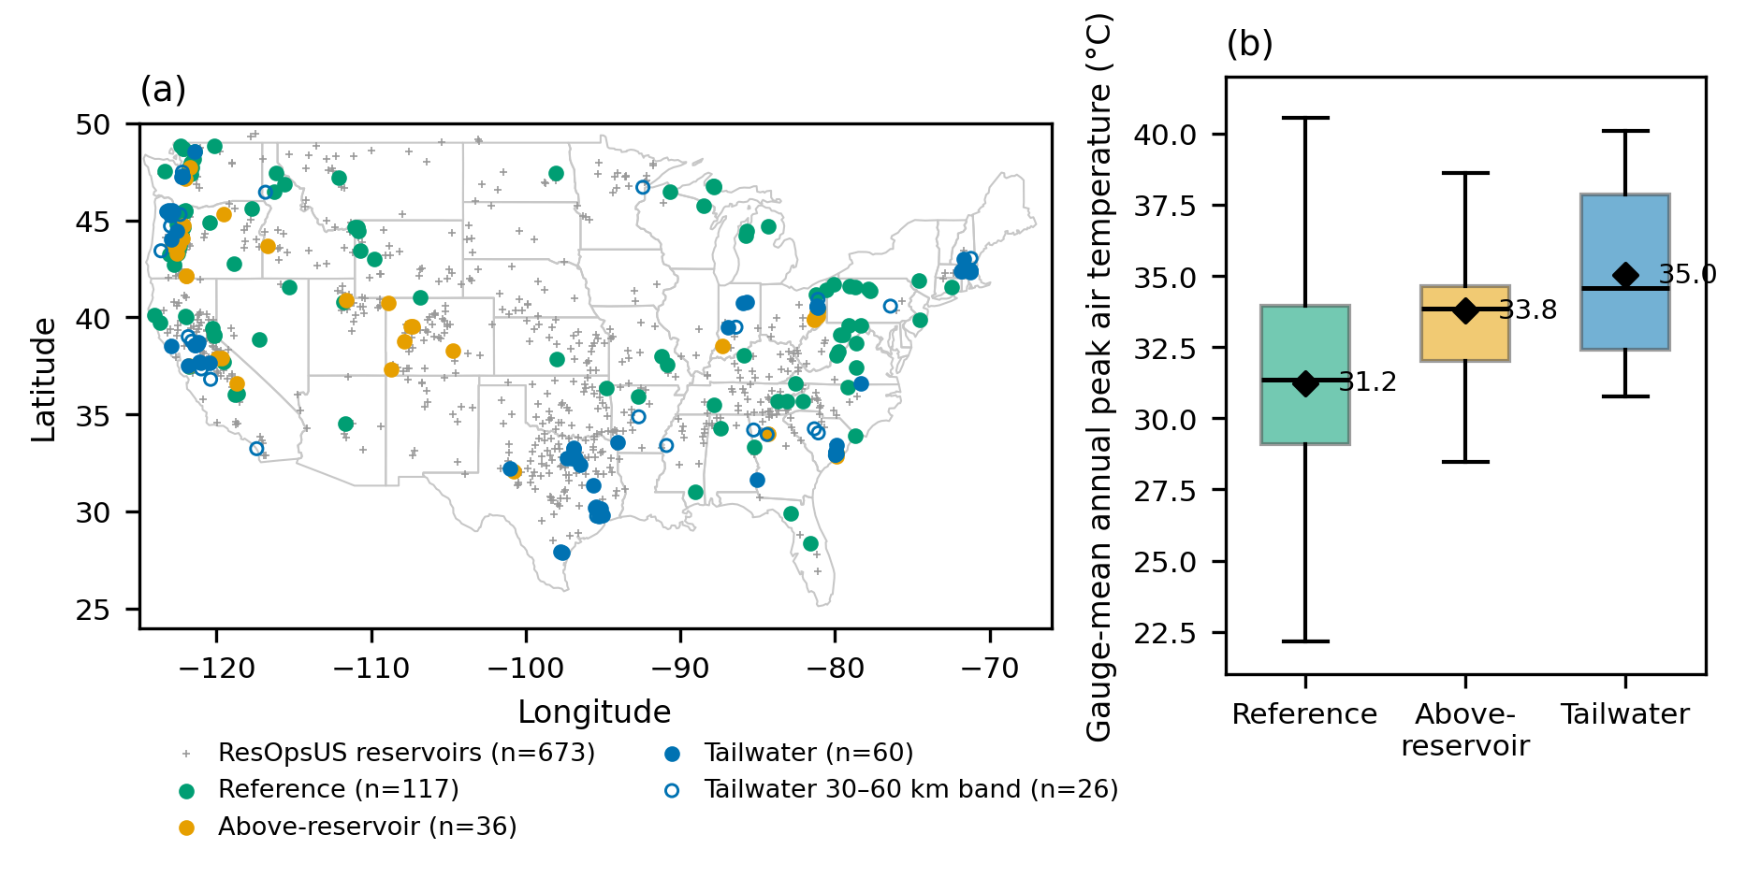
Fig. 2 — Annual peak coupling and peak timing across the three tiers. (a) Gauge-level β (red line: median; open diamond: mean; dashed line: β = 1, a unit-slope reference). (b) Distribution of per-gauge median water-minus-air peak-date offsets; mean offsets are 0.9, 4.3 and 8.0 days in reference, above-reservoir and tailwater tiers under the ≥8-year gate. The downstream distance profile is shown once in Fig. 8b.
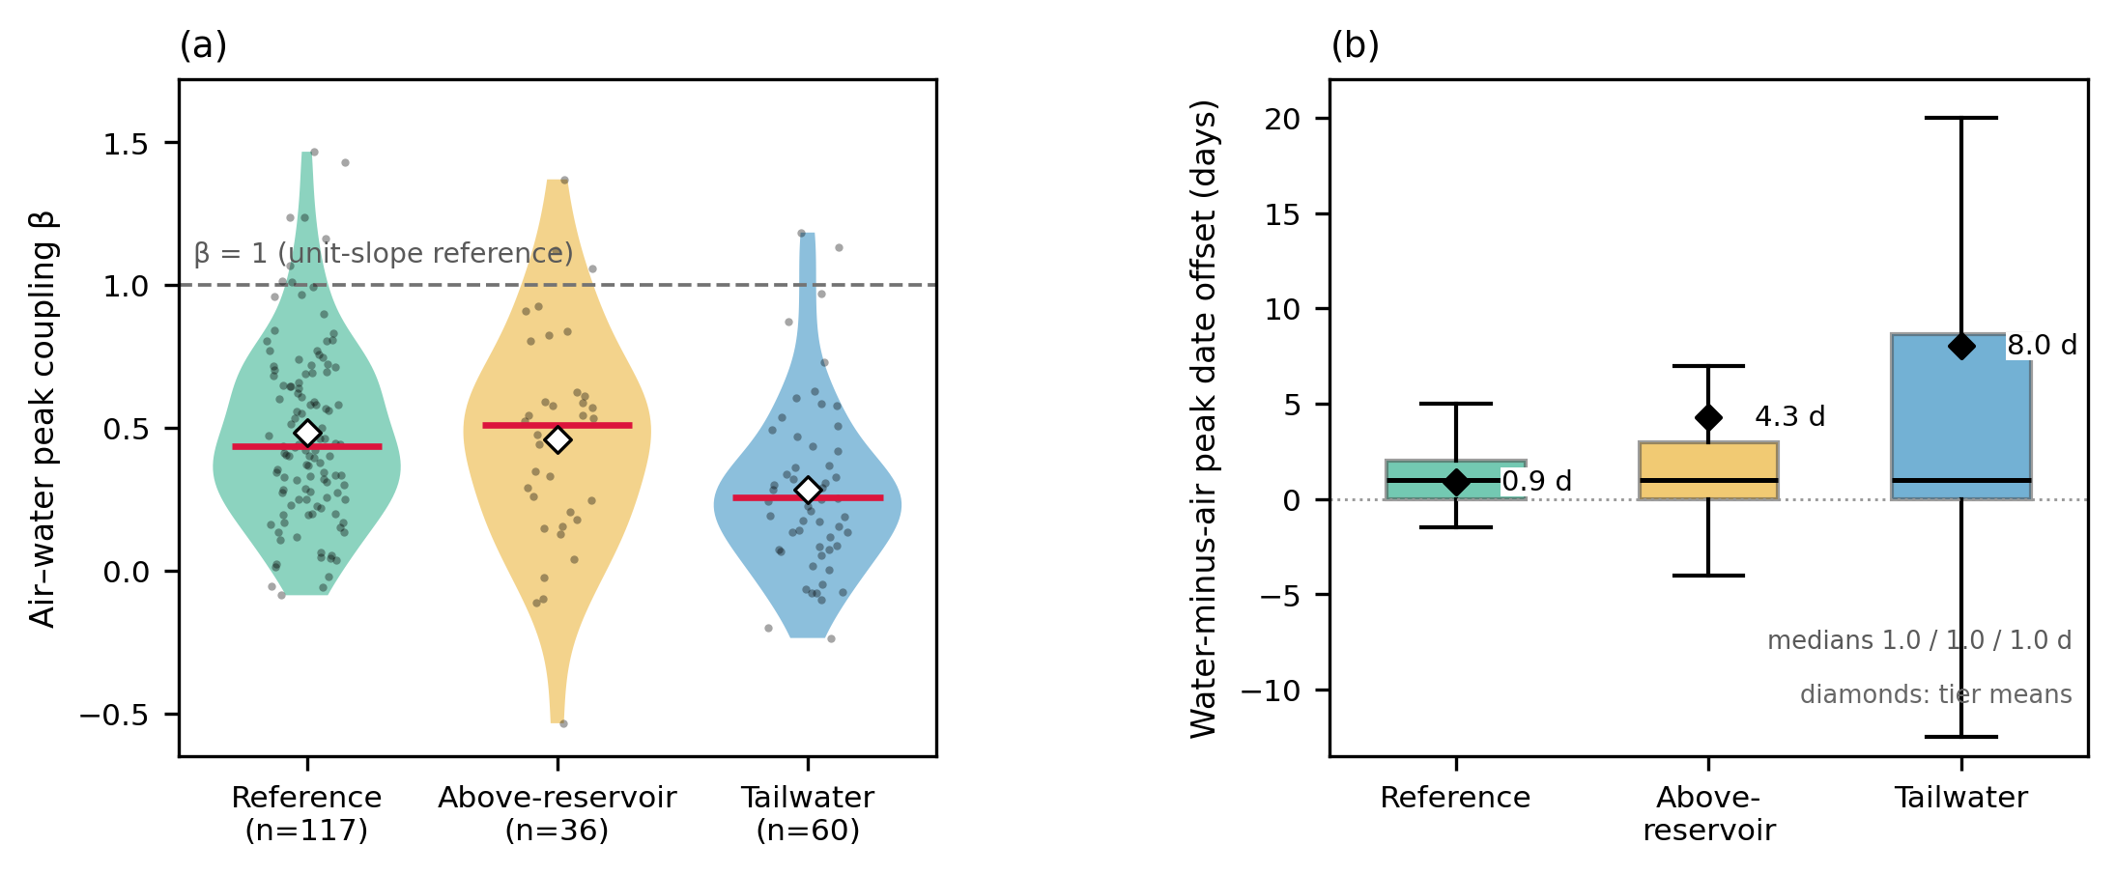
Fig. 3 — Tier slopes under four analysis frameworks: the gauge-level mixed model (full-covariance 95% CIs), two-stage tier means (joint bootstrap CIs), consecutive-year first differences (±1.96 s.e.), and the precision-weighted synthesis (point estimates). The frameworks estimate different quantities (partially pooled fixed slopes; unweighted means of per-gauge slopes; slopes from consecutive-year pairs; inverse-variance weighted means), so levels are comparable within a row, not across rows; each framework places the tailwater slope below the other two tiers.
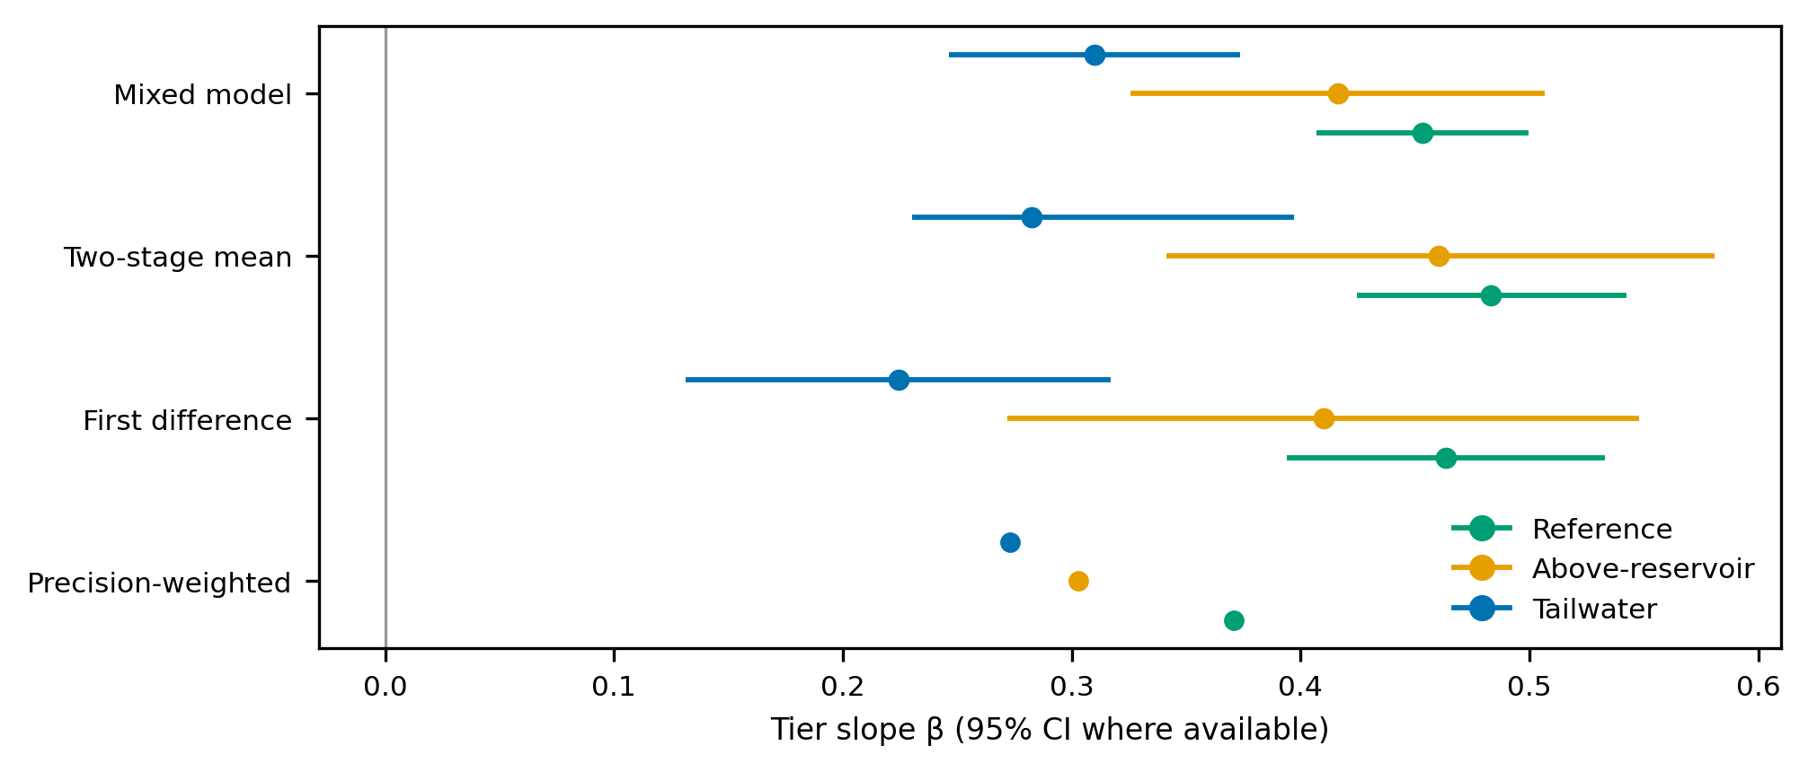
Fig. 4 — Same-river paired systems (n = 3 complete pairs): mean annual AMWT7 (over each pair’s overlapping years) upstream and downstream of each dam. Blue: cooler below the dam; red: warmer (colors differ from the tier scheme). Labels give the dam and the mean difference. The paired systems illustrate that local thermal direction depends on release configuration; Supplementary Table S5 lists gauges and overlapping-year counts.
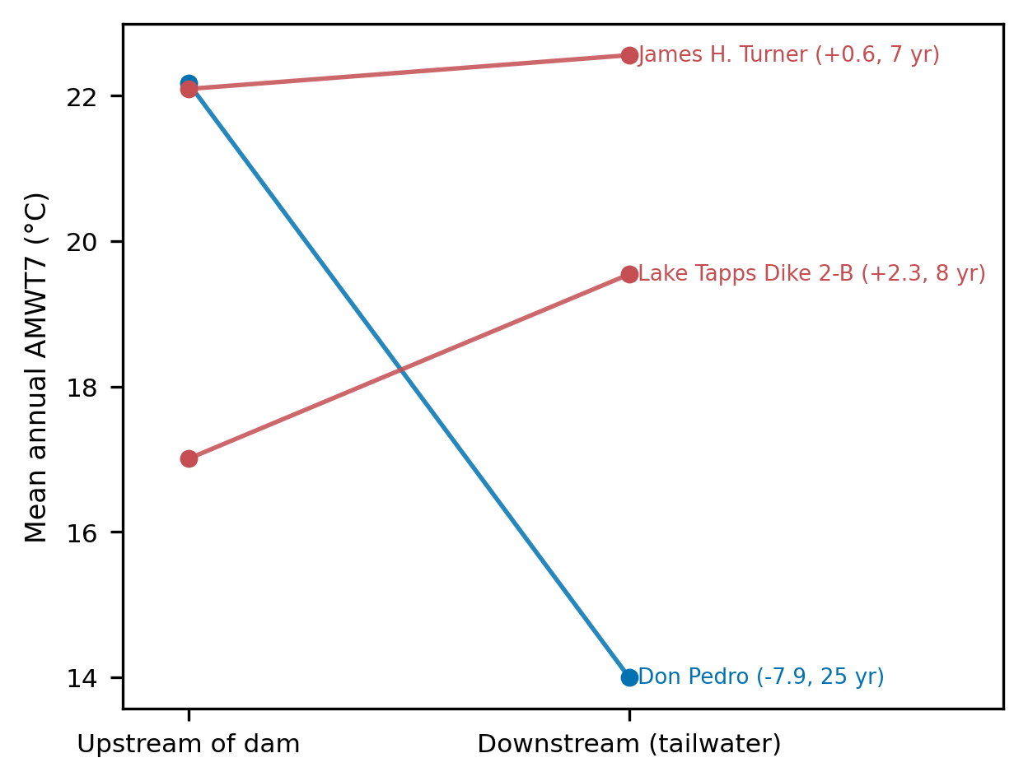
Fig. 5 — Absolute exposure and its sensitivity to warming. (a) Median days per year above 18, 22 and 26 °C by tier (gauges with at least one eligible year; n = 142/39/70). Panel b uses gauges with at least eight eligible years (n = 117/36/60). (b) Marginal exposure sensitivity: additional days above 22 °C per degree of annual peak air warming (mean of per-gauge OLS slopes; whiskers: gauge-level bootstrap 95% CIs). The open marker shows reference gauges restricted to the tailwater tier’s thermal state (median ≥ 50 days year⁻¹).
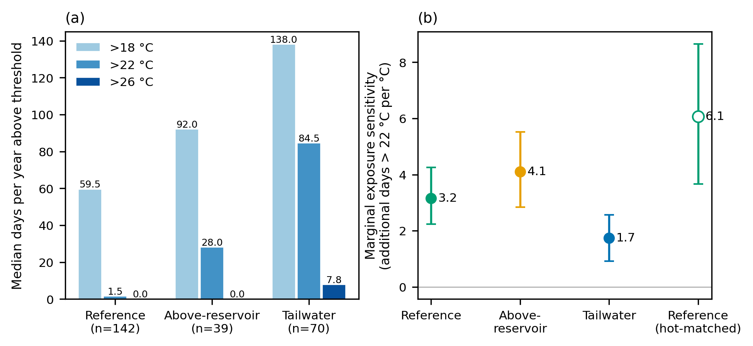
Fig. 6 — The Shasta case: antecedent release state and the tailwater peak. (a) Annual peak water temperature below Keswick Dam and annual peak air temperature at the site, 2006–2024. (b) Tailwater peak against mean reservoir storage over the strictly antecedent window [T−30, T−1]; fitted slope −0.99 °C per million acre-feet (r = −0.748, leave-one-out range −0.802 to −0.724). Five May-peak years are identified in the released peak-date table.
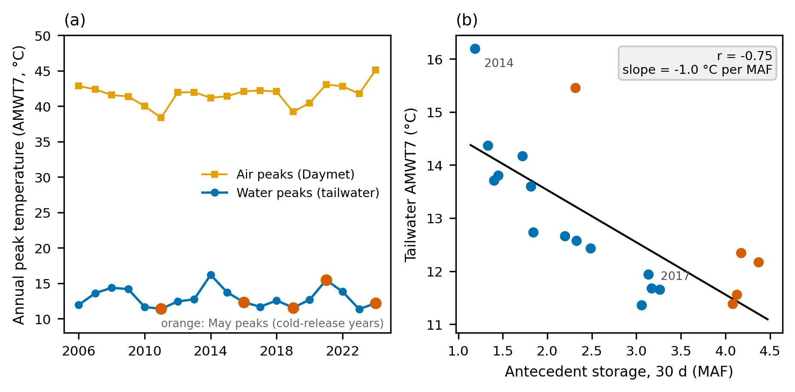
Fig. 7 — Release-state coupling across 18 reservoirs with co-recorded daily operations: partial correlation between antecedent storage and the tailwater thermal peak (controlling the atmospheric peak), per reservoir. Blue: negative; orange: positive; dashed line: random-effects Fisher-z pooled estimate (−0.194); 12 of 18 correlations are negative (exact one-sided p = 0.119). Labels give reservoir mean depth as recorded in GRanD v1 (flagged values treated as missing). Champion Creek Dam is omitted because its eligible tailwater gauge contributes six storage-complete years, below the ten-year gate. The storage window is strictly antecedent to each annual peak; Shasta is excluded and treated separately in Section 3.6.
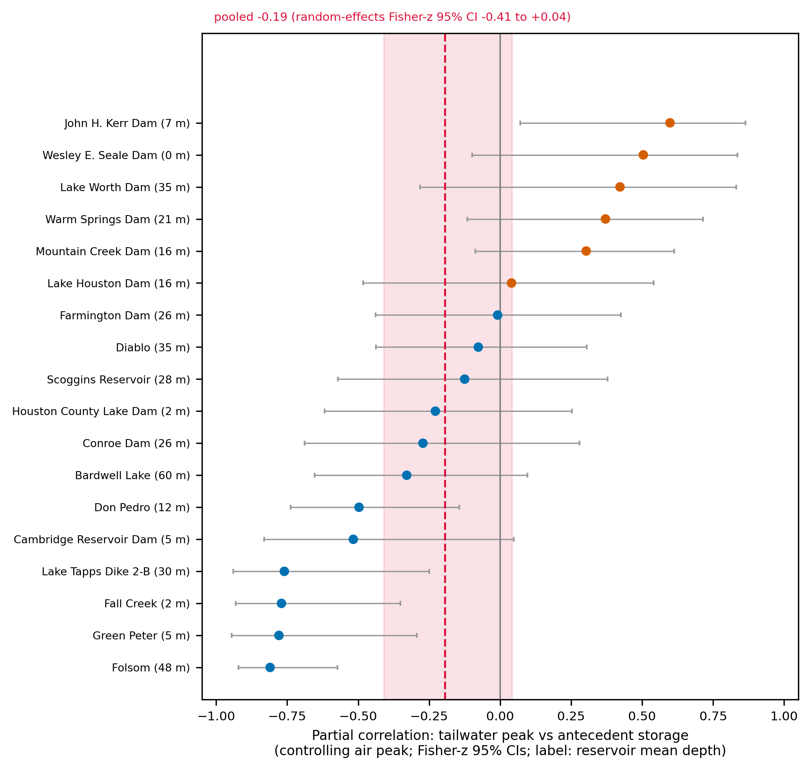
Fig. 8 — Release-state heterogeneity and the downstream distance profile. (a) Bivariate Pearson r² for the tailwater thermal peak against antecedent storage and against the atmospheric peak, per reservoir; 10 of 18 reservoirs lie above the 1:1 line. These are two-variable associations; partial and independent variance estimates are reported elsewhere. Panel (a) uses the same 18-reservoir set as Fig. 7. (b) Gauge-level β by distance below the reservoir, with means for 0–10 km (n = 19; β = 0.223), 10–30 km (n = 41; β = 0.310) and the 30–60 km sensitivity band (n = 26; β = 0.392).
