- change work direction: wd save project as: 7pmw01 file: get pdb 7pmw
- tasks: protein preparation wizard:
Global settings:
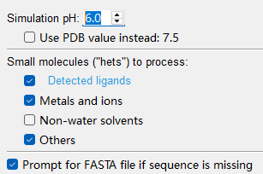
Preprocess:
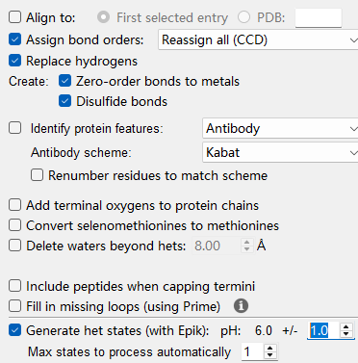
Optimize H-bond Assignments:
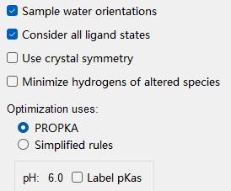
Minimize and delete waters
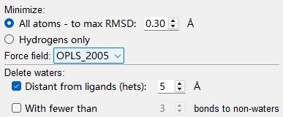

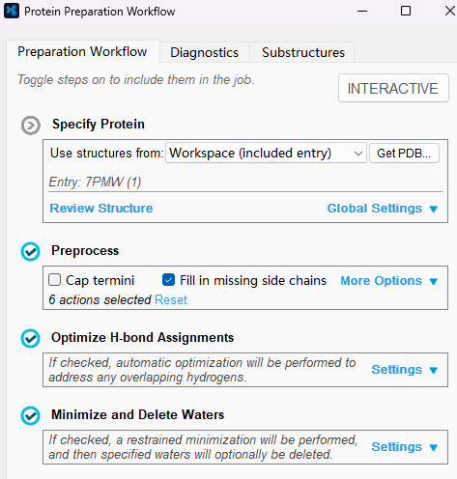

- prepare all smiles的*.mae文件
File import structure
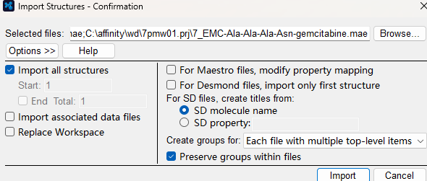

- Receptor Grid Generation
Receptor
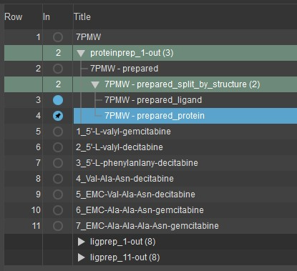

Split proteinprep into protein and ligand only want prepared_protein，then docking的时候，就除去原来的ligand，然后receptor grid generation
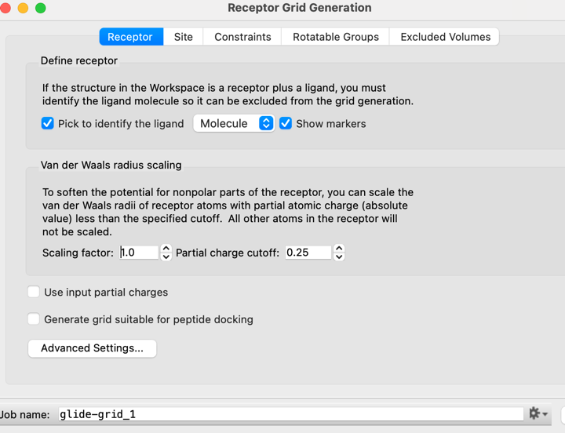
Pick to identify the ligand和site 二选一，不是同时选择。
Pick to identify the ligand 在ligand里面选 L，变成绿色。
Site
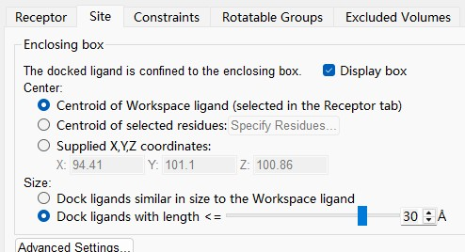
前药明显大于Ala–Phe，应扩大外部Grid box，建议先尝试约25–30 Å。我设置是30。（自己去挑选棍子周围的氨基酸。我在hierarchy里面把Ala–Phe去掉了）。

- LigPrep
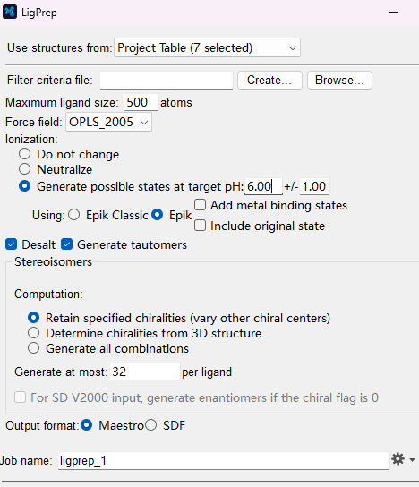
- ligand docking
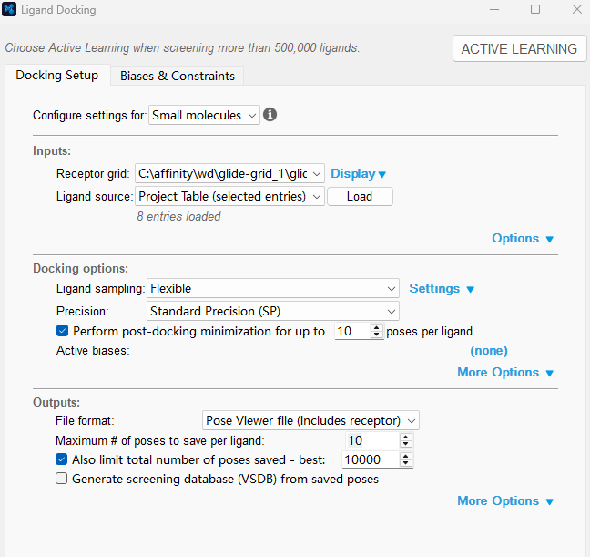
Receptor grid 找到glide_grid 里面*.zip文件Project Table（selected entries）8个都选中。

