Synthesis of the Risk Factors of Alcohol Overconsumption During the COVID-19 Based on Scoping Review

EDITOR(S): Hana Hayashi
CONTRIBUTOR(S): Yue Li, Shujuan Chen, Akihiro Shimoda
REVIEWER(S): Min Zhang, Wei Li

PUBLISHED: Sep 04th, 2024
REPORT NO.: GBI-BH-2024-01
SERIES: GreyBay Behavioral Health Research Series

INSTITUTION: GreyBay Institute, Shenzhen, China


This report was supported by the Public Hygiene and Health Commission of Shenzhen Municipality. The findings and conclusions presented in this report are those of the authors and do not necessarily represent the official views of the Commission.

© 2024 GreyBay Institute
This report is licensed under Creative Commons Attribution 4.0 (CC BY 4.0).
Research question
What are the risk and protective factors of binge drinking, and what are the facilitators and obstructs of alcohol consumption?

Methods
To address the question, a literature review was conducted by searching the database PubMed on August 24, 2021, using the search terms: (alcohol consumption[Title] OR consumption of alcohol[Title] OR alcohol addiction[Title] OR alcohol abuse[Title] OR alcohol use[Title] OR binge drinking[Title]) NOT (patient*[Mesh Terms] OR patient*[Title/Abstract] OR pregnancy[Mesh Terms] OR pregnan*[Title] OR intervention[Mesh Terms] OR intervention*[Title] OR children*[Mesh Terms] OR child*[Title/Abstract] OR meta-analysis[Title]). Filters as the following were applied: human, reviews or systematic reviews, English, and publication date between 2011 to the date of search. The search yielded 520 records. After title and abstract screening, 89 papers were included to full text review, where 12 were further excluded remaining 77 studies in this final report.

Results
Summary
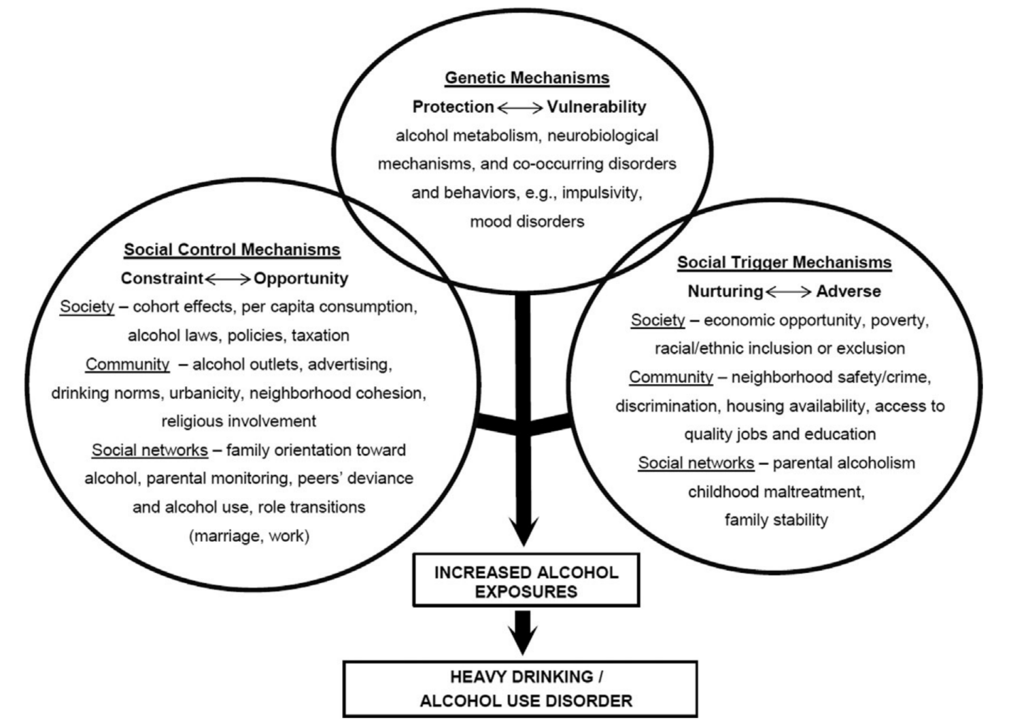
Figure 1. Theoretical mechanisms for genetic and environmental influences on increased alcohol exposures

Overall, based on analysis of the targeted literature, the key determinants for alcohol overconsumption (AO) are categorized into five levels: socioeconomic status (SES), individual level, interpersonal level, community level, media level and law/policy level. The numbers of literature for each category are 10, 50, 15, 6, 8, 9 respectively.

Figure 1 is a good summary of all levels of risk factors and their possible mechanisms. For SES, factors including dwelling locations, education level, income level, social classes were examined. Individual level has the biggest number of factors that are found associated with AO, including sex/gender, age, race/ethnicity, marital status, employment status, genetics, religion, ideology, childhood, history, experience, psychological, behavioral, lifestyle, personality, neurobiological, comorbidity, cognitive and knowledge. Interpersonal level is comprised of factors that relate to people’s social networks, such as external triggers, family, peers, social networks, romantic relationship and social connectedness. While the community level includes neighborhood social and physical environment towards alcohol consumption, which includes alcohol availability, alcohol marketing in local community, alcohol retail privatization, neighborhood culture, attitudes and social environment. Risk factors at the media level include content exposure, marketing/advertising and mass media campaigns. Laws and policies that target different aspects such as price/taxes of alcohol, drugs and cigarettes controls, ads by the manufacturers, neighborhood availability, restrictions on sellers, minimum age and driving related regulations, have been included in this review.

Key Determinants
Socioeconomic Status
The relationship between SES and AO is inconclusive across studies and varies by cultures. Definitions of alcohol use and abuse varied widely between studies, as did socioeconomic groupings (1), which also influenced the consistency across studies. In general, higher SES tends to be associated with more frequent drinking while lower SES corresponds with consuming larger quantities per occasion (2). Also, alcohol use was found to be more prevalent in lower socioeconomic groups in the majority of South East Asian studies but not for African studies (1).

For education specifically, better educated men were more likely to drink and to drink more than once a week, but less likely to be heavy alcohol users or have alcohol-related problems (3). In a group of older adults, alcohol consumption was associated with lower level of education (4). For adolescents, studies consistently have found that grades, educational expectations, and school bonding are negatively correlated with alcohol use (5). In terms of income, most of the extant studies detected a significant relationship between income and drinking among men and showed that low economic status is positively associated with various measures of alcohol consumption (3).

Income lost (6), job loss (6, 7) and unemployment (3) are also risk factors of AO. While in another study, employed individuals tend to drink more than those who are unemployed (2). Within employed individuals, alcohol use was found influenced by the physical and psychosocial aspects of employment, such as employee dissatisfaction, workplace controls and workplace culture. Besides, homelessness is positively associated with AO (2).

While there are literatures supporting both living in rural areas (2, 4) and urban areas (3, 8, 9). Associations between marital status and AO were mixed (3).

Socioeconomic disadvantage can be translated as lack of opportunities for personal development through education, professional training, having secure and rewarding jobs, access to good healthcare, and also opportunities for creative and stimulating leisure activities. Socioeconomic disadvantage also affects the living environment, the neighborhoods where minorities live. These neighborhoods are frequently in inner-city areas, which are racially and economically segregated and characterized by substandard housing, poor schools, high crime, an excessive number of alcohol outlets, gang-related violence, and general social disorganization. Excessive drinking can be used as a coping mechanism for life in these conditions (10).

Individual level
Substantial studies have shown that being male is risk factor of AO (3, 8, 11-13). However, evidence also shows that alcohol consumption by women is increasing (14) and women are more vulnerable to the consequences of AO (13, 15). Being in the LGBTI group is also associated with AO (2). For age range, there are evidence showing people being in age over 14 (8), between 18 and 34 (3) or between 18 and 25 (12) tend to consume more alcohol. Also, older people drink more frequently, younger people drink larger quantity per occasion (2). Across all studies that investigated the relationship between racial groups and AO, minority groups in a certain culture were found to have a higher risk of AO (2, 10, 12, 16).

Genetically, previously known associations with alcohol metabolizing enzymes (ADH1B, ALDH2) have been well studied (13, 15, 17, 18). Additionally, novel associations with loci containing the genes KLB, GCKR, CRHR1 and CADM2 have been reported (17). Analyses have leveraged these genetic findings to reveal important relationships between alcohol use. Alcohol misuse have been shown to overlap strongly with psychiatric disorders, whereas aspects of alcohol consumption have shown stronger links to metabolism (17).

For religion, except pro-communist ideology may increase the risk of AO, all other religions were found protective and can produce a major degree of support for people trying to maintain abstinence from alcohol (5, 8, 19, 20). Spiritual experiences and spiritual practices, including prayer and mindfulness meditation, may be helpful in reducing hazardous drinking (21).

Childhood, personal history and experience can play a strong role in shaping people's drinking behaviors. During childhood, reduced parental attention (8), childhood maltreatment including childhood sexual abuse, childhood physical abuse, and neglect (2, 11), family breakdown (2), parental drug use (2), early uptake of drinking (2, 22), family history of alcoholism (22). Furthermore, personal experiences including risky drinking events (e.g., 21st birthdays) (19), cyberbullying (7), victimization at work (7), racial discrimination (16), bullying and other forms of peer victimization (23), trauma (24), military deployment to conflict zone (25) have been shown to elevate later-life risk of AO. Moreover, childhood risk factors for later alcohol use can be elevated in disadvantaged communities (2).

Psychological factors can be considered as both outcomes of environmental cues and the cause of AO. In other words, psychological mechanisms can explain many associations between certain triggers and AO. All negative affects, including craving (26), stress (24, 27), anxiety (7, 11, 26, 28, 29), tiredness (26), depression (6-8, 11, 29-31), loneliness (6, 7) and role/identity loss (27). Though retirement and death of a spouse or a close relative have not been found to have a clear association with AO (27).Drinking behaviors can also be explained by drinking to cope motives (19, 32) and self-medication (23), since people might use alcohol as a maladaptive attempt to cope with or self-medicate the negative affects mentioned above. Drinking is also considered beneficial to the construction of gender and identity (33), and is responsible for the drinker identity formation during adolescence (34). On the other hand, self-esteem and the feeling of community attachment was proved to be a protective factor of AO (5).

For individual’s behavior and lifestyle, exposure to long working hours may have increased alcohol consumption, but it was uncertain about the effect on risky drinking (35). During the outbreak of the Covid-19 pandamic, increased availability of free time, eating more, changes in sleep, living/working from home with children and having one child under the age of 18 years are found to be risk factors of AO (6, 7). There is a study about sleep particularly, showing that circadian misalignment and sleep loss could lead to AO (36). Other substance use (19) and illicit drug use (5) are also associated with AO. For adolescents, school misbehavior, skipping school, hours of school work and smoking are positively associated with AO (5). However, it is inconclusive that physical activity/exercise or sports participation can reduce alcohol consumption (2, 5, 7, 37). In fact, sports participation can lead to socialization, which can end up with alcohol use.

While change in psychological state can explain short-term alcohol use due to triggered negative affects, personality and neurobiological mechanisms can explain long-term drinking behaviors. Internalizing problems are characterized by anxious and depressive symptoms, social withdrawal and somatic complaints. Externalizing problems on the other hand are defined as aggressive, oppositional, and delinquent behavior. Positive associations between externalizing problems and alcohol use behaviors were found (5, 30). The likelihood of observing positive associations was higher for more severe alcohol use outcomes. While internalizing problems tended to be negatively associated with alcohol consumption but positively associated with more severe outcomes (heavy/problematic drinking, alcohol use disorder) (30). Disinhibiting traits like impulsivity (defined as a predisposition for rapid, unplanned
actions, without considering potential negative consequences of these actions (38)), sensation-seeking, and risk-taking were shown to be associated with heavy or binge drinking in young adulthood (5, 11, 26, 38, 39). Also, poor inhibitory control or impaired control (11, 40-42), lack of premeditation (39), lack of perseverance (39), positive and negative urgency (39), reduced sensitivity to alcohol sedation and increased sensitivity to alcohol related disruptions in memory (22) are risk factors of AO. Urgency reflects a disposition to engage in mood-based rash action, and has since been separated into two facets. The tendency to act impulsively when distressed is termed negative urgency, whereas the tendency to act impulsively when in an exceptionally good mood is termed positive urgency. Lack of premeditation is the form of impulsivity most commonly referred to in the literature, the tendency to act without forethought. Lack of perseverance reflects a reduced capacity to persist with a task, or a heightened susceptibility to boredom (39).

Some comorbidities are highly correlated with AO. Social anxiety disorder or antisocial personality disorder (29, 43, 44), PTSD (45), personality disorder (44, 46) and mental health problems (2) are found positively associated with AO. Though personality disorder (44, 46) and PTSD (45) can be both the causes and the consequences of AO.

Culture and norms shape people’s view towards alcohol at the cognitive level. Culture is an important and prominent correlate of alcohol use (47-50). There are two ways that culture or acculturation may increase the incidence of AO. First, the disruptive effects of acculturative change and the stressors of new demands are associated with an increase in alcohol consumption. Second, cultural groups shape expectations about the effects of alcohol use and their definition of drunkenness (48). For norms, it was found that middle-aged non-problematized drinkers constructed their drinking practices by creating a narrative of normative drinking via discourses of gender, identity, play, and learning to drink. They also used drinking norms to construct their gender and identity (33). Evidence also shows that low normative perceptions of drinking is protective to AO (19). Besides, misinformation about alcohol can lead to AO (7).

Community level
Alcohol availability and neighborhood culture towards drinking are the most important two determinants of people’s drinking patterns at the community level. Factors about availability include community level availability, outlet density (51) and physical availability of take-away alcohol (52). Local heavy drinking culture (20) and high levels of both adult and adolescent alcohol use in the community (53) are found associated with AO. While neighborhood attitudes toward drinking was found not significantly associated with AO (53). Besides, alcohol marketing in local community (51) and alcohol retail privatization (54) are risk factors of AO. However, neighborhood characteristics including residential mobility, neighborhood disorder or crime, employment or job availability, social capital (community attachment, closeness and supportiveness and community participation) and collective efficacy were found unrelated (or weakly related) to AO (53, 55).

Environmental level
Drinking behaviors in one’s social networks (56), including family members (5, 8, 11) and peers (8, 57), are positively associated with one’s drinking behaviors. The influence of peer’s behavior on adolescent’s drinking behavior can be explained by social learning theory, which posits that adolescents learn both by direct experience and by observation. Previous work has indicated that observation of peers is a major source of influence on adolescent health attitudes, intentions, and behaviors. In particular, early alcohol initiation is determined at least in part by alcohol use by adolescents’ friends as well as by social network characteristics. Thus, according to social learning theory, observation of peers influences alcohol use intentions and behaviors. In today’s world, this observation may occur both online and offline (58).

Besides peer’s drinking behavior, peer pressure to drink alcohol (8, 59), peer approval to drink alcohol (8, 27, 29), peer selection seeking drinking peers (57) can also increase the risk of AO. Low school bonding or school disengagement (5) and lower social connectedness (6, 7) are also risk factors of AO. In romantic relationships, people are attracted to similarly drinking others. With greater relationship commitment there is greater desistance from drinking (60).

Environmental stressors, drug-associated environmental cues, social encounters (26) can trigger drinking behaviors. The mechanism of how environmental factors promote AO can be explained by cue reactivity theory (61), which is defined as emotional, behavioral, and/or physiological responses evoked by external (e.g. images, smells, scripts) cues. Notably, economic crisis is a strong environmental stressor that can increase the risk of AO (62, 63).

Media level
Alcohol portrayals in movies, music videos and soap operas can act as environmental cues and increase the risk of AO (57). Figure 2 is an illustration of how movie alcohol portrayal can interact with other variables and cause long-term or immediate alcohol consumption. This theoretical framework can also explain similar effect of media content exposures on alcohol consumption. For example, exposure to alcohol-related content on the Internet might predispose young people to patterns of alcohol use by promoting alcohol as a natural and vital part of life (58).

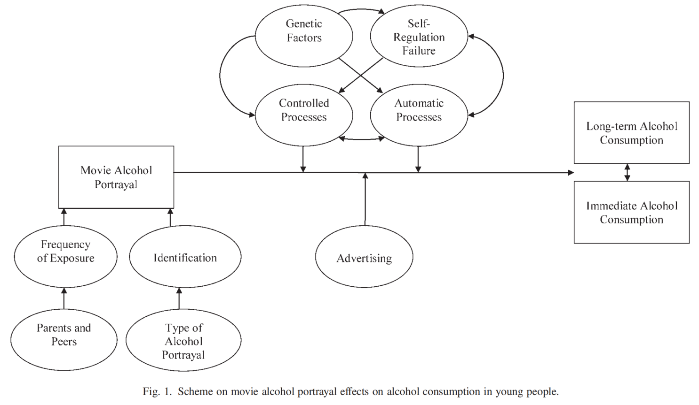
Figure 2. Scheme on movie alcohol portrayal effects on alcohol consumption in young people.

Advertisement is also an influential pathway at the media level. Alcohol advertising, including alcohol promotion (e.g., alcohol-sponsored events) and owning alcohol-related merchandise were proved to be risk factors of AO (64, 65). Digital alcohol marketing, including clicking on an alcohol ad, visiting an alcohol-branded website, liking or sharing an ad on social media, or downloading alcohol-branded content can also increase the risk of AO (66).

On the positive side of media, mass media health campaigns about alcohol are often recalled by individuals, and have achieved changes in knowledge, attitudes and beliefs about alcohol. However, there is little evidence of direct impact on alcohol consumption (67).

Law and policy level
Generally, enforcement of liquor laws is a protective factor of AO (53). Laws and policies can use different instruments and target various aspects of alcohol consumptions. Price increase (2, 68) and alcohol excise tax (63, 69) are powerful economic techniques to lower the demand of alcohol. In addition to tax­related polices, several other regulations also may directly or indirectly affect the prices of alcoholic beverages. These options include, but are not limited to, regulations on wholesale and retail distribution, bans on price­ related promotions, and (targeted) minimum­pricing policies. However, the empirical evidence on the impacts of these policies is very limited (69).

Interestingly, laws on drugs and cigarettes can influence alcohol consumption because they can be considered as both substitutions for and complements of alcohol. The extant literature provides some evidence for both substitution (i.e., more liberal marijuana policies related to less alcohol use as marijuana becomes a substitute) and complementary (i.e., more liberal marijuana policies related to increases in both marijuana and alcohol use) relationships in the context of liberalization of marijuana policies in the United States (70). For cigarettes, current evidence suggests reducing the nicotine content of cigarettes may benefit public health by reducing alcohol use and problematic drinking over time as a consequence of reduced exposure to nicotine and the smoking cues associated with drinking. Nicotine withdrawal could increase risk of drinking, although these effects should be short-lived and could be mitigated by other sources of nicotine (71).

For alcohol advertisement bans, a policy study has revealed that alcohol consumption decreased since 2008, while alcohol excise tax, sales time restrictions and ad bans have increased since 2005. However, the precise role and the causal effect of these bans were unclear (69).

Dram shop liability holds the owner or server(s) at a bar, restaurant, or other location
where a patron, adult or underage, consumed his or her last alcoholic beverage responsible for harms subsequently inflicted by the patron on others. Liability in a state can be established by case law or statute. Overservice laws prohibit the sale of alcoholic beverages to intoxicated patrons drinking in on-premises retail alcohol outlets (i.e., premises where the alcohol is consumed where purchased) (72). Sales time restrictions is another form. For instance, off-premise sale of alcoholic beverages is prohibited from 10p.m. to 10 a.m. in Estonia (69). Enhanced enforcement of these laws is intended to ensure compliance by premises personnel. These interventions are ultimately designed to promote responsible beverage service by reducing sales to intoxicated patrons, underage youth, or both (72). In fact, there was indeed a significant reduction in alcohol-related harms and AO with the presence of dram shop liability in jurisdictions where premises are licensed (72).

Alcohol consumption tends to increase with greater physical availability. Research shows that alcohol-related problems can be minimized by limiting availability through reducing hours of sale and/or lowering alcohol outlet density (2). Moreover, regulations on minimum drinking age, drink driving laws and random breath testing were also proved to be beneficial in decreasing the incidence of AO (2).

Special Notes
The study by Roche et al. is the single most comprehensive study that summarized the majority of above-mentioned factors in an ordered way. At the end of the result section, studies that evaluated the cost-effectiveness of alcohol interventions at the population level were summarized. Interventions that were found to be cost-effective include: making alcohol more expensive and less available; banning alcohol advertising; brief interventions; RBT for drivers; increasing the minimum legal drinking age to 21 years; and mass media ‘drink driving’ campaigns (2).

Among included studies, there were two studies that particularly focused on the influence of Covid-19 pandemic on alcohol consumption. Murthy and Narasimha found that the changes in the pattern of use of alcohol and resultant effects due to the pandemic are evident. Immediate effects have been an increase in alcohol-related emergencies including alcohol withdrawal, withdrawal-related suicides, methanol toxicity and alcohol-related motor vehicle accidents (7). While Creswell and Bachrach discussed the role of external and internal factors in coping motive pathways to alcohol use (6).

Reference information
Here are some commonly used screening tools for alcohol consumption or alcohol use disorder: AUDIT, CAGE, TWEAK, CRAFFT, RAPS4-QF, FAST, RUFT-Cut and POSIT (2).

Conclusions
Summarizing the evidence above, we can conclude that AO is affected by factors at various levels, and these factors usually interplay with each other and rarely act alone in determining individual’s drinking behaviors. In general, influencing factors can be dichotomized into two groups, those trigger instant alcohol consumptions (e.g., peer’s behaviors and environmental cues) and those act as prerequisites or foundations for the stimuli to become effective (e.g., personalities, childhood history).

In the background of this report, we should pay attention to the underlying role of the Covid-19 pandemic to better model its marginal effect on people’s alcohol consuming behaviors, and to better recognize the place where interventions may be more cost-effective. Covid-19 pandemic cannot change the factors in the second group and will only modify the factors in the first category. However, factors in the second group can be used as identifiers to detect the vulnerable populations due to the impact.

Covid-19 pandemic is thought to bring changes in the following aspects that may increase the chance of AO: psychological distress, increased availability of free time, misinformation about alcohol, heavy drinking pre-pandemic, job loss, eating more, changes in sleep, higher anxiety and depression, living with children, reduced physical activity, loneliness, reduced community attachment, cyberbullying, victimization at work, lower social connectedness and having one child under the age of 18 years. Conceivably, populations with lower SES, having psychological comorbidities, with alcohol-related histories, living in a community with culture that favor alcohol use where insufficient enforcement of alcohol regulations will have worse consequences in terms of AO, though information other than SES might be difficult to obtain and to be targeted on.

Understanding these factors is important in guiding future prevention and intervention efforts and in shaping alcohol policies. Here summarized several suggestions for intervention design. First, for individual based interventions, higher effectiveness can be anticipated in people with lower SES. For example, job loss compensations, improvement of working environment will produce higher utility when implemented on low SES populations. Second, targeting prevention and intervention efforts toward young adults during their college years may increase the effectiveness of those efforts, reducing the negative consequences of alcohol use and averting problematic trajectories. Evidence has shown that interventions targeting at-risk children/families may curb later alcohol consumption and harms. Effective interventions include family home visiting, parental education, school preparation programs, family interventions, brief interventions, and school organization and behavior management (2). Third, more opportunities can be organized at the community level to mitigate people’s negative emotions and to increase community attachment, which often leads to increased alcohol consumption. These activities can be online socializing, psychological consulting, information sharing on how to keep a organized lifestyle. Fourth, via various platform (both online and offline), media should take the responsibility of providing people with better ways to socialize and to get rid of anxiety and stress, and with more knowledge on the deleterious effect on human health. The changing of societal values, norms and attitudes towards alcohol and related identity may take time, but the media is a good place to deliver such messages to the society. Last and most importantly, at the regulation level, regulations need to be tighter, and the enforcement of these regulations needs to be stricter. For instance, an increase in alcohol excise tax may both decrease alcohol consumption and increase tax revenue.

References
1. Allen LN, Townsend N, Williams J, Mikkelsen B, Roberts N, Wickramasinghe K. Socioeconomic status and alcohol use in low- and lower-middle income countries: A systematic review. Alcohol. 2018;70:23-31.
2. Roche A, Kostadinov V, Fischer J, Nicholas R, O'Rourke K, Pidd K, et al. Addressing inequities in alcohol consumption and related harms. Health Promot Int. 2015;30 Suppl 2:ii20-35.
3. Murphy A, Roberts B, Stickley A, McKee M. Social factors associated with alcohol consumption in the former Soviet Union: a systematic review. Alcohol Alcohol. 2012;47(6):711-8.
4. Nadkarni A, Murthy P, Crome IB, Rao R. Alcohol use and alcohol-use disorders among older adults in India: a literature review. Aging Ment Health. 2013;17(8):979-91.
5. Patrick ME, Schulenberg JE. Prevalence and predictors of adolescent alcohol use and binge drinking in the United States. Alcohol Res. 2013;35(2):193-200.
6. Creswell KG, Bachrach RL. A Commentary on Drinking to Cope During the COVID-19 Pandemic: The Role of External and Internal Factors in Coping Motive Pathways to Alcohol Use, Solitary Drinking, and Alcohol Problems. Alcohol Clin Exp Res. 2020;44(11):2150-3.
7. Murthy P, Narasimha VL. Effects of the COVID-19 pandemic and lockdown on alcohol use disorders and complications. Curr Opin Psychiatry. 2021;34(4):376-85.
8. Athauda LK, Peiris-John R, Ameratunga S, McCool J, Wickremasinghe R. Factors Influencing Alcohol Use Among Adolescents in South Asia: A Systematic Review. J Stud Alcohol Drugs. 2020;81(5):529-42.
9. Dixon MA, Chartier KG. Alcohol Use Patterns Among Urban and Rural Residents: Demographic and Social Influences. Alcohol Res. 2016;38(1):69-77.
10. Caetano R, Vaeth PA, Chartier KG, Mills BA. Epidemiology of drinking, alcohol use disorders, and related problems in US ethnic minority groups. Handb Clin Neurol. 2014;125:629-48.
11. Wilsnack RW, Wilsnack SC, Gmel G, Kantor LW. Gender Differences in Binge Drinking. Alcohol Res. 2018;39(1):57-76.
12. Delker E, Brown Q, Hasin DS. Alcohol Consumption in Demographic Subpopulations: An Epidemiologic Overview. Alcohol Res. 2016;38(1):7-15.
13. Erol A, Karpyak VM. Sex and gender-related differences in alcohol use and its consequences: Contemporary knowledge and future research considerations. Drug Alcohol Depend. 2015;156:1-13.
14. White AM. Gender Differences in the Epidemiology of Alcohol Use and Related Harms in the United States. Alcohol Res. 2020;40(2):01.
15. Deak JD, Miller AP, Gizer IR. Genetics of alcohol use disorder: a review. Curr Opin Psychol. 2019;27:56-61.
16. Desalu JM, Goodhines PA, Park A. Racial discrimination and alcohol use and negative drinking consequences among Black Americans: a meta-analytical review. Addiction. 2019;114(6):957-67.
17. Sanchez-Roige S, Palmer AA, Clarke TK. Recent Efforts to Dissect the Genetic Basis of Alcohol Use and Abuse. Biol Psychiatry. 2020;87(7):609-18.
18. Bujarski S, Ray LA. Experimental psychopathology paradigms for alcohol use disorders: Applications for translational research. Behav Res Ther. 2016;86:11-22.
19. Krieger H, Young CM, Anthenien AM, Neighbors C. The Epidemiology of Binge Drinking Among College-Age Individuals in the United States. Alcohol Res. 2018;39(1):23-30.
20. Castaldelli-Maia JM, Bhugra D. Investigating the interlinkages of alcohol use and misuse, spirituality and culture - Insights from a systematic review. Int Rev Psychiatry. 2014;26(3):352-67.
21. Witkiewitz K, McCallion E, Kirouac M. Religious Affiliation and Spiritual Practices: An Examination of the Role of Spirituality in Alcohol Use and Alcohol Use Disorder. Alcohol Res. 2016;38(1):55-8.
22. Silveri MM. Adolescent brain development and underage drinking in the United States: identifying risks of alcohol use in college populations. Harv Rev Psychiatry. 2012;20(4):189-200.
23. Maniglio R. Bullying and Other Forms of Peer Victimization in Adolescence and Alcohol Use. Trauma Violence Abuse. 2017;18(4):457-73.
24. Anthenelli RM. Overview: stress and alcohol use disorders revisited. Alcohol Res. 2012;34(4):386-90.
25. Kelsall HL, Wijesinghe MS, Creamer MC, McKenzie DP, Forbes AB, Page MJ, et al. Alcohol use and substance use disorders in Gulf War, Afghanistan, and Iraq War veterans compared with nondeployed military personnel. Epidemiol Rev. 2015;37:38-54.
26. Vengeliene V, Foo JC, Kim J. Translational approach to understanding momentary factors associated with alcohol consumption. Br J Pharmacol. 2020;177(17):3878-97.
27. Emiliussen J, Nielsen AS, Andersen K. Identifying Risk Factors for Late-Onset (50+) Alcohol Use Disorder and Heavy Drinking: A Systematic Review. Subst Use Misuse. 2017;52(12):1575-88.
28. DeMartini KS, Carey KB. The role of anxiety sensitivity and drinking motives in predicting alcohol use: a critical review. Clin Psychol Rev. 2011;31(1):169-77.
29. Cruz E, Martins PDC, Diniz PRB. Factors related to the association of social anxiety disorder and alcohol use among adolescents: a systematic review. J Pediatr (Rio J). 2017;93(5):442-51.
30. Ning K, Gondek D, Patalay P, Ploubidis GB. The association between early life mental health and alcohol use behaviours in adulthood: A systematic review. PLoS One. 2020;15(2):e0228667.
31. Balhara YPS, Gupta P, Elwadhi D. Co-occurring depression and alcohol-use disorders in South-East Asia: A narrative review. WHO South East Asia J Public Health. 2017;6(1):50-9.
32. Skrzynski CJ, Creswell KG. Associations between solitary drinking and increased alcohol consumption, alcohol problems, and drinking to cope motives in adolescents and young adults: a systematic review and meta-analysis. Addiction. 2020;115(11):1989-2007.
33. Muhlack E, Carter D, Braunack-Mayer A, Morfidis N, Eliott J. Constructions of alcohol consumption by non-problematised middle-aged drinkers: a qualitative systematic review. BMC Public Health. 2018;18(1):1016.
34. Lee CK, Corte C, Stein KF. Drinker Identity: Key Risk Factor for Adolescent Alcohol Use. J Sch Health. 2018;88(3):253-60.
35. Pachito DV, Pega F, Bakusic J, Boonen E, Clays E, Descatha A, et al. The effect of exposure to long working hours on alcohol consumption, risky drinking and alcohol use disorder: A systematic review and meta-analysis from the WHO/ILO Joint Estimates of the Work-related Burden of Disease and Injury. Environ Int. 2021;146:106205.
36. Hasler BP, Soehner AM, Clark DB. Sleep and circadian contributions to adolescent alcohol use disorder. Alcohol. 2015;49(4):377-87.
37. Dodge T, Clarke P, Dwan R. The Relationship Between Physical Activity and Alcohol Use Among Adults in the United States. Am J Health Promot. 2017;31(2):97-108.
38. Herman AM, Duka T. Facets of impulsivity and alcohol use: What role do emotions play? Neurosci Biobehav Rev. 2019;106:202-16.
39. Stautz K, Cooper A. Impulsivity-related personality traits and adolescent alcohol use: a meta-analytic review. Clin Psychol Rev. 2013;33(4):574-92.
40. Lopez-Caneda E, Rodriguez Holguin S, Cadaveira F, Corral M, Doallo S. Impact of alcohol use on inhibitory control (and vice versa) during adolescence and young adulthood: a review. Alcohol Alcohol. 2014;49(2):173-81.
41. Leeman RF, Patock-Peckham JA, Potenza MN. Impaired control over alcohol use: An under-addressed risk factor for problem drinking in young adults? Exp Clin Psychopharmacol. 2012;20(2):92-106.
42. Leeman RF, Beseler CL, Helms CM, Patock-Peckham JA, Wakeling VA, Kahler CW. A brief, critical review of research on impaired control over alcohol use and suggestions for future studies. Alcohol Clin Exp Res. 2014;38(2):301-8.
43. Bulley A, Miloyan B, Brilot B, Gullo MJ, Suddendorf T. An evolutionary perspective on the co-occurrence of social anxiety disorder and alcohol use disorder. J Affect Disord. 2016;196:62-70.
44. Guy N, Newton-Howes G, Ford H, Williman J, Foulds J. The prevalence of comorbid alcohol use disorder in the presence of personality disorder: Systematic review and explanatory modelling. Personal Ment Health. 2018;12(3):216-28.
45. Smith NDL, Cottler LB. The Epidemiology of Post-Traumatic Stress Disorder and Alcohol Use Disorder. Alcohol Res. 2018;39(2):113-20.
46. Newton-Howes G, Foulds J. Personality Disorder and Alcohol Use Disorder: An Overview. Psychopathology. 2018;51(2):130-6.
47. Zamboanga BL, Tomaso CC, Kondo KK, Schwartz SJ. Surveying the literature on acculturation and alcohol use among Hispanic college students: we're not all on the same page. Subst Use Misuse. 2014;49(8):1074-8.
48. Castro FG, Barrera M, Jr., Mena LA, Aguirre KM. Culture and alcohol use: historical and sociocultural themes from 75 years of alcohol research. J Stud Alcohol Drugs Suppl. 2014;75 Suppl 17:36-49.
49. Alvarez MJ, Frietze G, Ramos C, Field C, Zarate MA. A Quantitative Analysis of Latino Acculturation and Alcohol Use: Myth Versus Reality. Alcohol Clin Exp Res. 2017;41(7):1246-56.
50. Chartier KG, Karriker-Jaffe KJ, Cummings CR, Kendler KS. Review: Environmental influences on alcohol use: Informing research on the joint effects of genes and the environment in diverse U.S. populations. Am J Addict. 2017;26(5):446-60.
51. Bryden A, Roberts B, McKee M, Petticrew M. A systematic review of the influence on alcohol use of community level availability and marketing of alcohol. Health Place. 2012;18(2):349-57.
52. Sherk A, Stockwell T, Chikritzhs T, Andreasson S, Angus C, Gripenberg J, et al. Alcohol Consumption and the Physical Availability of Take-Away Alcohol: Systematic Reviews and Meta-Analyses of the Days and Hours of Sale and Outlet Density. J Stud Alcohol Drugs. 2018;79(1):58-67.
53. Jackson N, Denny S, Ameratunga S. Social and socio-demographic neighborhood effects on adolescent alcohol use: a systematic review of multi-level studies. Soc Sci Med. 2014;115:10-20.
54. Hahn RA, Middleton JC, Elder R, Brewer R, Fielding J, Naimi TS, et al. Effects of alcohol retail privatization on excessive alcohol consumption and related harms: a community guide systematic review. Am J Prev Med. 2012;42(4):418-27.
55. Bryden A, Roberts B, Petticrew M, McKee M. A systematic review of the influence of community level social factors on alcohol use. Health Place. 2013;21:70-85.
56. Knox J, Schneider J, Greene E, Nicholson J, Hasin D, Sandfort T. Using social network analysis to examine alcohol use among adults: A systematic review. PLoS One. 2019;14(8):e0221360.
57. Koordeman R, Anschutz DJ, Engels RC. Alcohol portrayals in movies, music videos and soap operas and alcohol use of young people: current status and future challenges. Alcohol Alcohol. 2012;47(5):612-23.
58. Moreno MA, Whitehill JM. Influence of Social Media on Alcohol Use in Adolescents and Young Adults. Alcohol Res. 2014;36(1):91-100.
59. Morris H, Larsen J, Catterall E, Moss AC, Dombrowski SU. Peer pressure and alcohol consumption in adults living in the UK: a systematic qualitative review. BMC Public Health. 2020;20(1):1014.
60. Fischer JL, Wiersma JD. Romantic relationships and alcohol use. Curr Drug Abuse Rev. 2012;5(2):98-116.
61. Vujanovic AA, Lebeaut A, Zegel M, Smit T, Berenz EC. Post-traumatic stress and alcohol use disorders: recent advances and future directions in cue reactivity. Curr Opin Psychol. 2019;30:109-16.
62. de Goeij MC, Suhrcke M, Toffolutti V, van de Mheen D, Schoenmakers TM, Kunst AE. How economic crises affect alcohol consumption and alcohol-related health problems: a realist systematic review. Soc Sci Med. 2015;131:131-46.
63. Lai T, Habicht J. Decline in alcohol consumption in Estonia: combined effects of strengthened alcohol policy and economic downturn. Alcohol Alcohol. 2011;46(2):200-3.
64. Finan LJ, Lipperman-Kreda S, Grube JW, Balassone A, Kaner E. Alcohol Marketing and Adolescent and Young Adult Alcohol Use Behaviors: A Systematic Review of Cross-Sectional Studies. J Stud Alcohol Drugs Suppl. 2020;Sup 19:42-56.
65. Jernigan D, Noel J, Landon J, Thornton N, Lobstein T. Alcohol marketing and youth alcohol consumption: a systematic review of longitudinal studies published since 2008. Addiction. 2017;112 Suppl 1:7-20.
66. Noel JK, Sammartino CJ, Rosenthal SR. Exposure to Digital Alcohol Marketing and Alcohol Use: A Systematic Review. J Stud Alcohol Drugs Suppl. 2020;Sup 19:57-67.
67. Young B, Lewis S, Katikireddi SV, Bauld L, Stead M, Angus K, et al. Effectiveness of Mass Media Campaigns to Reduce Alcohol Consumption and Harm: A Systematic Review. Alcohol Alcohol. 2018;53(3):302-16.
68. Sharma A, Sinha K, Vandenberg B. Pricing as a means of controlling alcohol consumption. Br Med Bull. 2017;123(1):149-58.
69. Xu X, Chaloupka FJ. The effects of prices on alcohol use and its consequences. Alcohol Res Health. 2011;34(2):236-45.
70. Guttmannova K, Lee CM, Kilmer JR, Fleming CB, Rhew IC, Kosterman R, et al. Impacts of Changing Marijuana Policies on Alcohol Use in the United States. Alcohol Clin Exp Res. 2016;40(1):33-46.
71. Dermody SS, Donny EC. The predicted impact of reducing the nicotine content in cigarettes on alcohol use. Nicotine Tob Res. 2014;16(8):1033-44.
72. Rammohan V, Hahn RA, Elder R, Brewer R, Fielding J, Naimi TS, et al. Effects of dram shop liability and enhanced overservice law enforcement initiatives on excessive alcohol consumption and related harms: Two community guide systematic reviews. Am J Prev Med. 2011;41(3):334-43.

