Evaluating Convolutional Block Attention for EMNIST Letters Classification: A Study of I–L Confusion
Part C Technical Paper

Abstract
Handwritten character recognition remains difficult when classes share nearly identical stroke structures. This study evaluates the Convolutional Block Attention Module (CBAM) as an extension to convolutional neural networks (CNNs) for EMNIST Letters, motivated by persistent confusion between the visually similar I and L classes in earlier coursework. CBAM sequentially applies channel attention and spatial attention to reweight informative feature channels and locations. Two controlled experiments were conducted: V2 Baseline versus V2 + CBAM without augmentation, and V3 Augmented versus V3 + CBAM using the same data-augmentation strategy. In the V2 experiment, CBAM slightly reduced test accuracy from 93.95% to 93.80% and macro F1 from 0.9392 to 0.9379, while total I↔L errors changed only from 217 to 216. In the V3 experiment, CBAM reduced accuracy from 94.43% to 94.08%, increased test loss from 0.1552 to 0.1698, and increased total I↔L errors from 220 to 226. Across both experiments, CBAM consistently reduced L→I errors but increased I→L errors, indicating error redistribution rather than resolution. V3 Augmented remained the strongest overall model. To test whether this pattern was specific to one training run, all four models were retrained across three random seeds (42, 88, 123) on an identical data split; total I↔L errors stayed within a narrow 219-220 band regardless of CBAM in every seed, and the I→L increase with CBAM was consistent across all three seeds for V2 (though less consistent for V3). The results show that CBAM is lightweight in parameter count but did not provide a consistent performance benefit for this low-resolution task.

1. Introduction

1.1 Background and Problem
Offline handwritten character recognition (HCR) receives only a static image and must separate classes despite large variation in style, slant, scale and stroke thickness. CNNs are effective because they learn hierarchical spatial features directly from pixels, but high overall accuracy can hide local failure modes when two classes differ only by a very small stroke. In EMNIST Letters, low-resolution 28×28 images make this especially relevant because the distinguishing evidence may occupy only a few pixels (Cohen et al., 2017).
The earlier CA1 study developed three CNN variants: a baseline V1, a deeper V2 with Batch Normalisation and Dropout, and a V3 that retained the V2 architecture but used realistic data augmentation. CA1 reported increasing accuracy from 91.13% to 93.59% and then 94.40%, yet I–L confusion remained. These CA1 values are historical motivation; the controlled Part C experiments retrain the V2 and V3 controls and therefore use their own directly matched results for comparison.
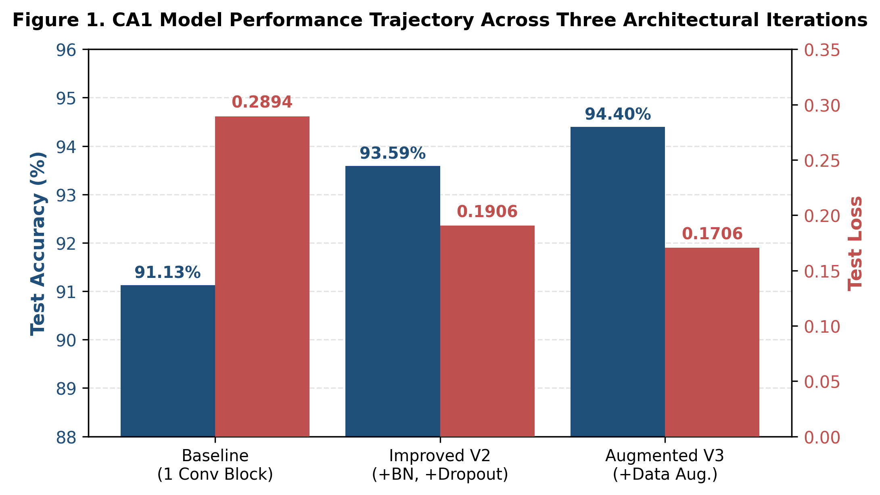
Figure 1. Historical CA1 model-performance trajectory used to motivate the Part C investigation (source: CA1 coursework).

1.2 Motivation for CBAM
Standard convolution does not explicitly create input-dependent weights that decide which feature channels or spatial locations should be emphasised. Attention mechanisms address this by recalibrating learned feature maps. CBAM is a lightweight module that applies channel attention followed by spatial attention (Woo et al., 2018). This mechanism is relevant to I–L recognition because the decision may depend on subtle endpoints or a short base stroke rather than on the dominant vertical stem.
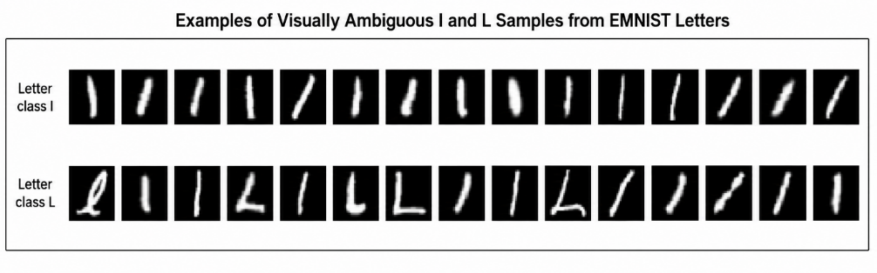
Figure 2. Representative I and L samples illustrating the visual ambiguity of low-resolution handwriting (source: CA1 dataset samples).

1.3 Research Questions and Contribution
- To what extent does integrating CBAM improve CNN-based EMNIST Letters classification, particularly for the visually ambiguous I and L classes?
- Does CBAM remain beneficial when combined with the stronger CA1 V3 data-augmentation strategy?
The contribution of this paper is empirical rather than purely theoretical: it reviews CBAM and related work, implements CBAM in the CA1 V2/V3 backbone, performs two controlled comparisons, evaluates overall and class-specific metrics, and inspects remaining I–L errors qualitatively.

2. Related Work

2.1 EMNIST and Standard CNNs
EMNIST extends the MNIST format to handwritten letters and other characters while retaining 28×28 grayscale images (Cohen et al., 2017). CNNs remain a strong baseline for offline HCR because convolutional filters learn local edges, corners and stroke combinations. However, repeated pooling and low spatial resolution can weaken fine details that distinguish similar letters.

2.2 Squeeze-and-Excitation Networks
Hu, Shen and Sun (2018) introduced Squeeze-and-Excitation (SE) blocks, which perform input-dependent channel recalibration. Global average pooling summarises each channel and a small bottleneck network predicts channel weights. SE establishes the channel-attention foundation that CBAM extends, but it does not explicitly determine where an informative feature occurs.

2.3 Convolutional Block Attention Module
Woo et al. (2018) proposed CBAM, which combines channel and spatial attention sequentially. The channel module uses both global average and max pooling, while the spatial module aggregates across channels and applies a 7×7 convolution to produce a two-dimensional attention map. CBAM improved several natural-image benchmarks with modest parameter overhead, but those results do not establish that the same gains transfer to 28×28 handwritten letters.
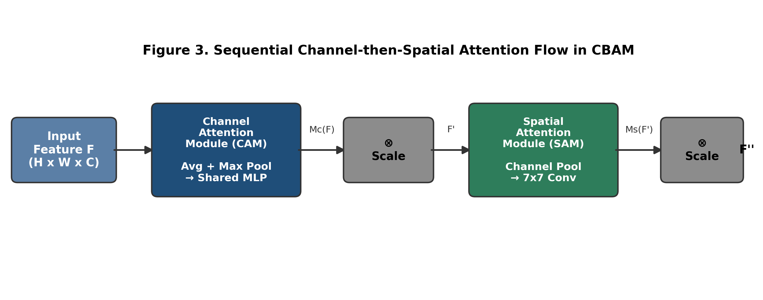
Figure 3. Sequential channel-then-spatial attention flow in CBAM, adapted from Woo et al. (2018).

2.4 Attention in Handwritten Character Recognition
Wu et al. (2023) incorporated a modified cross-stage CBAM (C-CBAM) into Reconstructed SqueezeNext for offline handwritten Chinese character recognition. Their reported results showed a 1.04 percentage-point increase in top-1 accuracy with a 1.21% parameter increase. This is relevant evidence that channel-spatial attention can support stroke-level discrimination, but the dataset differs substantially from EMNIST in resolution, character complexity and number of classes.
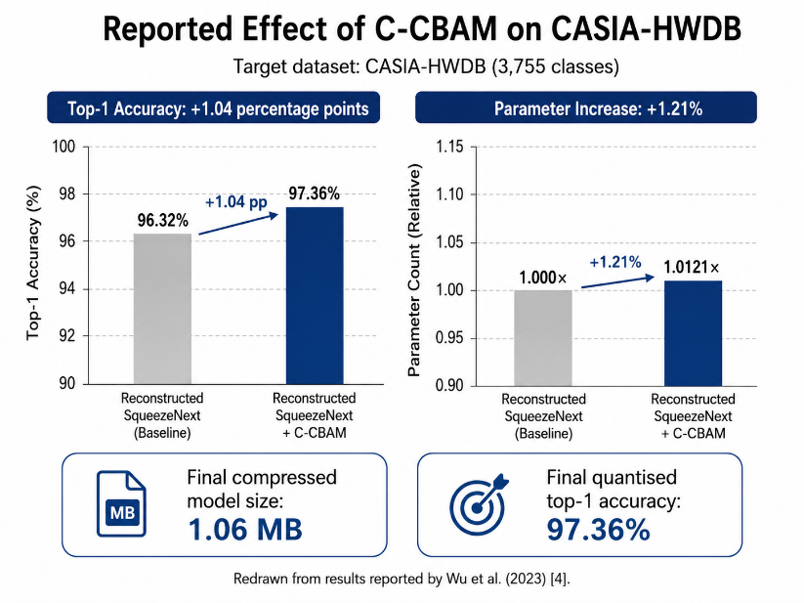
Figure 4. Reported effect of C-CBAM on CASIA-HWDB, redrawn from Wu et al. (2023).

3. Dataset and Experimental Setup

3.1 Data Cleaning and Preprocessing
The same EMNIST Letters CSV pipeline used in CA1 was reproduced. Invalid labels outside 1–26 were removed, duplicate rows were dropped, and labels were converted to zero-based indices 0–25. The cleaned dataset contained 88,798 samples. Each 784-element pixel vector was reshaped to 28×28, transposed to correct orientation, expanded to 28×28×1, and normalised from [0,255] to [0,1]. No horizontal flip was applied during preprocessing.
A stratified 70%/15%/15% train-validation-test split was created using random seed 88, producing 62,158 training samples, 13,320 validation samples and 13,320 test samples. The same split was used for every Part C model so that model comparisons used identical unseen test images.

3.2 Control Backbone and Training
The V2 control uses three convolutional layers with 32, 64 and 128 filters, Batch Normalisation, two MaxPooling layers, a 256-unit dense layer, Dropout 0.4 and a 26-way softmax output. Both V2 models use Adam with learning rate 0.0005, categorical cross-entropy, batch size 128, a maximum of 20 epochs and Early Stopping on validation loss with patience 4.
V3 uses the same network architecture but trains on augmented batches. The augmentation settings are rotation range 5°, zoom 0.1, width shift 0.1, height shift 0.1, horizontal_flip=False and fill_mode="nearest". Validation and test data are not augmented. V3 training uses the same optimiser, learning rate and batch size, with Early Stopping patience 3.

4. CBAM Technical Methodology

4.1 Channel Attention Module
The Channel Attention Module (CAM) determines which feature channels are most important for the current input image.
For a feature tensor , each of the channels can be viewed as a different learned feature detector. Some channels may respond strongly to vertical strokes, edges or endpoints, while others may contain less useful information for a particular character.
CAM first compresses each channel into a single value using two operations:
- Global average pooling, which measures the overall strength of a feature across the whole image
- Global max pooling, which captures the strongest response within that channel
These two channel descriptors are passed through the same small two-layer multilayer perceptron (MLP). Their outputs are added together and passed through a sigmoid function to produce the channel-attention weights .
The original feature tensor is then multiplied by these weights: F′=Mc​(F)⊗F
Channels given larger weights are strengthened, while less useful channels are suppressed. In the context of EMNIST Letters, this allows the network to place greater emphasis on feature channels that respond to useful stroke information, such as a vertical stem or a small endpoint. Average pooling captures the overall presence of such features, while max pooling helps retain strong local responses that might otherwise be weakened when averaged across the entire feature map.

4.2 Spatial Attention Module
The Spatial Attention Module (SAM) determines where the most important information is located within the feature map.
After channel attention produces the refined feature tensor F′, SAM compresses the channel dimension in two ways. Average pooling across channels summarises the overall activation at each spatial location, while maximum pooling across channels keeps the strongest feature response at each location.
These two operations produce two two-dimensional maps of size H × W. The maps are concatenated and passed through a 7 × 7 convolution followed by a sigmoid activation to generate the spatial attention map Ms(F′).
The spatially refined output is: F″ = Ms(F′) ⊗ F′
Each value in the spatial attention map acts as a weight for a particular location. Regions assigned larger weights are emphasised, while less informative regions are suppressed.
For EMNIST Letters, SAM could therefore place greater emphasis on small spatial details that help distinguish visually similar characters. For example, an L may contain a short base stroke near the lower part of the image, while an I may contain different terminal or vertical-stroke characteristics.
However, SAM can only emphasise information that is already present in the feature maps. If a distinguishing stroke is extremely faint, missing or lost because of the low 28 × 28 resolution, spatial attention cannot reconstruct that missing information.

4.3 Integration into the CA1 CNN
CBAM was inserted after each Batch Normalisation layer in the three convolutional feature blocks. The underlying V2/V3 backbone was otherwise kept unchanged, ensuring that CBAM remained the main architectural difference between the compared models. The V2 Baseline and V3 Augmented models each contain 1,280,154 parameters, while their CBAM variants contain 1,286,076 parameters, an increase of only 5,922 parameters (0.463%). This controlled design allows the effect of the attention mechanism to be evaluated without substantially changing the original CNN architecture.

5. Experimental Results

5.1 Experiment 1: V2 Baseline vs V2 + CBAM
Experiment 1 isolates the architectural effect of attention without data augmentation. Both models converged to similar validation regions, but CBAM did not produce a sustained validation advantage.
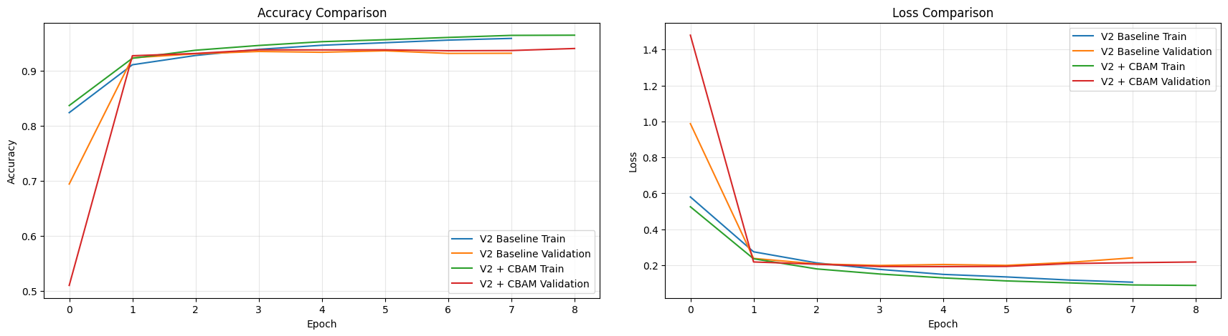
Figure 5. V2 Baseline and V2 + CBAM training/validation accuracy and loss.
Metric | V2 Baseline | V2 + CBAM | Change
Test accuracy (%) | 93.9489 | 93.7988 | −0.1501 pp
Test loss | 0.1929 | 0.1922 | −0.0007
Macro F1 | 0.9392 | 0.9379 | −0.0013
I recall | 0.8541 | 0.7879 | −0.0662
L recall | 0.6719 | 0.7461 | +0.0742
I→L errors | 62 | 95 | +33
L→I errors | 155 | 121 | −34
Total I↔L errors | 217 | 216 | −1
Training time (s) | 158.80 | 365.73 | +130.3%

CBAM slightly lowered overall accuracy and macro F1. Its clearest effect was directional: L recall improved and L→I errors fell by 34, but I recall declined and I→L errors rose by 33. Total I↔L errors changed by only one, so CBAM redistributed the confusion rather than meaningfully reducing it. The parameter increase was small, but observed training time more than doubled.

5.2 Experiment 2: V3 Augmented vs V3 + CBAM
Experiment 2 tests whether augmentation and attention are complementary. Both models used the same augmentation pipeline, so CBAM remained the main architectural difference.
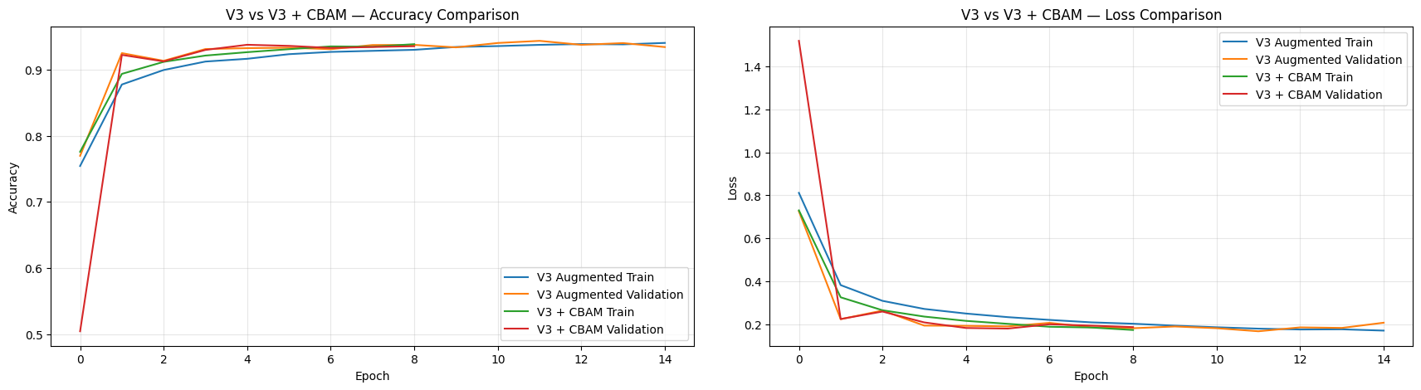
Figure 6. V3 Augmented and V3 + CBAM training/validation accuracy and loss.
Metric | V3 Augmented | V3 + CBAM | Change
Test accuracy (%) | 94.4294 | 94.0766 | −0.3528 pp
Test loss | 0.1552 | 0.1698 | +0.0146
Macro F1 | 0.9443 | 0.9405 | −0.0038
I recall | 0.7724 | 0.6829 | −0.0895
L recall | 0.7520 | 0.8281 | +0.0761
I→L errors | 103 | 148 | +45
L→I errors | 117 | 78 | −39
Total I↔L errors | 220 | 226 | +6
Training time (s) | 342.31 | 460.91 | +34.6%

V3 Augmented remained stronger: it had higher accuracy and macro F1 and lower loss. CBAM again improved L recall but reduced I recall, with I→L errors increasing by 45 while L→I errors decreased by 39. Unlike Experiment 1, total I↔L confusion increased by six errors. The same directional pattern across both experiments suggests that CBAM altered the decision balance between I and L rather than resolving their ambiguity.

5.3 Final Four-Model Comparison
Model | Acc. % | Loss | Macro F1 | I→L | L→I | Total I↔L | Params | Time (s)
V2 Baseline | 93.9489 | 0.1929 | 0.9392 | 62 | 155 | 217 | 1,280,154 | 158.80
V2 + CBAM | 93.7988 | 0.1922 | 0.9379 | 95 | 121 | 216 | 1,286,076 | 365.73
V3 Augmented | 94.4294 | 0.1552 | 0.9443 | 103 | 117 | 220 | 1,280,154 | 342.31
V3 + CBAM | 94.0766 | 0.1698 | 0.9405 | 148 | 78 | 226 | 1,286,076 | 460.91

V3 Augmented achieved the highest test accuracy (94.43%), lowest loss (0.1552) and highest macro F1 (0.9443). V2 + CBAM achieved the lowest total I↔L error count, but only by one error compared with V2 Baseline. Better overall classification therefore did not necessarily correspond to the smallest error count for one specific class pair.
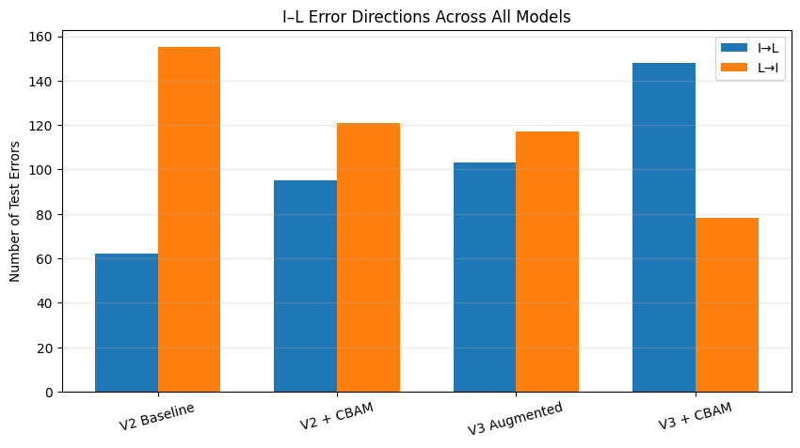
Figure 7. Directional I–L errors across all four controlled models.

5.4 Class-Level Results and Failure-Case Analysis
The full classification reports confirm that CBAM had mixed class-specific effects. For V2, I precision improved from 0.7232 to 0.7500 but I recall fell from 0.8541 to 0.7879; L recall improved from 0.6719 to 0.7461 while L precision fell from 0.8269 to 0.7748. For V3, I precision increased from 0.7505 to 0.8032 but I recall fell from 0.7724 to 0.6829; L recall increased from 0.7520 to 0.8281. G and Q also showed small mixed changes, reinforcing that the attention effect was class-dependent rather than uniformly positive.
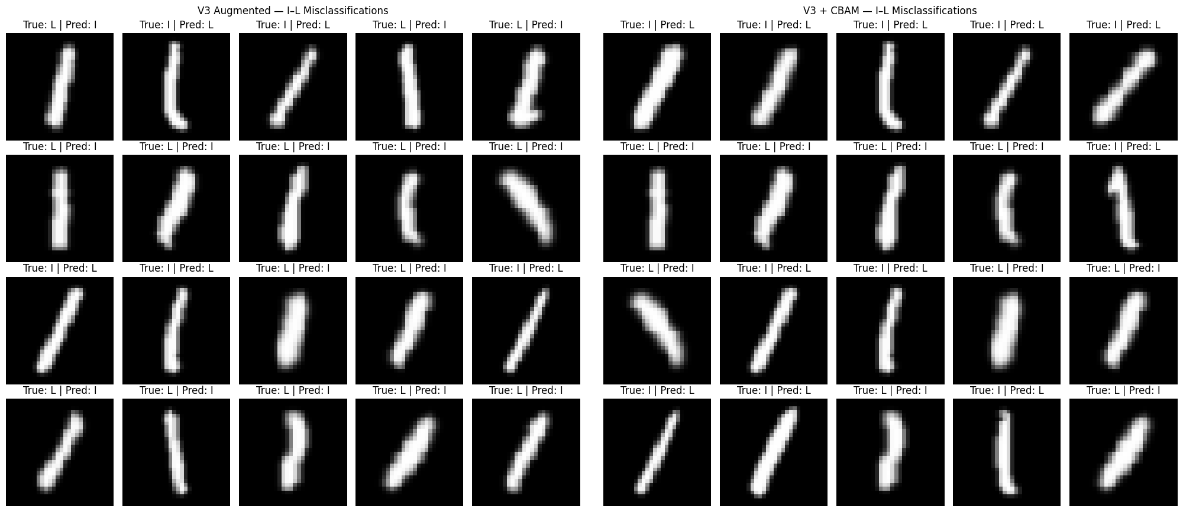
Figure 8. Representative remaining I–L errors for V3 Augmented and V3 + CBAM.
Many errors contain only a single narrow vertical or slanted stroke. Some L samples have a weak or extremely short base stroke, while some I samples are curved or angled. Several examples are difficult even for a human observer to distinguish confidently. CBAM can reweight visible features, but it cannot recover discriminative stroke information that is absent or barely represented in a 28×28 image.

5.5 Multi-Seed Robustness Check
Sections 5.1-5.4 report results from a single training run per model (seed 88). To test whether the observed CBAM effect reflects a genuine pattern rather than one training run's random weight initialisation and batch ordering, all four models were retrained from scratch across three seeds (42, 88 and 123). The train/validation/test split (Section 3.1) was kept identical across seeds so every run was evaluated on the same unseen test images; only weight initialisation and training-batch shuffling varied.

V2 Baseline vs V2 + CBAM (mean ± std, n = 3 seeds)
Metric | V2 Baseline | V2 + CBAM | Change
Test accuracy (%) | 93.89 ± 0.08 | 93.88 ± 0.30 | −0.01 pp
Test loss | 0.195 ± 0.002 | 0.186 ± 0.008 | −0.009
Macro F1 | 0.939 ± 0.001 | 0.939 ± 0.003 | 0.000
I→L errors | 85.3 ± 22.5 | 100.0 ± 15.1 | +14.7
L→I errors | 134.0 ± 24.6 | 119.7 ± 8.1 | −14.3
Total I↔L errors | 219.3 ± 6.8 | 219.7 ± 7.2 | +0.4

V3 Augmented vs V3 + CBAM (mean ± std, n = 3 seeds)
Metric | V3 Augmented | V3 + CBAM | Change
Test accuracy (%) | 94.48 ± 0.23 | 94.28 ± 0.24 | −0.20 pp
Test loss | 0.159 ± 0.004 | 0.166 ± 0.003 | +0.007
Macro F1 | 0.945 ± 0.002 | 0.943 ± 0.003 | −0.002
I→L errors | 115.7 ± 23.7 | 124.3 ± 28.3 | +8.6
L→I errors | 103.3 ± 19.5 | 95.7 ± 24.8 | −7.6
Total I↔L errors | 219.0 ± 5.6 | 220.0 ± 5.2 | +1.0

Per-Seed Directional Errors for the CBAM Models
Seed | V2+CBAM I→L | V2+CBAM L→I | V3+CBAM I→L | V3+CBAM L→I
42 | 88 | 127 | 132 | 85
88 | 95 | 121 | 148 | 78
123 | 117 | 111 | 93 | 124
The multi-seed results confirm the central finding rather than overturning it. Total I↔L errors stayed within a narrow band of approximately 219-220 for all four models across every seed, so CBAM did not reduce the overall I-L confusion in either experiment once training-run variance is accounted for. Overall accuracy and macro F1 also showed no meaningful CBAM benefit on average: the V2 accuracy gap (−0.01 pp) is far smaller than the seed-to-seed spread, and the V3 gap (−0.20 pp) is of a similar size to that spread rather than clearly exceeding it.
The directional redistribution effect was highly consistent for V2: I→L errors increased with CBAM in all three seeds (87→88, 62→95, 107→117), and L→I errors fell in two of three seeds and were essentially unchanged in the third. For V3, the same direction (I→L up, L→I down) held for seeds 42 and 88 but reversed at seed 123 (I→L fell from 143 to 93, L→I rose from 81 to 124). This indicates that the V3+CBAM directional effect, while present in the majority of seeds, is less stable than the V2+CBAM effect and is itself sensitive to training randomness — a nuance that a single-seed comparison could not reveal.

6. Discussion

6.1 Why CBAM Did Not Produce a Consistent Gain
The results do not support a general claim that CBAM improves this EMNIST configuration. The module is designed to emphasise informative existing features, not create new information. In low-resolution handwriting, the relevant serif or base stroke may already be weak, clipped or visually indistinguishable. Attention may therefore strengthen a useful cue in some samples while shifting the decision boundary unfavourably in others.
A second factor is diminishing returns. V2 already contains Batch Normalisation, multiple convolutional layers and Dropout, while V3 additionally exposes the model to realistic geometric variation. The V3 baseline therefore begins from a stronger representation. The failure of V3 + CBAM to outperform V3 suggests that channel-spatial recalibration was not automatically complementary with augmentation in this setting.

6.2 Relationship to Published Evidence
Woo et al. (2018) reported that CBAM improved performance on large natural-image datasets, while Wu et al. (2023) found benefits from a CBAM-related method in handwritten Chinese character recognition.
However, these results cannot be expected to transfer directly to EMNIST Letters because the datasets are very different. EMNIST images are only 28×28 pixels, and difficult pairs such as I and L may differ by only a very small stroke. In some samples, that distinguishing stroke is weak or almost absent. CBAM can help the network emphasise useful features that are already present, but it cannot create missing visual information. This helps explain why CBAM was successful in previous studies but did not consistently improve the models in this experiment.
The main lesson is that an attention mechanism should be tested on the specific dataset and task rather than assuming that improvements reported on other datasets will automatically occur on EMNIST.
6.3 Computational Trade-off
CBAM increased the parameter count by only 0.463%, confirming that it is lightweight in model size. However, observed training time increased from 158.80 s to 365.73 s in the V2 comparison and from 342.31 s to 460.91 s in the V3 comparison. These times should be interpreted as end-to-end observed runtimes rather than pure per-step overhead because Early Stopping can produce different numbers of completed epochs. Even so, the experiments show that parameter count alone does not capture the practical computational cost of repeated pooling, small MLP operations, spatial convolution and feature-map multiplication.

6.4 Limitations and Threats to Validity
- The main experiments were evaluated across only three random seeds (Section 5.5); this confirmed the redistribution pattern but is still too few seeds to support formal statistical significance testing, and a larger number of seeds would give tighter confidence in the size of the effect, particularly for the noisier V3 comparison.
- Only one main CBAM placement and configuration was tested; the reduction ratio, spatial kernel and placement were not exhaustively tuned.
- The experiments were conducted on 28×28 grayscale EMNIST images, limiting the amount of spatial detail available to attention.
- Some I and L images are inherently ambiguous or contain weak distinguishing strokes, creating an information limit that architecture alone may not overcome.
- Observed training time depends on the hardware/software environment and the number of epochs completed before Early Stopping.

7. Conclusion

7.1 Research Question 1
To what extent does integrating CBAM improve CNN-based EMNIST Letters classification, particularly for the visually ambiguous I and L classes?
The answer is negative overall, with class-specific effects. In the V2 experiment, CBAM reduced accuracy from 93.95% to 93.80% and macro F1 from 0.9392 to 0.9379. Total I↔L confusion changed only from 217 to 216 errors. L→I errors decreased, but I→L errors increased almost equally. CBAM therefore did not meaningfully resolve I–L confusion; it mainly redistributed the direction of the errors. This redistribution was confirmed across three random seeds (Section 5.5): I→L errors rose with CBAM in every seed tested, while total I↔L errors stayed within a narrow band regardless of CBAM, so the single-seed result was not an artefact of one training run.

7.2 Research Question 2
Does CBAM remain beneficial when combined with the stronger CA1 V3 data-augmentation strategy?
No. V3 Augmented achieved 94.43% accuracy, 0.1552 loss and 0.9443 macro F1. Adding CBAM reduced accuracy to 94.08%, increased loss to 0.1698, reduced macro F1 to 0.9405 and increased total I↔L errors from 220 to 226. V3 Augmented therefore remained the strongest overall model. Across three seeds this direction held on average, though less consistently than in Experiment 1: the same I→L-up/L→I-down pattern appeared in two of three seeds but reversed at seed 123, indicating the V3+CBAM interaction is more sensitive to training randomness than the V2+CBAM effect.

7.3 Final Insight and Future Work
The main finding is that adding a more advanced attention mechanism does not automatically improve an already effective CNN. In this experiment, data augmentation was the more successful improvement: V3 Augmented achieved the strongest overall test accuracy, lowest test loss and highest macro F1. In contrast, CBAM did not improve overall generalisation in either controlled comparison.
However, the CBAM experiments were still informative. CBAM consistently changed the class-specific decision behaviour by reducing L→I errors while increasing I→L errors. The failure-case analysis further showed that many remaining errors contained weak or ambiguous distinguishing strokes, suggesting that feature attention alone cannot recover visual information that is barely present in the original 28×28 image.
Therefore, the main lesson from this project is that architectural improvements should be evaluated empirically rather than assumed to be beneficial. A negative result can still provide useful evidence by showing what changed, what failed, and why the proposed improvement may not suit the specific dataset.
This project has already repeated the experiments across three random seeds (Section 5.5); the pattern held for V2 but was less stable for V3, so a useful next step would be extending this to five or more seeds, particularly for the V3 comparison, to obtain a tighter estimate of the effect size. Future work could also compare channel-only, spatial-only and full CBAM, test alternative attention placements and hyperparameters, and use Grad-CAM or attention-map visualisation to examine which stroke regions influence the predictions.
References
- Cohen, G., Afshar, S., Tapson, J. and van Schaik, A. (2017) ‘EMNIST: Extending MNIST to handwritten letters’, 2017 International Joint Conference on Neural Networks (IJCNN), pp. 2921–2926. doi: 10.1109/IJCNN.2017.7966217.
- Hu, J., Shen, L. and Sun, G. (2018) ‘Squeeze-and-Excitation Networks’, Proceedings of the IEEE Conference on Computer Vision and Pattern Recognition (CVPR), pp. 7132–7141. doi: 10.1109/CVPR.2018.00745.
- Thawdar Lin Wai (2026) ‘CA1: Regularised and Augmented CNN Architectures for EMNIST Letters Classification’, unpublished coursework report, Singapore Polytechnic.
- Woo, S., Park, J., Lee, J.-Y. and Kweon, I.S. (2018) ‘CBAM: Convolutional Block Attention Module’, Proceedings of the European Conference on Computer Vision (ECCV), pp. 3–19.
- Wu, R., Zhou, F., Li, N., Liu, X. and Wang, R. (2023) ‘Reconstructed SqueezeNext with C-CBAM for offline handwritten Chinese character recognition’, PeerJ Computer Science, 9, e1529. doi: 10.7717/peerj-cs.1529.

