1. Problem Statement

The problem we are trying to solve is to make a movie website that allows user to register, login view and search movie, TV and actor and actress. First of all, the main page lists marked movies by this user. After login, user should be able to search movie, TV shows or people by their names. For the movie, if the user goes to the movie tab from the main page, the user can see the list of popular movies, and the user can choose any movie to see the details of this movie. Then the user should be able to add this particular movie to their favorite movie list. Besides, the user should also be able to make comments on this particular movie. And this is for the movie.

As for the TV shows and people, the user can do the same thing like searching, seeing the details, adding to favorite list and make comments on the particular TV shows or people.

And for the additional work, add a group tag. This tag can show the most popular movies.

1. Proposed Solution

For the login, we make a local database that can store the information of the user’s name and password.

For the building of our website, we user API we find online and use it in our project. And after that we parser the Json file and pass it to the class, and then later show it on the website.

For adding the favorite one and the commending on a movie, we also store the input by the user into our local database.

And for the additional work, we add a group tag, which can be accessed into the list, showing the ten most popular movies, TV shows or people based the users’ choices of popular movies, TV shows and people.

3. Architecture:

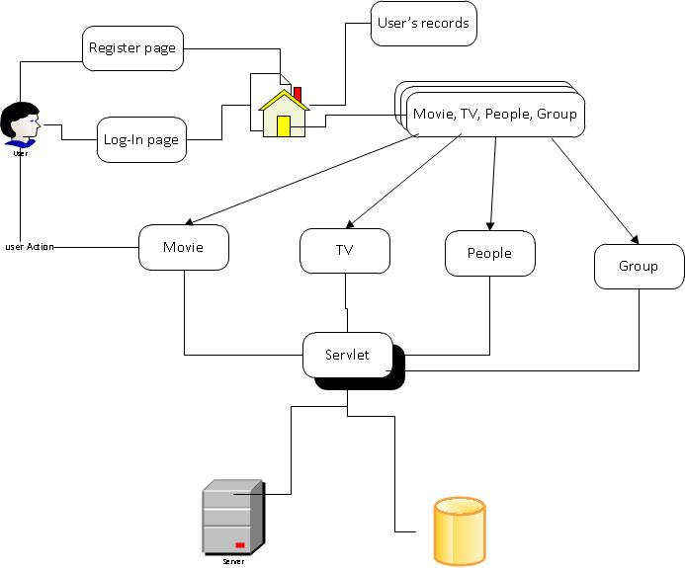

Our project contains six packages, user, movie, TV, people, comment, group.

4. APIs

Movies

* Latest Movies

http://api.themoviedb.org/3/movie/latest?api_key=cb308fc308a03542532cff9b7c2ed4d9

* Upcoming Movies

http://api.themoviedb.org/3/movie/ Upcoming?api_key=cb308fc308a03542532cff9b7c2ed4d9

* Now playing movies

http://api.themoviedb.org/3/movie/ now_playing?api_key=cb308fc308a03542532cff9b7c2ed4d9

* Popular Movies

http://api.themoviedb.org/3/movie/ popular?api_key=cb308fc308a03542532cff9b7c2ed4d9

* Top rated Movies

http://api.themoviedb.org/3/movie/ top_rated?api_key=cb308fc308a03542532cff9b7c2ed4d9

TVs

* Latest TVs

http://api.themoviedb.org/3/tv/latest?api_key=cb308fc308a03542532cff9b7c2ed4d9

* Currently on the air TVs

http://api.themoviedb.org/3/tv/on_the_air?api_key=cb308fc308a03542532cff9b7c2ed4d9

* Air today TVs

http://api.themoviedb.org/3/tv/airing_today?api_key=cb308fc308a03542532cff9b7c2ed4d9

* Top rated TVs

http://api.themoviedb.org/3/tv/top_rated?api_key=cb308fc308a03542532cff9b7c2ed4d9

* Popular TVs

http://api.themoviedb.org/3/tv/popular?api_key=cb308fc308a03542532cff9b7c2ed4d9

Search

* Search movie by movie name

http://api.themoviedb.org/3/search/movie?api_key=cb308fc308a03542532cff9b7c2ed4d9

* Search TV by TV name

http://api.themoviedb.org/3/search/tv?api_key=cb308fc308a03542532cff9b7c2ed4d9

* Search actor/actress by name

http://api.themoviedb.org/3/search/person?api_key=cb308fc308a03542532cff9b7c2ed4d9

5. Technology stack

Operating System: Mac Ox, Windows8

Server: Apache Tomcat 7.0

DateBase: MySql 5.1

Language: Java, JSP, Sql, Html, CSS

IDE: Eclipse, MySqlWorkBench

6. User Cases

* **Use Case**: Register New User [Register]

**Description**: User wants to create a new user account

**Precondition**: This user haven’t created an account before

**Actors**: User

**Steps**:

* [User] – submits information
* [MTS] – creates a new user account

**Post condition**: none

**Alternate paths**:

* [User] – submits information but this user account exits
* [MTS] – message: You have registered already.
* [MTS] – jumps to user log in page
* **Use Case**: User Login [Login]

**Description**: User login to user account

**Precondition**:

* User account exits
* Pass word is correct

**Actors**: User

**Steps**:

* [User] – submits user name and pass word
* [MTS] – displays user information

**Post condition**: none

**Alternate paths**:

* [User] – submits user name and pass word but user account doesn’t exit
* [MTS] – jumps to register page
* [User] – submits user name and password but password is incorrect
* [MTS] – error message: Password is incorrect
* [MTS] – jumps to user login page
* **Use Case: User mark a Favorites Movie [MarkFavoriteMovie]**

**Description**: user mark a movie as favorite and save this movie in user information page

**Precondition**: user has logged in

**Actors**: user

**Steps**:

* [User] – marks a favorite movie
* [MTS] – displays this movie in favorites movies list in user information page

**Post condition**: none

**Alternate paths**:

* [User] – marks a favorite movie, but user doesn’t login
* [MTS] – jumps to user login page
* **Use Case: User mark a Favorites TV [MarkFavoriteTV]**

**Description**: user mark a TV show as favorite and save this movie in user information page

**Precondition**: user has logged in

**Actors**: user

**Steps**:

* [User] – marks a favorite TV show
* [MTS] – displays this TV show in favorites TVs list in user information page

**Post condition**: none

**Alternate paths**:

* [User] – marks a favorite TV show, but user doesn’t login
* [MTS] – jumps to user login page
* **Use Case**: View popular movies

**Description**: User wants to view brief description of all of popular movies

**Precondition**: None

**Actors**: User

**Steps**:

* [User] – Click the movie tag
* [MTS] – Displays brief description of popular movies

**Post condition**: None

**Alternate paths**: None

* **Use Case**: View top rated

**Description**: User wants to view brief description of all of top rated movies which are voted by users.

**Precondition**: None

**Actors**: User

**Steps**:

* [User] – Click the top rated tag
* [MTS] – Displays brief description of all of top rated movies which are voted by users.

**Post condition**: None

**Alternate paths**: None

* **Use Case**: View upcoming movie

**Description**: User wants to view brief description of upcoming movies which will be on show recently.

**Precondition**: None

**Actors**: User

**Steps**:

* [User] – Click the upcoming tag
* [MTS] – Displays brief description of upcoming movies which will be on show recently.

**Post condition**: None

**Alternate paths**: None

* **Use Case**: View now-playing movie

**Description**: User wants to view brief description of movies which are on show now.

**Precondition**: None

**Actors**: User

**Steps**:

* [User] – Click the now-playing tag
* [MTS] – Displays brief description of movies which are on show now.

**Post condition**: None

**Alternate paths**: None

* **Use Case**: View popular actor

**Description**: User wants to view brief introduction of actors.

**Precondition**: None

**Actors**: User

**Steps**:

* [User] – Click the actor tag
* [MTS] – Displays brief introduction of famous actors

**Post condition**: None

**Alternate paths**: None

* **Use Case**: search movies

**Description**: User wants to search some movies by their names or by actors of the movies.

**Precondition**: None

**Actors**: User

**Steps**:

* [User] – Input movie names or actors’ name of movies.
* [MTS] – Displays brief description of all movies that are related to inputs of users.

**Post condition**: None

**Alternate paths**:

* [User] – Input movie names or actors’ name of movies.
* [MTS] –Displays error message that no related movies found!
* **Use Case**: View popular TV shows

**Description**: User wants to view the brief description of all of popular TV shows

**Precondition**: None

**Actors**: User

**Steps**:

* [User] – Click the TV shows tag
* [MTS] – Displays brief description of popular TV shows

**Post condition**: None

**Alternate paths**: None

* **Use Case**: View top rated

**Description**: User wants to view the brief description of all of top rated TV shows which are voted by users.

**Precondition**: None

**Actors**: User

**Steps**:

* [User] – Click the top rated tag
* [MTS] – Displays brief description of all of top rated TV shows which are voted by users.

**Post condition**: None

**Alternate paths**: None

* **Use Case**: View on-the-air TV shows

**Description**: User wants to view brief description of TV shows which are on the air now.

**Precondition**: None

**Actors**: User

**Steps**:

* [User] – Click the on-the-air tag
* [MTS] – Displays brief description of TV shows which are on the air now.

**Post condition**: None

**Alternate paths**: None

* **Use Case**: View airing-today TV shows

**Description**: User wants to view brief description of TV shows which will be airing today.

**Precondition**: None

**Actors**: User

**Steps**:

* [User] – Click the airing-today tag
* [MTS] – Displays brief description of TV shows which will be airing today.

**Post condition**: None

**Alternate paths**: None

* **Use Case**: search TV shows

**Description**: User wants to search some TV shows by their names or by actors of the TV shows.

**Precondition**: None

**Actors**: User

**Steps**:

* [User] – Input TV shows’ names or actors’ name of TV shows.
* [MTS] – Displays brief description of all TV shows that are related to inputs of users.

**Post condition**: None

**Alternate paths**:

* [User] – Input TV shows’ names or actors’ name of TV shows.
* [MTS] –Displays error message that no related TV shows found!
* **Use Case**: search Actors

**Description**: User wants to search some actors by their names.

**Precondition**: None

**Actors**: User

**Steps**:

* [User] – Input actors’ name.
* [MTS] – Displays brief description of all movies and TV shows that are related to inputs of users.

**Post condition**: None

**Alternate paths**:

* [User] –Input actors’ name.
* [MTS] –Displays error message that no related actors found!

7. UML Diagram

