Bidirectional inverter Control HW Design Report

Part number：
Date: 2026/09/30
Author: Yoram. Zhang

1. Overall System Architecture

The entire system’s hardware consists of three major components: the main power circuit,
the control circuit, and the auxiliary power supply circuit. As shown in picture 1

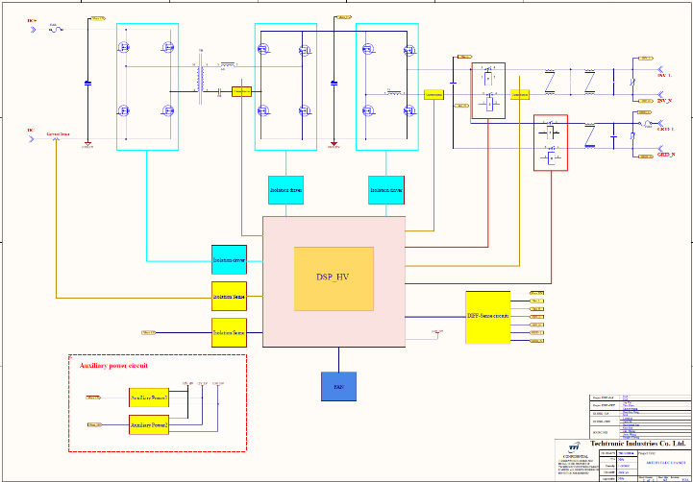

- Main power circuit
Bidirectional inverters enable bidirectional energy flow, it can run in inverter mode converting electricity energy from dc bus into AC power for output, also run in charge mode external AC power into DC power to charge the energy storage unit on the DC side. Main power topology, in discharge mode is full bridge LLC boost combine full bridge inverter output sinewave voltage, in charge mode is no bridge full bridge combine full bridge LLC buck output dc voltage.
- Control circuit
Bidirectional inverters use DSP (tms320f2800137) control, in discharge DSP control LLC boost and full bridge inverter, in charge mode DSP control no bridge PFC and full bridge LLC.
- Auxiliary power supply circuit
Control circuits, signal conditioning circuits, driver circuits, communication circuits, and other components in the system circuit all require corresponding power supplies, including P12V for the PWM driver circuit, P5V for the PFC signal conditioning circuit, and P3.3V for the control circuit.

2. LLC Boost Principal Analysis
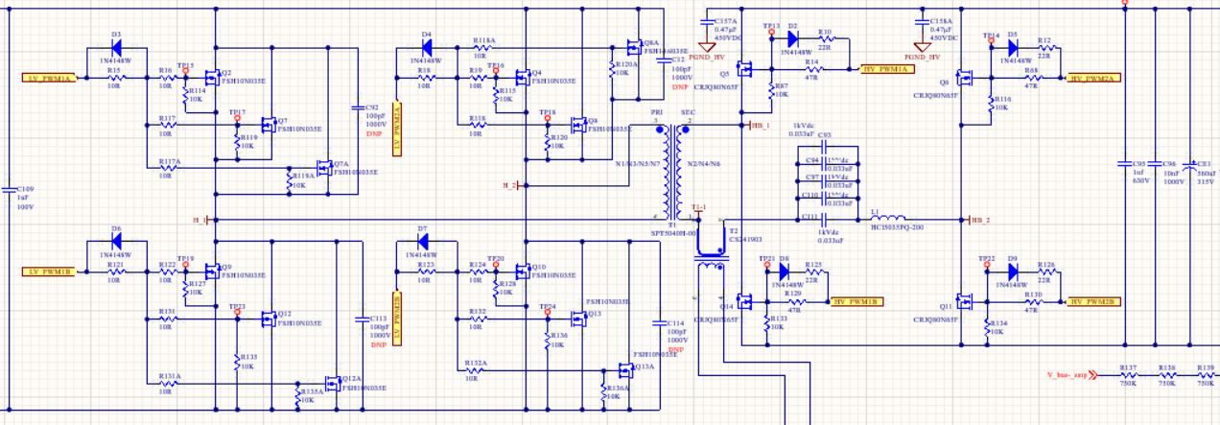

In LLC Boost state Q2 Q4 Q9 Q10

