**foodpanda analyst takehome test**

### Part 1 - SQL

To work on these questions two .csv files have been provided. Please ensure you have these files before proceeding:

1. orders.csv
2. vendors.csv

You may wish to study the data in both datasets carefully before attempting the exercise. We recommend loading the datasets on a BigQuery sandbox (<https://cloud.google.com/bigquery/docs/sandbox>) as an environment for you to write and test your queries.

Please provide SQL queries (saved as a PDF) to answer the following questions. Expected answers are provided for reference.

#### 1 - List all the orders that were made in Taiwan

Expected answer:

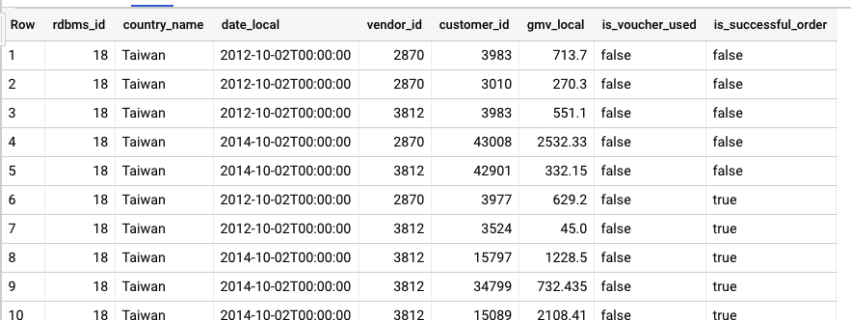

#### 2 - Find the Total GMV by country

Expected answer:

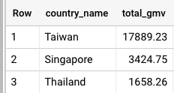

#### 3 - Find the top active vendor by GMV in each country

Expected answer:

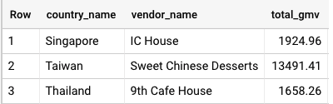

#### 4 - Find the top 2 vendors per country, in each year available in the dataset

Expected answer:

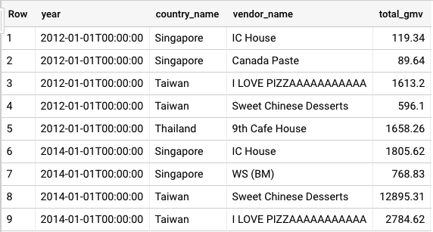

### Part 2 - Data visualisation

* Have a look at the New New York Subway public Dataset.xlsx. You should have the following tables.
  + subway_ridership_2013_present
  + station
  + route
* The subway company would like to test out ticket pay rise for 2019, please provide the following delivering:
  + A dashboard with mainly a map for illustrating the ridership of different stations in 2018.
  + An analysis of the historical ridership of different routes, and suggest which 3 routes could be pioneering for the pay raise. You are expected to provide the % amount of increase with clear reasonings backed up.
  + Try to think out of the box! Including other relevant datasets for further deep dive will be a plus.
* Send the final workbook (tableau public or data studio public link) together with a PDF export and be prepared to do a 15 minutes presentation on that workbook onsite/via call
* Tips
  + Download Tableau Desktop (<https://public.tableau.com/en-us/s/>) or utilize Google Data Studio for this visualization exercise
  + Create a story/dashboard(s) using Tableau or Data Studio (<https://onlinehelp.tableau.com/current/pro/desktop/en-us/stories.html>)
  + If you have a trial version of Tableau desktop, you could download the necessary tables as csv files and use them locally. Save your file as twbx to include the data tables in your file.
  + If you’re using data studio, please make sure the dashboard view settings is set to public