Deep Learning HW1

Zeng Yueran 1002207

1. Why split class-wise?

Because we need to ensure that there exists training (and validation and testing) samples for each class. Otherwise if we random split on the whole dataset, the accuracy will be low if missing training samples for a particular class. Also, splitting class-wise will also ensure that the dataset is balance—the number of samples are the same for each class, so that we are able to train binary SVMs.

1. 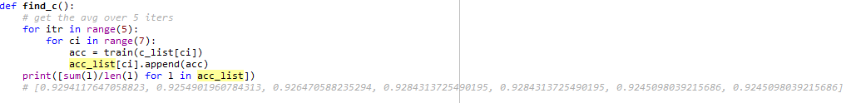Selection of C

Attached is the function to find C. Iterate 5 times for each C and compute the average of the accuracy. The highest accuracy obtained is when C=0.01, with accuracy of 0.929.

|  |  |
| --- | --- |
| Value of C | Accuracy |
| 0.01 | 0.9294117647058823 |
| 0.1 | 0.9254901960784313 |
| 0.1^0.5 | 0.926470588235294 |
| 1 | 0.9284313725490195 |
| 10^0.5 | 0.9284313725490195 |
| 10 | 0.9245098039215686 |
| 100^0.5 | 0.9245098039215686 |

1. Failed cases

The following is the confusion matrix of the test set

For instance, when we look at the first row, 17 samples are classified correctly, while 3 samples are classified wrongly (1 is classified in class 7, 2 are in class 13).

The overall accuracy on the test set is 93.8%

