Deep learning coding homework

Zeng Yueran 1002207

Training loss over 50 epochs:

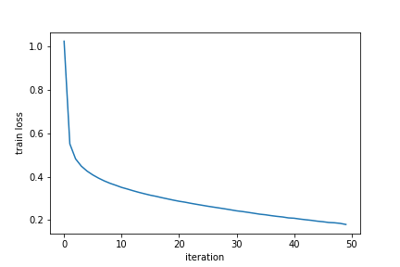

Validation loss over 50 epochs:

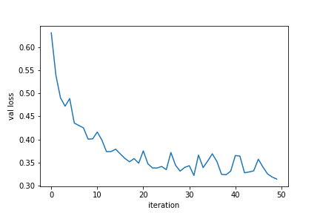

Accuracy averaged over all classes: 89.16%

Ranking of by class-wise accuracy:

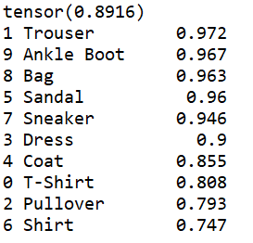

Hardest class to predict is Shirt, easiest is trouser