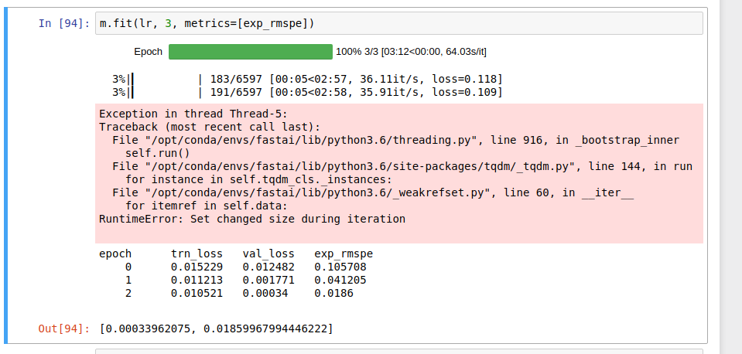

1. Understand the timing

64.03s/it: one epoch of 6597 iterations takes 64.03 seconds
36.11it/s: 36.11 iterations done in one second
6597: one epoch contains 6597 iterations, one iteration for each mini batch

2. Install Spacy for lesson 4 and 5:

in the fastai virt env:

conda install spacy
python3 -m spacy download en
3. Restart the jupyter notebook may help on some cases, such as when you see the following:
