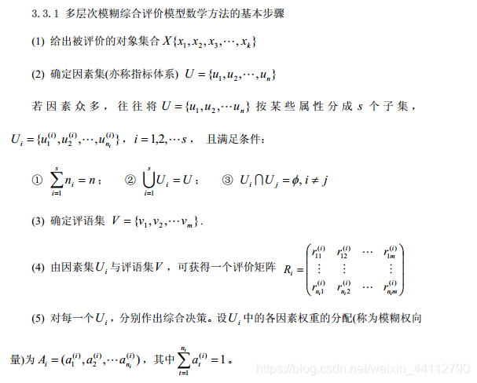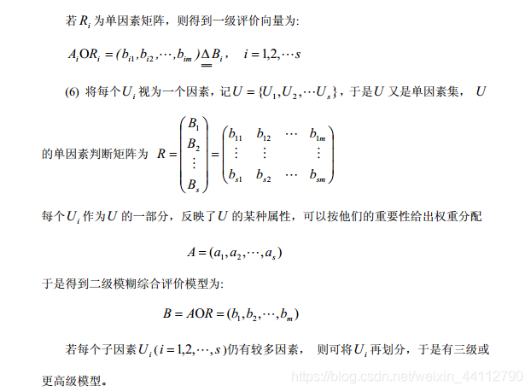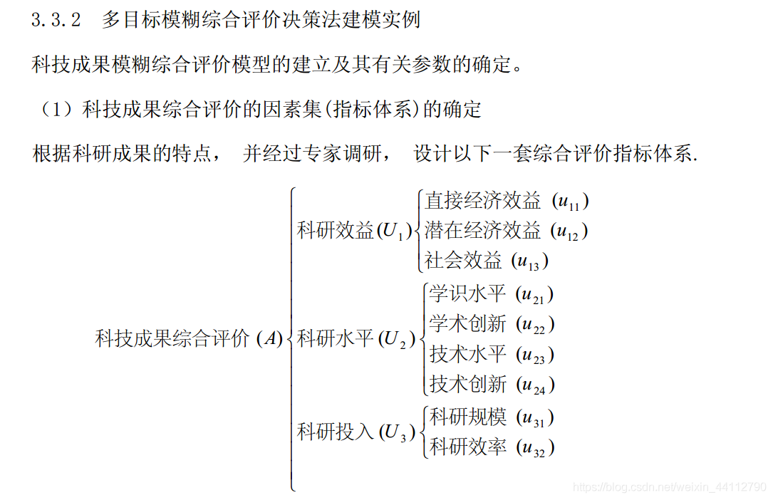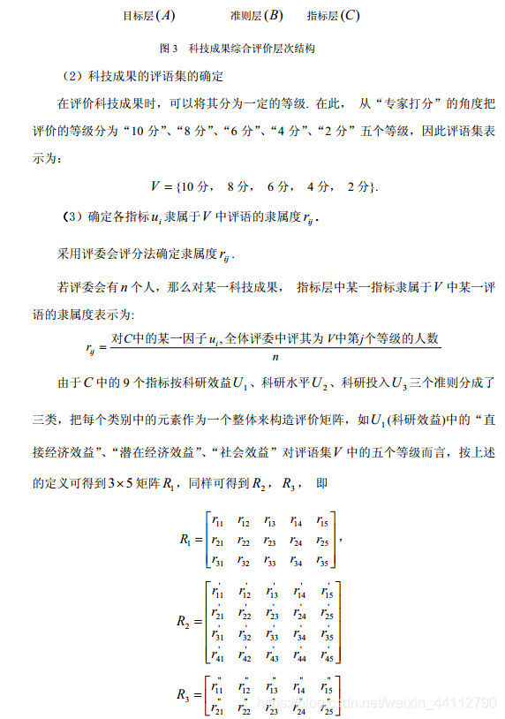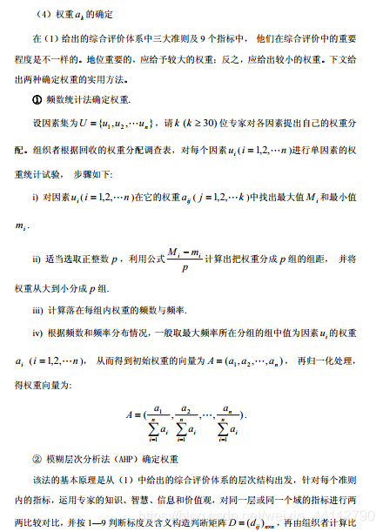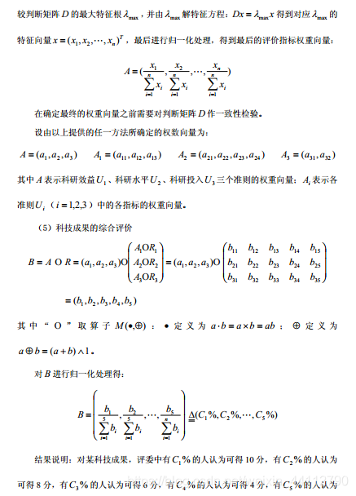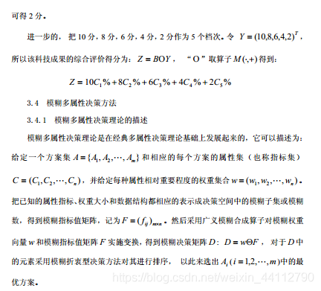

代码

具体实现

权重 ak 的确定

频数统计法确定权重

算法理论
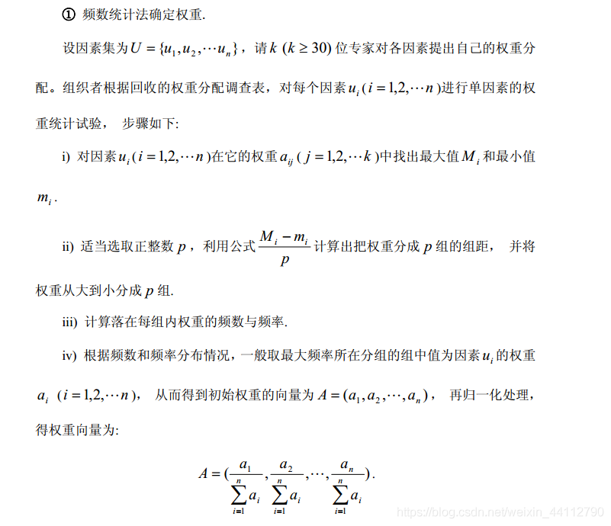
算法代码：

def frequency(matrix,p):
'''
频数统计法确定权重
:param matrix: 因素矩阵
:param p: 分组数
:return: 权重向量
'''
A = np.zeros((matrix.shape[0]))
for i in range(0, matrix.shape[0]):
## 根据频率确定频数区间列表
row = list(matrix[i, :])
maximum = max(row)
minimum = min(row)
gap = (maximum - minimum) / p
row.sort()
group = []
item = minimum
while(item < maximum):
group.append([item, item + gap])
item = item + gap
print(group)
## 初始化一个数据字典，便于记录频数
dataDict = {}
for k in range(0, len(group)):
dataDict[str(k)] = 0
## 判断本行的每个元素在哪个区间内，并记录频数
for j in range(0, matrix.shape[1]):
for k in range(0, len(group)):
if(matrix[k, j] >= group[k][0]):
dataDict[str(k)] = dataDict[str(k)] + 1
break
print(dataDict)
## 取出最大频数对应的key，并以此为索引求组中值
index = int(max(dataDict,key=dataDict.get))
mid = (group[index][0] + group[index][1]) / 2
print(mid)
A[i] = mid
A = A / sum(A[:]) ## 归一化
return A

模糊层次分析法确定权重

算法理论

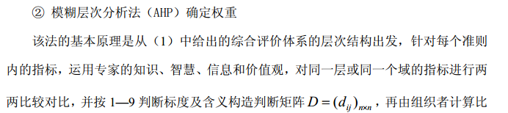
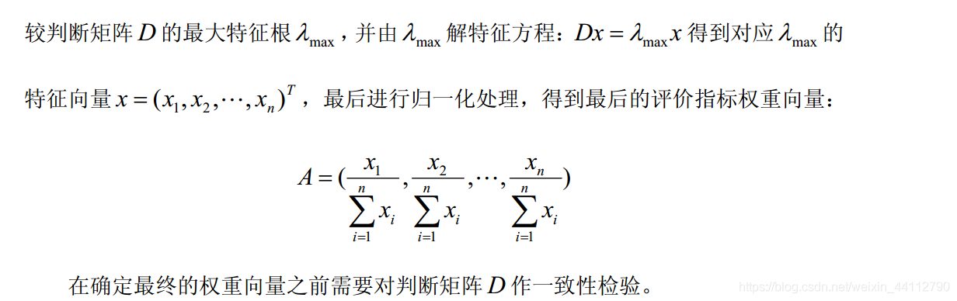
def AHP(matrix):
if isConsist(matrix):
lam, x = np.linalg.eig(matrix)
return x[0] / sum(x[0][:])
else:
print("一致性检验未通过")
return None

def isConsist(matrix):
'''
:param matrix: 成对比较矩阵
:return: 通过一致性检验则返回true，否则返回false
'''
n = np.shape(matrix)[0]
a, b = np.linalg.eig(matrix)
maxlam = a[0].real
CI = (maxlam - n) / (n - 1)
RI = [0, 0, 0.58, 0.9, 1.12, 1.24, 1.32, 1.41, 1.45]
CR = CI / RI[n-1]
if CR < 0.1:
return True, CI, RI[n-1]
else:
return False, None, None

综合评价

算法理论
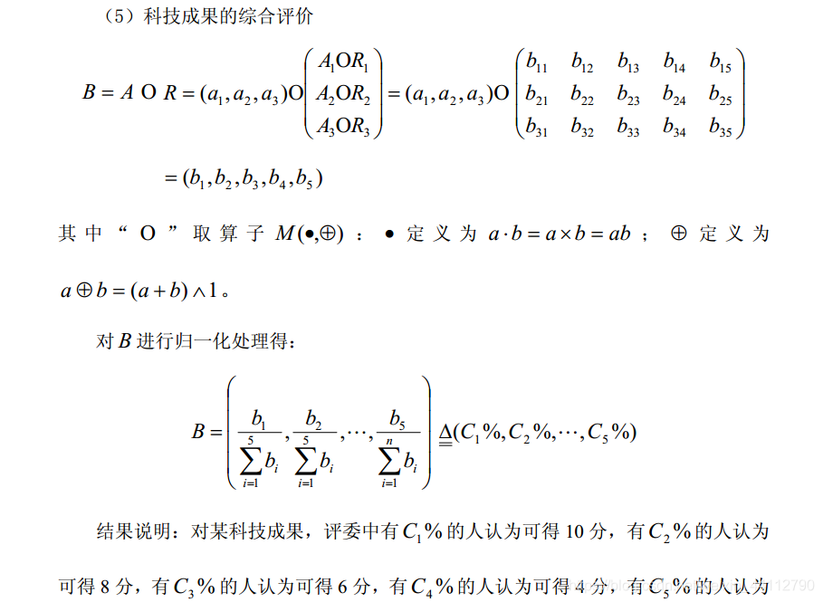

算法代码

def appraise(criterionMatrix, targetMatrixs, relationMatrixs):
'''
:param criterionMatrix: 准则层权重矩阵
:param targetMatrix: 指标层权重矩阵列表
:param relationMatrixs: 关系矩阵列表
:return:
'''
R = np.zeros((criterionMatrix.shape[1], relationMatrixs[0].shape[1]))
for index in range(0, len(targetMatrixs)):
row = mul_mymin_operator(targetMatrixs[index], relationMatrixs[index])
R[index] = row
B = mul_mymin_operator(criterionMatrix, R)
return B / sum(B[:])

