匈牙利算法python代码：

from scipy.optimize import linear_sum_assignment

cost =np.array([[4,1,3],[2,0,5],[3,2,2]])
row_ind,col_ind=linear_sum_assignment(cost)
print(row_ind)#开销矩阵对应的行索引
print(col_ind)#对应行索引的最优指派的列索引
print(cost[row_ind,col_ind])#提取每个行索引的最优指派列索引所在的元素，形成数组
print(cost[row_ind,col_ind].sum())#数组求和

# 输出：
# [0 1 2]
# [1 0 2]
# [1 2 2]
# 5

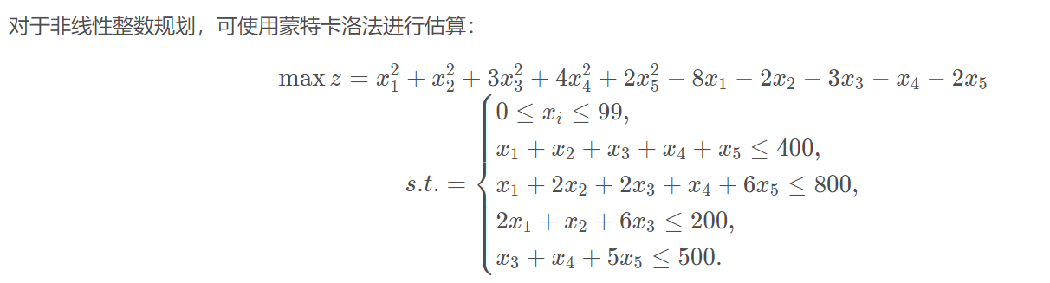
求解的Python代码

import numpy as np

def check(x):
if x.sum() > 400:
return False
if x[0]+2*x[1]+2*x[2]+x[3]+6*x[4] > 800:
return False
if 2*x[0]+x[1]+6*x[2]>200:
return False
if x[2]+x[3]+5*x[3]>200:
return False

return True

def get_radom():
x = np.random.randint(100, size=5)
while not check(x):
x = get_radom()
return x

lim = 10**6
ans = -1

for i in range(lim):
num = get_radom()
ans = max(ans, num.all())
if i % 10000 == 0:
print(i)

print('ans=' + ans)

