# NM2207

Session 02

Assignment

Overview of what we’ll do today:

* Code up a webpage with HTML form elements

1. Watch and code along with the HTML Forms and Formatting Forms with Tables in HTML videos from my colleague Prof. Jen Golbeck at Maryland, shared with permission:

1. <https://www.youtube.com/watch?v=c5ugqp9rl-c&list=PLk_jmmkw5S2Dst2tllJx4RpMj0n7GWLLi&index=9&t=0s>
2. <https://www.youtube.com/watch?v=fWE2tvT929g&list=PLk_jmmkw5S2Dst2tllJx4RpMj0n7GWLLi&index=9>

These videos are intended to help you use your creativity to create a contact form as below in the index.html which is within the Session03.codealong folder. Ignore the styling in this image.

The two elements used in this form are input type=”text” and input type “selector”.

You can also add a radio button to ask them if they are married or not.

All of these elements are described here: <https://www.w3schools.com/html/html_forms.asp>

Fig 1. Form screenshot

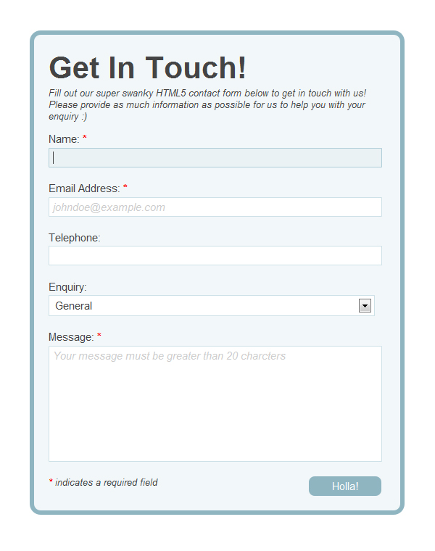

Fig.2 The different kinds of input elements

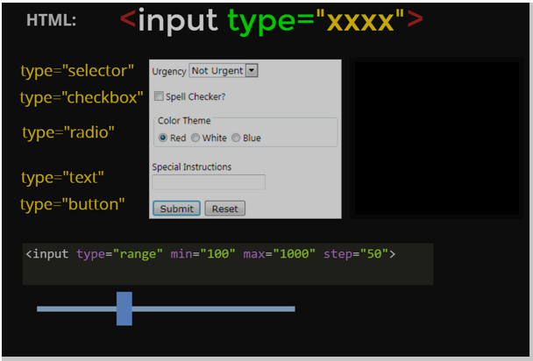

Part 2. Upload

When you are done with all the codealongs, upload Session02.assignment into FileZilla, and update the links on your homepage so that your tutor can find the homework. Make sure all the links work, and the photos are visible too!

If any of the links break, identify which one, and check the paths.

* If you have used absolute paths (e.g. paths starting with “C:”) then you need to use relative paths instead
* If you have used relative paths but something is still breaking, then your files are not where you expect them to be. Before reaching out with screenshots, please check each path manually. Your tutor will have to do the same.