
https://www.inc.com/geoffrey-james/3-entrepreneur-veterans-explain-how-military-experience-is-good-for-business.html

- Swiss elite in 20th century: closed, protectionist, informal agreements.
- Strong right-wing parties, business orgs facilitated self-organization.
- Informal contracting bypassed federal state, reducing bureaucracy.
- Informal consensus between bank and business CEOs smoothed tensions.
- Pre-1990s elite profile: Swiss men with military service, right-wing affiliation.
- Military experience facilitated informal interactions, national cohesion during Cold War.


https://ec.europa.eu/commission/presscorner/detail/en/ip_24_1508

- Globalization era blurs nation state and capital boundaries, including Switzerland.
- Since late 20th century, decrease in top managers with military rank.
- Rise in importance of international education, especially MBA, and work experience in global financial centers.
- Trend perceived ambiguously by Swiss political and economic centers of power.
- In 2007, clause limiting foreigners on boards repealed.
- Switzerland's evolution reflects alignment with neoliberal capitalism of early 21st century.

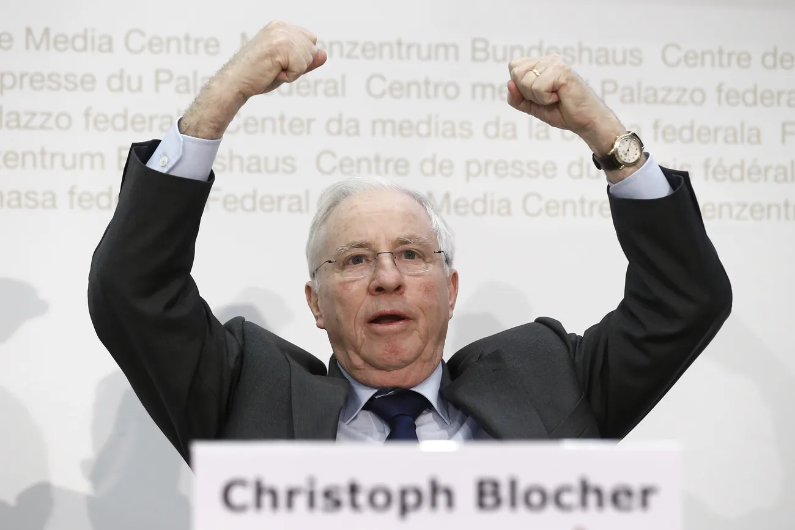
https://www.swissinfo.ch/eng/politics/is-the-swiss-people-s-party-far-right/48995330

- Since 1990s, industry-financier consensus weakened, giving way to political instruments.
- Parliamentary phase gains importance over informal bargaining.
- Association of Small and Medium Enterprises, Swiss People’s Party criticize Economiesuisse for favoring banking/pharmaceutical sectors, high executive salaries.
- Populist right-wing parties gain traction, pressuring transparency in business operations.
- Cancelation of golden parachute rule for executives and victory of popular initiative against EU worker movement.

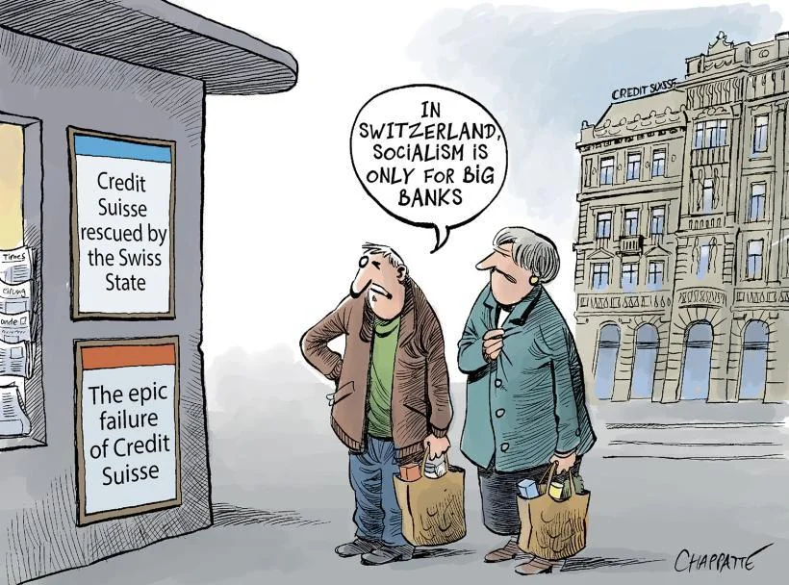

https://www.reddit.com/r/Switzerland/comments/11wfuo6/is_switzerland_turning_to_red/

- Credit Suisse's collapse in March 2023 leads to merger with UBS, monopolizing Swiss banking sector.
- Concerns arise over monopoly bank in private hands, "too big to fail" principle, and nationalized debts.
- Swiss state may struggle to cover UBS's potential losses in bankruptcy; no bank large enough to buy it out.
- FINMA finds UBS bailout plans incomplete, deeming it "too big to be rescued."
- Takeover results in 16 billion Swiss francs worth of Credit Suisse bonds written off, impacting Swiss financial debt market.
- Conflicts weaken and split business elite, empowering formal public governance instruments.

