**Computer lab 1**

**Dynamics of Hodgkin-Huxley Model**

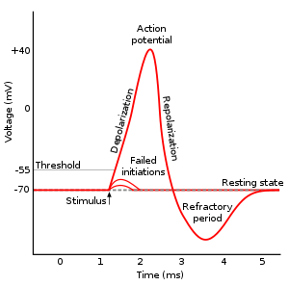Nearly all [cell membranes](https://en.wikipedia.org/wiki/Cell_membrane) in animals, plants, and fungi maintain a [voltage](https://en.wikipedia.org/wiki/Voltage) difference between the exterior and interior of the cell, called the [membrane potential](https://en.wikipedia.org/wiki/Membrane_potential). In some types of electrically active cells, including [neurons](https://en.wikipedia.org/wiki/Neuron) and muscle cells, the voltage fluctuations frequently take the form of a rapid upward (positive) spike followed by a rapid fall. **These up-and-down cycles are known as *action potentials*.**

There are two important levels of membrane potential:

* **the**[**resting potential**](https://en.wikipedia.org/wiki/Resting_potential), which is the value the membrane potential maintains as long as nothing perturbs the cell,
* **the**[**threshold potential**](https://en.wikipedia.org/wiki/Threshold_potential), Action potential are triggered when membrane potential reach the threshold value.

The course of the action potential can be divided into five parts:

* **the rising phase** (depolarization): the membrane potential depolarizes (becomes more positive).
* **the peak phase**: the membrane potential reaches a maximum.
* **the falling phase** (repolarization): the membrane potential becomes more negative, returning towards resting potential.
* [**afterhyperpolarization**](https://en.wikipedia.org/wiki/Afterhyperpolarization): the membrane potential temporarily becomes more negatively charged than when at rest.
* **the**[**refractory period**](https://en.wikipedia.org/wiki/Refractory_period_(physiology)): during which a subsequent action potential is impossible or difficult to fire

Voltage-gated ion channels are crucial in the generation of action potentials. The Hodgkin-Huxley model quantitively describes how the opening and closing of Na+, K+, and Cl- shape the action potential.

i. Implement an active point neuron model in NEURON (one section, one segment, hh1 channel); Give a constant current injection to trigger an action potential; Plot and describe how the current (INa, IK), state variables (m,h for Na+, **n for K+**) and the conductance (gNa, gK) evolve with time.

Parameter set (in default units of NEURON)

L=10 μm, diam=10μm, Ra=100 Ohm⋅cm, cm=1 Farads/cm2, hh1.gnabar=0.12 S/ cm2, hh1.gkbar=0.036 S/ cm2, hh1.gl=0.0003 S/ cm2

The amplitude of current injection I = 0.1 nA

ii. Use the dynamics of state variables to explain the mechanisms underlying the five phases of the action potential.

iii. Now there are three different protocols for current injection, the neuron will immediately generate an action potential when I0 is given (protocol A). What do you expect about the neuron’s response to protocol B and C? (e.g. the delay of action potentials when I0 is given) Check the results with NEURON and explain your findings from the aspect of the (in)activation of ion channels.

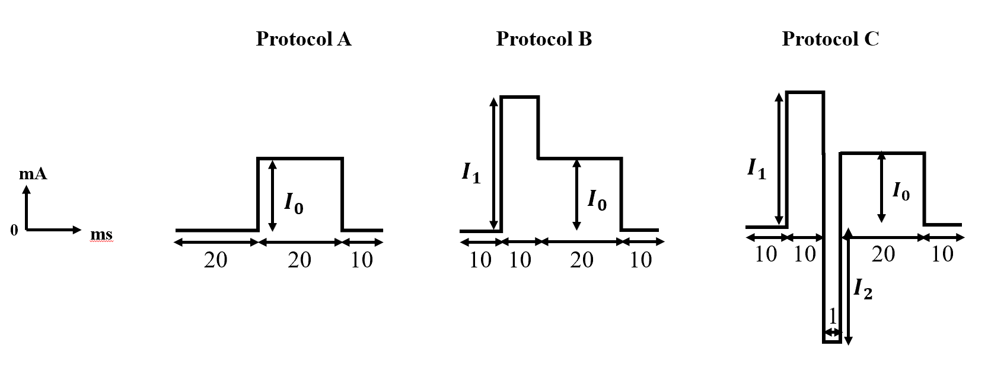

**nA**

Parameter set:

$$I_{0}=0.1 nA , { I}_{1}=1.0 nA, { I}_{2}=-1.0 nA$$

iv. **Calcium channels.** HH model only includes 3 types of ion channels Na+,K+,Cl-, however, [voltage-gated calcium channels](https://en.wikipedia.org/wiki/Voltage-gated_calcium_channel) are also activated when neurons fire action potentials. Experiments show that slow calcium spikes provide the driving force for a long burst of rapidly emitted sodium spikes. **T-type calcium channels** are [low-voltage](https://en.wikipedia.org/wiki/Low_voltage)-activated [calcium channels](https://en.wikipedia.org/wiki/Calcium_channel) found in the cardiac muscle cells and thalamus nerve cells. Add CaT channels to the HH model in question i; Plot and describe the voltage response of your model (like how the response differs from the original HH model’s); Interpret your finding from the aspect of the (in)activation of ion channels.

Parameter set: hh1.el=-65 mV (maybe you can explain why soma will spontaneously spike when hh1.el=-54.3 mV, if you have extra time)

v. **Fast spiking.** Give a stronger current injection ($I=0.5$) into the point neuron, does the neuron succeed in firing continuous action potentials? Explain the reason why the neuron succeeds/fails to generate spikes. Try to enable the model to generate fast spikes (shorter intervals between adjacent spikes) by modifying the parameters of hh1.mod, and explain why the modified model is fast-spiking.