Install software on laptop
- terminator
  - sudo apt install terminator
- vscode
  - sudo apt install ./code_1.77.3-1681292746_amd64.deb
  - https://code.visualstudio.com/docs/setup/linux
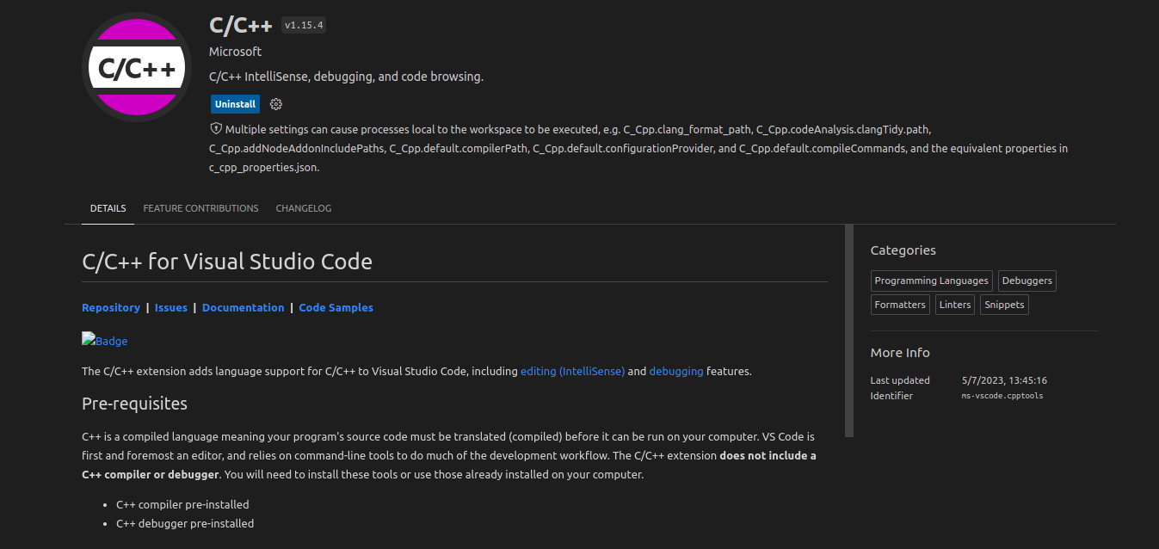
  - install c/c++ intellisense extension

- git gui
  - sudo apt install git-gui
- ifconfig
  - sudo apt install net-tools
- vnc viewer
  - sudo apt install ./VNC-Viewer-7.1.0-Linux-x64.deb

Install ROS Noetic
http://wiki.ros.org/noetic/Installation/Ubuntu

- to test if ros was install correctly : rosversion -d

Install required ros packages
- caktin_tools
  - sudo apt install python3-catkin-tools
  - to be able to use catkin build
- teleop_twist_keyboard
  - sudo apt install ros-noetic-teleop-twist-keyboard
  - http://wiki.ros.org/teleop_twist_keyboard

teleop commands
forward : (i)
- linear: x: 0.5
backward : (,)
- linear: x: -0.5
left : (j)
- angular: z: 1.0
right : (l)
- angular: z: -1.0
forward left : (u)
- linear: x: 0.5
- angular: z: 1.0
forward right : (o)
- linear : x: 0.5
- angular: z: -1.0
backward left : (m)
- linear: x: -0.5
- angular: z: -1.0
backward right : (.)
- linear: x: -0.5
- angular: z: 1.0

