# **Supplemental Figures** for “Towards a platform quantitative systems pharmacology (QSP) model for preclinical to clinical translation of antibody-drug conjugated (ADCs)”

Journal of Pharmacokinetics/Pharmacodynamics

Bruna Scheuher, Khem Raj Ghusinga, Kimiko McGirr, Maksymilian Nowak, Sheetal Panday, Joshua Apgar, Kalyanasundaram Subramanian and Alison Betts

Corresponding author: Alison Betts, Applied BioMath, 561 Virginia Road, Concord MA 01742  
Email: [alison.betts@appliedbiomath.com](mailto:alison.betts@appliedbiomath.com)

**Figure S1A: Schematic representation of the *in vitro* model**

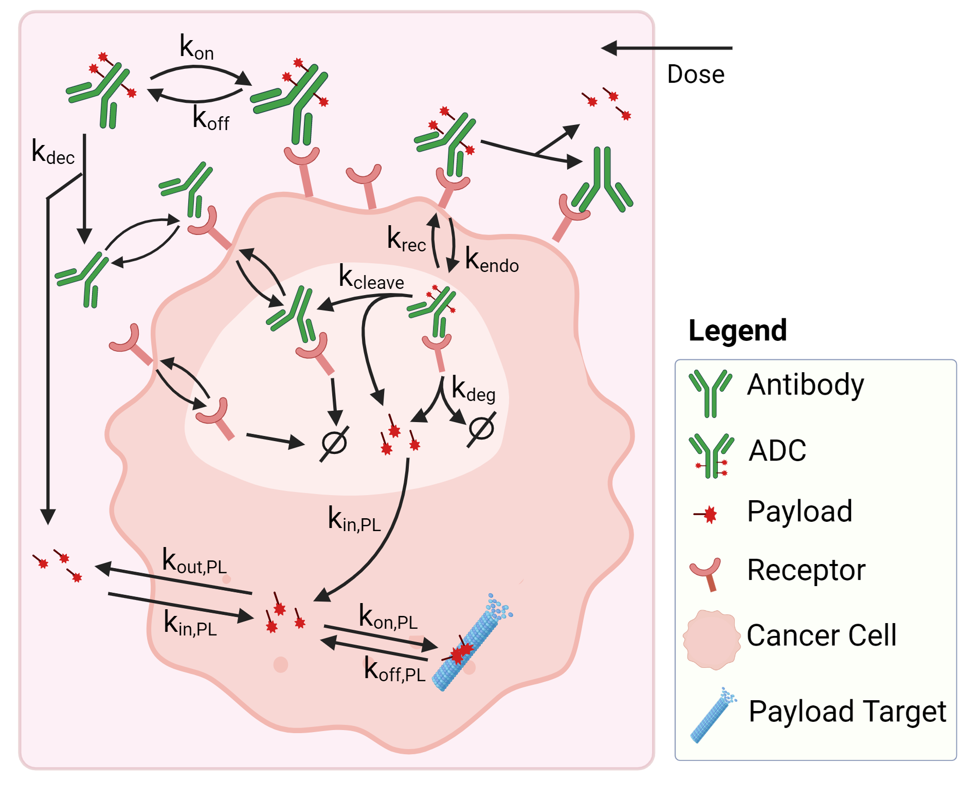

**Figure S1B: Observed (*symbols*) and in vitro model calibrated or predicted (*lines*) trastuzumab internalization data. (A)** Model calibration: 125I- trastuzumab was incubated (gray shaded area) with SK-BR-3 breast cancer cells and cell surface, dissociated, internalized and catabolized radioactivity was measured **(B)** Model validation: Trastuzumab was incubated with BT-474 cancer cells and internalized trastuzumab was measured

**(A) (B)**

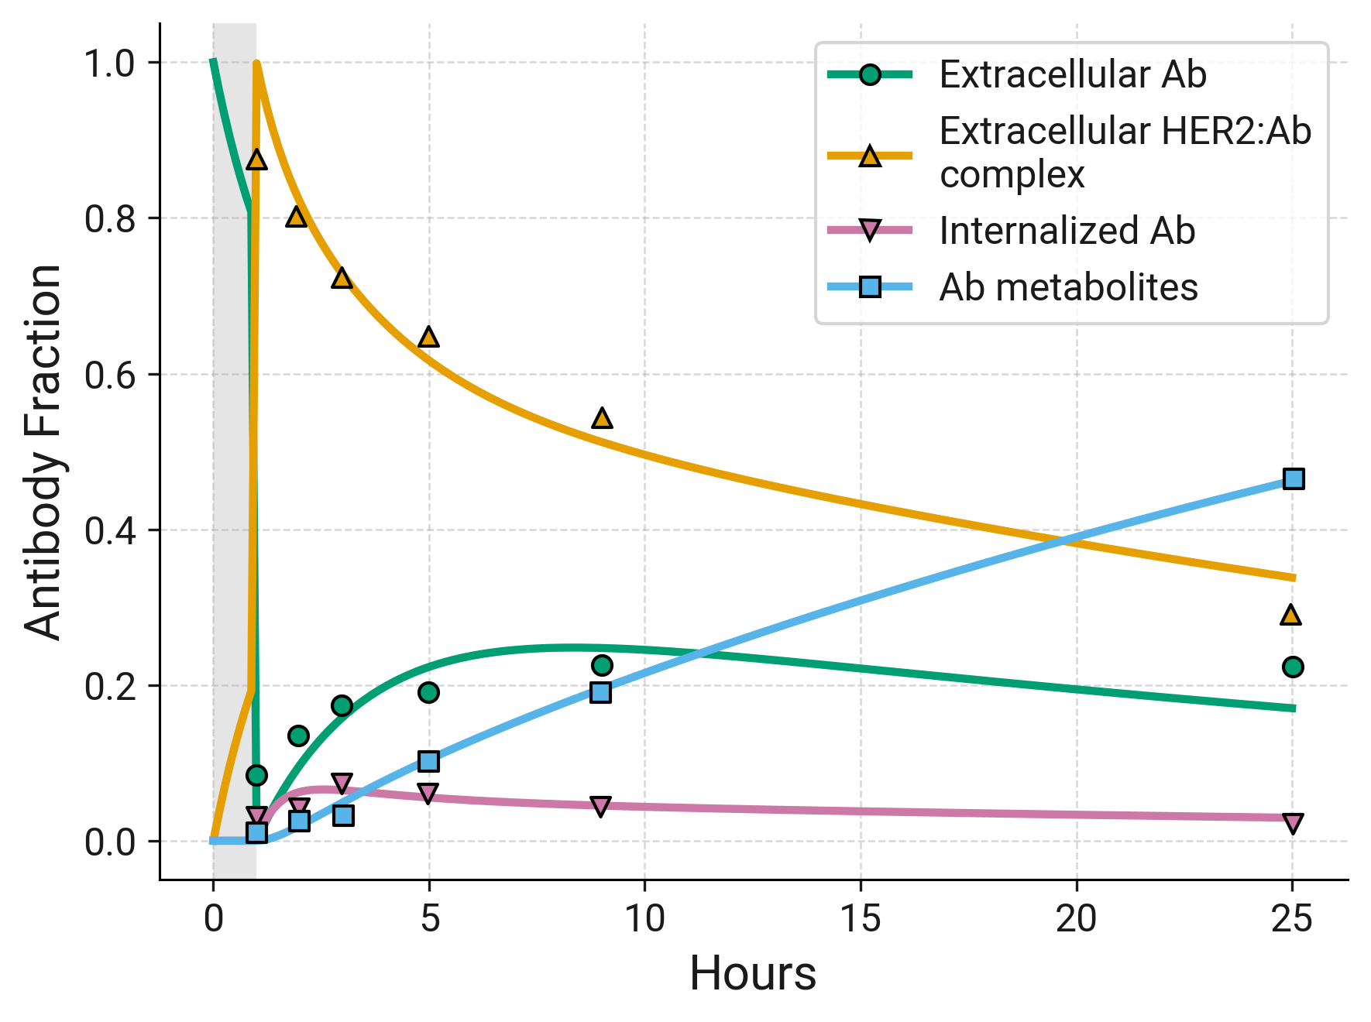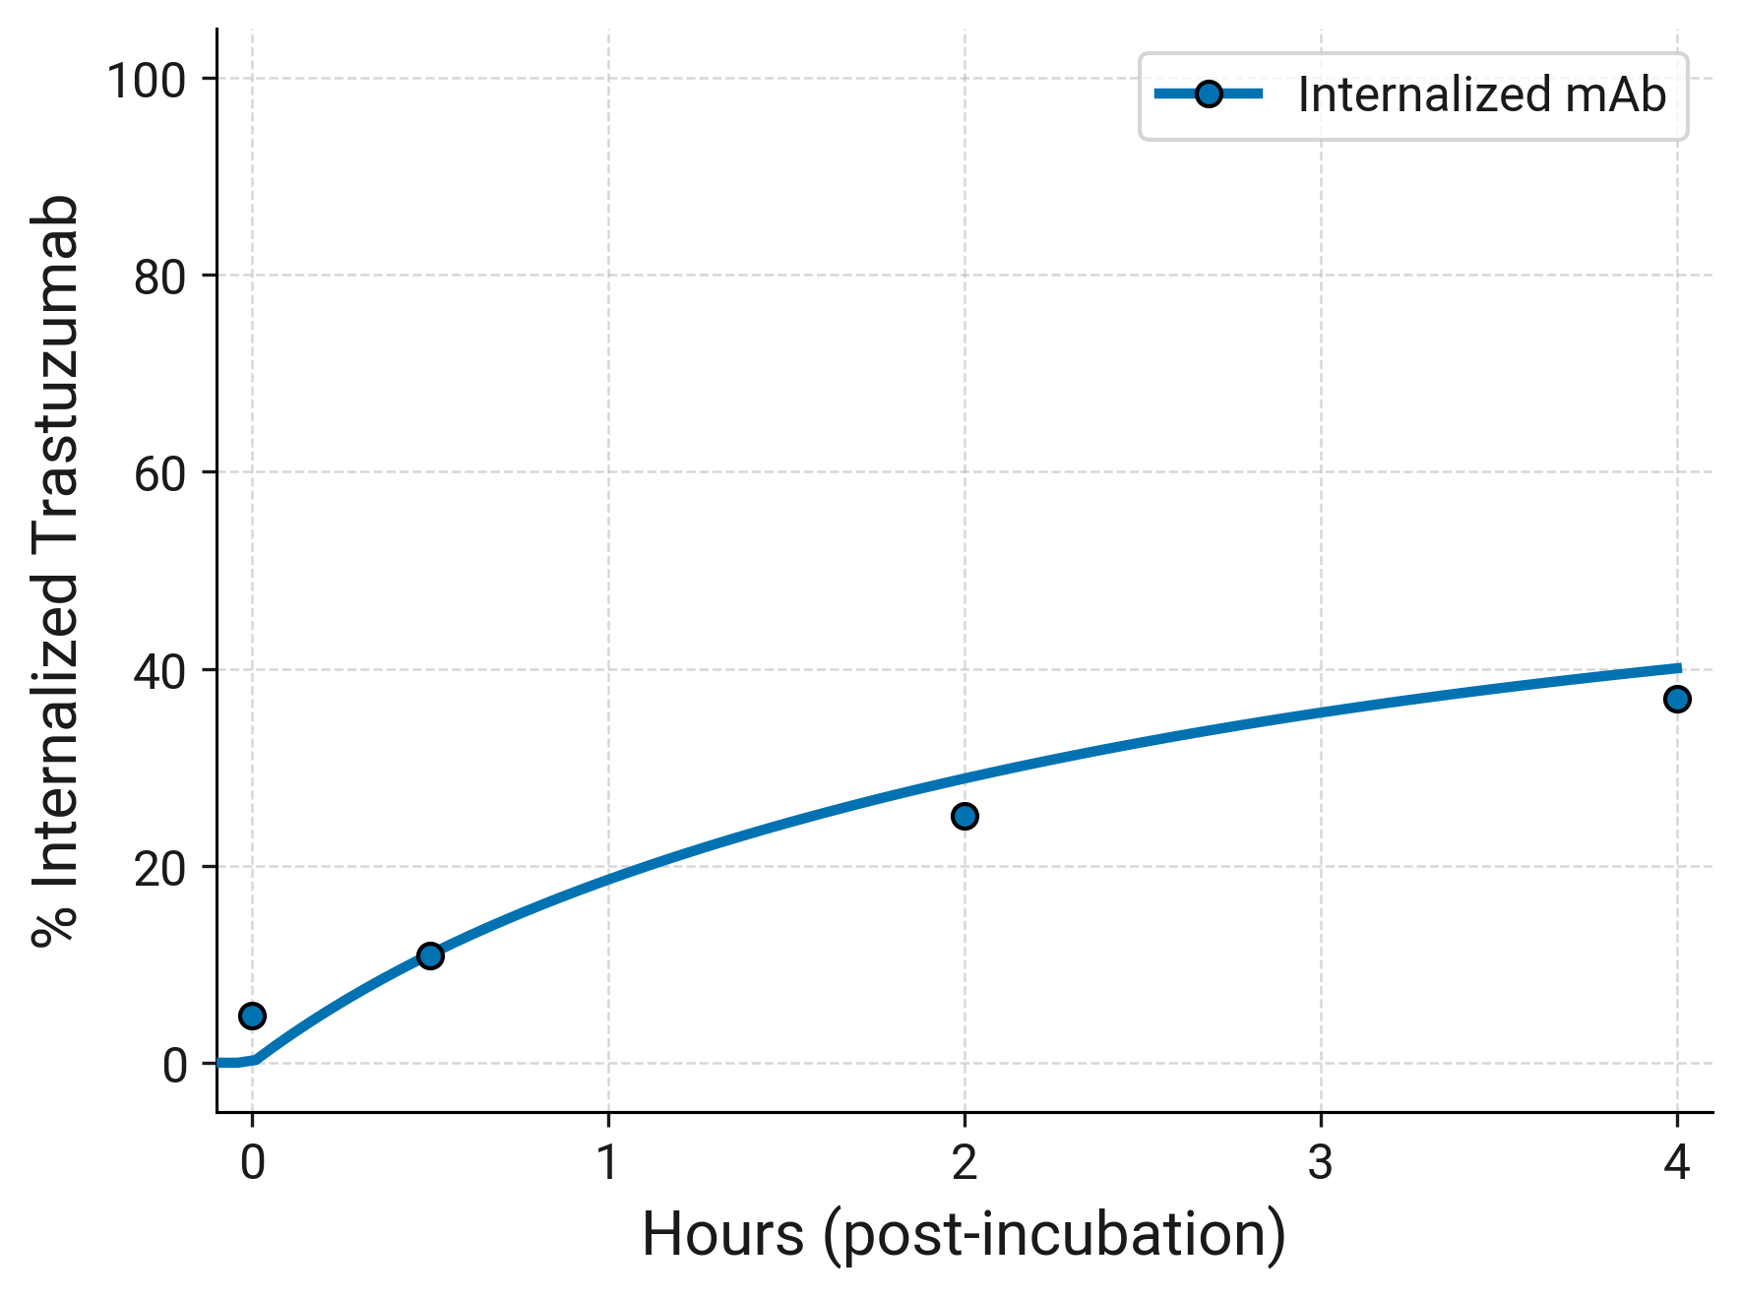

**Figure S2: Schematic representation of the mouse model**

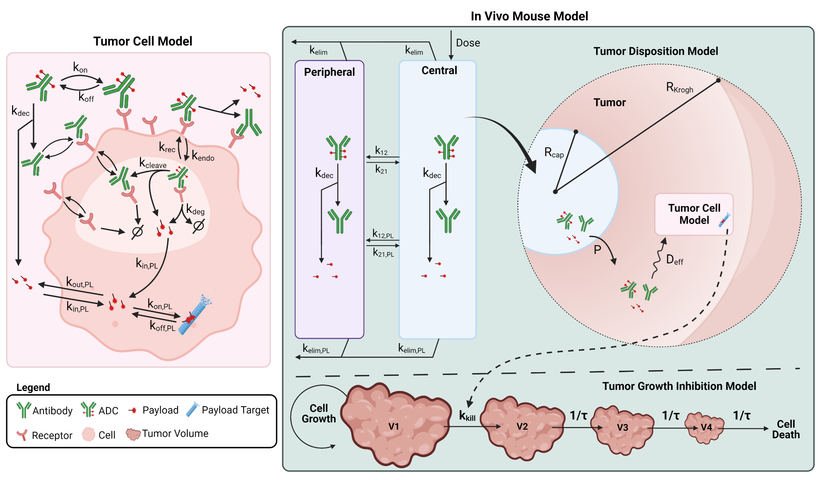

**Figure S3: Observed (*symbols*) and model calibrated (*lines*) plasma PK profiles for ADC and total antibody following single dose IV administration of (A) T-DM1** **and (B) T-DXd at 3 mg/kg to non-tumor bearing mice.** The model was used to fit the data for both ADCs simultaneously, and only deconjugation rate was allowed to vary between ADCs.  
**Observed (symbols) and model predicted (lines) plasma PK profiles following IV administration of (C) a maytansine with structural similarity to DM1 at 0.1mg/kg and (D) DXd at 1 mg/kg to non-tumor bearing mice.** The model was used to fit the data for both payloads simultaneously, and only half-life was allowed to vary for each payload.

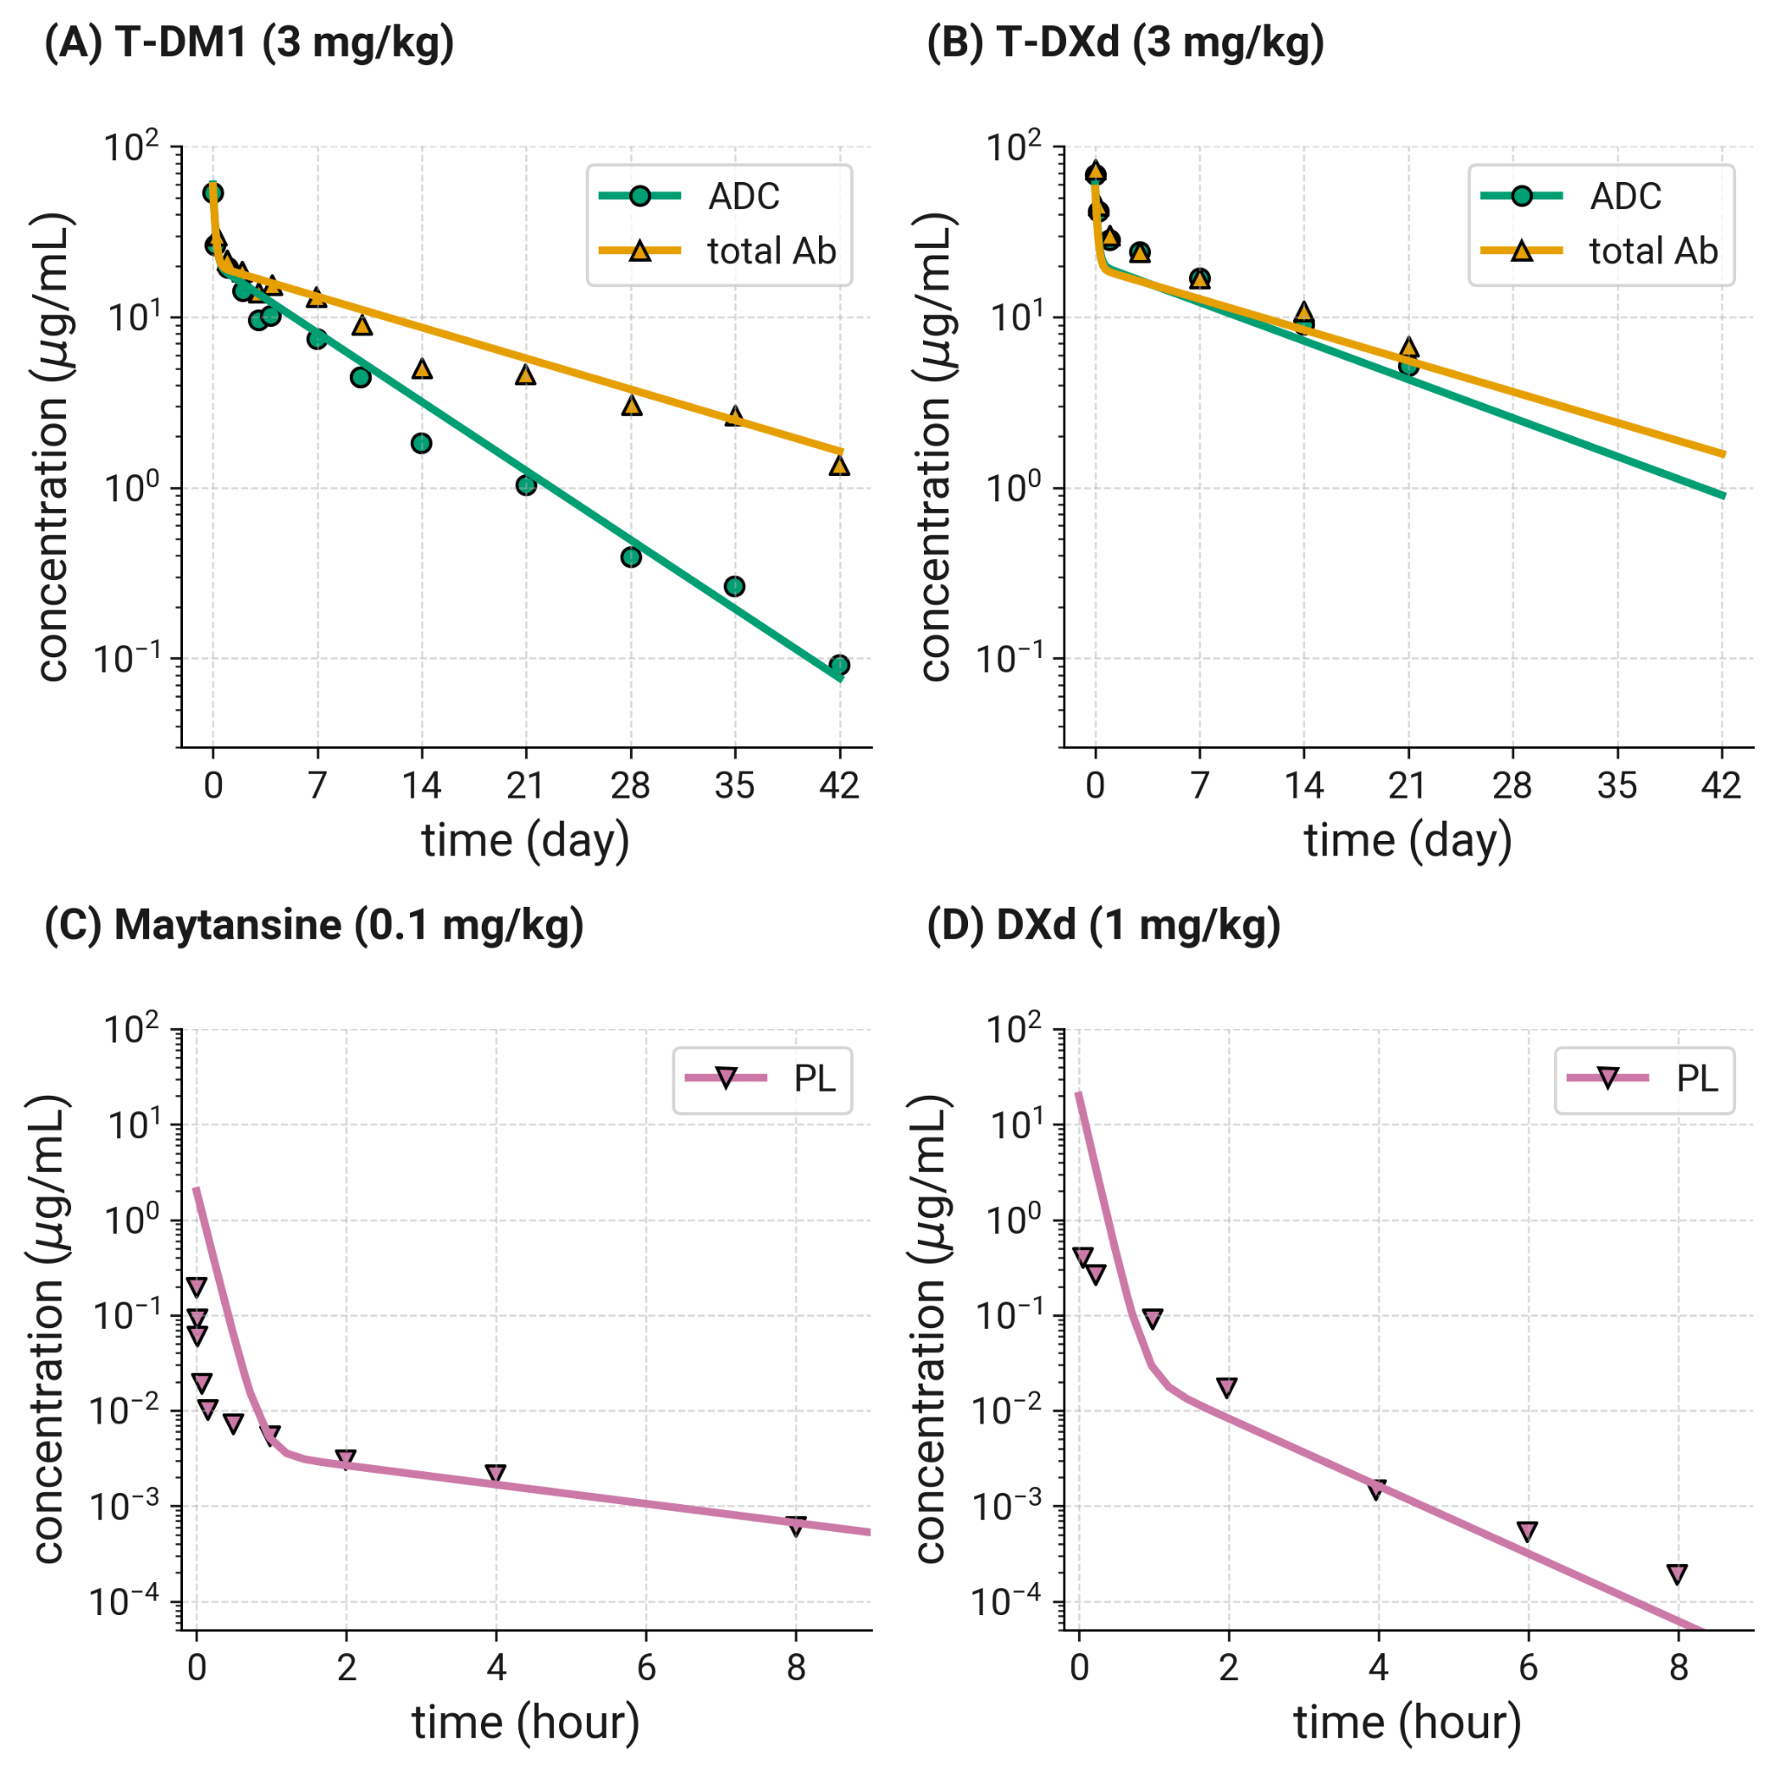

**Figure S4: Observed (*symbols*) and in vivo PK/PD model calibrated (*lines*) tumor growth inhibition by T-DM1 in KPL4 and BT474 xenograft mouse studies.**

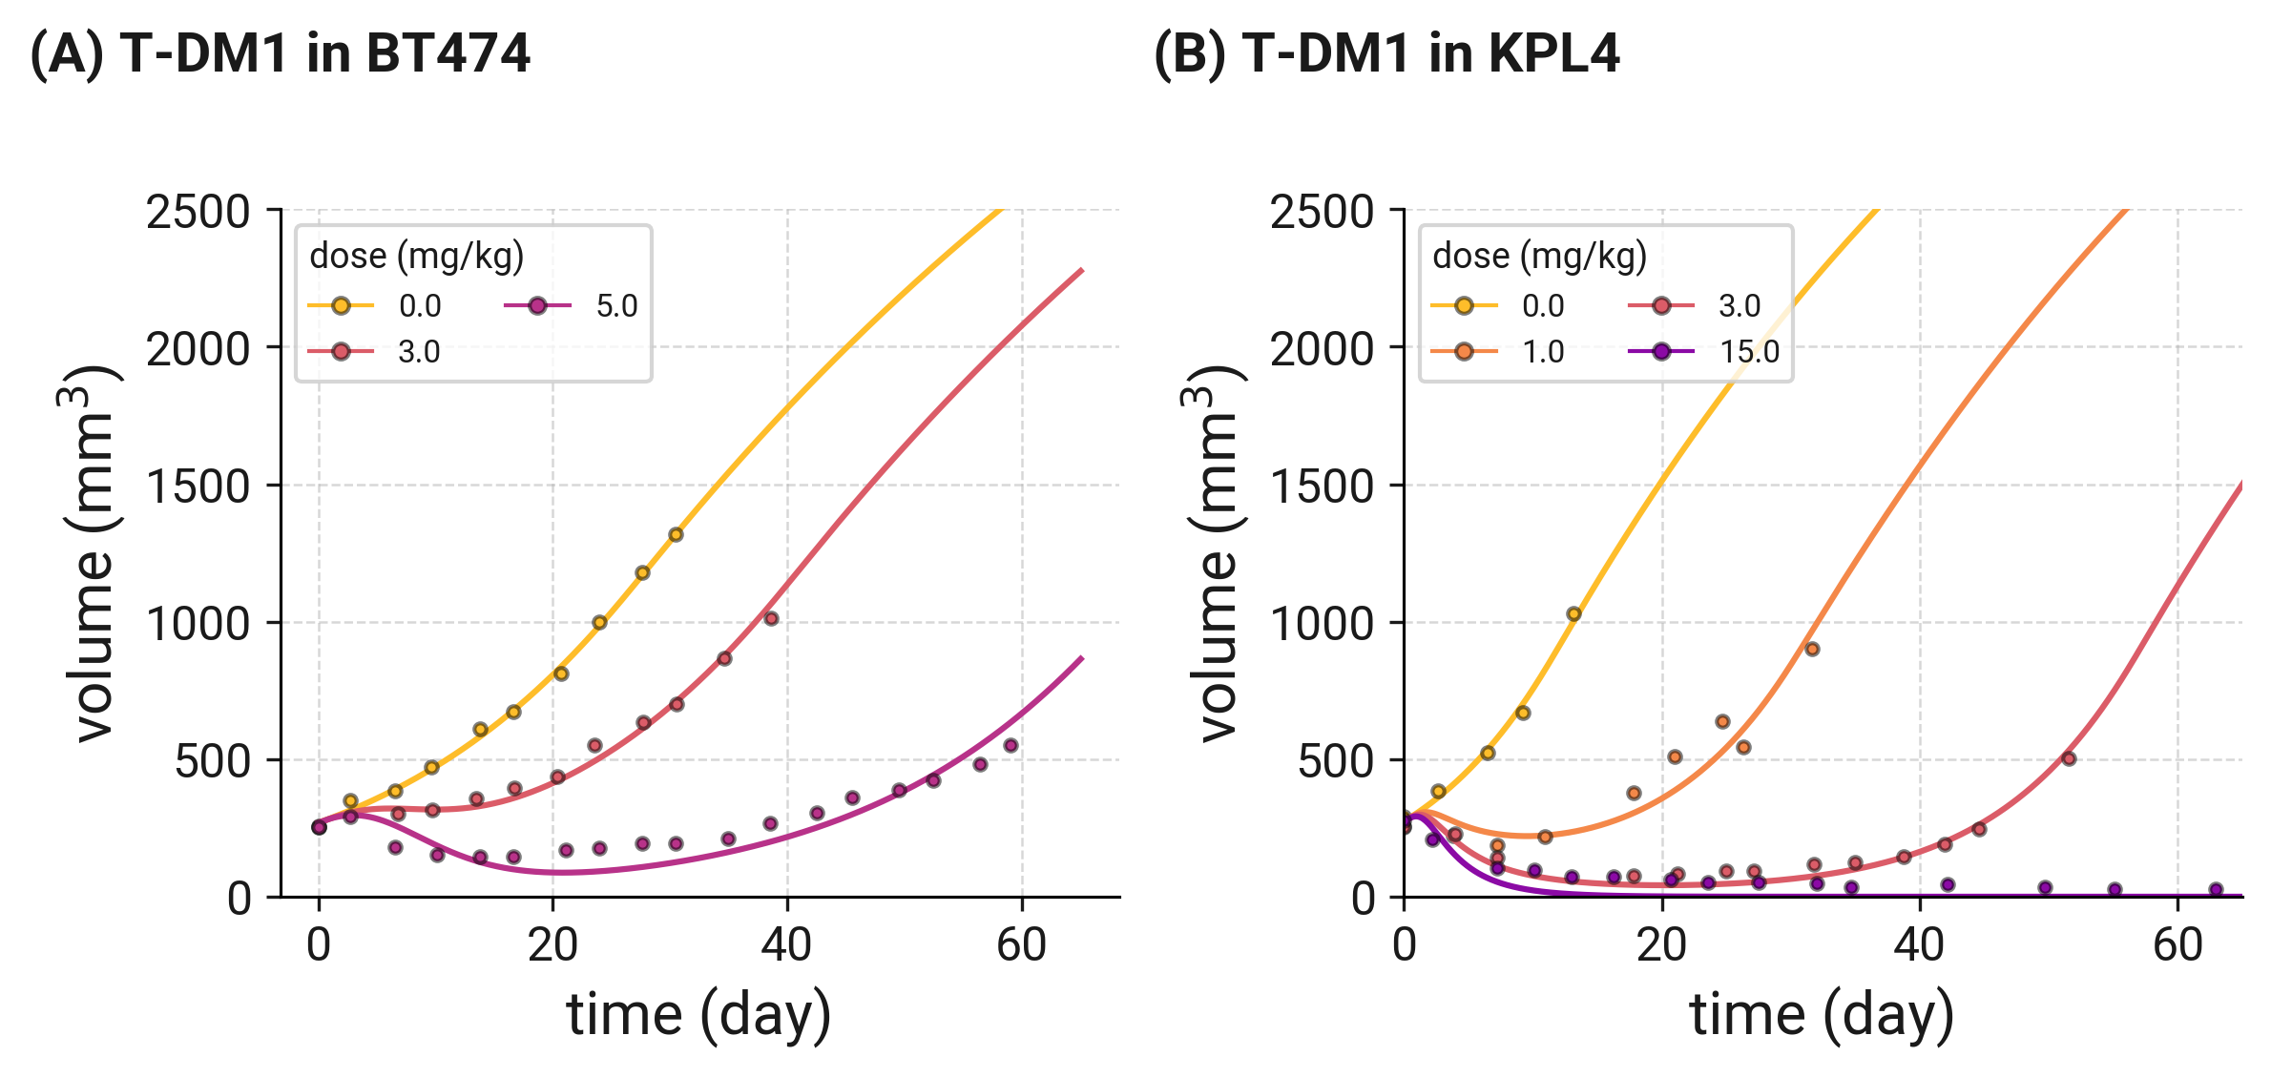

**Figure S5: Global sensitivity analysis of Human T-DM1 model parameters.** Latin hypercube partial rank correlation coefficient (LHS- PRCC) was performed to understand which parameters impacted tumor growth volume (summarized by AUC of tumor volume). Parameters shown had a Bonferroni-adjusted p-value > 0.05 and are ordered from greatest to least sensitive based on their PRCC value. Drug parameters (e.g. DAR) were sampled from a linear uniform distribution (red), while most system parameters (e.g. biological parameters) were sampled from a log normal distribution (blue).

