[root@dabiao zabbix-2.4.8]# service zabbix_server start
Starting zabbix_server: /usr/local/sbin/zabbix_server: error while loading shared libraries: libmysqlclient.so.20: cannot open shared object file: No such file or directory
ln -s /usr/local/mysql/lib/libmysqlclient.so.20 /usr/lib64

zabbix监控报错zabbix server is not running
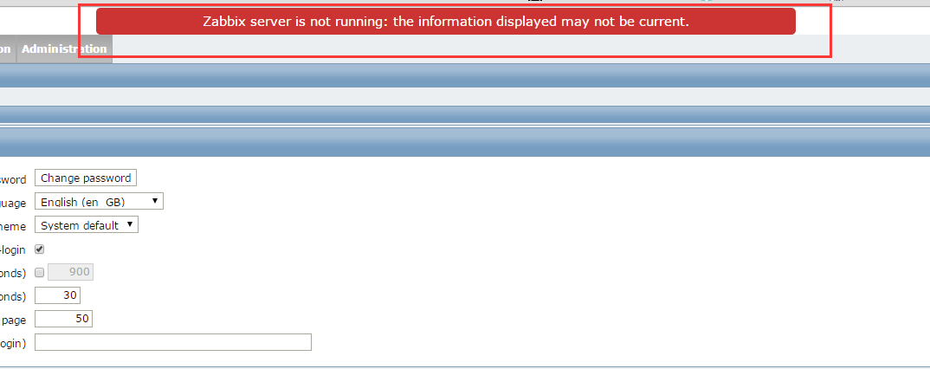
开启fsockopen函数
在php.ini打开allow_url_fopen = On和模块 extension=php_openssl.dll

