- Introduction
This project is a warehouse management system based on Python, adopting the OOP design concept. It features a GUI interface through Tkinter, supporting core capabilities such as adding, deleting, modifying, and querying goods, inventory value statistics, and user hierarchical permission control. With a wide range of application scenarios, it is a visual, simple and easy-to-operate warehouse management system.
- Core function
This system can achieve the functions of adding, deleting, querying and modifying goods, and can perform verification and provide corresponding feedback, avoiding the incorrectness of inventory information and ensuring the accuracy of inventory information. This project can realize the automatic calculation of goods value. The system can calculate the total value of any single item or the total value of the entire inventory in the current warehouse in real time, making the value of the warehouse clear immediately and facilitating the acquisition of financial data for warehouse management by users. It has a user permission hierarchical management function, dividing user permissions into three levels: employee, manager, and administrator. Different levels have different permission functions - employees can only view warehouse data, managers can view and modify, and administrators have all permissions. It has a graphical visual interface, and warehouse management operations can be completed through the tkinter window page without command input, making it easy to use and getting started.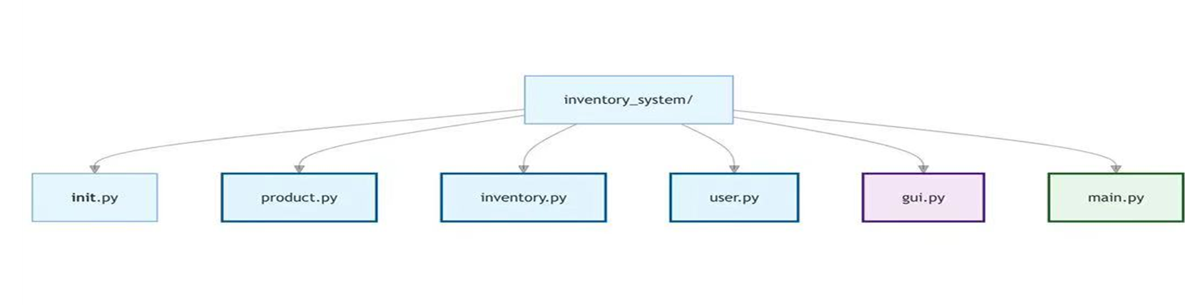
- Technical summary
1. Developed based on Python, it adopts pure object-oriented (OOP) architecture, splitting the product, inventory, user, and GUI interface into independent modules, with a clear code structure that is easy to maintain and expand.
2. The graphical interface is implemented using the built-in Tkinter library of Python, without the need for additional dependencies, and is compatible with multiple platforms. The interface includes standard components such as tables, input boxes, buttons, labels, and pop-up windows.
3. Technical features: It can achieve class and encapsulation, with the product class, inventory management class, and user permission class independently encapsulated, allowing for hierarchical control; it can handle exceptions, catching data format errors, duplicate IDs, non-existent products, and other exceptions throughout the process; it can achieve real-time data refresh, automatically updating the list and total value after operations to ensure data synchronization.
4)usage of OOP concepts
5)external resources
6)self-reflection

