Program Structures and Algorithms

Spring 2023(SEC –03)

NAME: Yufan Gao

NUID: 002755691

**Task:**

Implement TwoSumWithCalipers, ThreeSumQuadratic, ThreeSumQuadraticWithCalipers and ThreeSumBenchmark. Then I need to estimate the time differences among these different approaches.

**Relationship Conclusion:**

Quadratic approach is the fastest. O(N^2)

Quadrithmic approach is the second fast. O(N*logN)

Cubic is the slowest. O(n^3)

**Evidence to support that conclusion:**

This is the screen shot of Benchmark with 7 groups of data.

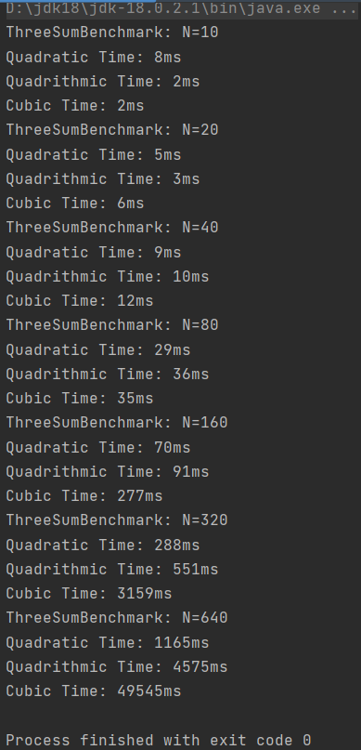

In the quadratic approach(no matter whether we use caliper), we use two loops only, one outside, one inside. For the outside loop, we just iterate each index in the array. In the inside loop, since the input array is ordered as we assumed, we let the outside index to be the middle index of the inside loop. And we create other two indices j and k to expand the scale of three sum searching process. Besides, we only have to handle the sum in three conditions(=0 <0 >0) which cost linear time. Thus, the outside loop and the inside loop both cost only linear time. So the total time complexity is O(N^2). And this is exactly why it’s faster than quadrithmic and cubic methods.

**Graphical Representation:**

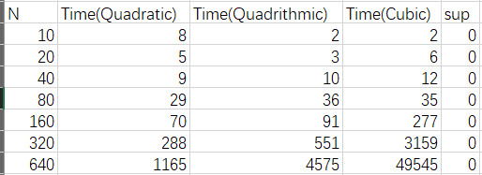

Time Observations:

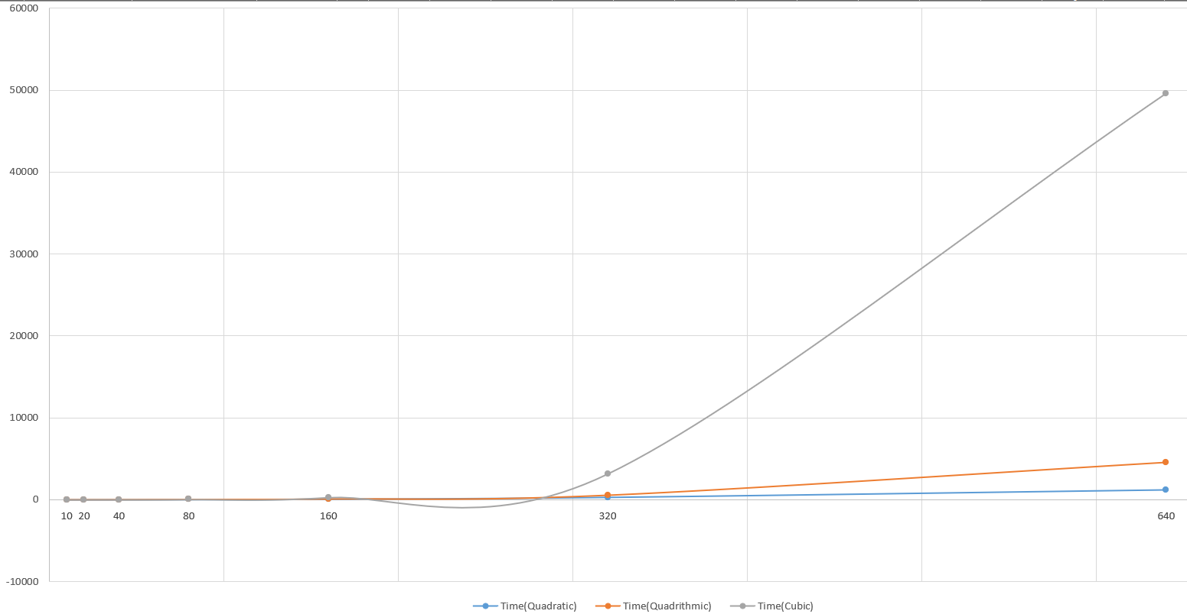

**Unit Test Screenshots:**

