Program Structures and Algorithms

Spring 2023(SEC –03)

NAME: Yufan Gao

NUID: 002755691

**Task:**

We have three parts of implementation. The first part is to implement the three methods in Timer class. And be sure to pass the BenchmarkTest and TimerTest. The second part is to implement the InsertionSort. Part three is to design and implement a test class to show the difference between the time consumed by four approaches of InsertionSort.

**Relationship Conclusion:**

For the four approaches of InsertionSort, InsertionSort for ordered used the least time. Then the second less-time-consuming method is InsertionSort for partially-ordered. InsertionSort for random and for reversed-ordered used the longest time to finish, and these two methods consumed about the same amount of time.

**Evidence to support that conclusion:**

Output of my test method:

2023-02-04 21:26:00 INFO Benchmark_Timer - Begin run: Insertion sort for Random for 1000 Integers with 100 runs

2023-02-04 21:26:01 INFO Benchmarks - 1.810 ms

2023-02-04 21:26:01 INFO Benchmark_Timer - Begin run: Insertion sort for Random for 2000 Integers with 100 runs

2023-02-04 21:26:01 INFO Benchmarks - 7.010 ms

2023-02-04 21:26:01 INFO Benchmark_Timer - Begin run: Insertion sort for Random for 4000 Integers with 100 runs

2023-02-04 21:26:04 INFO Benchmarks - 25.530 ms

2023-02-04 21:26:04 INFO Benchmark_Timer - Begin run: Insertion sort for Random for 8000 Integers with 100 runs

2023-02-04 21:26:15 INFO Benchmarks - 100.950 ms

2023-02-04 21:26:15 INFO Benchmark_Timer - Begin run: Insertion sort for Random for 12000 Integers with 100 runs

2023-02-04 21:26:41 INFO Benchmarks - 228.010 ms

2023-02-04 21:26:41 INFO Benchmark_Timer - Begin run: Insertion sort for Ordered for 1000 Integers with 100 runs

2023-02-04 21:26:41 INFO Benchmarks - 0.010 ms

2023-02-04 21:26:41 INFO Benchmark_Timer - Begin run: Insertion sort for Ordered for 2000 Integers with 100 runs

2023-02-04 21:26:41 INFO Benchmarks - 0.020 ms

2023-02-04 21:26:41 INFO Benchmark_Timer - Begin run: Insertion sort for Ordered for 4000 Integers with 100 runs

2023-02-04 21:26:41 INFO Benchmarks - 0.040 ms

2023-02-04 21:26:41 INFO Benchmark_Timer - Begin run: Insertion sort for Ordered for 8000 Integers with 100 runs

2023-02-04 21:26:41 INFO Benchmarks - 0.060 ms

2023-02-04 21:26:41 INFO Benchmark_Timer - Begin run: Insertion sort for Ordered for 12000 Integers with 100 runs

2023-02-04 21:26:41 INFO Benchmarks - 0.110 ms

2023-02-04 21:26:41 INFO Benchmark_Timer - Begin run: Insertion sort for Partially-ordered for 1000 Integers with 100 runs

2023-02-04 21:26:41 INFO Benchmarks - 0.620 ms

2023-02-04 21:26:41 INFO Benchmark_Timer - Begin run: Insertion sort for Partially-ordered for 2000 Integers with 100 runs

2023-02-04 21:26:41 INFO Benchmarks - 3.380 ms

2023-02-04 21:26:41 INFO Benchmark_Timer - Begin run: Insertion sort for Partially-ordered for 4000 Integers with 100 runs

2023-02-04 21:26:42 INFO Benchmarks - 13.260 ms

2023-02-04 21:26:42 INFO Benchmark_Timer - Begin run: Insertion sort for Partially-ordered for 8000 Integers with 100 runs

2023-02-04 21:26:48 INFO Benchmarks - 52.010 ms

2023-02-04 21:26:48 INFO Benchmark_Timer - Begin run: Insertion sort for Partially-ordered for 12000 Integers with 100 runs

2023-02-04 21:27:15 INFO Benchmarks - 244.230 ms

2023-02-04 21:27:15 INFO Benchmark_Timer - Begin run: Insertion sort for Reverse-ordered for 1000 Integers with 100 runs

2023-02-04 21:27:15 INFO Benchmarks - 1.440 ms

2023-02-04 21:27:15 INFO Benchmark_Timer - Begin run: Insertion sort for Reverse-ordered for 2000 Integers with 100 runs

2023-02-04 21:27:16 INFO Benchmarks - 5.690 ms

2023-02-04 21:27:16 INFO Benchmark_Timer - Begin run: Insertion sort for Reverse-ordered for 4000 Integers with 100 runs

2023-02-04 21:27:19 INFO Benchmarks - 23.570 ms

2023-02-04 21:27:19 INFO Benchmark_Timer - Begin run: Insertion sort for Reverse-ordered for 8000 Integers with 100 runs

2023-02-04 21:27:29 INFO Benchmarks - 98.020 ms

2023-02-04 21:27:29 INFO Benchmark_Timer - Begin run: Insertion sort for Reverse-ordered for 12000 Integers with 100 runs

2023-02-04 21:27:54 INFO Benchmarks - 224.350 ms

**Graphical Representation:**

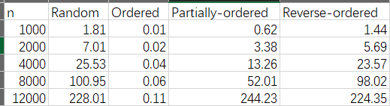

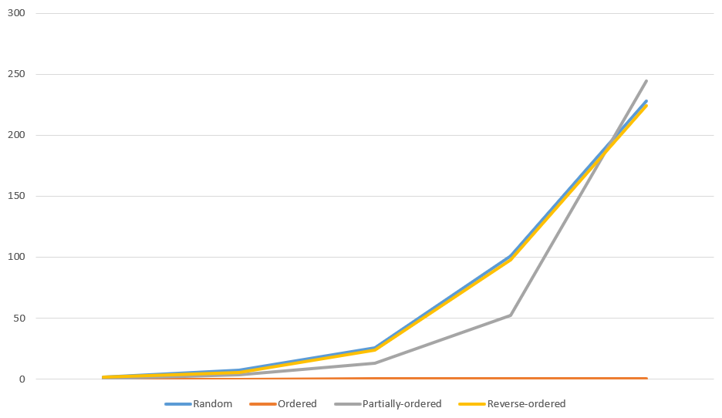

**Unit Test Screenshots:**



