Program Structures and Algorithms

Spring 2023(SEC –03)

NAME: Yufan Gao

NUID: 002755691

**Task:**

Implemented find(), mergeComponents(), doPathCompression() in class UF_HWQUPC.

Created count(), main() in UF_Client class which is added to union_find package.

Determined the relationship between the number of objects (n) and the number of pairs (m).

**Relationship Conclusion:**

m = n – 1

**Evidence to support that conclusion:**

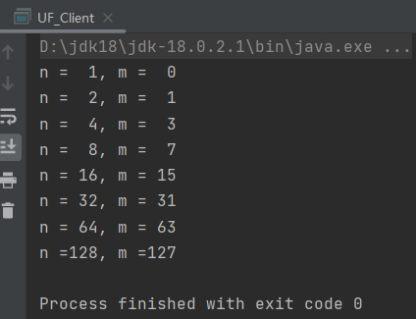

**Graphical Representation:**

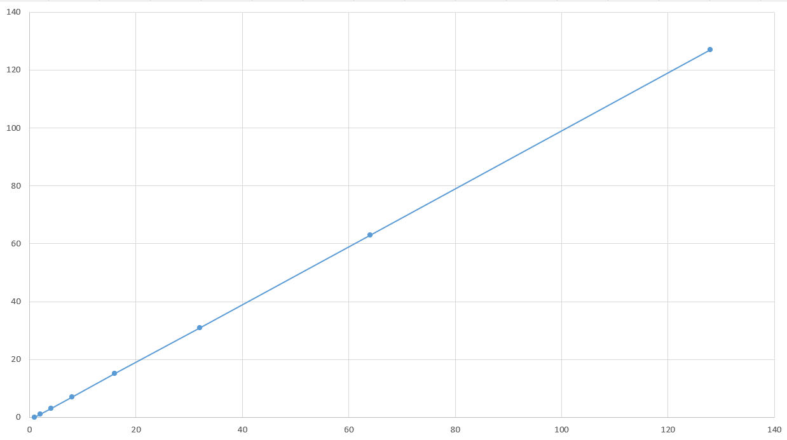

**Unit Test Screenshots:**

