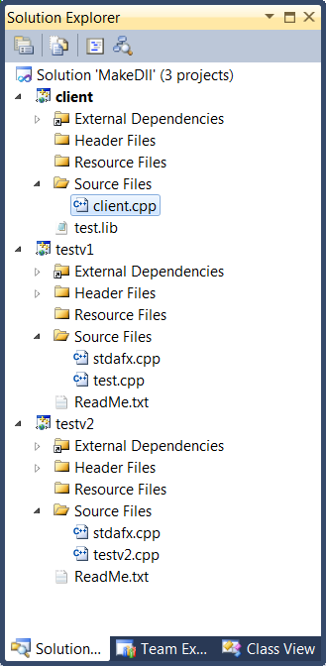

The screenshot to the right shows all of the projects in the MakeDll solution.

Note that test.lib is included in the client project. This tells the linker that the client will use exports defined in this file and will prevent the link from stopping the build because of unresolved references.