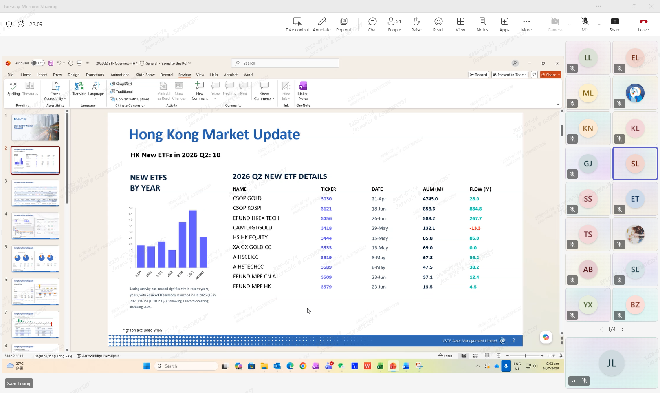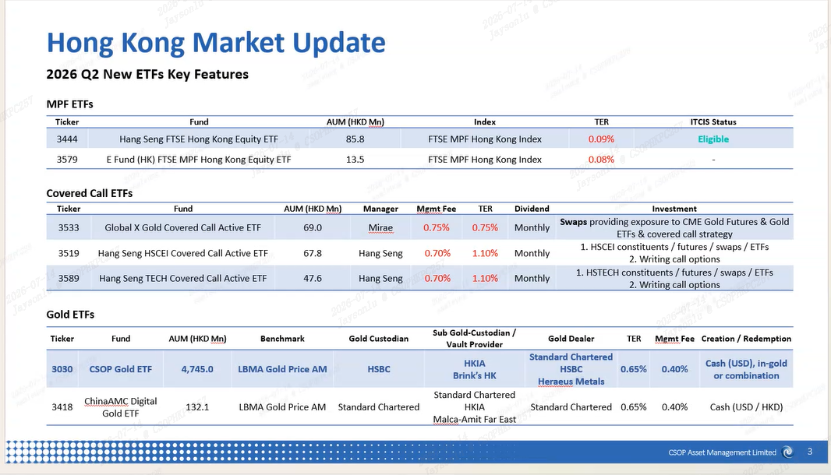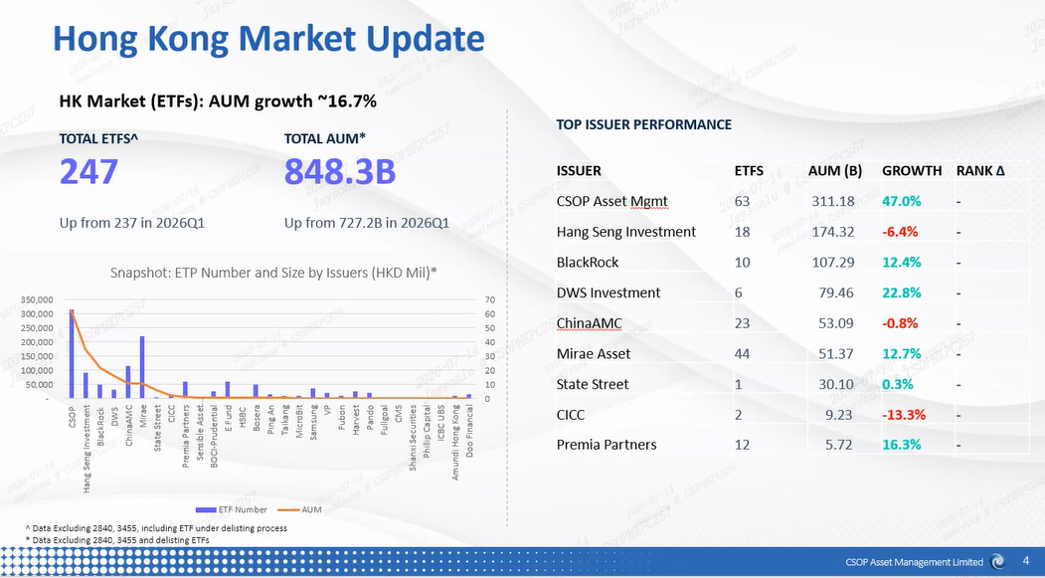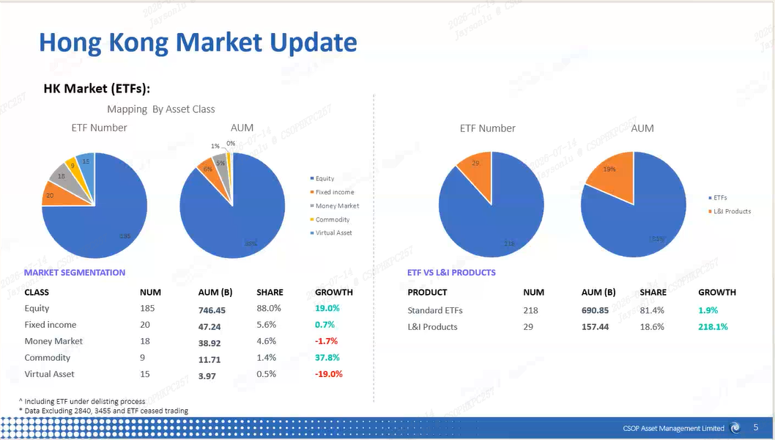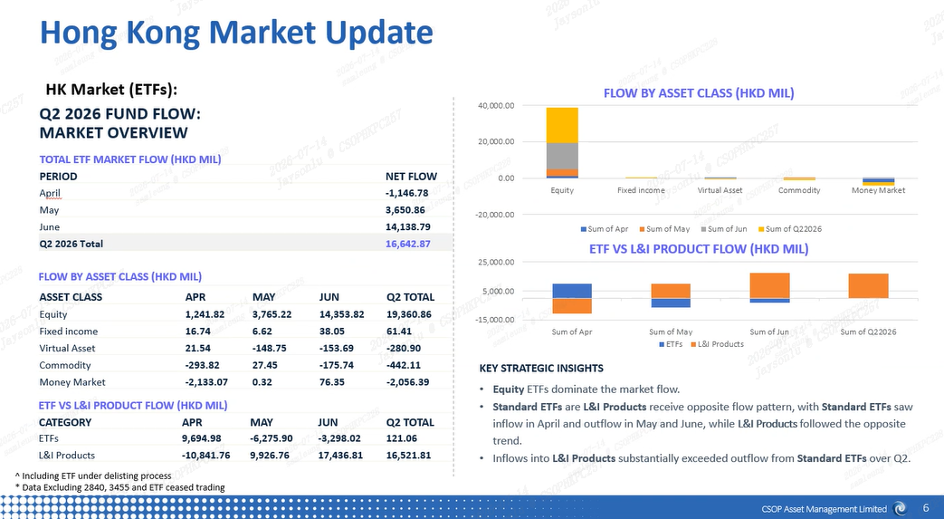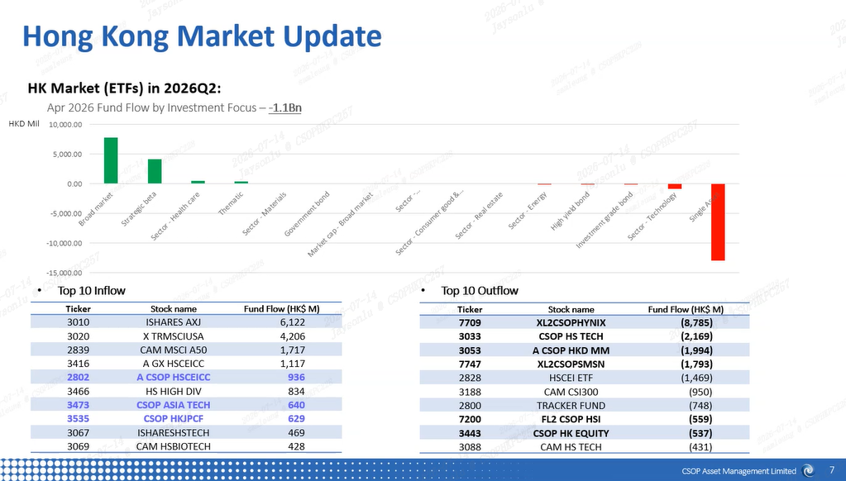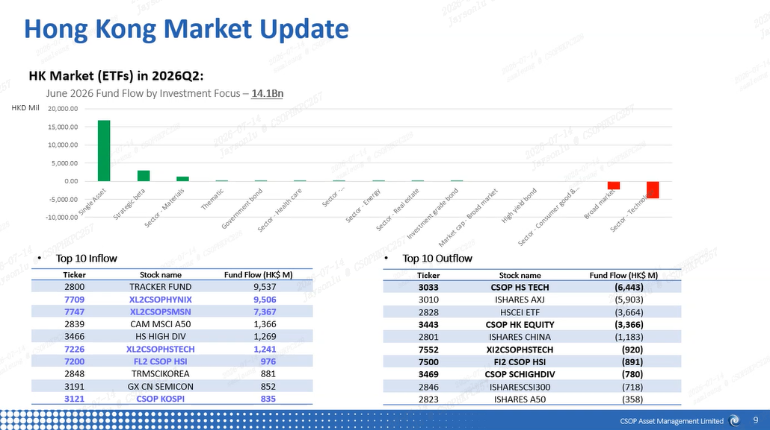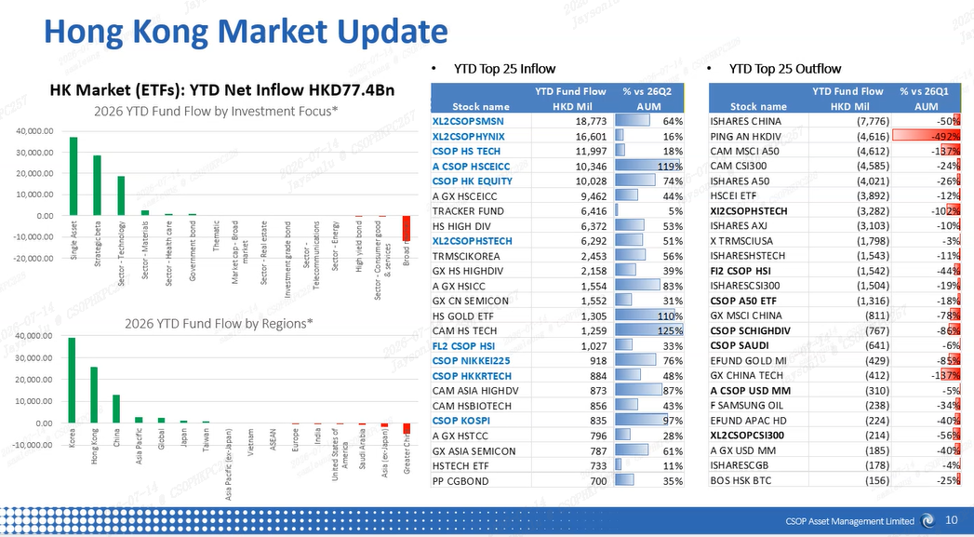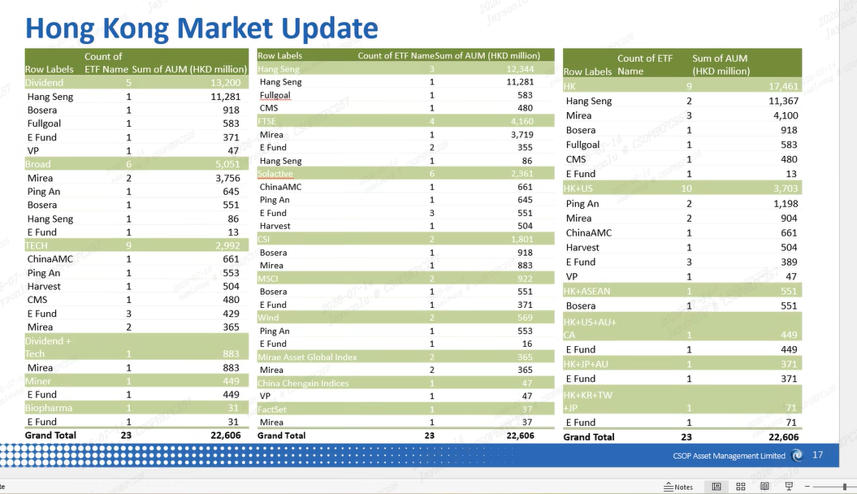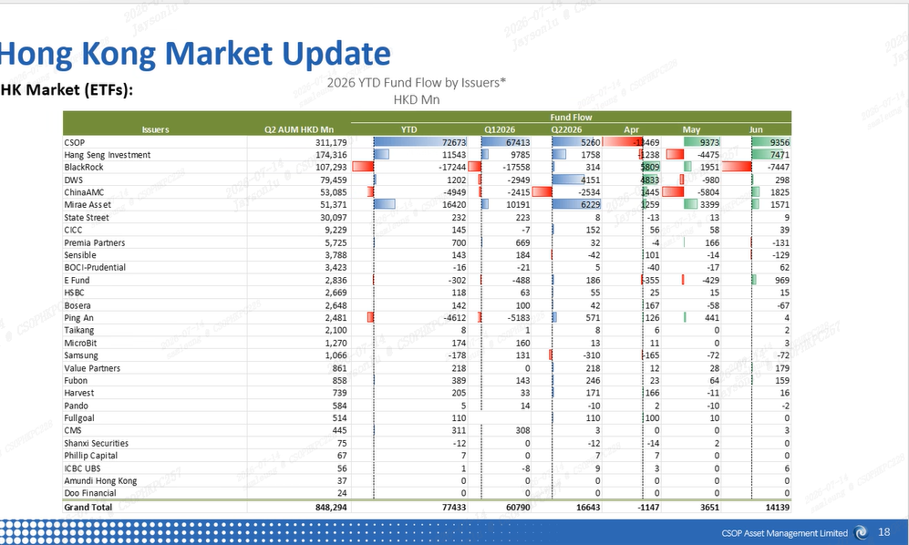

Jayson Lu
Jennifer Li
Meredith Lu
Sam Leung
Tina Shu
Lulu Shu
Amy Bu
Stephen Liang
Hannah Han
Emily Han
Hannah Jian
Kerwin Ng
Elena Kang
Leaving...
Aaron Yang
Zicong Wang
Maverick Guo
1/2
Transcript
Follow the conversation better in real time by using live captions.
Switch to live captions
Show both original and translation
to engage high activity private domain clients and guide rational investment behaviors. And last week, we also delivered a career theme Rd. show covering 200 high net wealth clients via tag broker.
stabilizing market sentiment ahead of ADR. And this week, we will also hold additional role shows with Nora Holdings and first right QDs to further solidate client confidence. And we also made a follow-up.
communication meeting with what right securities. We will align our product strategies with the investment frameworks with their IC teams to drive higher product penetration.
and for gold project ，we continue the preparation of DDQ documents in collaboration with shun yuan laying the solid foundation for the project's next phases 。
And then for overseas market, firstly, last week, we launched business negotiation with Taiwan's leading third-party financial platform, which covers over 50% of local users. So it's full stack.
capabilities in financial marketing and online brokerage services will serve as the co-pillar for our localized product promotion in the region.
and for Japan, the DA application for move Japan has been submitted for OA internal approval and the official signing should be completed upon approval.
And then for MuMu Singapore product, we have analyzed the product proposal and presentation deck and a special review meeting with the MuMu team is scheduled for this Tuesday to discuss proposal.
and collect feedback for all iteration.
Ah, then on the gc side, starting with the GangTong ETF, last week due to recent fluctuations in A-shares and Asia-Pacific markets, we increased our promotion of 3441, and customer interest in dividend products continued to rise.啊，然后是gc方面，首先是港通etf啊，上周的话，因为近期a股和亚太市场的行情比较波动，所以我们是加大了对3441的一个宣传推广力度，然后平台客户对红利产品的关注度也持续提升。
3441 is recommended as one of the asset allocation options.推荐3441作为资产配置的选择之一。
Then 3431. Because the recent Korean market has increased pulldown volatility, we continue to reassure existing holders by reducing redemptions and guiding them to buy positions on dips to position for the next round of rebound opportunities in the Korean market.然后3431 ，因为最近韩国市场回撤波动加大，我们是持续安抚现有持有人降低赎回，并且引导持有人逢低加仓来布局下一轮的韩国市场的反弹机遇。
Next, regarding mutual linked funds, first is Asia Pacific Select. Recently, when the on-exchange ETF of Asia Pacific Select experienced pulldown and discounting rallies, we promptly alerted and online clients to gradually increase positions during the pullback.然后在互挂基金方面，首先是亚太精选，近期亚太精选的场内E T F在出现回回撤折价行情的时候，我们是及时提示和线上的客户在回调中逐步加仓。
The latest ETF size is 3.1 billion. In addition, for off-exchange ETF linking, we have also encouraged KOLs to increase promotion of the quota advantages of off-exchange funds and to increase their positions. Currently, the latest scale of linked funds is 1.02 billion, with 560,000 holding clients.etf的最新规模为31亿。此外，场外的etf链接，我们也引导kol加大宣传场外基金的额度优势，引导地位加仓，目前链接基金的最新规模是10.2亿，持有客户是560000 。
As for DeepTech Link, after the recent rebound, client redemptions have decreased, and the scale has rebounded along with net asset value. We are continuing to increase investment on multiple platforms such as Ant, Tiantian, JD.com, and Xiaohongshu.然后很深科技链接的话，呃近期反弹之后，客户的赎回有所减少，呃规模跟随净值也有所回升，我们是继续加大在蚂蚁天天京东小红书等多平台的投放。
This drives new customer conversion and increased positions among existing customers, while also maintaining ongoing communication with the Huatai Bairui e-commerce team to update Hengke's long-distance materials, then strive for opportunities to submit future platform apartment reports. Finally, regarding platform cooperation and communication, we have recently been closely communicating with the Huashun team about the current market situation.带动新客转化和老客加仓，同时也和华泰百瑞电商团队持续的沟通，更新恒科的长途素材，然后争取后续平台公寓的一些提报机会，然后最后在平台合作交流方面，近期我们和同华顺的团队继续密切交流近期的市场情况。
It is also expected that quotes and plans for future promotion and launch will be confirmed soon. At the same time, due to the recent consecutive corrections in the Asia-Pacific market, holders of Asia-Pacific Select who have accumulated on the Dongcai and Tiantian Fund platforms are also paying attention to the market outlook.然后预期也会在最近确认报价以及确认后续推广上线的计划，同时因为近期亚太市场连续回调啊，之前在东财和天天基金平台上积累的亚太精选的持有人也在关心后续的行情。
and trading advice. We are actively reassuring clients and conveying some positive signals of buyback buys to the financial advisor team.以及操作建议，我们也在积极的安抚客户，以及向理财师团队传达回调买入的一些积极信号。
I think that's all for digital finance last week. Then I will pass to digital assets team. Thank you.I think that's all for digital finance last week. Then I will pass to digital assets team. Thank you.
Bruce Chen9:36 AM
For the digital asset team on Hong Kong parts on the OSL side, we're sorting out the technical issues related to the main and burn process, as well as completing the account setup. With Hashkey, we had started...For the digital asset team on Hong Kong parts on the OSL side, we're sorting out the technical issues related to the main and burn process, as well as completing the account setup. With Hashkey, we had started...
the connectivity testing with the token agent. For Finroot side, we are in discussions regarding the distribution agreement. We also had discussions on stable coin adoption opportunities and use cases.the connectivity testing with the token agent. For Finroot side, we are in discussions regarding the distribution agreement. We also had discussions on stable coin adoption opportunities and use cases.
On Singapore market, we are working closely with legal counsel to finalize the insurance plan and related arrangements. On the international side, we are continuing engagement with ecosystem players such as Panka Store.On Singapore market, we are working closely with legal counsel to finalize the insurance plan and related arrangements. On the international side, we are continuing engagement with ecosystem players such as Panka Store.
Ask the gates and sign in, also the liquidity providers and aggregators, including the cross over Meteora, also for market makers such as strong trading and tokenization agents such as Twenty Five.Ask the gates and sign in, also the liquidity providers and aggregators, including the cross over Meteora, also for market makers such as strong trading and tokenization agents such as Twenty Five.
On the marketing side, together with the marketing team, we had discussions with BTC Inc. on the planning and collaborations opportunities for the upcoming Bitcoin Conference in Hong Kong. That's all for today.On the marketing side, together with the marketing team, we had discussions with BTC Inc. on the planning and collaborations opportunities for the upcoming Bitcoin Conference in Hong Kong. That's all for today.
Go to current

