Fisher Yu 13918677360 yuff100@[163|hotmail|gmail].com
-- 5 years C/C++ experience
-- 5 years large scale telecommunication product development
-- 1 year minor team management

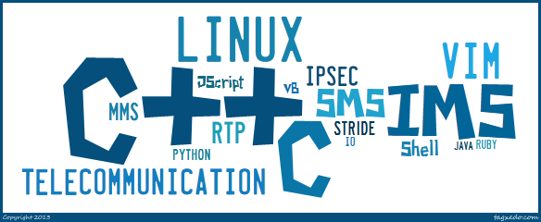
Private Information
Gender：male
Birth：1982/01

Projects
Mavenir Systems：
2013/01 till now：UAG
- Design/Develop/Test/Maintain RTP media module
- Lead a team to design/develop/test/maintain MSRP/RTP(including Slowpath and Fastpath) module

2009/08 -- 2012/12：RMS
- Design/Develop/Test/Maintain Call Control/SIP/CDR module
2. Take the responsible of capacity testing

2009/03 -- 2011/10：TAS/BSG
- Test/Maintain H248 module
- Develop/Test/Maintain SIP module
- Design/Develop/Test/Maintain CDR module

2008/05 -- 2009/08：IMS
- Develop/Test/Maintain SIP module
- Design/Develop/Test/Maintain CDR module
- Take the responsible of capacity testing

Motorola：
2007/10 -- 2008/05：WiMAX Handset application
- Take the responsible of reviewing design/develop document
- Design/Develop integrating test cases

2007/04 -- 2007/10：OMA PoC Based PTX Server
- Design/Develop the architecture and major function of PTX Server
- Design/Develop a testing client

Motorola (Intern)：
2006/02 -- 2006/08：iDEN Handset application
- Design/Develop/Maintain STRIDE/JScript based automation mobile application testing script

资源世代：
2005/09 -- 2006/02：SIP Server
1. Develop SIP Server which can work for VoIP/IVR/VoiceMail/Conference/...
Working
2008/05 till now:
Mavenir Systems
Software Engineer -- Senior Software Engineer -- Senior Technical Lead

2007/04 -- 2008/05:
Motorola (China) Ltd. Nanjing Software Branch
Software Engineer

2006/02 -- 2006/08：
Motorola (China) Ltd. Nanjing Software Branch
Intern Software Engineer

2005/09 -- 2006/02:
SDR (Shenzheng) Ltd.
Part-time Software Engineer

Education
2004/09 -- 2007/04:
Nanjing University of Posts and Telecommunications
Computer Application (in Telecommunication) -- Master

2000/09 -- 2004/07:
Nanjing Normal University
Electronic Information Engineering -- Bachelor

Training
2007/11:
ESI & The George Washington University
Software Testing for Better Project Management

2007/07：
Motorola University
Effective Presentations

2007/4 -- 2007/5：
Motorola University
Motorola University ITP/RTP training

