Vehicle Type Classification
Machine Learning Course Project I — Classification
Yug Sahni · M.Tech CSE (Semester 1), IIIT Bangalore

1. Problem and Dataset
The task is multi-class classification: predict vehicle_class (0, 1 or 2) of a vehicle from 20 numeric specifications — engine displacement, horsepower, torque, cylinders, weight, wheelbase, length, width, height, fuel-tank capacity, city and highway fuel efficiency, ground clearance, turning radius, cargo capacity, 0–100 km/h time, braking distance, tyre width, drag coefficient and battery capacity. The training file has 10,000 labelled rows; the test file has 2,500 rows whose labels are hidden. Only 40% of the test rows count for the public leaderboard; the other 60% are hidden and decide the final grade, so models were chosen by cross-validation, not by chasing the public score. Submissions are CSV files with vehicle_id and vehicle_class. Models used are the ones taught in the course: Logistic Regression, Decision Tree, Naive Bayes and Random Forest. Every experiment uses a fixed random seed (42).

2. Exploratory Data Analysis
- Clean and balanced. No missing values in train or test; all 20 features are numeric. Classes are balanced (33.9% / 33.3% / 32.9%), so no resampling or class weights are needed and accuracy is a fair metric.
- Duplicate rows. 2,500 training rows are exact copies of other rows (2,500 pairs, same features and label, different vehicle_id), leaving 7,500 unique rows. No test row appears in train and the test set has no duplicates.
- Classes have different profiles. Class 2 has the most power (horsepower, torque, cylinders, battery capacity), the fastest 0–100 time and is the lightest. Class 1 is the largest and heaviest (length, width, wheelbase, weight, fuel tank, cargo) with the longest braking distance. Class 0 sits in between and has the best fuel efficiency. The most informative single features by mutual information are braking distance, battery capacity, 0–100 time, wheelbase and length.
- Substantial class overlap. The classes overlap heavily on every single feature, and still overlap in a 2D projection (Figure 3), especially class 0 against the others. This suggests an accuracy ceiling around 89–90%.
- Strong multicollinearity. 14 feature pairs have |r| > 0.9 (maximum 0.96, e.g. horsepower–torque, wheelbase–width). This breaks the independence assumption of Naive Bayes and makes linear-model coefficients less stable.
- Bounded values, no outliers, no major drift. Values are bounded: many rows sit exactly at a feature's minimum (e.g. 2,302 at the minimum ground clearance), visible as spikes in the distributions. No value is beyond 4 standard deviations, so there are no extreme outliers. Train and test distributions are close (largest KS statistic 0.056).
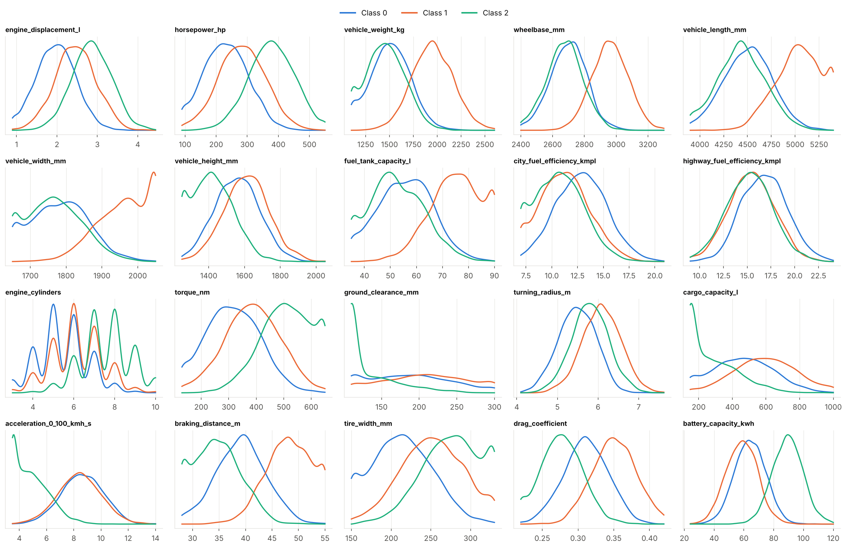
Figure 1. Distribution of every feature by class.
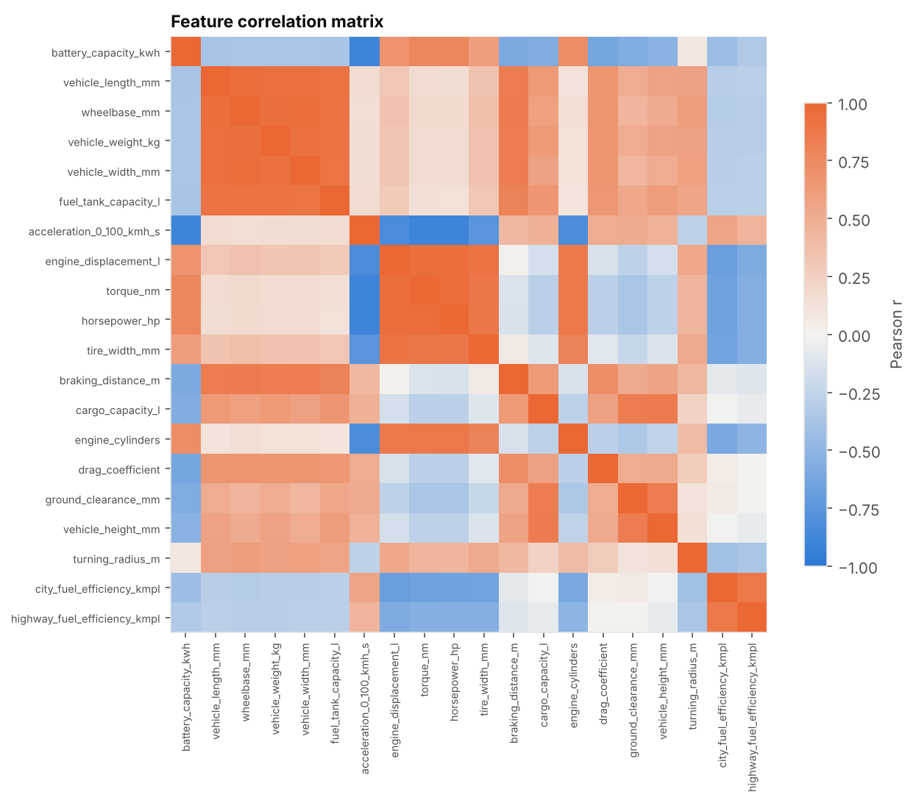
Figure 2. Feature correlation matrix.
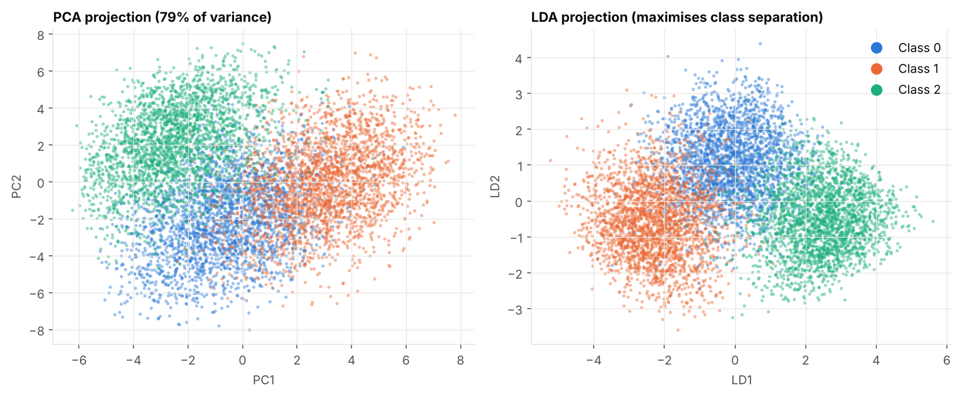
Figure 3. 2D PCA and LDA projections of the 7,500 unique rows.

3. Data Preprocessing
Step | Justification
Drop vehicle_id | It is an identifier only and carries no information about the class.
Remove the 2,500 duplicate training rows | With duplicates left in, a random CV split puts a row in training and its twin in validation. A default Random Forest scored 0.929 in 5-fold CV with duplicates versus 0.883 without, so the duplicates inflate the score by about 4.7 points. Labels never conflict, so no information is lost.
No imputation | There are no missing values.
No outlier removal | Values are bounded and none exceeds 4 SD; removing rows would only lose data.
Standardise the features (Logistic Regression and Naive Bayes) | Regularised logistic regression needs features on a comparable scale. It is fitted inside the CV pipeline, so each fold uses only its own training data and nothing leaks. Tree models do not need scaling.
PCA whitening (Naive Bayes only, tuned choice) | Decorrelates the features so Naive Bayes' independence assumption holds better. Compared with no preprocessing and a power transform.
No resampling or class weights | The classes are balanced.
No feature engineering | Ratio features (power-to-weight, footprint and others) did not improve Logistic Regression or the trees in cross-validation (differences within ±0.3%, smaller than fold-to-fold noise), so the raw 20 features are used.

4. Models Used
Best score per model. CV accuracy is 5-fold stratified cross-validation on the 7,500 unique rows for the best tuned configuration; the public score is what Kaggle reported for that model's submission file.
Model | 5-fold CV acc. | Repeated CV (5×6 or 5×3) | Public LB score | Submission file
Logistic Regression | 0.8943 | 0.8934 ± 0.008 | 0.903 | submission_logistic_regression.csv
Random Forest | 0.8848 | 0.8840 ± 0.005 | 0.892 | submission_random_forest.csv
Naive Bayes (tuned, PCA-whitened) | 0.8628 | 0.8634 ± 0.009 | 0.868 | submission_naive_bayes.csv
Decision Tree | 0.8641 | 0.8606 ± 0.009 | 0.866 | submission_decision_tree.csv
Naive Bayes (plain Gaussian) | 0.8475 | – | 0.847 | submission_naive_bayes_plain.csv

5. Hyperparameter Tuning
Every model was tuned by cross-validated search (5-fold stratified, scoring = accuracy, identical folds for all models, seed 42). The best configuration was then re-evaluated with repeated CV (new random splits) to check that the score is stable, and its training accuracy was compared with its CV accuracy to look for overfitting. The final model is refit on all 7,500 unique rows to make the submission.
Model | Search | Settings explored | Best settings
Logistic Regression | Grid search, 10 values | C (inverse regularisation, L2): 0.001, 0.003, 0.01, 0.03, 0.1, 0.3, 1, 3, 10, 100 | C = 0.3. Accuracy is flat (0.894) for C from 0.1 to 10; only strong regularisation (C ≤ 0.01) hurts.
Decision Tree | Grid search, 540 combinations | criterion {gini, entropy}; max_depth {3,4,5,6,7,8,10,12,None}; min_samples_leaf {1,2,5,10,20,40}; ccp_alpha {0, 0.0005, 0.001, 0.002, 0.005} | entropy, max_depth 7, min_samples_leaf 5, ccp_alpha 0.001
Random Forest | Randomised search, 20 of 600 combinations | n_estimators {200,400,600}; max_depth {None,8,12,16,24}; min_samples_leaf {1,2,3,5,8}; max_features {sqrt, log2, 0.3, 0.5}; criterion {gini, entropy} | 400 trees, gini, max_depth 16, min_samples_leaf 1, max_features sqrt
Naive Bayes | Grid search, 39 combinations | Preprocessing {none, power transform, standardise + PCA-whitening}; var_smoothing: 13 values from 1e-11 to 10 | PCA-whitening with var_smoothing 1.0 (CV 0.8628). Best without any preprocessing: 0.8475; power transform: 0.8492.

Extra checks on Logistic Regression: adding squared and interaction terms lowered CV accuracy to about 0.890; L1 regularisation gave 0.893; dropping the weakest features lowered it to 0.887–0.890. None beat plain L2 logistic regression.

6. Results and Discussion
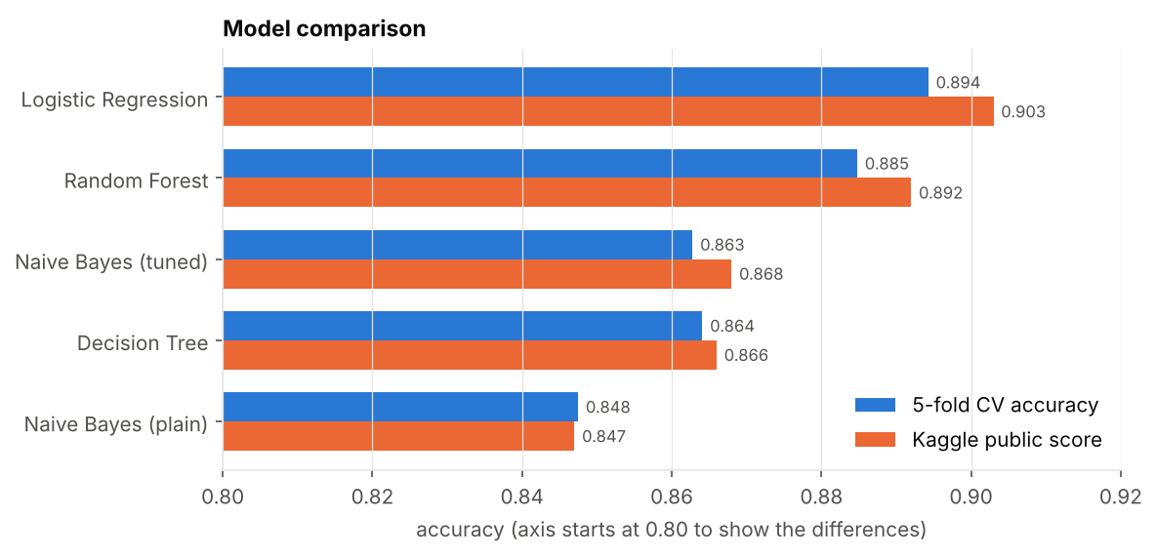
Figure 4. Cross-validation accuracy and Kaggle public score per model (axis starts at 0.80).
- Linear model wins. Logistic Regression is best in both CV (0.894) and on the public leaderboard (0.903). Its training accuracy (0.895) matches its CV accuracy, so it is not overfitting. Because the best model is linear, the class boundaries are close to linear in these features, as the LDA projection in Figure 3 also suggests.
- Trees: variance matters. A single Decision Tree is the weakest tree-based model (CV 0.864). An unpruned tree reaches 100% training accuracy but only 82% in CV, a classic high-variance case; pruning (depth 7, leaf size 5) recovers about 4 points. Random Forest averages many trees and gains about 2 points over one tree (0.885), but it still scores 99.6% on its own training data, so it memorises the training set and generalises less well than the simpler linear model.
- Naive Bayes and correlation. Plain Gaussian Naive Bayes is the weakest model (0.8475 CV, 0.847 public). With 14 strongly correlated feature pairs, correlated evidence is counted several times. Decorrelating with PCA-whitening and tuning var_smoothing lifts it to 0.863 (0.868 public), but it stays about 3 points below Logistic Regression.
- Reliability and ceiling. CV and public scores agree closely (within about 0.01 for every model) and give the same ranking, so the cross-validation estimate, with duplicates removed, can be trusted. All models stop at roughly 0.86–0.90. Logistic Regression's repeated-CV standard deviation is about 0.008, so a difference of 0.003 between near-equal models is noise. The public score uses only 40% of the test data, so I did not choose models by that score; the hidden 60% should behave like the CV estimate (about 0.89).

7. Best Model
Best public-leaderboard model: Logistic Regression (L2 regularisation, C = 0.3, standardised features, trained on the 7,500 unique rows) with a public score of 0.903. Its submission file is submission_logistic_regression.csv. It is also the best model by cross-validation (0.8943), which makes it a safe final choice for the private leaderboard.

8. GitHub Link
[Paste the repository URL here before submitting]
Suggested contents of the repository: 1_logistic_regression.ipynb, 2_decision_tree.ipynb, 3_random_forest.ipynb, 4_naive_bayes.ipynb (each regenerates its submission CSV), plot_data.ipynb (EDA figures), the five submission CSV files, and the competition data in a data/ folder.

