

Faculty of Technology and Engineering
Chandubhai S. Patel Institute of Technology (CSPIT) Department of Computer Science & Engineering
Date:24/09/2026
Laboratory Manual

Academic Year | : | 2026-27 | Semester | : | 3rd
Course code | : | ITUE203 | Course name | : | WEB DEVELOPMENT FRAMEWORKS

Practical No: 5

Problem Statement: Registration form, HTML 5 Input types, JavaScript Validation, Regular Expressions, Password strength, Error messages, Accessibilities.

Objective: Registration Form – Create student form with Name, Email, Mobile, Password, Confirm Password, Course, Year, Gender, Terms.
HTML5 Input Types – Use correct input types and attributes.
JavaScript Validation – Validate all fields using JavaScript.
Regular Expression – Use Regex for Name, Email, Mobile, Password, etc.
Password Strength – Show password strength.
Error Messages – Display errors near the relevant fields.
Accessibility – Use proper labels and keyboard-friendly form.

GitHub Repository Link

https://github.com/yug1127/wdf-practicals-25cs084.git

Screenshots:

Complete Registration Form:

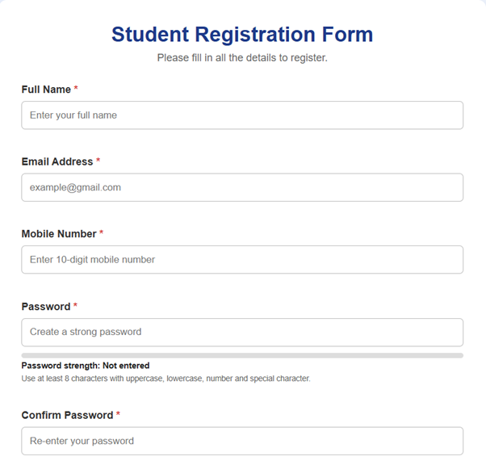
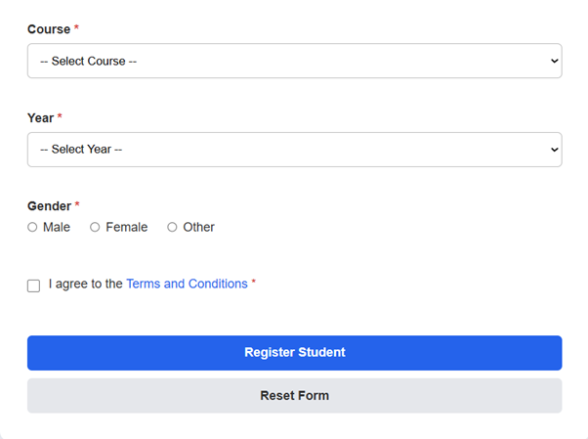

Successful Validation:

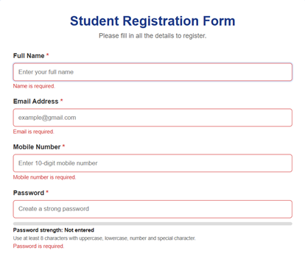
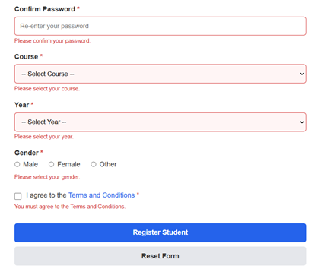

Invalid mobile/name/email validation:

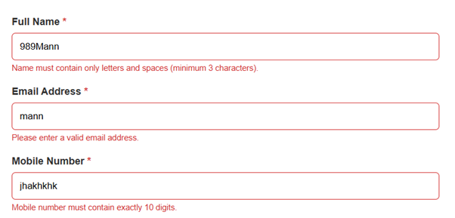

Password & Confirm Password & Strength:

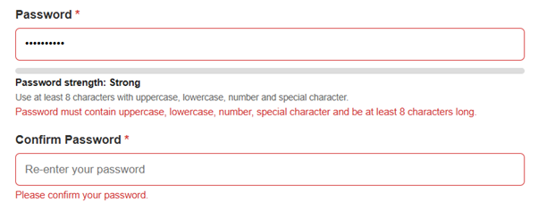

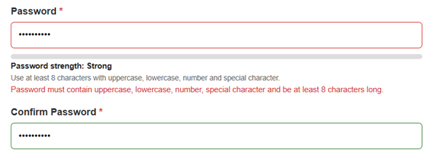

Terms not accepted:



Terms accepted:



